Jeff Ma, SLU (Five potential projects)
- Building walls in civil engineering remains a repetitive and ergonomically unfriendly task that often generates inconsistent results. In this project, the student will learn how to teach and program industrial robots that are commonly used in industry automation and then the student will develop an advanced robotic 3D printing system to transition from manual wall-builders into safer robot-operated roles. The system will use model-based control and artificial intelligence to account for uncertainties in its environment to create consistent, high-quality results.
- Welding metal parts remains a repetitive and ergonomically unfriendly task that often generates inconsistent results. In this project, the student will learn how to teach and program industrial robots that are commonly used in industry automation and then the student will develop an advanced robotic welding system to transition from manual welders into safer robot-operated roles. The system will use model-based control and artificial intelligence to account for uncertainties in its environment to create consistent, high-quality results.
- Assembling mechanical components into systems remains a repetitive and ergonomically unfriendly task that often generates inconsistent results. In this project, the student will learn how to teach and program industrial robots that are commonly used in industry automation and then the student will develop an automated assembling system to transition from manual assemblers into safer robot-operated roles. The system will use model-based control and artificial intelligence to account for uncertainties in its environment to create consistent, high-quality results.
- In this project, the student will use Allen-Bradley Programmable logic controller (PLC) to automate the packaging and material handling processes. Sensors will be used to provide input to the system and actuators will be used as the output. Artificial Intelligence will be used to handle uncertainties.
- In this project, the student will use nanosecond laser system to machine silicon wafers. Laser parameters (laser beam size, laser energy level, overlapping ratio, sample-to-lens distance) will be varied to investigate possible laser machining mechanisms when machining silicon wafers.

Fuzhong Zhang, WashU
The Zhang Lab at Washington University (https://sites.wustl.edu/fuzhongzhanglab/home/) offers a research project to STARS 2022 students on synthetic biology for advanced materials. The Zhang Lab has interest in using synthetic biology approaches to engineer microbes to produce advanced materials. This STARS project mainly focuses on high-performance fiber materials. The goal of this project is to explore protein sequence space to identify novel fiber materials with high strength and toughness. The student is expected to perform molecular cloning, microbial cell engineering, and fermentation to produce hybrid proteins. The students will also be involved in protein purification and fiber spinning. Weekly meetings will be arranged between the student and the mentor for training and result discussion.
Relevant references:
J Li, Y Zhu, H Yu, B Dai, YS Jun, F Zhang, Microbially Synthesized Polymeric Amyloid Fiber Promotes β-Nanocrystal Formation and Displays Gigapascal Tensile Strength. ACS Nano 15 (7), 11843-11853
CH Bowen et al., Microbial production of megadalton titin yields fibers with advantageous mechanical properties. Nature communications 12 (1), 1-12

Angela Hirbe, WashU SOM
Our lab is interested in identification of novel therapeutic targets and diagnostic biomarkers for sarcomas, aggressive cancers that arise from bone or soft tissue. We are particularly interested in those sarcomas that arise in cancer predisposition syndromes such as NF1. One project in the lab involves investigation of the role an amino acid transporter, ASCT2, in development of MPNST (an aggressive sarcoma that arises from nerves) and whether it can be utilized as a diagnostic biomarker to aid in early detection of this cancer.

Gerardo Camilo, SLU
Many of the crops that humans consume, and are dependent on, are bee pollinated. Yet, many of those pollinating species are decreasing in abundance and diversity worldwide. At the same time, the human population is approaching 8 billion with the vast majority us living in cities. How can we conserve and manage pollinating species in urban areas in a way that can result in consistent crop yields is one of the main research questions addressed in my lab. We also try to understand how urban environments, especially in the way we take care of our lawns and green spaces, influence the ecological diversity of bees.

Mark McQuilling, SLU
Computational flow control study for shock wave - boundary layer interactions:
Shock wave - boundary layer interactions (SWBLIs) occur in the engine inlet region of modern supersonic aircraft and cause decreased engine performance, increased fuel consumption, and additional wear and tear on downstream engine components. This project seeks to explore the effects of various blowing configurations for controlling the loss-inducing flow separation caused by the SWBLI, where mass flow is injected just upstream of a normal shock wave in a Mach 1.6 supersonic flow. Students will gain a fundamental understanding of high-speed aerodynamics and learn to use a computational fluid dynamics software, which is a widely used modern engineering tool for studying fluid dynamics problems.

Keith J. Stine, UMSL
Development of Gold Nanostructures for use as Biosensors: The STARS student will participate in the preparation of gold nanostructures and their application for the development of biochemical sensors of potential use for disease diagnosis. The nanoparticles or nanostructures will be created using chemical or electrochemical methods and their structure will be characterized using scanning electron microscopy. These nanostructures will be attached to proteins capable of binding to protein biomarkers or other disease related biomarkers for sepsis or cancer. The binding performance will be evaluated using either electrochemical or optical methods. All of this work will take place in the Department of Chemistry and Biochemistry at University of Missouri – Saint Louis.

Dilip Shah, Donald Danforth Plant Science Center
“The primary focus of research in the Shah Lab at the Danforth Center is to provide robust and sustainable protection to crops from fungal diseases. Small highly potent antifungal peptides offer significant potential for development as spray-on biofungicides in agriculture. The STARS student will work on characterizing the antifungal activity of two small cysteine-rich peptides. The student will purify two antifungal peptides using biochemical tools and determine their antifungal activity against a fungal pathogen Botrytis cinerea which causes economically devastating gray mold disease in vegetables, fruits and flowers. In addition, s/he will test these peptides for their ability to confer resistance to this pathogen in a model plant Nicotiana benthamiana and in tomato.”

Eike Bauer, UMSL
Our research develops new catalyst systems based on iron. Catalysts speed up chemical reactions, and can allow for chemical reactions to take place under milder conditions than they would otherwise require, reducing the energy and cost needed for the synthesis of organic compounds, such as pharmaceuticals. The research intends to screen novel iron catalysts produced by the Bauer research group for catalytic activity, to optimize the reaction conditions for these catalysts, and to minimize waste whenever possible. The overall goal of the project is to develop “greener” ways, that is, more environmentally friendly ways to achieve certain chemical transformations that would otherwise be impossible or unreasonable. Iron catalysts fulfill this goal, because iron is non-toxic and environmentally benign. Students will learn the handling of modern instrumentation as used in pharmaceutical industry, forensics, or chemical production, such as gas chromatography, infrared spectroscopy, nuclear magnetic resonance and more. www.eike-bauer.net

Sliviya Zustiak, SLU Biomedical Engineering
Title: "Nanocomposite materials for drug delivery applications"

Some of the newest and most promising drugs currently on the market are proteins, which can cure a variety of previously incurable diseases. Unfortunately, proteins tend to have short half-life in blood and hence, diminished efficacy. One way to improve treatment efficacy is to design efficient protein delivery devices. Our lab works with two-dimensional nanoclays added to hydrogels to serve as sustained release protein delivery devices. However, the field still lacks a clear understanding about the manner in which proteins interact with the nanoclays and how that affects their sustained release. During their summer research experience, students will test various release buffer conditions, such as ionic strength, pH and hydrophobicity, to determine how they affect protein-nanoclay interactions and resulting protein release from the nanocomposite hydrogels.

Badri Adhikari, UMSL
Dr. Badri Adhikari's research group studies how artificial intelligence and machine learning methods can be used to improve human health. As a mentee, you will work with the graduate students in his lab. For the internship project, you will have two options. The first project is developing machine learning (ML) models to learn the foundations of ML. You will first develop ML models that can automatically learn patterns from existing tabular data to make predictions on new data. A simple example project would be building an ML model that learns to predict the ratings for new movies after learning from existing movie ratings. The second project is to build deep learning (DL) models to learn the foundations of convolutional neural networks--a core concept behind many modern automated technologies such as self-driving vehicles. A simple example project would be to build a model that learns to detect someone's mood (smiling, sad, neutral, angry, etc.) by looking at their face photo. For both projects, you will have the option to select your data. By working on these projects, you will have the opportunity to: 1) learn Python programming, 2) learn how machine learning and deep learning methods can mine patterns hidden in data, and 3) learn to use the powerful Keras library in Python. Prior computer programming experience is preferred but not required. Mentor: Dr. Badri Adhikari -- https://badriadhikari.github.io/.

Mikhail Berezin, WashU SOM
- In this project, the student will learn about developing fluorescent molecules for cancer imaging, including how to purify and characterize novel compounds using high-performance liquid chromatography and mass spectrometry, key techniques of synthetic organic chemistry. The student will also gain exposure to the biological testing of these molecules and explore the medical uses of molecularly targeting optical imaging agents for disease detection.
- The project will focus on recognizing therapeutical targets and treatments for chemotherapy-induced neuropathy with the model of neuron regeneration of mouse DRG. Students will learn primary tissue culture, microscopy imaging, biochemistry techniques such as real-time quantitative polymerase chain reaction (RT-qPCR), western blot, and immunohistochemistry. Additionally, they will work on image processing and data analysis with software includes ImageJ and Prism.

Jeff Catalano, WashU
The Catalano group studies the reactions between water and natural solids to understand the evolution of the Earth, the health of ecosystems, and the habitability of other planets. In 2022, the group welcomes a STARS student to work on a project that investigates chemical interactions between simple biomolecules and minerals that occurred early in Earth’s history. The goal of this project is to identify realistic pathways for the development of more complex molecules before the origin of life.

Ray Mu, UHSP
Emerging Water Contaminant Evaluation and Technology Development to Improve Saint Louis Drinking Water Quality
Water is a very crucial natural resource for humans. In the US, accessing safe water is a luxury most of us enjoy with little thought. Nonetheless, there are billions of people who still lack access to safe drinking water all over the world. The growing number of environmental contaminants detected in water bodies has drawn ever-increasing attention over the last decade. Numerous emerging environmental contaminants may cause serious health issues. The recent occurrence studies of these contaminants show both industrial and household activity introduction of chemicals into water resources. These various sources result in a large variety of chemicals such as heavy metals, Trihalomethanes, pharmaceutical, and personal care products (PPCPs), and disinfection byproducts detected in water nationwide. In order to meet the detection needs and screening studies, this study will focus on ICP-MS, GC-MS, or LC-MS/MS method development, validation, and utilization of these techniques for water analysis of different classes of emerging environmental contaminants. Students will be involved to varying degrees in the above research project. One or two research students will work on sample collection, preparation, and analysis for this project. In addition to training them on basic experimental skills, research methods, and data analysis, students will also learn how to read articles, perform literature reviews, and generate and design follow-up research experiments.

Adriana Montano, SLU
We are focused on the research of lysosomal storage disorders. We have been studying the basic biology of the Mucopolysaccharidoses in order to develop novel treatments. Mucopolysaccharidoses are rare genetic disorders that are prevalent in children. In addition, we are conducting a pilot study to establish newborn screening of Mucopolysaccharidoses

Gregory Yablonsky, SLU
- Mathematical Modelling of Complex Chemical Catalytic Reaction: Optimal Behavior and Deactivation: A topic of research will be mathematic modeling of complex chemical reactions [1], e.g., catalytic oxidation and dehydrogenation reactions. A focus will be done on computer calculations of different regimes of practical interest, e.g., steady-state, and non-steady-state regimes, equilibria and extrema, processes with deactivation [2]. The research project will be performed via the in-person interaction in the Washington University (Brauer Hall).
References
1. G.B Marin, G.S. Yablonsky, and D. Constales, Kinetics of Chemical Reactions: Decoding Complexity, Wiley-VCH, 2019, 2nd ed, 442 pp
2. Z. Gromotka, G.S Yablonsky, N.J. Ostrovskii, and D. Constales, “Three-Factor Kinetic Equation of Catalyst Deactivation”, Entropy, 23(2021)818
2. Panoramic View on Catalytic Science and Technology.Catalysis is one of main driving forces of the contemporary human civilization which is based on the advanced catalytic technology (petrochemical industry, production of fertilizers etc.). The goal of this project is presenting the panoramic view on evolution of main concepts of catalytic science and technology up to contemporary frontiers. As the result, the student will gain a deep understanding of catalytic science, engineering, and technology and why their integration is a cornerstone of the future progress. The research project will be performed via the in-person interaction in the Washington University (Brauer Hall).
References
G.B Marin, G.S. Yablonsky, and D. Constales, Kinetics of Chemical Reactions: Decoding Complexity, Wiley-VCH, 2019, 2nd ed, 442 pp

Fenglian Xu, SLU
The student will be investigating the role and mechanisms of progranulin-induced autophagy response in neurons under high glucose. A major characteristic of type II diabetes is chronic high glucose (hyperglycemia) that contributes to many pathologies in diabetes. Hyperglycemia specifically has been shown to predispose individuals to neurodegenerative diseases like Alzheimer’s, with diabetics having greater prevalence and severity of symptoms. Common to these sets of conditions is impaired autophagy, a cellular self-degradative process that breaks down protein aggregates that become harmful if allowed to accumulate. Progranulin is a lysosomal protein that is highly expressed in neurons and crucial to protein breakdown. Mutations to this gene are a genetic cause of the neurodegenerative disease frontotemporal lobar dementia through accumulation of TDP-43 protein aggregates, and restoration of progranulin expression has been shown to alleviate symptoms. However, it has not been determined if progranulin can also facilitate breakdown of protein aggregates that form under high-glucose conditions, and if so, by what cellular mechanism. The student will carry out experiments to help fill this gap in knowledge under the supervision by the PI and a graduate student in the Department of Biology at Saint Louis University.

Aimee Dunlap, UMSL
We study the evolution of information use (learning, memory, and decision making) using bees and fruit flies as model systems. We test how bees incorporate different aspects of their environment, like floral and social information, to determine how they forage on flowers efficiently and track changes across the season. Using the same economic theory, we also test predictions about decision making in fruit flies using behavior, gene expression, and bioinformatics. We are keen to use laboratory- and theory-based understanding of insect learning and decision making to help us understand patterns of biodiversity loss in pollinators. This summer, all of the work is with pollinators in the lab and/or outside. Potential projects to work on include a) testing bumble bees in the lab for how the environmental effects of biopesticides and lead affect bee learning, individual behavior, and social behavior; b) joining work in the field collecting data on bees and hover flies in community gardens and natural areas throughout St. Louis; c) analyzing video data of pollinator interactions with flowers in urban and suburban community orchards, testing hypotheses about how bees are collecting pollen from flowers; and d) testing for how well bees remember different attributes of flowers, versus what bees are remembering from other bees.

Muhammad Hagras, UHSP
Computational Modeling of the Binding of Different Drugs at Their Receptors:
In this project, each student will be assigned a certain protein/enzyme to study and learn about in literature. Afterwards, each student will start modeling this protein and visualize its 3D structure and locate its active binding site. Next, the student will simulate the native protein solvated in water box using molecular mechanics/dynamics program (Gromacs). Finally, the student will study the interaction between the assigned drug molecule to the binding site and calculate the binding energy. In addition, the student will analyze the specific interaction that drug makes with the different residues of the active site. In this project, each student will learn the structure/function relationship of each drug molecule besides acquiring basic knowledge in running molecular simulations.
The student should be able to connect remotely to my computational cluster at UHSP to run their simulations (which is very convenient). They will use Gromacs package to run their molecular mechanics/dynamics simulation.

Yehuda Ben-Shahar, WashU
The student will use genetic approaches to study the chemosensory system of the vinegar fly, Drosophila melanogaster. The legs of flies contain many chemosensorysensory neurons that detect tastants and pheromones important for normal fly behavior. One particular group of neurons, which express an ion channel pickpocket 23, are important for male courtship behavior but are not well understood. Using genetics and microscopy, the student will identify which chemoreceptors these neurons express in order to better understand their function in chemosensation and male courtship behavior.

Dr. Song Hu and Dr. Jin-Moo Lee (Coadvisors), WashU
Quantifying blood vessel “curving” in RVCL disease patients:
Retinal Vasculopathy with Cerebral Leukoencephalopathy (RVCL) is a very rare genetic disease whose pathological process results in the deterioration of small blood vessels. Consequently, there is a loss of blood supply that affects the brain and retina resulting in multiple complications ranging from deep visual impairment to even a series of “mini-strokes.” To better understand the pathophysiology of RVCL, we want to investigate different aspects of small blood vessels, specifically capillaries. Vessel curving, for example, can serve as one of the prognostic biomarkers of RVCL disease. However, to observe this phenomenon, a tool to study such small blood vessels is needed. A collaboration between Dr. Song Hu (Biomedical Engineering Department) and Dr. Jin-Moo Lee (Neurology Department) at Washington University in St. Louis proposes a non-invasive cuticle nailbed imaging technique using photoacoustic microscopy (PAM); an innovative optical modality that takes advantage of the tissue’s response (a local rise in temperature) to light. Once the data is acquired, a quantification of capillary curving is needed to evaluate the differences between RVCL patients and healthy controls. In this project, the student will aid in the development of an algorithm that quantifies capillary curving. Furthermore, they will have the opportunity to engage in clinical research, while also learning the basics of PAM and the intersection of engineering and medicine.

Kelly Harris, WashU
- Asthma & Environmental Injustice: Beginning with a literature review, this study examines the effectiveness and feasibility of housing assessments and interventions to address environmental injustice and mitigate the impacts of environmental conditions on asthma.
- Health and School Readiness: This study interrogates a large nationally representative data set to examine the relationship between early child health outcomes, healthcare access and utilization, family and neighborhood vulnerability, and educational outcomes among youth.
- School-Based Asthma Management: This study is a research-school partnership to (1) understand the impacts of chronic diseases on academic achievement and attainment, engagement and participation for youth, and (2) develop and adapt interventions to support school-aged youth with asthma and other chronic diseases and aligned implementation strategies.

Scott Sell, SLU
https://scholar.google.com/citations?user=o0skvW0AAAAJ&hl=en&oi=ao
The focus of our lab is the fabrication and evaluation of tissue engineering scaffolds capable of replicating both the form and function of the native extracellular matrix (ECM). Through the creation of idealized tissue engineering structures, we hope to harness the body’s own reparative potential and accelerate regeneration. Of principal interest to our laboratory is the fabrication of scaffolds capable of promoting wound healing and the filling of large tissue defects, as well as orthopedic applications such as bone and ligament repair. We are primarily interested in the utilization of the electrospinning process to create nanofibrous polymeric structures that can be applied to a wide range of applications and the creation of mechanically robust alginate hydrogels.

Jonathan Fisher, SLU
We are interested in the interplay among nutrient sensors in the control of glucose metabolism in skeletal muscle. Skeletal muscle comprises roughly 40% of body mass and is a key driver of whole-body metabolism. For example, most of the carbohydrate ingested in a meal ends up stored in skeletal muscle. When glucose uptake into and storage by skeletal muscle drops, that results in the high blood glucose levels known as insulin resistance or diabetes. We will examine how a sensor of nutrient sufficiency (mTOR), a regulator of fuel uptake and storage (Akt), and a sensor of metabolic stress (AMPK) suppress glucose uptake into muscle when nutrients are plentiful and enhance glucose uptake under conditions of fuel insufficiency or metabolic stress. The goal is to identify novel means to control blood glucose levels by regulating glucose uptake into muscle. Find out more here.

Chung Wong, UMSL
We perform research in computer-aided drug discovery and computational biosciences. Depending on your interests and background, you may participate in projects relating to method development or applications. Programming skills are required for projects involving method development. Applications suitable for short-term summer projects include the computer-aided optimization of compounds that target the protein kinase c-MET for treating cancer, and predicting the sensitivity or resistance of clinically observed mutants of the epidermal growth factor receptor in lung cancer to drugs or drug candidates.

James Bashkin, UMSL
We work on making potential antiviral agents and testing certain aspects of their activity, such as cell uptake, using mammalian cell culture techniques. Lately, we have focused on negative-strand RNA viruses such as RSV (respiratory syncytial virus) and related targets. We also use similar methods to fight cancer by blocking the binding of harmful transcription factors to DNA.

Michael R. Nichols, UMSL
Biochemical and neuroinflammatory processes in Alzheimer’s Disease:
In Dr. Nichols’ research group, graduate students, undergraduate students, and technicians work together to understand the underlying biochemistry of Alzheimer’s disease (AD). Specifically, we study many aspects of the amyloid-beta protein (Aβ), the primary trigger for AD. Aβ is the main component of the senile plaques that accumulate in the brains of AD patients. Our work combines both biophysical and cellular studies. We have projects in many areas, but one of our recent ones has been to develop a new antibody that recognizes a particular form of Aβ. You will work on some aspect of this project and participate in the characterization of the antibody and utilize the antibody to better understand the mechanisms of Aβ uptake in immune cells. You will perform enzyme-linked immunosorbent assays ELISAs, Western Blots, and perhaps confocal fluorescence microscopy for this project. The results will help us to understand the possible applications of the antibody, and how Aβ interacts with cells. Students from my lab have gone on to industry, graduate school, medical school, and physician’s assistant school.

Wenyan Xiao, SLU
Xiao’s lab studies the mechanism of gene expression in plants. Specifically, we investigate epigenetic gene regulation of reproduction using the model plant Arabidopsis thaliana. Projects can be involved in genetics, molecular biology and plant biology depending on students’ interest (https://www.slu.edu/arts-and-sciences/biology/faculty/xiao-wenyan.php).

Ajay Jain, SLU
- Bowel resection results in short bowel syndrome (SBS), a devastating condition with insufficient remaining intestine to sustain nutritional needs from enteral nutrition (EN). Indeed, SBS patients, in the absence of EN, require intravenous nutrition via a process called Total Parenteral Nutrition (TPN) for survival. Tens of thousands of patients worldwide require TPN, many with lifelong dependence. Despite the undeniable benefits of TPN, side effects in SBS include intestinal failure associated liver disease (IFALD) which encompasses intra hepatic bile acid (BA) accumulation, steatosis, cholestasis, inflammation, glucose intolerance and dyslipidemia. Gut injury with gut atrophy and gut permeability changes also occur in SBS. The etiology of TPN associated injury in SBS is incompletely defined, partly due rodent and other small animal models that do not adequately recapitulate human SBS. Emerging data in more robust large animal models of SBS, including results from our published studies suggests that alterations in gut signaling modulate injury mechanisms in SBS. While many prior studies have focused on the detrimental effects induced by TPN constituents, based on our strong data, we instead postulate the novel hypothesis that the state of luminal content deprivation as occurring in SBS alters gut-derived signals contributing to liver and gut injury, which is prevented if EN is given in SBS. Using a highly translatable SBS model, our lab is advancing strategies to mitigate serious complications and provide key insights into drivers of injury in SBS and its mitigation with a novel system. Students will be able to work on this model and be involved in developing novel therapeutics.
- Over 13,000 patients with advanced liver disease await a liver transplant; however, due to the acute shortage of livers almost 8 people die every day on the waiting list, despite an almost 9% discard rate of ‘marginal donor livers’ (MDL), deemed unsuitable for transplantation due to the high risk of ischemia reperfusion (IR) injury. The clinical repercussions of IR injury ranges from significant hepatocellular damage causing postoperative complications to prolonged ICU stay and potential death of the recipient. Marginal livers include those with severe steatosis, old donors and from donation after cardiac death all of which are frequently discarded due to intolerance of these organs to IR injury. We propose that understanding and targeting pathways regulating IR injury, prior to organ transplantation would enable successful transplant of such MDL, increasing the supply of available livers. In order to investigate the basic biology of IR and to test novel therapeutics to reduce the effects of IR we have developed a novel model utilizing human MDL placed on an Extracorporeal Membrane Oxygenation (ECMO) machine extensively modified to pump and bifurcate blood flow into hepatic and portal circulation. Unlike previous systems our model can provide unmixed dual arterial and portal circulations to perfuse two liver segments simultaneously. Splitting a single liver serves as a robust internal control for the significant variability between individual donor livers and specifically isolate the effects of ischemia-reperfusion injury. We are using this system in our lab to interrogate underlying biology of ischemia-reperfusion and it is a powerful system to test therapeutic targets to mitigate the effects of IR mediated injury. Students will be able to work on this model and be involved in diagnostic and therapeutic methodologies.

Bettina Casad, UMSL
Social Neuroscience and Intergroup Relations (SNAIR) Lab: Our research examines how threatening environments (e.g., classrooms) affect minoritized groups’ (i.e., women, racial minorities) cognitive performance, education and career aspirations, psychological well-being, and physical health. We examine electrophysiological mechanisms of prejudice and discrimination and how minoritized groups respond to and cope with bias (i.e., sexism, racism). Student interns will learn how to use electroencephalogram (EEG) caps to record brain activity, cardiovascular equipment to measure heart rate, electrocardiogram (ECG), blood flow, and sensors to detect eye movements (EOG), and skin conductance. Interns will collaborate with Dr. Casad, graduate students, and undergraduate students to collect data from participants in our experiments, analyze, and present the data. Graduates from the SNAIR Lab have gained admission to medical schools and Ph.D. programs in psychology and neuroscience. Lab alumni are employed as university professors and research scientists in laboratory settings.

Jim O'Brien (UMSL) and Leah O'Brien (SIUE)
Activity: High Sensitivity Molecular Spectroscopy conducted by Intracavity Laser Absorption Spectroscopy (ILS) with High Resolution Fourier Transform Spectroscopy (FTS) Detection. We study the electronic structure of gas-phase free radicals such as Tungsten Sulfide and Oxide (WS, WO), Titanium Fluoride (TiF), Molybdenum Nitride and Oxide (MoN, MoO) and Copper Oxide. These species can be created for spectral observations in hollow cathode plasma discharges and the electronic structure is investigated by recoding and analyzing the ILS absorption spectra. We aim to characterize the electronic, vibrational and rotational structure of these species, which are important for catalysis, CVD processes and in advancing theory – each project contributes to a larger study of periodic trends in molecular bonding. Students will learn about laser spectroscopy, generating small molecules in plasmas, spectral analysis and molecular bonding. Over the past several summers, STARS students engaged in such work have been co-authors of papers published in top journals such as the Journal of Molecular Spectroscopy. In summer 2022, focus will be on a couple of the above-mentioned species looking at several vibrational bands in different electronic transitions using ILS based on Ti:sapphire (e.g., TiF) and Dye Lasers (e.g., WS).

Xuemin Wang, UMSL
Wang lab investigates the molecular mechanisms by which stress cues in plants are perceived and transduced into cellular and physiological responses, with the goal to improve plant stress tolerance and production.
Plants are sessile, and what are the mechanisms enabling them to rapidly react and adapt to ever changing environments? The focus of the lab is to understand how membrane lipids and associated genes and enzymes function as cellular mediators, as many cellular responses to stress cues are initiated at cell membranes. Ongoing projects include investigating how lipid remodeling and signaling mediate plant response to phosphate deficiency, drought, and high salinity, and how lipid signaling and metabolism interact with biological clock, Students will learn to test specific hypotheses and use various experimental approaches, including biochemical, molecular, cellular, biotechnological, and physiological analyses. Gene cloning, protein expression and purification, enzyme assays, genetic manipulations, genotyping, phenotyping, PCR, bioinformatics, mass spectrometry, and confocal imaging are common techniques used in the research.
Istvan Kiss, SLU
Chemical Brain and Chaos: Complex dynamics of networks of electrochemical reactions:
Overall goal in our group is the development of a nanoscale chemical computing device (e.g., a chemical form of machine learning) that can process information, incorporates battery and sensors to perform higher level functions such as memory and adaptation. To achieve this goal we investigate collective dynamics (e.g., synchronization and chaos) of networks of current generating chemical reactions with electrochemical cells.
The research will introduce the students to modern signal processing techniques obtained from multi electrode array measurements from electrochemical processes and gene expression data from circadian rhythms. Primary application of the technique is towards network inference and graph theoretic description of complex systems.
Vasit Sagan, SLU
Developing climate resilient crops using geospatial technologies including satellite and drone-based imaging, indoor scanning systems, and field surveys: The STARS student will work with a group of postdoc fellows and graduate students to screen for crops that has maximum nitrogen use efficiency, sequester more carbon, and produce more yield under abiotic stress. The students will engage in field work, drone data collection, conducting ground surveys, and using machine learning to predict yield.

Stephen Holmes, UMSL
Project 1. Low coordination number complexes display magnetic properties that are among the most promising single-ion magnets known for to date. While weak ligand fields and relatively small spin orbit coupling parameters are generally encountered for first row transition metal complexes, second and third row analogues are expected to display considerably higher ones, possibly leading to magnetically anisotropic intermediate or low spin electronic configurations. Orbital degeneracy may be exploited to introduce first-order angular momentum contributions into the magnetic ground state. The key feature of this electronic configuration is that doubly degenerate spin ground states are retained regardless of the sign of the zero-field parameter, while less efficient second-order interactions, arising from mixing of spin-orbit coupled excited states, become less important for magnetic anisotropy.
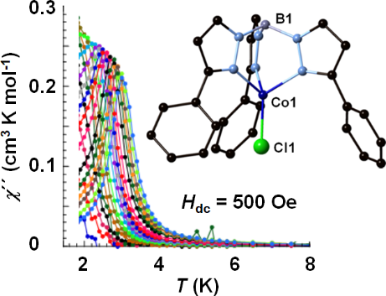
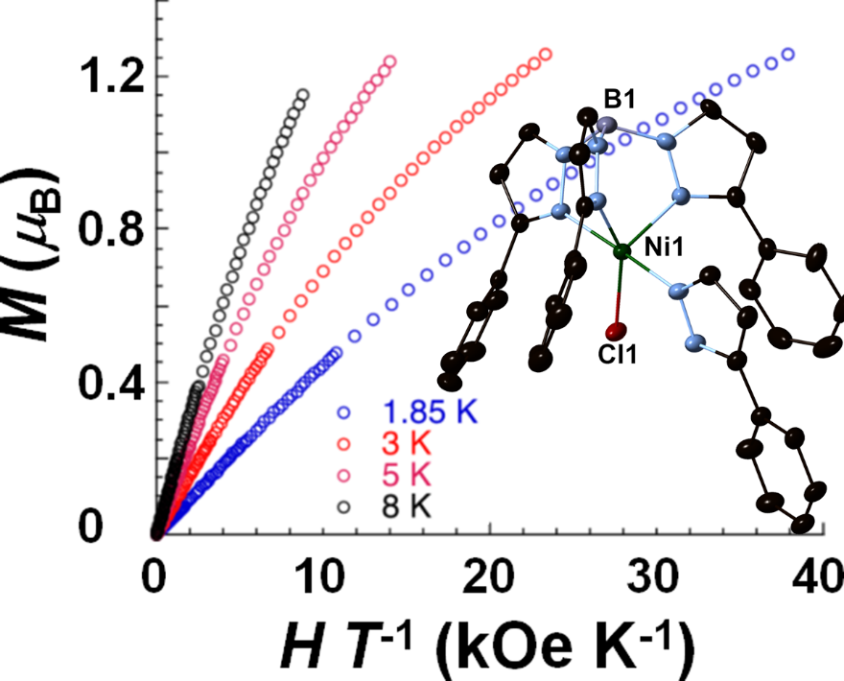

Figure 1. (left) χ´´ vs T data and X-ray structure for (Tp^{Ph})Co^{II}Cl. (right) M vs H T⁻¹ data and X-ray structure for (Tp^{Ph})Ni^{II}Cl(3-phenylpyrazole).

A series of single-molecule magnets (SMMs) containing sterically demanding tris(3-phenylpyrazolyl)borate ligands, namely (Tp^{Ph})MX analogues (M^{II} = Nb, Mo, W), will be prepared and characterized via UV-vis, X-ray structural, electrochemical, and magnetic techniques. Tunable slow magnetic relaxation is expected with halide substitution in the mononuclear [(Tp^{Ph})M^{III/IV}X] (X = Cl, Br, I) series (Figure 1). Spectroscopic and magnetic studies will clearly assist efforts to better understand how magnetic properties are related to degeneracy of spin ground states, symmetry, and extent to which metal-halide bonding controls these issues in single-molecule magnetic complexes.
Stephen Holmes continued, UMSL
Project 2. The rational design of structurally related multifunctional materials relies heavily on a thorough understanding of the optical and magnetic properties of their components. Over the past decade, we have exploited the pyrazolylborate family of building blocks, to serve as vehicles for the preparation of many single-molecule magnets and photochromic materials. While numerous Fe/Co complexes and chains are known to display thermo- and photochromic behavior the analogous Fe/Mn ones remain unknown (Figure 2). Using a modular approach, the magnetic and optical properties of tri- and tetranuclear clusters may be tuned via three general approaches: (1) ancillary ligand replacement and (2) anion substitution. Recent efforts to prepare new bistable derivatives will be described.
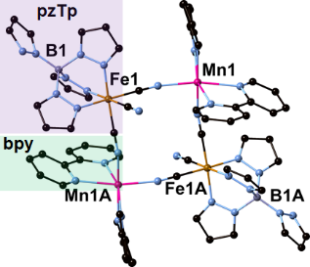

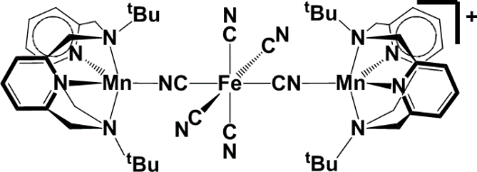

Figure 3. (top) X-ray structure of a molecular square [(pzTp)Fe(CN)₃]₂-[Mn(bpy)₂]₂[OTf]₂. (bottom) Proposed trimetallic {FeMn₂}⁺ complex for study.
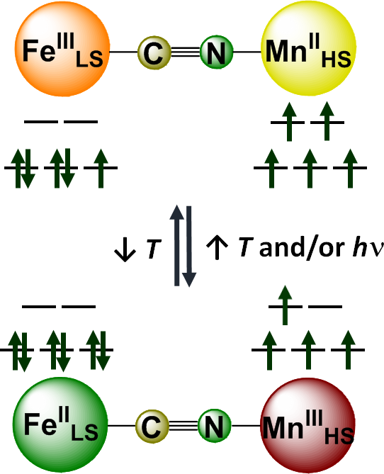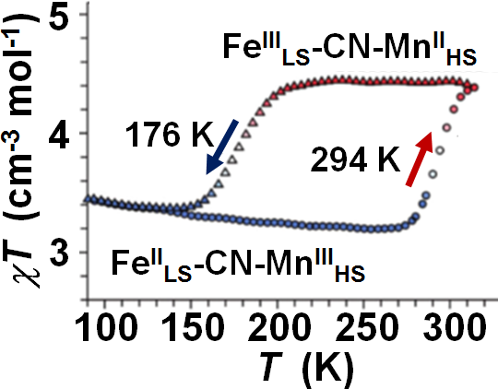

Figure 2. (top) Electronic states and (bottom) magnetic data for bistable three-dimensional Fe/Mn Prussian blues.
We propose that charged clusters offer the prospect of controlling intermolecular contacts, lattice solvent, and packing arrangements via ancillary ligand and anion choice, such that tunable optical and magnetic properties may be realized within a common structural archetype. Under ideal circumstances, cationic clusters may provide practical opportunities for the control of spin-lattice relaxation processes that influence relaxation rates of magnetic and photstationary states. Through ligand and metal ion substitution, we intend to systematically investigate how spin-orbit interactions and magnetic anisotropy may be tuned as a function of pyrazolylborate steric demand and donor strength, intermolecular contacts, and spin state degeneracy within a family of mononuclear photoresponsive {Fe₂Mn₂} and {FeMn₂} clusters (Figure 3).

Phyllis Stein, WashU SOM
Projects will involve learning about the types of heart rate variability (HRV) measures that are derived from continuous ECG recordings. Generally, these are from Holter monitors, wearable devices that record the subjects' actual electrocardiogram which is then analyzed using special software that detects each individual heartbeat and labels it as normal or ectopic. After the results are overread for accuracy, the scanner exports a text file that lists each beat on the recording and the time in ms from the last one. However, some of the recordings come the the ICU or NICU.
HRV is calculated from the beatfile, and plots of heart rate or HRV vs time allow the researcher to derive a lot of information about the health of the person who had the recording. HRV is a measure of cardiac autonomic functioning, that is the health of the sympathetic and parasympathetic nervous systems and has been a powerful predictor of outcomes in different studies. The HRV lab has over 25,000 stored beatfiles from different studies of both healthy people and people with known clinical conditions as well as some from infants, all of which can be accessed remotely. Some datasets involve repeated recordings on the same people, for example the effect of weight loss or exercise training. STARS students have been able to choose the area they are most interested in investigating, after an initial conversation with Dr. Stein, because the research potential of these datasets has not been fully exploited and there are some newer ways to characterize HRV, including, for example sleep-wake patterns and have not been applied to them. Students with programming skills have, in the past, been able to apply novel but publicly available algorithms to existing data, but most have been able to pick a research question that can be answered using existing HRV measures.
Dr. Stein is working remotely, and STARS meetings will be conducted using Microsoft Teams. Last summer STARS students were given guest accounts on Teams so that they could access the data for their studies.
Wendy Olivas, UMSL
The proper function of each cell of an organism requires that proteins are expressed from genes at the right time, the right place, and in the correct amount. Errors in protein expression could lead to cellular dysfunction and disease. The Olivas lab studies how members of the Puf family of eukaryotic RNA-binding proteins help regulate protein expression by controlling the lifespan of mRNAs, and thereby controlling the level of protein production from those mRNAs. We use both the yeast Saccharomyces cerevisiae model system as well as human neural cell lines to perform experiments investigating the mechanisms by which Puf proteins stimulate mRNA degradation and the role Puf proteins play in diseases such as Parkinson’s disease.

Uthayashanker Ezekiel, SLU
Project topic: TBD
Dana Morrone, UHSP
Project topic: TBD

Vijay Sharma, WashU SOM
Project topic: TBD
Srikanth Singamaneni, WashU
Project topic: TBD

