Accessing Collaborative Study Guides in Google Docs
- Use the Chrome Browser – Google Docs may now fully work on other browsers
- DO NOT USE YOUR OWN PERSONAL GOOGLE DOCS ACCOUNT. Use your UMSL account.
- You get to your UMSL Google Docs account by entering the URL – mydrive.umsl.edu – then enter your UMSL ID (the one you use to access My Gateway or canvas) and then your UMSL password.
- The URL link in the course page on my web site should open the document for you and you will be able to add comments. If you use that link, you should automatically have access because you are a registered UMSL student.
- If you have trouble, go to Instructional Technology (IT) in Lucas Hall and they will happily help you figure out what to do. They have helped me many times.
- To add comments, highlight the question number, the whole question, or a key word in the question. You should see a small black square appear at the right side margin. If you click on that, a place opens up where you can add your comments. Then post it. You can also reply to what others have posted.
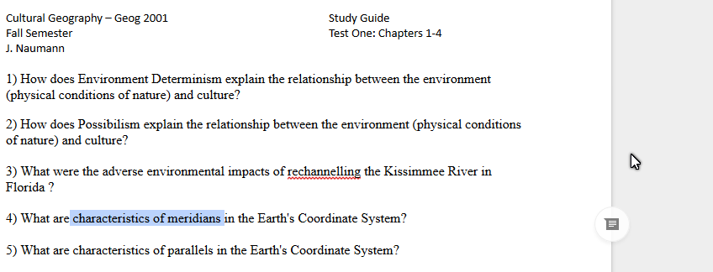
Highlighted terms
Little black square

Click on the black square and you will see what is below.
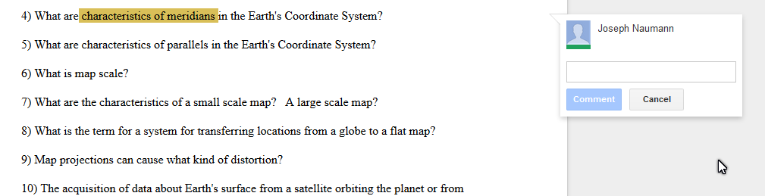
Click here to post your answer or comment.
Type your comments here.

This is what it should look like.
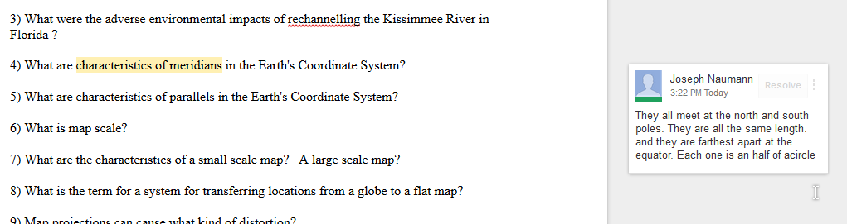

If you want to comment on a comment, click on the highlighted term or on the answer box and this is what you will see.
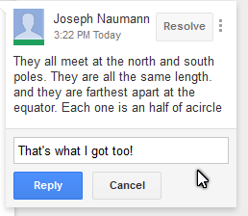
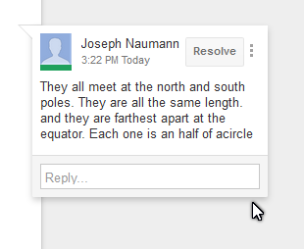
Type your reply where it says reply.

Then cli ck on the reply button and your comment will be posted

Once it is posted, it will look like this:
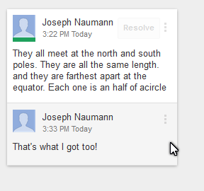
Of course the name on the reply will not be the same as the first person who posted a comment for that question. Now someone could click on the reply and make a reply to that replhy.

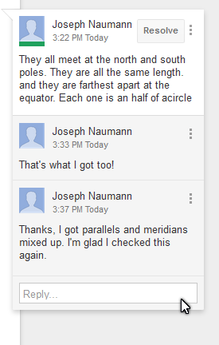
Now a third person with another name has commented on the comment.

