Finding North America’s lost medieval city

Cahokia was North America's biggest city—then it was completely abandoned. I went there to find out why.
Annalee Newitz - 12/13/2016,
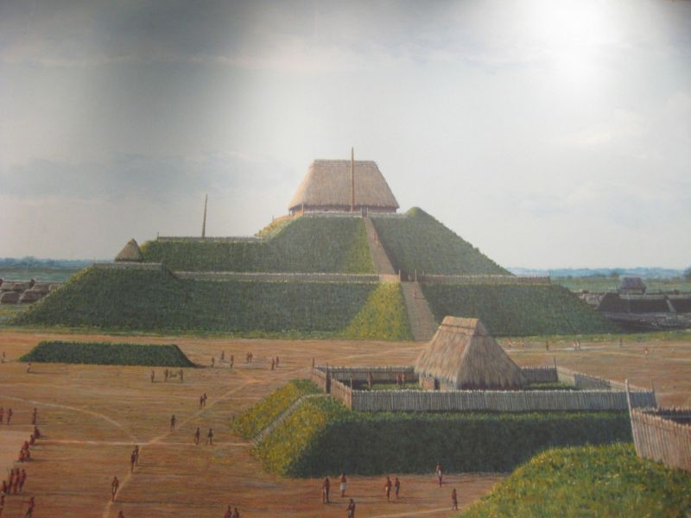
Artist's recreation of downtown Cahokia, with Monk's Mound at its center.
A thousand years ago, huge pyramids and earthen mounds stood where East St. Louis sprawls today in Southern Illinois. This majestic urban architecture towered over the swampy Mississippi River floodplains, blotting out the region's tiny villages. Beginning in the late 900s, word about the city spread throughout the southeast. Thousands of people visited for feasts and rituals, lured by the promise of a new kind of civilization. Many decided to stay.
At the city's apex in 1100, the population exploded to as many as 30 thousand people. It was the largest pre-Columbian city in North America, bigger than London or Paris at the time. Its colorful wooden homes and monuments rose along the eastern side of the Mississippi, eventually spreading across the river to St. Louis. One particularly magnificent structure, known today as Monk’s Mound, marked the center of downtown. It towered 30 meters over an enormous central plaza and had three dramatic ascending levels, each covered in ceremonial buildings. Standing on the highest level, a person speaking loudly could be heard all the way across the Grand Plaza below. Flanking Monk’s Mound to the west was a circle of tall wooden poles, dubbed Woodhenge, that marked the solstices.
Despite its greatness, the city’s name has been lost to time. Its culture is known simply as Mississippian. When Europeans explored Illinois in the 17th century, the city had been abandoned for hundreds of years. At that time, the region was inhabited by the Cahokia, a tribe from the Illinois Confederation. Europeans decided to name the ancient city after them, despite the fact that the Cahokia themselves claimed no connection to it.
Centuries later, Cahokia's meteoric rise and fall remain a mystery. It was booming in 1050, and by 1400 its population had disappeared, leaving behind a landscape completely geoengineered by human hands. Looking for clues about its history, archaeologists dig through the thick, wet, stubborn clay that Cahokians once used to construct their mounds. Buried beneath just a few feet of earth are millennia-old building foundations, trash pits, the cryptic remains of public rituals, and in some places, even, graves.
To find out what happened to Cahokia, I joined an archaeological dig there in July. It was led by two archaeologists who specialize in Cahokian history, Sarah Baires of Eastern Connecticut State University and Melissa Baltus of University of Toledo. They were assisted by Ph.D. candidate Elizabeth Watts of Indiana University, Bloomington, and a class of tireless undergraduates with the Institute for Field Research. Together, they spent the summer opening three large trenches in what they thought would be a sleepy little residential neighborhood southwest of Monk's Mound.
They were wrong. The more they dug, the more obvious it became that this was no ordinary place. The structures they excavated were full of ritual objects charred by sacred fires. We found the remains of feasts and a rare earthen structure lined with yellow soils. Baires, Baltus, and their team had accidentally stumbled on an archaeological treasure trove linked to the city's demise. The story of this place would take us back to the final decades of a great city whose social structure was undergoing a radical transformation.

East St. Louis palimpsest
Finding a lost city in the modern world isn’t exactly like playing Tomb Raider. Instead of hacking through jungle and fighting a dragon, I drove to Cahokia on a road that winds through the depressed neighborhoods of East St. Louis and into Collinsville, Illinois. As recently as the 1970s, the ancient city’s elevated walkways and mounds were covered over by suburban developments. Just west of Monk's Mound was the Mounds Drive-In Theater. Farmers often plowed over Cahokia’s smaller landmarks.
All that changed 40 years ago when Illinois declared Cahokia a state historic site, and UNESCO granted it World Heritage status. The state bought 2,200 acres of land from residents, clearing away the drive-in and a small subdivision. Now the Cahokia Mounds State Historic Site and Visitors’ Center is devoted to preserving what remains of the ancient city’s monumental downtown architecture.
When I arrived there last summer, archaeologists Baires, Baltus, and their team had already been digging for several weeks in the broiling southern Illinois heat. To reach their excavation, I pulled up on a gravel turnout behind some old gas tanks and trudged through the muddy grass of an unmarked field until I saw a bunch of people with shovels clustered around three open pits. It was 7am, but I was already a bit tardy—the team started every day around 6:30am to avoid working through the late afternoon heat. 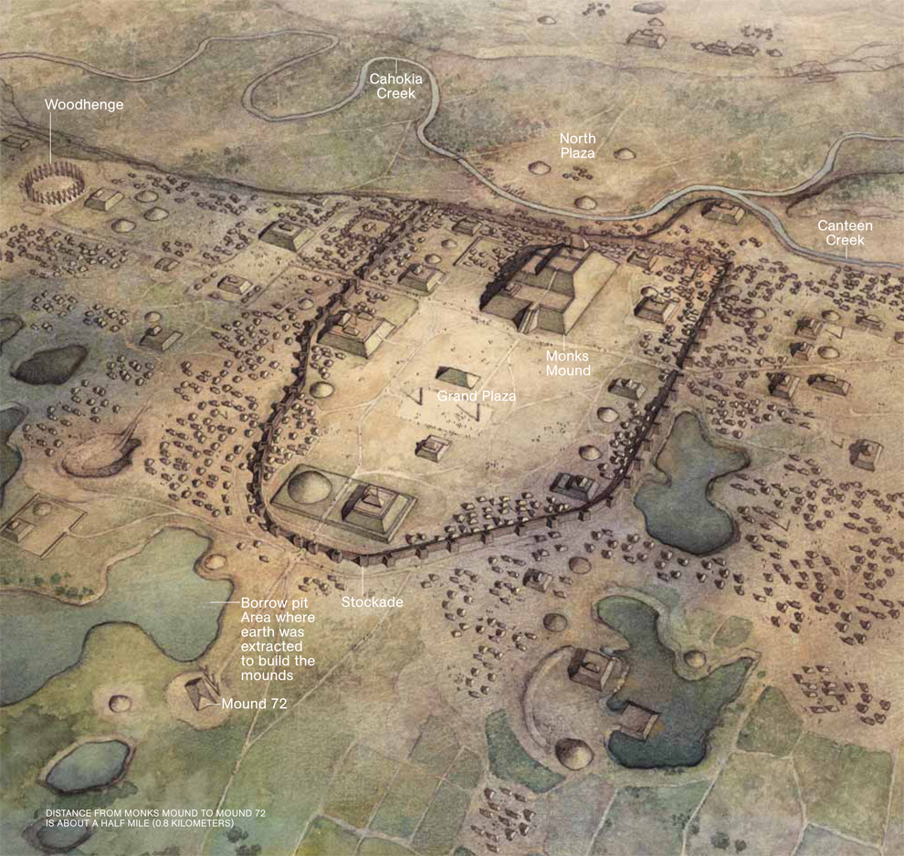
Figure 1 An artist's interpretation of what downtown Cahokia would have looked like in the late Sterling period, after the palisade wall had been built around Monk's Mound and the Grand Plaza.
Baires and Baltus chose to explore this unassuming area known as the CABB Tract based on a magnetometry survey that Watts had done several months before. Using a handy shoulder-mounted magnetometer, Watts carefully paced out the entire field, looking for signs of ancient habitation.
Magnetometers are perfect for sniffing out buried structures because they can detect anomalies that represent disturbed earth, burned objects, and metals several feet beneath the surface. Watts' magnetometry map revealed a distinctive pattern of promising dark rectangular spots, their shapes and positions too precise to be natural. They looked an awful lot like the floors of homes arranged in a semi-circle, perhaps around a courtyard.
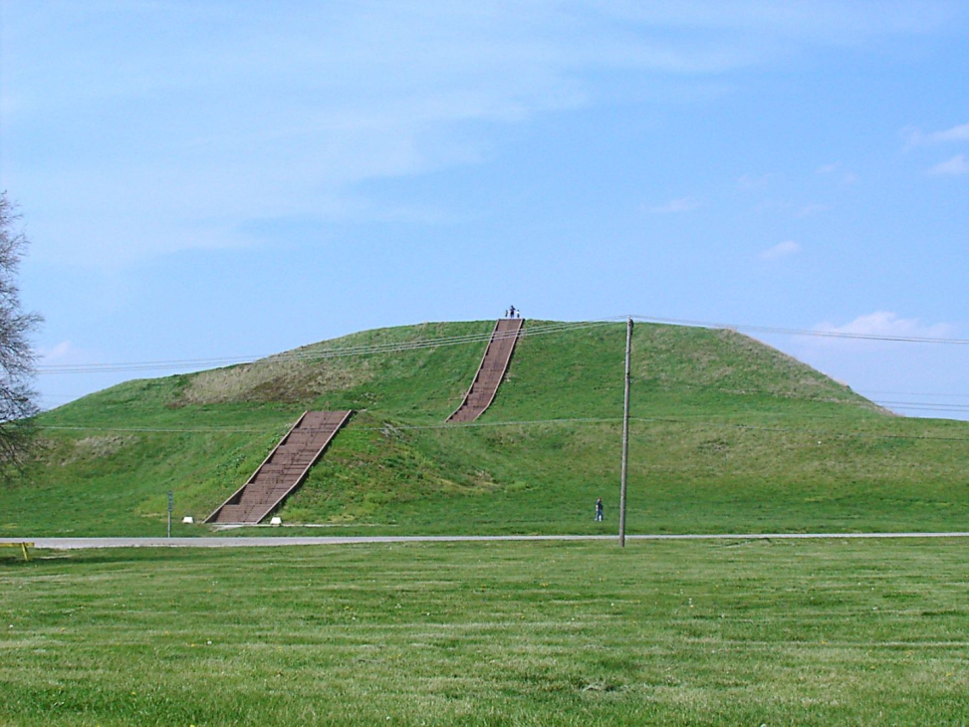
Figure 2 Monk’s Mound today
The courtyard shape is what caught Baltus and Baires’ attention. Late in Cahokia's history, there was an inexplicable shift in the city's layout: People abruptly stopped building on a north-south grid and returned to open courtyard plans that imitated the village layouts from before Cahokia's founding. The archaeologists wanted to know what ordinary people were doing during the city's transition, and this spot was well beyond the elite sphere of Monk's Mound. They broke into the earth above three separate anomalies, eventually creating three trenches called excavation blocks (EB 1, 2, and 3 for short).
When I arrived, Baires, Baltus, and Watts were looking down into EB1, muttering to each other about what they’d found. "Ugh—what is this?" Baires asked, looking intently at the floor of a structure that had not seen light for almost a thousand years. I knelt down next to her at the carefully squared-off edge of the pit, trying to imagine a building here. "It's a palimpsest,” Watts suggested. The group had uncovered layer upon layer of material, suggesting many structures were built in this same place over time. Like most of the team, Watts stood barefoot in the muddy trench so as not to disturb the ground where Cahokians once walked.
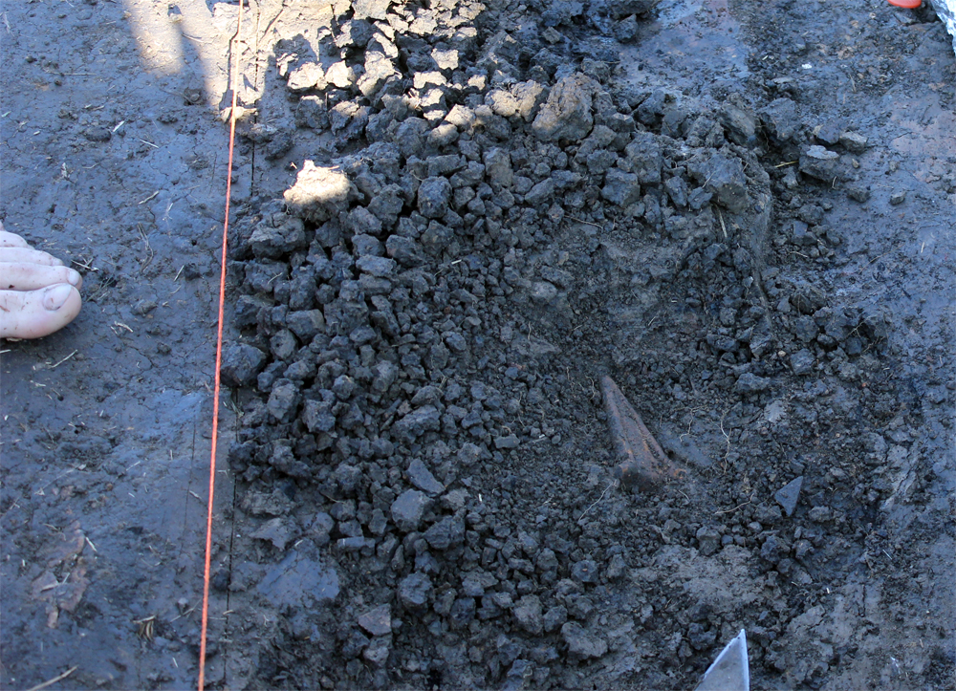
Figure 3 The triangle-shaped ceramic item you see is the handle for a beaker that once held Black Drink, a highly caffeinated beverage that Cahokians drank to induce hallucinations and vomiting during rituals. Archaeologist's toe included for size comparison.
Even with my untrained eye, I could tell she was pointing at overlapping building floors: one area of darker clay ended abruptly in a diagonal line like a wall, and alongside it was a uniformly colored area of clay studded with charcoal and artifacts. The walls themselves, made from posts sunk into the clay, had long ago rotted away.
These structures weren’t modest little homes, either. At least one ritual fire had burned here, its flames consuming valuable offerings like mica, a ceremonial beaker for holding the heavily caffeinated Black Drink, a beautifully woven mat, a pottery trowel imported from a remote village, and an ancient projectile point from pre-Cahokia peoples that would have been centuries old by the time it was buried here. EB 2 and 3 were similarly unusual, yielding finds that suggested feasting and ritualistic earth-moving activities.
What Baires and Baltus thought would be a bunch of private homes turned out to be a public area full of “special use structures,” the preferred archaeological term for any building whose purpose goes beyond the everyday. People used these buildings for everything from political debates and social gatherings to spiritual practices and party venues. Looking over the neighborhood, Baires said simply, "I've never seen anything like this." Following her gaze, I could no longer see the field bordered by trees and distant gas tanks. Instead, there were meeting halls, a wide courtyard with a decorated wooden pole at its center, and a sacred pit where Cahokians borrowed clay for their mounds. A huge trash pile full of deer bones and broken pottery hinted at a big feast.
I was looking back in time to a period when the quiet fields around me would have been packed with people, houses, and mounds all the way to the horizon.

The Mississippians
Mound cities are an ancient tradition in North America, going back millennia before Cahokia. The continent's first known earthwork is at Poverty Point in Louisiana, built 3,400 thousand years ago, when the earliest Egyptian pyramids were under construction. Today you can still see its remains in crescent-shaped ridge mounds that look like huge nested parentheses on a bluff overlooking a now-dry riverbed. Over a thousand years after Poverty Point was abandoned, people from the Hopewell culture built even more astounding mound cities in Ohio and throughout the northeast.
The framers of Cahokia would have known about some of these ancient places and probably wanted to build a city in their image. They also wanted to build it fast.
University of Illinois at Urbana-Champaign archaeologist Tim Pauketat has studied Cahokia for most of his career. He writes that its mounds appear so abruptly in the archaeological record that it's as if they were built directly on top of a constellation of small towns that belonged to people known today as Woodland Indians. As the city grew, farms full of maize and other starchy seeds spread outward from Cahokia into the Illinois uplands.
Pauketat believes that something like a religious revival spurred the city's sudden appearance. Revival movements were common among Native Americans of the southeast. Indian oral histories and writings from European observers recount how charismatic spiritual leaders emerged to lead cultural transformations in eighteenth and nineteenth century Native American communities. Groups would come from miles around to hear the leader's teachings and set up temporary camps for feasting and celebration. The new leaders' ideas would spread like wildfire, carried by people who had gone to the revival camps or storytellers repeating what they had heard.
Many of these revivals were inspired by astronomical events. Pauketat suggests this might have been the case with the revival that founded Cahokia: In 1054, just as the city was growing, a supernova lit up the sky for almost a month. It was so bright that it would have been visible during the day and as luminous as the full Moon at night. It’s possible that an enterprising group of religious or political leaders took the supernova as a sign that it was time to found a new kind of civilization. Pauketat suggests that Cahokia’s earliest residents were immigrants from all over the area, possibly even from as far away as Mexico’s mound-building Toltec civilization. Perhaps the exploding star inspired a new set of beliefs that united previously disparate groups in a common purpose.
Shortly after Cahokia’s founding, the Cahokian way of life spread to the entire Mississippian region. Along the Mississippi River, Pauketat writes, archaeologists have found the remains of countless southern cities modeled on Cahokia, “populated by people who grew corn, built rectangular pyramidal mounds and flat plazas, and crafted or decorated objects with images of sky and earth gods and godlike ancestors.” Cahokians made a distinctive form of ceremonial pottery, called Ramey, that can be found throughout the Mississippian settlements. People shared Ramey far and wide to honor the city that founded their civilization.

How to dig up a lost city

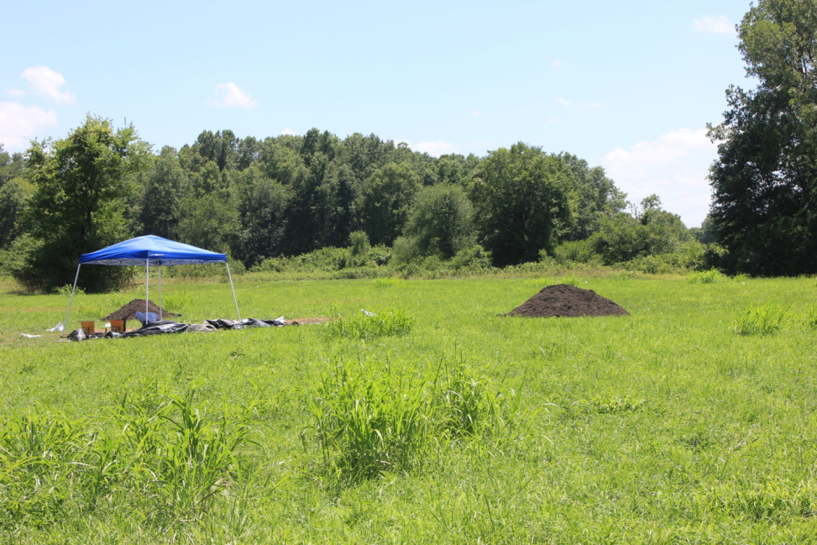
Figure 4 A view of Excavation Block 1, where the archaeological team uncovered evidence of multiple structures full of burned offerings.
Cahokia lies in a crazy quilt of ecosystems along the Mississippi River called the American Bottom. Rain and floods fill the area with seasonal ponds and swamps, while the surrounding bluffs give way to prairies perfect for growing food staples like maize and other starchy seeds.
Over the CABB Tract the sky was a scalding blue, and the heat was clotted with humidity.
Baires and Watts revealed their secret to staying cool: bring a bottle of completely frozen water in the morning, and it will have melted to chilled perfection by mid-day. It’s excellent for pressing against sweaty foreheads as it defrosts, too. Even though the pits were shaded with canvas roofs, we took frequent breaks to guzzle water and reapply sunblock. Everyone wore hats with varying degrees of sartorial cunning. Ultimately it didn't matter how dorky you looked, as long as you didn't go home with a burned neck or face.
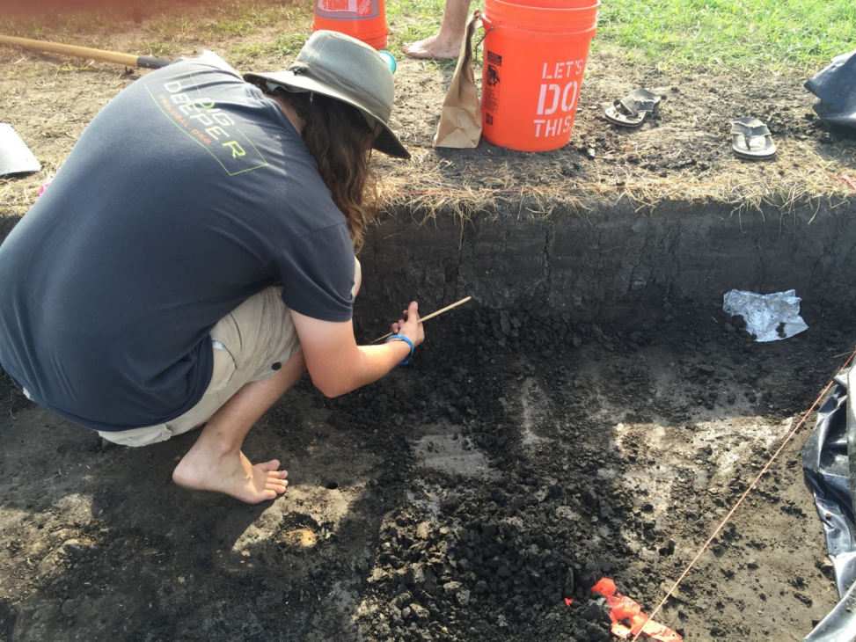
Figure 5 A student excavates at EB 1.
At first, I wandered between the excavation blocks, trailing after Baires and Baltus as they made their rounds and checked the students’ work. At EB1 and EB2, there were dozens of finds: chunks of ceremonial pottery, a tiny human face recreated in clay, projectile points, the remains of a woven mat, and the triangular handle of a beaker that once held Black Drink, a highly caffeinated beverage used during ceremonies to induce hallucinations and vomiting. EB3 remained a mystery. It looked like part of a palisade wall ringing the neighborhood on the magnetometry survey, but Baires and Baltus had come to believe it might be something else.
The two crouched together at the edge of each block, conferring with Watts and the students. Occasionally they directed the students to wrap an especially valuable find in tin foil, or fold it into a lunch bag. Everything was carefully labeled, and even the soil itself was scooped into buckets and pushed through a sieve later to catch any remaining items.
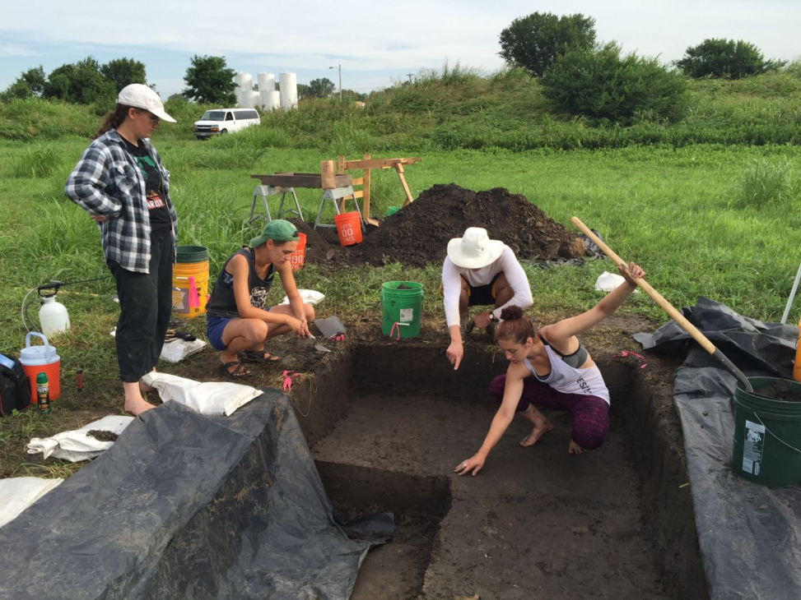
Figure 6 Archaeologist Sarah Baires looks at the mysterious EB 3. Student Emma Wink shows her the layer of yellow soil, which the team hypothesizes is part of a ramp leading into a borrow pit.
I started to learn archaeologist lingo. Strategies for “chasing out” or “following out” features that emerged from the clay were developed on the fly. “Let’s follow out this line of burned clay,” Baires directed a student in EB1. The bottom of each structure was a “basin,” because the Cahokians built with sunken floors. The massive quarries where they dug up clay for their mounds were “borrow pits.” When we found a structure wall, we “caught its edge” or “caught a corner.” It’s as if we were racing after a history that was on the verge of escape.
Pretty much every dig in Cahokia begins with “chunking out” a foot of sterile ground created by years of farmers plowing up the land. Beneath that, the city’s layers begin. With each centimeter removed, the archaeologists go backward in time, working their way through the city’s late-phase dissolution, into the classic era with its masterful pottery and art.
Digging is a specialized craft, and the students were learning it on the job. Eastern Connecticut State undergrad Emma Wink, who was working tirelessly to chase out an odd layer of yellow soil at the mysterious EB3, told me that she was so focused on her work that she forgot everything else. “I’m basically a mole person,” she joked. Over at EB1, where the most artifacts are emerging, Western Washington University senior Will Nolan followed out a tantalizing layer of burn. He said he could feel the difference between layers. The burn felt “crunchy, grainy, and harder to dig.” He knew when he’d gone through the burn because the next layer was “smooth and sticky.”
Finally I had to try it myself. Baires loaned me a shovel with a carefully sharpened edge and explained that I wouldn't be digging. I’d be “shovel scraping,” skimming off just a thin layer of the basin at EB2. Each scrape left a curled sheet of clay in my shovel like a thick, dirty scroll. Any time I felt resistance in the mud or heard a crunch, I immediately stopped and examined the ground, using a pointed trowel to dig gently around anomalous lumps. My first find was a slab of red pottery that crumbled to dust in my fingers. “Don’t worry about that,” Baires assured me. “It’s just unfired clay and it won’t hold up.” Later, I found nuggets of charcoal, blobs of yellow pigment, a few jagged pieces of fired pottery, and several burned deer bones.
The bones were the worst, because there were so many of them that it halted our digging dozens of times. We had to be careful to determine that these weren't human bones, because human remains must be reported immediately. Though we'd already identified these as deer bones, archaeologists will sometimes do a lick check to be sure. Lick check? I stared at Baires in bewilderment. “Do you want to lick it?” she asked. “Bones are porous, so your tongue will stick to it.” The students looked at me. Would the weird journalist do it? Hell yeah, I would. I brought a small fragment of bone to my mouth, tasted salt, and felt my tongue adhere lightly to the surface. “Yep, it’s deer,” Baires shrugged.
After I’d been shovel scraping for an hour, blisters started coming up and popping on my fingers. When I fell exhausted into bed at 8:30pm, I could feel the exact part of my thigh that I used to push the shovel handle. I couldn't stop thinking about how I licked the bones of a deer that was cooked for a feast in Cahokia 900 years ago. I wish I could have been there to see the party, but this might be the next best thing.

Heterarchy
When you're excavating at Cahokia, you start to appreciate what it was like to build the mounds here a millennium ago. We shoveled clay into buckets, sweated, hydrated, and repeated. Our hands were covered in garbage and dirt. We watched the sun’s path overhead to mark the time, always wary of looming storm clouds. Of course, we hadn't gone completely medieval. Baltus supplemented our personal observations with a couple of weather satellite apps on her phone. Even when the sky looked cloudless, the American Bottom could brew up a storm in less than an hour.
One afternoon, everyone's mobiles lit up with dire warnings about a dangerous hailstorm. Racing against the weather, we packed up shovels and bags with military precision. Once the dark gray clouds gathered over the Mississippi, it could start pouring within minutes. We crammed ourselves into a van and took shelter at a nearby Mexican restaurant as thunder rattled the windows and winds uprooted trees in nearby East St. Louis.
Over steaming plates of enchiladas and pitchers of frozen margaritas, I pumped the archaeologists for information about what social structure united tens of thousands of people in Cahokia so long ago. What could have drawn so many people to perform backbreaking labor in the broiling humidity? My thoughts went to the charismatic leaders who led Cahokia's revival movements. “Who got to be at the top of Monk’s Mound?” I asked. “Was it a chief or some kind of religious leader?” From the way the archaeologists looked at each other I could tell this was a trigger question. “This is a hotly debated topic,” Baltus said finally with a laugh.
Even if we imagined this revival coming from the teachings of one person, Baires warned that it probably wasn’t as if there was a single “chieftain” leading everyone to build their houses a certain way or line their borrow pits with colorful clay. “I don’t like the idea of a chieftain,” she explained. “I think power was more diverse than that. It was a heterarchy.”
I rolled the unfamiliar word around on my tongue. “Heterarchy—like, a monarchy except a lot of people are in power?” The margaritas didn't help my listening comprehension.
The answer turned out to be yes and no. Cahokia’s heterarchy might have been a lot of different groups making decisions and governing themselves. Perhaps there were craft guilds or neighborhood associations. Already, I'd seen that the CABB Tract was full of ritual items. Perhaps they had their own leadership council, too? “If Cahokia was a religious movement, people might have engaged with that on their own terms,” Baltus said. “Their idea of spirituality may have come from home, not the top of the mound.”

Troubled times in Cahokia
If you look online or in books for illustrations that recreate Cahokia, you’ll notice an almost universal error. The mounds and swales of the city are shown covered in a light dusting of green grass, almost like a golf course. Nothing could be further from the truth. In a fascinating book called Envisioning Cahokia, a group of archaeologists explains that the city and its monuments would have been bald black mud. No grass would have survived within city limits, though many houses would have been surrounded by gardens for growing beans, squash, and other staples.
Against the dark, swampy mud, the wood-framed and thatched houses of Cahokians would have been colorful, decorated with mats, carvings, and plaster. Public areas featured wooden poles, possibly painted and decorated with fur, feathers, baskets of grain, and other symbolic items. People also decorated themselves. Several tools for making tattoos have been uncovered at Cahokia, as have beads and jewelry. Figurines found in Mississippian cities show that people wore body paint, patterned clothes, and earrings. Men played a game with pucks and spears called Chunkey. Women farmed on their knees, using handheld hoes made with wood and sharp stone. And as huge garbage pits full of animal bones, drug paraphernalia, and fancy pottery attest, everybody at Cahokia loved to party.
Archaeologists mark the eras of the city based on the orientation of its houses. During the Lohmann phase (1050-1100 CE), when people were first building Cahokia’s Grand Plaza and Monk’s Mound, most houses were organized into courtyard patterns. During the Stirling phase (1100-1200 CE), often called Classic Cahokia, most of the city was on a strict grid with houses and mounds oriented in a north-south direction. This was also the city's heyday, when it had the biggest population. In the final Moorehead phase (1200-1350 CE), people returned to the courtyard plans of the Lohmann phase.
But these different city phases weren't just architectural fads. Indiana University, Bloomington, archaeologist Susan Alt argues the transformation “marked social change." Nowhere are these changes more obvious than in the downtown area where Monk's Mound rises above the Grand Plaza. This central meeting place was an engineering marvel, carefully sloped during the city's construction to allow water to drain off during public events. Everything about the architecture here suggests a highly stratified society led by charismatic figures who lived above Cahokia's sprawl on the smoothed top of Monk's Mound. Ordinary residents of the city spent many long hours ritualistically hauling clay in baskets from borrow pits to build the mounds. The leaders repaid them with words of wisdom and massive feasts. But at some point that wasn't enough anymore.
During the late Stirling phase, there must have been quite a bit of urban unrest. The elites of Monk's Mound erected an enormous wooden palisade wall all the way around the Grand Plaza, effectively enclosing themselves in a walled neighborhood. This may have led to more problems. If people were literally kept out of the downtown area by a giant wall, as Baltus puts it, “they might feel disenfranchised." Shortly thereafter, the Grand Plaza fell into disrepair. Alt writes, "Domestic buildings and refuse-filled features seem to have been relocated around and onto the plaza perimeter, perhaps as part of a general redesign of downtown Cahokia in conjunction with the recently built palisade wall. By 1300, there were probably few to no residents left in this inner sanctum." In other words, non-elites moved into the area and even dumped trash there. During this period, Woodhenge was also torn down.
As the city reshaped itself during the Moorehead phase, Cahokians violently rejected the people and symbols of their once-monumental downtown. Roughly half the city's population moved away, and those remaining began to retreat into their own neighborhoods, conducting smaller public rituals and events. The courtyard and public buildings in the CABB Tract reflect this new kind of social organization. The city's central authority had been supplanted by local communities.
Why did the people of Cahokia lose faith in the revival that built a city? The answer may lie inside the mounds themselves.

Theatrical sacrifice
Back in the 1960s, when scientists were still in the habit of digging up Native American ancestors without permission, an early Cahokia archaeologist named Melvin L. Fowler opened up a mound. There, he found the remains of several public rituals—and over a hundred bodies—that give us a glimpse of politics and spirituality in Stirling-era Cahokia.
Fowler knew that the classical Cahokia grid was mostly aligned on a north-south axis. But there was one oddly shaped mound that didn’t fit. Mound 72 is one of the city’s few “ridge top mounds,” meaning its rectangular body was constructed with a peaked top like a roof. And though it stood precisely south of Monk’s Mound, it was angled 30 degrees off the east-west axis, pointing in the exact direction of the summer and winter solstice. Fowler suspected this mound might be something special.
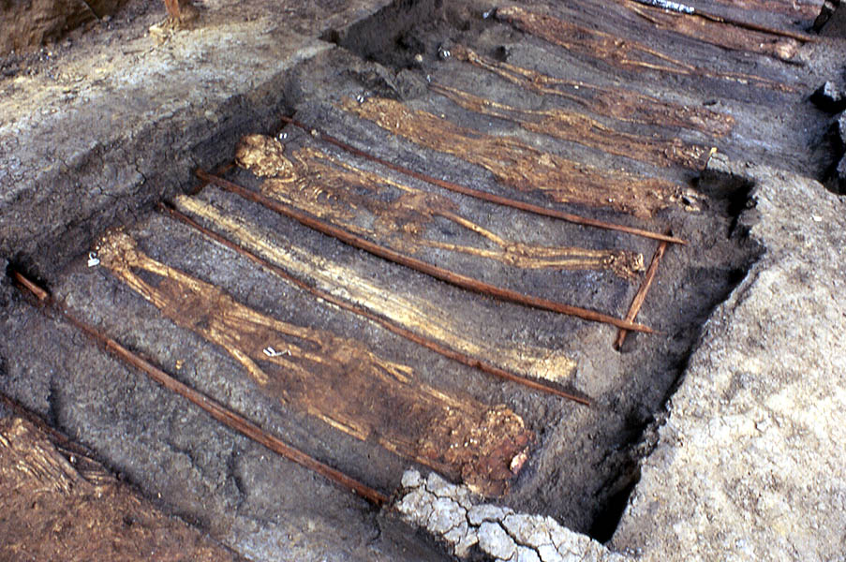
Figure 7 Here are some of the sacrifices that Melvin Fowler uncovered at Mound 72. The wooden rectangles around each skeleton are the remains of litters beneath the bodies.
When Fowler and his colleagues dug, they discovered that Mound 72's ridge top was actually built over three previous mounds, each one marking a significant moment in the city’s history during the 10th and 11th centuries. One of those mounds contained the bodies of 52 young women, sacrificed in some way that did not leave marks on their bones. Their bodies had been stacked in two tidy layers on top of clay platforms, then ritualistically covered over with earth. Another held the bodies of men on litters, similarly arrayed. Buried beneath thousands of pounds of clay for centuries, their skeletons were pressed as flat as flowers between the pages of a book. Oxygen isotope analysis of their teeth, which can pinpoint where people were born, shows these people were all local to the American Bottom.
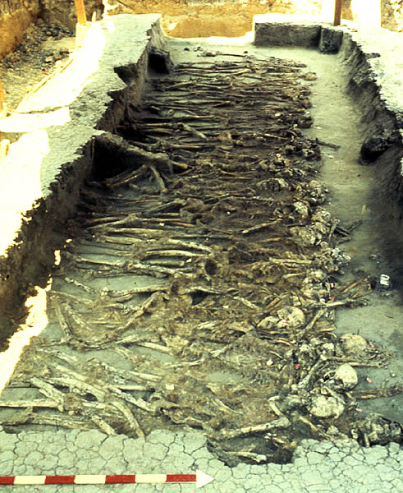
Perhaps the most famous burial in Mound 72 contains the bodies of two people, one atop the other, in what’s called the “beaded burial.” The top body was placed on a river of valuable blue shell beads and may have worn a cloak fashioned to look like a falcon. The burial included hundreds of gorgeous ceremonial projectile points, as well as piles of other valuable offerings. Alongside the beaded body were the remains of several other people, including some who had no heads. The find presented a tantalizing tableau for scientists who wondered about the spiritual and political beliefs of Cahokians.
Figure 8 The remains of more than 250 people were found inside Mound 72, likely sacrifices offered as part of rituals of fertility and renewal.
Debates over the meaning of the beaded burial have raged in the archaeological community for decades. Initially the bead-adorned skeletons were described as male, with the top one dubbed “the Birdman.” Fowler and other archaeologists assumed the Birdman was a celebrated ruler or warrior, perhaps the source for contemporary Siouan stories of the superhero Red Horn. But this interpretation has been pushed aside in the wake of a groundbreaking 2016 study by Illinois State Archaeological Survey Director Tom Emerson and his colleagues, which chronicles the first comprehensive skeletal analysis of the bodies in Mound 72. They discovered that the two people at the center of the tableau are in fact a young male and female, suggesting a ritual of fertility. This interpretation is bolstered by the remains of other male/female pairs buried with them, as well as the 52 young women who also represented reproductive bounty.
Now it would seem that the beaded burial wasn’t marking the grave of a great warrior or Cahokian founder. Instead, Emerson argues, we're probably seeing the remains of a public performance where people representing mythical figures were sacrificed. The city's elites may have led the performance to show their political and spiritual power, much the way their European counterparts of the same era were conducting public executions and crusades. “This scene looks more like a theatrical sacrifice rather than a burial,” Emerson and his colleagues write. They suggest it might have been a pageant where the city celebrated creation and renewal. Many of the offerings, like shells, are associated with the Underworld in local Native American belief systems—and the Underworld, in turn, is connected to farming and the land's fecundity.
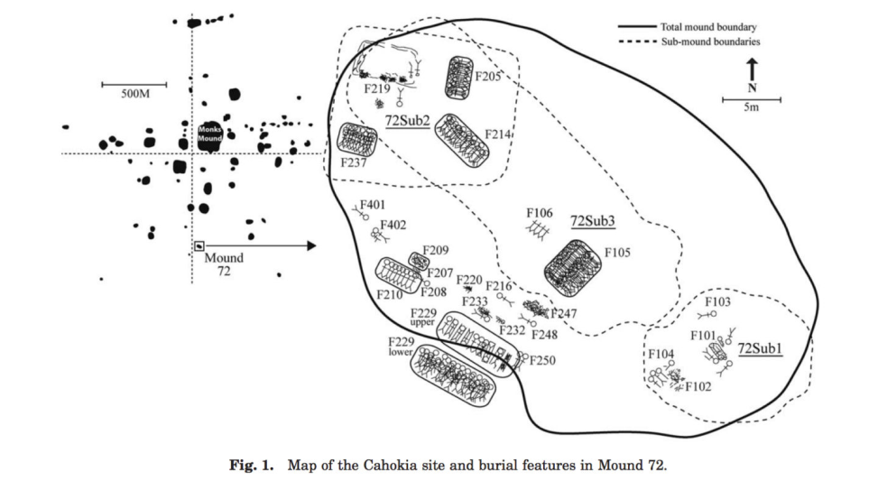
Sacrifices like the ones in Mound 72 may have involved joyous retellings of a creation story during the height of Cahokia's power. They might have been parties to commemorate a fruitful harvest. But over time they may have led to resentment, especially if decisions over life and death were in the hands of a few people ruling from on high. It's possible there was a political rebellion. Evidence from the Grand Plaza's decline would seem to support this idea. After the fall of the downtown area, we also see an abrupt end to human sacrifice. Maybe Cahokia's citizens toppled the regime that occupied Monk’s Mound and created a new social model.

The Upper World and the Underworld
Without a time machine, we'll never know exactly what the Cahokians' political struggles were about. Still, we have some hints about how they saw the world. The symbols they left behind suggest they divided the universe into an Upper World of spirits and ancestors, an Underworld of Earth and animals, and a human world in between. These worlds were not entirely separated, and the liminal spaces where they intermingled were places of great power. Images that bring worlds together are common in Mississippian art. The Upper World, represented by thunder and spirits, and the Underworld, represented by water and agriculture, are intertwined.
Baires and Baltus think Cahokians used water and fire in their everyday rituals to draw the Upper World and Underworld together.
We can see the transformative power of water written into the layout of Cahokia. Though the city's mounds attract the eye, the deep borrow pits were no less important to urbanites. Left open to the elements, they filled with water on a seasonal basis. The borrow pit that provided clay for Monk's Mound is so enduring that it's still filled with water to this day. Many pieces of ceremonial Ramey pottery are covered in images of water and fish, while shells filled burial mounds throughout the Mississippian world.
During the CABB Tract excavation, I got a chance to see how one neighborhood sculpted water into its daily activities. Baires pointed at a deep hole the students dug at EB3, uncovering several feet of a sloping ramp paved in yellow soils. It was obvious this yellow layer wasn't natural: it wasn't found in soil from the area and followed an exact 30-degree slope downward. Baires, Baltus, and Watts speculated that it was once the entrance to a shallow borrow pit that supplied this neighborhood with mud. We could see a history of this pit in its sediment layers. At first, the locals allowed the trough to become a seasonal pond. Later, they filled it back up with carefully layered clay, almost like they were building an inverted mound. “We caught the edge of a deliberately filled borrow pit,” Sarah explained with a grin. All the archaeologists are excited about this unusual find, which adds evidence to the idea that pits were as important to Cahokians as mounds.
Fire was even more important, especially late in the city's history. Fire could join worlds, because what was burned on Earth could ascend to the Upper World through smoke. Everywhere archaeologists dig at Cahokia, they find charred sacrifices. In 2013, construction workers building a freeway in East St. Louis discovered the remains of a late Cahokian neighborhood built entirely for the purpose of ritual burning. Dozens of tiny houses, full of corn and other valuables, were constructed rapidly and then torched. Nobody had ever lived in those homes. It appears that the entire neighborhood was essentially burned in effigy.
At the CABB Tract, all our excavation blocks were layered with periodic burns. The group at EB1 dug up enough ground for Baires and Baltus to figure out where all its overlapping structures once stood. The lowest level was a clay floor from the Stirling phase, at the height of Cahokia’s power. That floor was burned at some point and covered in another layer of clay for the floor of a later structure. In the later structure, people dug a pit into the floor, carefully lined it with a mat, then filled it with valuables like the beaker handle and ancient Woodland projectile point. That pit and its contents were burned too, possibly to commemorate the first burn.
Excavating burned offerings at Cahokia.
I watched as Baires and Baltus gingerly used their trowels to reveal charred remains of the mat that once lined the offering pit. Its furled edge wound across the clay and looked like a criss-cross pattern etched in charcoal. We weren't actually looking at the mat itself, but the impression it left behind in the earth as it smoldered. “It’s nuts,” Baires said. “We never find things like this.”
At EB2, there were no elaborately interpenetrating layers of ritual burning, but the structure itself was an unusually large rectangle that suggested a public space rather than a home. Plus, all those burned deer bones and broken Ramey pots inside were a sure sign that some kind of celebration happened here. It was easy to imagine the ceremonial structures we’d uncovered at EB1 and 2 standing next to a ritualistically dug trench, its floor layered with pale yellow clay.
Slowly, the layout of the neighborhood was emerging around us. This was no ordinary domestic area; people who lived here were heavily engaged in the city’s political and spiritual life, conducting regular rituals. But this place also represented a trend in late classical Cahokian culture. City dwellers stopped using Monk’s Mound and the Grand Plaza for public performances and started conducting more rituals at home, on a smaller scale. Local identity eclipsed city identity, and the rigid city grid returned to the courtyard layout of pre-Cahokian days.
This insight also shed light on the importance of the borrow pit at EB3. It was a localized version of the giant borrow pits that supplied clay for Monk’s Mound, offering people in the neighborhood a constant reminder of how the Underworld intrudes into our own.

A spiritual city
I have some of my best conversations with archaeologists in bars. And there's no better place to do it than at a pub in Edwardsville, IL called The Stagger Inn, founded by an archaeologist and known to Cahokia researchers simply as “the archaeologist’s bar.” Every Thursday, people working the digs all over Cahokia converged on the place for beer, hamburgers, and ridiculously delicious fries.
At a battle-scarred wooden table next to a stage where musicians are setting up, we were joined by Baltus and Baires’ colleagues, Susan Alt and Tim Pauketat. Alt and Pauketat were working at their own dig sites and have decades of experience studying Mississippian culture. I immediately started asking them about Cahokia's economic structure, because I couldn't figure out how Cahokians persuaded people in the outlying farms to bring them food. Was there some kind of trade network? Pauketat actually rolled his eyes when I asked that. He and Alt were both very opposed to the idea that Cahokia might have been a trade center,and called it a mistake to view the city as an economic entity. “The primary purpose of the city was not trade or work. It was spiritual,” Pauketat said after we plied him with more beer. “Wealth isn’t really the right word for what they had, but it was a side-effect.”
Alt had further evidence that Cahokia was a place devoted to spirituality. She was excavating at a site devoted to spiritual rituals called Emerald. Located in St. Clair County, Illinois, Emerald might even be the birthplace of Cahokian spirituality--it's full of Mississippian artifacts, but pre-dates Cahokia's population explosion. "Maybe people came there, then immigrated to Cahokia and stayed?” Alt mused. If true, that would provide more evidence for the idea that Cahokia's founding grew out of belief rather than trade concerns.
But there had to have been some economic system, I argued. After all, some people were growing food and other people were eating it. Was there trade with other cities along the river, or a marketplace where toolmakers from the downtown area could trade for maize from the uplands? Pauketat shrugged. “Sure, some people were specialized or getting food from other people, but practices were heterogeneous. It would have worked differently in different neighborhoods.” There was that idea of heterarchy again. Maybe people in one neighborhood traded their Ramey pottery with another neighborhood that produced particularly excellent reed mats. Maybe families another neighborhood pooled the food they gathered each day for big group dinners. And perhaps certain communities made special deals with outlying farms to get seasonal surpluses. The point is, the city didn't have a universal trade system or currency.
Cahokia's story still seems relevant in contemporary America. People didn't immigrate to the mound city just to find material wealth. They sought new kinds of political and spiritual ideas. But not everyone in Cahokia agreed on how to put those ideas into practice.

Revitalization before the fall
Baires and Baltus make a good investigative team because their areas of expertise span the city’s history: Baires focuses on the classic Stirling phase, while Baltus explores the later Moorehead phase. But both are fascinated by what Baltus calls a “rejuvenation period” late in the city’s life. Before it was completely abandoned in 1400 CE, Cahokia went through a final revitalization movement. This movement might have started with a person or group suggesting a new way to live, contact with new allies, or a new relationship to agriculture and the Underworld. As a result, Cahokia was rebuilt rapidly, by people seemingly on fire with belief.
When Cahokians dug, they often found old projectile points and other items from the Woodland peoples who lived in the area before the city was built. They treasured these items, the same way people today treasure ancient objects from Cahokia. This impulse explains why we found a Woodland projectile point in the ceremonial fires buried in the layers of EB1. It's as if people were embracing retro styles or traditional values. In the final revitalization period, people took this obsession with the past even further. They rebuilt their homes using the courtyard neighborhood layouts from Cahokia's earliest days. They were obviously re-examining history and seeing it in a different light.
“In the revitalization period, we see a return to old practices, including a decentralized religious practice,” said Baltus. But this decentralization didn't stop at city boundaries. In scattered Mississippian sites across the floodplain and the uplands, Cahokian practices slowly became unbound from Cahokia proper. Archaeologists still find ritual burnings on floors, but none of the Ramey pottery that was so characteristic of the city’s symbolism. The population of the city was draining away. As people left, they took some of Cahokia's culture with them, but left other parts behind.
In its heyday, the Cahokia revival encouraged people to build mounds and anchored their belief systems to the land. But during the city's final revitalization, those beliefs became unmoored from the city—perhaps due to disenfranchisement, or perhaps just a focus on smaller communities. Eventually this led to social dissolution. After all, Baltus explains, “if you don’t unite people around an identity tied to place, with practices that keep people together, there can be fragmentation.”
There were also environmental factors at play. Some archaeologists believe the city was inundated by a massive flood from the Mississippi River which was so destructive and deadly that the survivors didn’t want to stay. Baires and Baltus have long been skeptical of this idea, and devoted part of their summer to disproving it. They invited geomorphologist Michael Kolb to take soil cores around the edges of their dig site. Using a truck-mounted device, he punched out cores that went 3 meters deep, looking for a thick layer of buried river sediments suggesting a flood. He found nothing like that at all.
There's a more likely environmental explanation for the city’s decline. Cahokia suffered through a number of droughts, which would have made it difficult for the city to support a large population. Given that Cahokians' beliefs were tied to the landscape, any environmental changes would have affected them culturally too. “There’s a cycle,” Baltus explained. “There’s a drought and that changes people’s relationship to the land, then spiritual practices change, then land use changes, spiritual practices change again, and before you know it you have fragmentation and abandonment.”
Cahokia grew to such an enormous size because the structure of the city itself was part of its residents' spiritual and political worldview. But over time that centralized belief system began to crumble. When the last revitalization swept the city, people returned to the old ways. They looked to home for their sense of identity and community. Their once-unified city fragmented into many peoples who left the mounds behind.
They may have abandoned their great city, but Cahokians left an indelible mark on the land. Other Native American groups inhabited the city’s empty courtyards, and European colonists built farms and suburbs over them, but the monuments of Mississippian civilization still endure. There's no question that the mounds inspire a sense of wonder that transcends time.
One evening, around dusk, I climbed Monk’s Mound with a fellow adventurer. The sky was full of tall thunderheads, and the sunset was blood red between dark blotches of cloud that glowed sporadically with lightning. The tall grass around our ankles was blinking with fireflies, and the air was cool at the top of the mound. Below us we could see the graceful shape of the Great Plaza, and across the river were the lights of St. Louis. The thick air smelled like damp soil and farmland.
With our feet atop an ancient megalopolis and our eyes on distant skyscrapers, it felt as if cities here were inevitable. The land around St. Louis has been urban for a very long time. I’m not a New Agey person, but there was something undeniably magical about that. Standing on the flattened summit, we were balanced on a piece of earth that almost touched the chaotic heavens. It made sense that Cahokians believed the Underworld and Upper World met here, beneath the thunder and above the clay whose shape was forever altered by human history.
Annalee Newitz Annalee Newitz is the Tech Culture Editor at Ars Technica. She is also the author of Scatter, Adapt, and Remember: How Humans Will Survive a Mass Extinction, and her first novel will be published in 2017.

Artifacts from the site
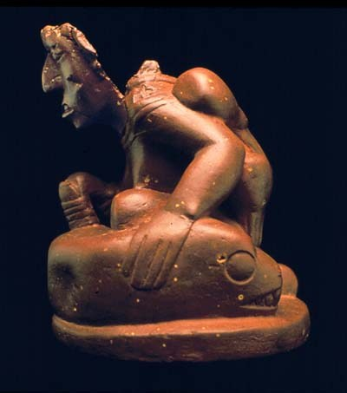
The Birger Figurine was discovered in an outlying neighborhood of Cahokia. It depicts a woman farming with a typical Cahokian hoe made from stone and wood. She's hoeing the back of a massive serpent with a bobcat’s head and a tail that branches into thick stalks sprouting gourds. On her back is a basket for carrying ancestor spirits.

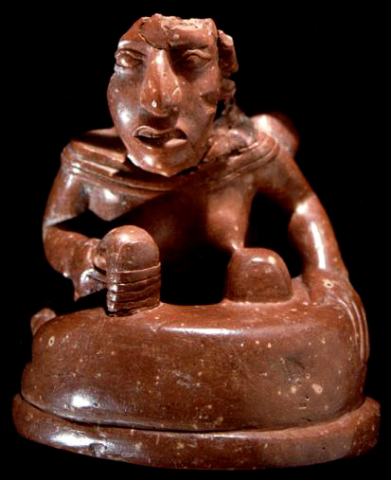
The look on her face is one of grim determination and strength. Her body unites the Underworld and the Upper World; she exists at the nexus of fertility, danger, and myth. She embodies the political and religious spirit of Cahokia, a city where worlds came together to create a powerful new civilization.

Location relative to St. Louis
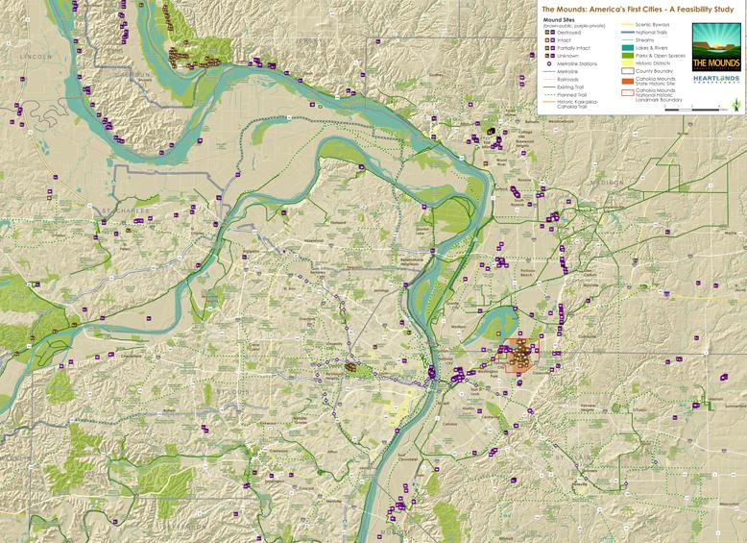
Figure 9 Map of current and destroyed Mississippian mounds in the St. Louis region.
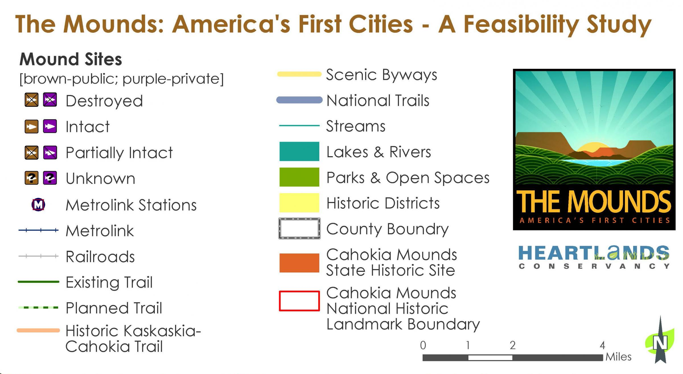
Figure 10 Key to the map enlarged

