The most detailed look yet at how early humans left Africa
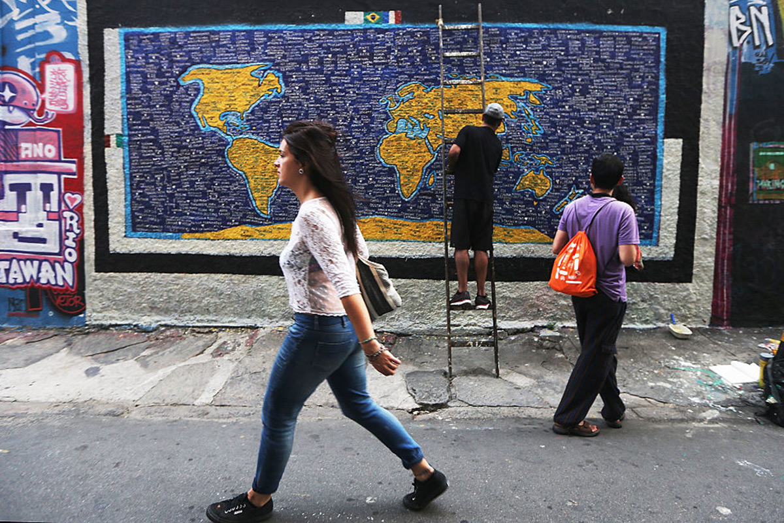
By Emily Benson
All non-Africans living today can trace the vast majority of their ancestry to a group of pioneers who left Africa in a single wave, tens of thousands of years ago.
We still don’t know the exact timing of that migration, precisely where it began, nor the details of movements and how individual populations developed within Africa.
But the discovery of a single exit is a major advance in illuminating the earliest days of humanity’s global sprawl, says Joshua Akey at the University of Washington in Seattle.
“The more we understand about this particular event in human history, the more it provides a complete picture of our past,” he says.
.
Modern humans arose in Africa, but where and when our earliest ancestors went next has been fiercely debated. Did they leave that continent in just a single wave, between 40,000 and 80,000 years ago, or in multiple pulses, beginning tens of thousands of years earlier?

Successful explorers
Archaeological finds show that humans were living outside Africa more than 100,000 years ago, Akey says, but many of these groups died out. The migrants who survived, however, passed their DNA to their descendants. To track those successful explorers, scientists turned to the genetic evidence buried in the cells of modern humans.
Developing a fuller picture of our ancestry requires the study of a range of diverse human populations. Collectively, the authors of three new studies took on that challenge by analysing the genomes of 787 people from more than 270 populations scattered across the globe.
Genetic similarities between populations show clear evidence for a single exit from Africa, says David Reich at Harvard University. Reich and his colleagues also determined that our African ancestors had already begun diverging into separate groups 200,000 years ago.
The researchers also looked for a mutation that might have occurred between 50,000 and 80,000 years ago, when human technology and culture took off, with advances in art, burial rituals and tool use.
But the team failed to find a genetic smoking gun, suggesting that progress was instead propelled by an environmental or lifestyle change, Reich says.

Climate factor
Environmental conditions, such as temperature and plant growth, may have prompted some early human migrations (see box below). And geographical barriers such as mountains and deserts may have kept populations separate, perpetuating genetic differences around the world, according to another of the genetics studies, led by Luca Pagani and Mait Metspalu at the Estonian Biocentre in Tartu.
Pagani and Metspalu and their colleagues also concluded that most modern non-Africans are descended from a single, out-of-Africa migration. But about 2 per cent of the genome of people from Papua New Guinea comes from an earlier exodus, Pagani says.
“We see vestiges of an earlier out-of-Africa expansion,” Metspalu says. But, in the end, the main migration almost completely overwhelmed that small, early wave, he adds.
In the first comprehensive study of genetic diversity among Indigenous Australians, Eske Willerslev at the University of Copenhagen in Denmark and his colleagues found that different indigenous groups within Australia are genetically quite distinct, but that they are all descended from a single, founding wave of people from Africa.

Diabetes clues
Because Indigenous Australians are prone to diabetes, studying their DNA could explain the genetic drivers behind the disease, Willerslev says.
“They could potentially hold the key as to why other non-Africans also have diabetes,” he says.
That kind of medical insight is one reason to delve into humanity’s genetic history, says Akey.
Another is simple curiosity about where we came from. But solving that riddle will require contributions from fields outside genetics, too, Akey says, such as archaeology and ecology.
“People are just inherently interested in their past,” he says.
Journal references: Nature, DOIs: 10.1038/nature18299; 10.1038/nature18964; 10.1038/nature19792; 10.1038/nature19365

Greening of deserts opened up routes out of Africa
Three new papers suggest that most, if not all, modern non-Africans originate from a single out-of-Africa migration (see main story, above). But they do not exclude the possibility of other, earlier migrations of people who subsequently went extinct.
Another study published today suggests that climate change may have driven four distinct waves of early human migration out of Africa in the past 125,000 years.
The ancient explorers followed vegetation-rich “green” routes across regions of the Middle East that today largely consist of desert.
But the migrants could only leave when long-term variations in Earth’s orbit led to warm, wet conditions along these corridors. During intervening arid, glacial periods, they were trapped.
As a result, early humans may have ventured out across Europe and Asia in four “pulsed” migrations linked to climate change events that boosted monsoon rains.
The researchers used a computer model to study how past climate and sea-level change may have affected global migration patterns over the past 125,000 years.
They identified waves of migration across the Arabian Peninsula and Levant region during four periods: between 106,000 and 94,000 years ago; 89,000 to 73,000 years ago; 59,000 to 47,000 years ago; and 45,000 to 29,000 years ago.
In each of these “windows”, climate change led to wetter conditions in the Arabian and Sinai Peninsulas, opening the gates for the migrants.
“The model simulates the overall dispersal of Homo sapiens in close agreement with archaeological and fossil data and features prominent glacial migration waves across the Arabian Peninsula and the Levant region,” write Axel Timmermann at the University of Hawaii at Manoa and his team. The findings show that changing climate related to periodic shifts in Earth’s orbit played a key role in shaping global population distributions, they say.
By Press Association

Mysterious Branch of Humanity Possibly Discovered
Charles Q. Choi, Live Science Contributor,LiveScience.com 22 hours ago
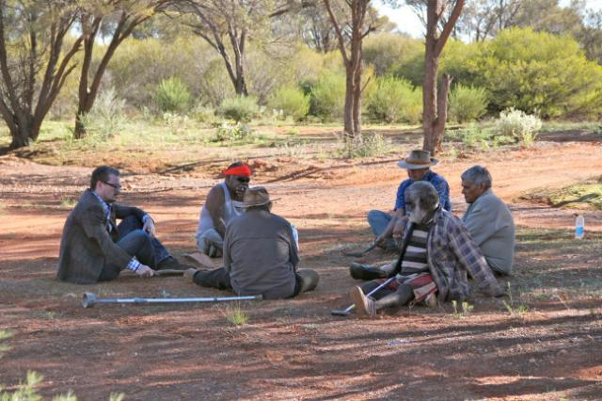
A group of humans migrating out of Africa some 40,000 to 70,000 years ago mingled with an as-yet unknown branch of humanity, researchers say.
Modern humans originated about 150,000 to 200,000 years ago in Africa. However, scientists have long debated when and how the modern human lineage spread out of Africa to nearly every corner of the globe. Nearly everyone outside Africa descended from an exodus that occurred between 40,000 and 70,000 years ago, but recent archaeological findings and climate models suggest that migrations of modern humans from Africa began at least 100,000 years ago.
One way to find out whether, in the past, modern humans dispersed from Africa in one wave or many — and to see if they intermingled with any other human lineages along the way — is to examine the genomes of present-day modern humans. [See Photos of Our Closest Human Ancestor]
"We're interested in understanding how our species has come to be how it is through the lens of ancient DNA," said Swapan Mallick, bioinformatics director at Harvard Medical School in Boston and lead author of one of the three studies appearing in the Sept. 22 issue of the journal Nature.
Previous human genetic databases often sampled a relatively narrow range of populations, which could skew results or miss key details about the migrations of modern humans out of Africa. Now, three studies have collected new, high-quality data from 787 human genomes from more than 280 geographically diverse populations around the world, including typically understudied and rapidly disappearing groups.
Among the understudied groups researchers looked at are African populations, which have considerable genetic, linguistic and cultural diversity. They also examined genomes from Australia, where previous research uncovered some of the earliest archaeological and fossil evidence of modern humans outside Africa.

New branch of humanity?
The genetic analyses revealed the genomes of present-day aboriginal Australians might harbor evidence of ancient interbreeding with an unknown human lineage.
"Who these people are, we don't know," said Eske Willerslev at the University of Copenhagen in Denmark, and senior author of one of the three studies.
Previous research unearthed bones from a mysterious extinct branch of the human family tree from Denisova cave in Siberia's Altai Mountains. Analysis of DNA extracted from the fossils suggested these "Denisovans" shared a common origin with Neanderthals, but were nearly as genetically distinct from Neanderthals as Neanderthals were from living people. [Denisovan Gallery: Tracing the Genetics of Human Ancestors]
Recent work suggested that Denisovans have contributed about 5 percent of their DNA to the genomes of present-day people of the Pacific islands of Oceania. However, these new findings suggest that what seemed to be evidence of Denisovans in the Pacific were actually signs of an unknown human lineage.
"These guys were very distantly related to Denisovans, but by no means Denisovan," Willerslev told Live Science. "They were even more distantly related to Neanderthals, and they might have been even more distantly related to modern humans. We believe that they interbred with modern humans shortly before modern humans crossed into the ancient continent of Sahul — what is now Australia, New Guinea and Tasmania — some 50,000 to 60,000 years ago."

Leaving Africa
The new findings also shed light on the controversy over whether modern humans dispersed from Africa in a single exodus or in multiple distinct waves at different times. When it came to people from Papua New Guinea, "we could discover, in the genomes of the Papuan individuals analyzed here, small traces of an additional, early expansion out of Africa that was previously hypothesized only from archaeological remains," Mait Metspalu, an evolutionary geneticist at the Estonian Biocenter in Tartu, Estonia, and senior author of one of the three studies, told Live Science.
The researchers suggest that at least 2 percent of the Papuan genome harbors traces of an early migration that happened about 120,000 years ago. Previous research suggested that non-Africans largely descend from an exodus that happened between 40,000 and 70,000 years ago.
"Our results, while for the most part confirming the already accepted model of a single expansion out of Africa as the source event of all non-African populations, show that additional expansions were not as unlikely as we thought," Luca Pagani, a molecular anthropologist at the Estonian Biocenter and lead author of one of the three studies, told Live Science.

Oldest living population
The scientists also discovered that aboriginal Australians "are one of the oldest living populations on Earth, and have been in the same area for the past 50,000 to 60,000 years," Willerslev said.
There was a great deal of controversy "over whether or not aboriginal Australians directly descend from the first humans entering Australia," Willerslev said. "The answer to that question is yes — our data is completely consistent with aboriginal Australians descending from the first humans to enter Australia. It shows a very long connection between those people and the land. [How Did Life Arise on Earth]
"I can't think of any other place in the world where humans have been so long in the same spot as Australia," Willerslev said. "Yes, there are populations in Africa that are older, but we have no idea if they stayed in the same area in Africa for as long a time."
This is the first comprehensive population-level whole-genome study of human genetic diversity in Australia. "We found that because aboriginal Australians have spent such a long time in Australia, they are very genetically diverse," Willerslev said. "An aboriginal Australian from eastern Australia and one from southwestern Australia are almost as different genetically as an Asian is from a European."
The researchers noted that about 90 percent of aboriginal Australians speak languages belonging to a single linguistic family, "but some people in northwest Australia speak other language families," Willerslev said. "It'd be very interesting to see what the story is there when it comes to how they migrated to Australia."
Original article on Live Science.

Editor's Recommendations
- In Photos: Amazing Human Ancestor Fossils from Dmanisi
- In Photos: New Human Relative Shakes Up Our Family Tree
- Image Gallery: 3-Year-Old Human Ancestor Revealed

