The Economist explains

The differences between the Catholic and Orthodox churches
Feb 12th 2016
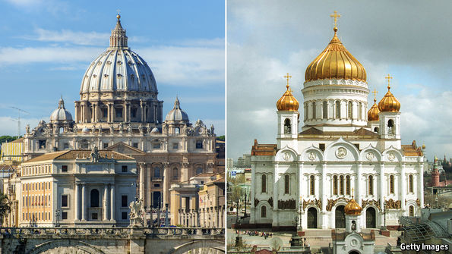
TO A non-Christian, or even to a Christian who prefers to keep doctrine and worship as simple as possible, the Catholic and Orthodox churches can look pretty similar. Both use elaborate ceremonies of ancient origin and have multiple ranks of robed clergy; both claim continuity with the dawn of the Christian era; both have rich theological and scholarly traditions and generally, long institutional memories. Only an apparently tiny difference separates the versions they use of the creed setting out their basic beliefs in a triune God of Father, Son and Holy Spirit. Why, then, do the two religious bodies not simply unite? On February 12th Pope Francis and Patriarch Kirill of Moscow, the head of the Russian Orthodox church, will meet in Cuba. Though not unprecedented in the last ten centuries such a meeting is nonetheless unusual. Why?
Part of the answer is that precisely because both institutions have long memories, differences which emerged many centuries ago still matter. The formal parting between the Christian West and the Christian East occurred in 1054; to some extent it reflected cultural and geopolitical competition between the Greek-speaking "east Roman" empire, in other words Byzantium, and Latin-speaking western Europe where Roman authority had collapsed in the fifth century, but new centres of power had emerged. Tensions rose in the early 11th century when the Catholic Normans overran Greek-speaking southern Italy and imposed Latin practices on the churches there. The Patriarch of Constantinople retaliated by putting a stop to outposts of Latin-style worship in his home city, and the pope sent a delegation to Constantinople to sort the matter out. The delegation's leader, Cardinal Humbert, excommunicated the Patriarch; the Patriarch promptly did the same to the visitor.
In the run-up to that final rupture there had been growing differences over the pope's claim to authority over the whole of Christendom, in contrast with the Orthodox view that all the ancient centres of the Christian world (Antioch, Alexandria, and Jerusalem as well as Rome and Constantinople) were approximately equal in status. The Orthodox took issue with the pope for mandating a version of the creed which in their view amounted to a subtle downgrading of the Holy Spirit. To this theological difference was added a massive geopolitical grievance: in 1204 Latin armies ransacked Constantinople, which was still the Christian world's greatest centre of commerce and culture and imposed a Latin regime for about six decades. In the Orthodox collective memory, this act of betrayal by fellow Christians weakened the great city and rendered inevitable its conquest by the Muslim Turks in 1453. Having gone their separate ways, the Christian West and Christian East spawned different theological traditions. The West developed the idea of purgatory and of "penal substitution" (the idea that Christ's self-sacrifice was a necessary payoff to a punitive Father-God). Neither teaching appeals to Orthodox Christians. The East, with a penchant for mixing the intellectual and the mystical, explored the idea that God was both inaccessible to human reason but accessible to the human heart.
To the Orthodox believer, Catholic theology seems excessively categorical and legalistic; to the Catholic mind, Orthodox thinking in its mystical flights can seem vague and ambivalent. In a few hours of set-piece discussion in Havana airport on February 12th, the pope and Patriarch will hardly be able to resolve these centuries-old differences. But at least they may understand each other a little better.

