The Anthropocene Is Here: Humanity Has Pushed Earth Into a New Epoch
by Deirdre Fulton, originally published by Common Dreams | TODAY
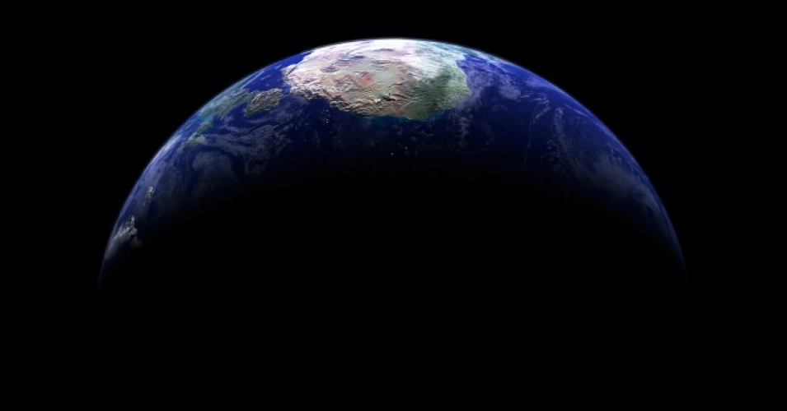
"We have had an incredible impact on the environment of our planet," says Colin Waters, principal geologist at the British Geological Survey. (Photo: Kevin Gill/flickr/cc)
The Anthropocene Epoch has begun, according to a group of experts assembled at the International Geological Congress in Cape Town, South Africa this week.
After seven years of deliberation, members of an international working group voted unanimously on Monday to acknowledge that the Anthropocene—a geologic time interval so-dubbed by chemists Paul Crutzen and Eugene Stoermer in 2000—is real.
The epoch is thought to have begun in the 1950s, when human activity, namely rapid industrialization and nuclear activity, set global systems on a different trajectory. And there's evidence in the geographic record. Indeed, scientists say that nuclear bomb testing, industrial agriculture, human-caused global warming, and the proliferation of plastic across the globe have so profoundly altered the planet that it is time to declare the 11,700-year Holocene over.
As the working group articulated in a media note on Monday:
Changes to the Earth system that characterize the potential Anthropocene Epoch include marked acceleration to rates of erosion and sedimentation; large-scale chemical perturbations to the cycles of carbon, nitrogen, phosphorus, and other elements; the inception of significant change to global climate and sea level; and biotic changes such as unprecedented levels of species invasions across the Earth. Many of these changes are geologically long-lasting, and some are effectively irreversible.
These and related processes have left an array of signals in recent strata, including plastic, aluminium and concrete particles, artificial radionuclides, changes to carbon and nitrogen isotope patterns, fly ash particles, and a variety of fossilizable biological remains. Many of these signals will leave a permanent record in the Earth's strata.
"Being able to pinpoint an interval of time is saying something about how we have had an incredible impact on the environment of our planet," said Colin Waters, principal geologist at the British Geological Survey and secretary for the working group. "The concept of the Anthropocene manages to pull all these ideas of environmental change together."
Indeed, the Guardian compiled more "evidence of the Anthropocene," saying humanity has:
- Pushed extinction rates of animals and plants far above the long-term average. The Earth is now on course to see 75 percent of species become extinct in the next few centuries if current trends continue.
- Increased levels of climate-warming CO2 in the atmosphere at the fastest rate for 66m years, with fossil-fuel burning pushing levels from 280 parts per million before the industrial revolution to 400ppm and rising today.
- Put so much plastic in our waterways and oceans that microplastic particles are now virtually ubiquitous, and plastics will likely leave identifiable fossil records for future generations to discover.
- Doubled the nitrogen and phosphorous in our soils in the past century with our fertilizer use. This is likely to be the largest impact on the nitrogen cycle in 2.5bn years.
- Left a permanent layer of airborne particulates in sediment and glacial ice such as black carbon from fossil fuel burning.
Now, scientists must commence their search for the "golden spike"—explained in the Telegraph as "a physical reference point that can be dated and taken as a representative starting point for the Anthropocene epoch." This could be found in anything from layers of sediment in a peat bog to a coral reef to tree rings.
"A river bed in Scotland, for example, is taken to be the representative starting point for the Holocene epoch," the Telegraph reports.
The Guardian points out: "For the Anthropocene, the best candidate for such a golden spike are radioactive elements from nuclear bomb tests, which were blown into the stratosphere before settling down to Earth."
However, Jan Zalasiewicz, a geologist at the University of Leicester and chair of the working group, told the paper that while "the radionuclides are probably the sharpest—they really come on with a bang," humanity has left no shortage of signatures.
"We are spoiled for choice," he said. "There are so many signals."
According to the Telegraph, once one or more golden spike sites have been selected, a proposal for the formal recognition of an Anthropocene epoch will be made to a series of commissions, culminating at the International Union of Geological Sciences. The process is likely to take at least three years.

Geologists search for Anthropocene 'golden spike'
By Jonathan Amos BBC Science Correspondent
- 30 August 2016 From the section Science & Environment

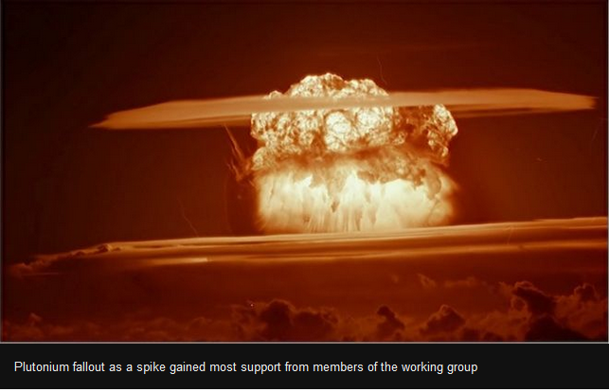The notion that we have entered a new geological age is real and should be formally recognised, according to an international report.
The verdict comes from a panel set up to judge the merits of adding an Anthropocene ("Age of Humans") time segment to the history of the Earth.
The group delivered its preliminary evidence and recommendations on Monday.
It now needs to identify a suitable marker in the environment that epitomises the start of the new phase.
Colin Waters from the British Geological Survey is secretary to the Anthropocene Work Group (AWG). He presented the progress report to the 35th International Geological Congress in South Africa.
"This is an update on where we are in our discussions," he told BBC News.
"We've got to a point where we've listed what we think the Anthropocene means to us as a working group.
"The majority of us think it is real; that there is clearly something happening; that there are clearly signals in the environment that are recognisable and make the Anthropocene a distinct unit; and the majority of us think it would be justified to formally recognise it.
"That doesn't mean it will be formalised, but we're going to go through the procedure of putting in a submission."
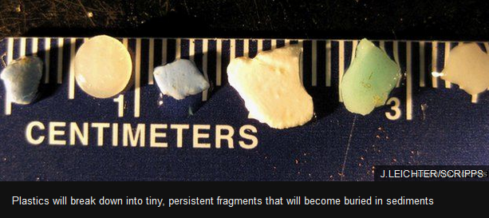The hunt is now on for a "golden spike", as it is known - the marker that scientists can point to years hence - perhaps millions of years hence - and say, "There! That's the start of the Anthropocene Epoch."
And it would likely be an "epoch", said Dr Waters, meaning the current phase of Earth history known as the Holocene has terminated. We would, however, remain within the Quaternary Period and the Cenozoic Era, which are higher rankings in the division of time.
Ten members of the 35-strong working group believe the best spike will probably be plutonium fallout from bomb tests in the 1950s, to be found in marine or lake sediments, ice layers or perhaps even speleothems (stalagmites and stalactites).
Others on the panel, however, think there could be better spikes than the radionuclide. Counter-proposals include remnant plastics or some kind of carbon signature that signifies the rapid rise in CO2 emissions.
Nonetheless, a clear majority of group members (28 of them) accept that whichever marker is chosen, it should reflect events on Earth around the 1950s.
This is the beginning of what is often referred to as the "great acceleration", when human impacts on our planet suddenly intensified and became global in extent.
The Anthropocene Working Group expects to take two or three years, at least, to settle on the best golden spike or spikes.
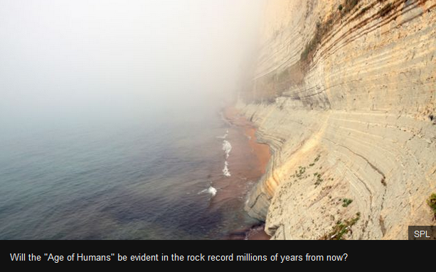Only then will the scientists produce their final assessment report, which will be sent for deliberation by the international geological community.
For an Anthropocene Epoch to be added to the "official" timeline of Earth history (the Chronostratigraphic Chart), it will need to win the backing of the International Commission on Stratigraphy (ICS) and then be further ratified by the executive committee of the International Union of Geological Sciences (IUGS).
Dr Waters said the AWG now needed the assistance of scientists who have cores of ocean sediment, coral specimens, speleothems and the like in their collections. These could all be relevant to the spike investigation.
"There may be research groups out there who have bore holes drilled through glacial ice, for example, which go through successions that could be used to define the Anthropocene.
"If they were to make those available so that we could do analyses of all the different signals, it would help us understand better whether this concept of the mid-20th Century being the boundary is the best one."
Without these offers of help the AWG might have to commission new drill holes - a process that could be very time consuming and very expensive.
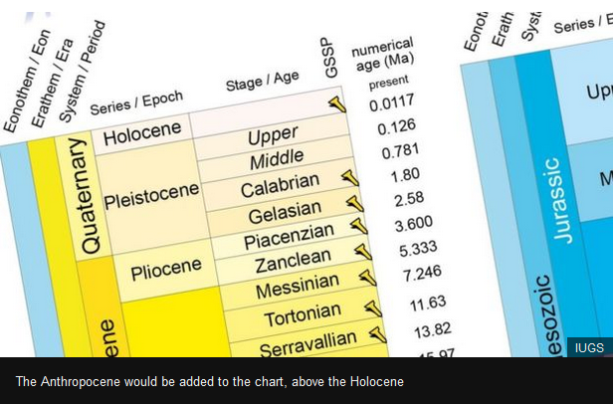Jonathan.Amos-INTERNET@bbc.co.uk and follow me on Twitter: @BBCAmos

