North Koreans are defecting from the country in droves
David Choi,Business 9/7/2016
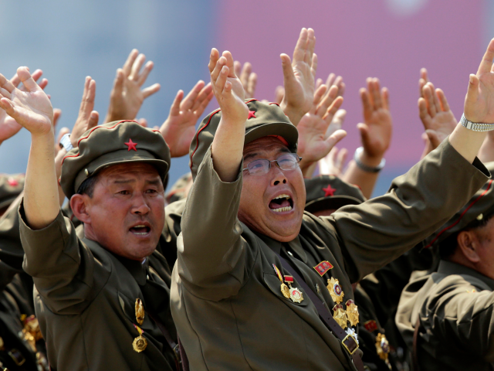(Korean War veterans shout slogans to North Korean leader Kim Jong-un during a parade in Pyongyang July 27, 2013.REUTERS/Jason Lee )
With everything from the fear of deadly snakes to alleged executions by anti-aircraft gun, it’s understandable why many North Koreans desire to flee the Hermit Kingdom.
What’s interesting to note, however, is the economic class of defectors that have found their way out of North Korea. According to a survey from the Korean Unification Ministry, the percentage of defectors from the “middle-class” rose from 19% in 2001 to 55.9% after 2014.
The increase stems from the fact that more defectors from higher statuses in the North possess the resources to escape, said the Unification Ministry.
So far this year, 894 North Koreans have escaped the country, compared to the 777 in the previous year during the same period. The Unification Ministry claims that this 15% increase is on track to bring the total amount of defectors to 30,000 by the end of the year.
Although the reasons to cross the border, or in some exceptional cases remain away from, are numerous, it’s noteworthy that one of their highly publicized punishments in North Korea seems to have decreased: North Korea leader Kim Jong Un is estimated to have executed about 130 officials in the 5 years he’s been in power, while Kim Jong Il, his father, had put to death over 2,000 officials in a 6 year span.
The latest high-profile defection comes from Thae Yong-Ho, North Korea’s deputy ambassador to London, who has since been accused by his former country of leaking state secrets, embezzlement, and child rape. As one of the highest-ranking North Korean officials to have defected, it wouldn't be far fetched to believe that others will eventually follow suit.

