Mysterious archaic humans left clues in a surprising place

The genetic legacy of two extinct human species persists to this day in our own genes, say scientists.

By Eva Botkin-Kowacki, Staff writer Christian Science Monitor
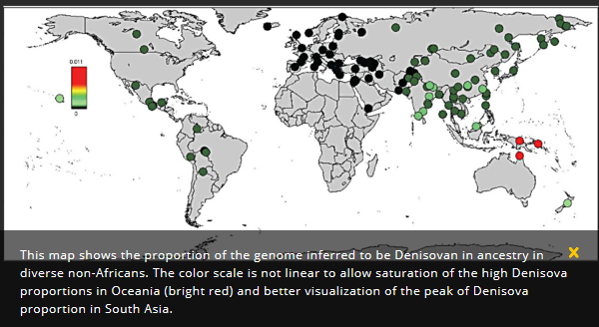
Tens of thousands of years ago, our species, Homo sapiens, interbred with two different archaic human species, Neanderthals and Denisovans. The evidence for these interspecies interactions is in our genes. But the details are still fuzzy.
So teams of scientists have been combing over that genetic evidence searching for clues. And recently, researchers have worked to separate the Neanderthal from Denisovan ancestry in modern human genomes to better understand their influence.
A new study that does just that finds that some non-African modern humans today could have Denisovans to thank for 3 to 6 percent of their DNA, whereas Neanderthals contributed just about 2 percent. That new paper published Monday in the journal Current Biology focuses in on Denisovan DNA in the modern human genome.
"We weren't the only humans in the world 50,000 years ago. There were these other humans that we not only met but interbred with," study author David Reich, a geneticist at Harvard Medical School, tells The Christian Science Monitor. "And those humans contributed a lot to who we are today."
The scenario went something like this: As H. sapiens began spreading out of Africa and into Eurasia and beyond, they would have encountered archaic human species that had already made the trek out of Africa.
Of those other humans, Neanderthals and Denisovans would have been the most closely related species to our own and therefore most compatible. The ancestors of Neanderthals and modern humans are thought to have diverged some 500,000 to 700,000 years ago and those of Denisovans diverged from those of Neanderthals some 350,000 to 420,000 years ago, Dr. Reich says.
But as those other human species went extinct tens of thousands of years ago, scientists must rely on the fossil record and the DNA they left behind in our own bodies for insights. The genetic clues may seem to be sparse hints at a complex, dynamic human history, but they actually could tell us a lot.
This new paper "allows a disambiguation between DNA from Denisovans and DNA from Neanderthals in modern human genomes," Rasmus Nielsen, a researcher at the Center for Theoretical Evolutionary Genomics at the University of California-Berkeley who was not part of this study, writes in an e-mail to the Monitor. "By doing so, they are able to date the time of the Neanderthal and Denisovan introgression events independently."
And separating out when the different species interbred with our own could tell us more about the mysterious human species, Denisovans.
Denisovans are only identified by a few fossilized remains and their DNA. The new study finds that Denisovans and modern humans interbred around 50,000 years ago, which adds a data point. Previously, some scientists had suggested that Denisvoans may have gone extinct before modern humans spread into their more easterly range. But, says Reich, this DNA evidence "tells you that the Denisovans were present in southeast Asia around 50,000 years ago."
Not only were these archaic humans in the region then, their DNA is concentrated in a surprising place, too. Although present-day humans from Oceania have the most Denisovan DNA, "there's more Denisovan ancestry today in South Asians than you would expect from existing models of history," Reich says. And that means that either there was a separate interbreeding event between the two species or more breeding among the hybrids that resulted from the interspecies match.

How many times did the human species intermingle?
A study published earlier this month suggested archaic humans (both Neanderthal and Denisovan) intermingled with H. sapiens remarkably frequently. But, as Reich says, "the genetic data are actually consistent with as few as one Denisovan admixture event into modern humans and as few as one Neanderthal admixture event into modern humans."
"The number of interbreeding events is highly debated among evolutionary biologists," Dr. Nielsen says.
And it could hinge on how scientists are interpreting the data. "There are an infinite number of models that you could imagine to explain the data," explains Joshua Akey, a co-author on the paper published earlier this month and a geneticist at the University of Washington in Seattle, in a phone interview with the Monitor.
Dr. Akey's view is that the best model is one of multiple interbreeding events, but he admits there is a lot of uncertainty.
Reich says perhaps the same data could be explained simply by the way that the hybrid populations then interbred with other H. sapiens populations outside of Africa. In this model, the genetics would have been diluted differently as different H. sapiens and hybrid populations met across the globe.
"It could be that there was a single mixture event followed by dilution, or it could be that it was multiple independent events," Reich says.

What did we get from our extinct forefathers?
"We're trying to understand the biological effect of this mixture with archaic humans and modern humans," Reich says. Was archaic human DNA beneficial to our own ancestors or detrimental?
Perhaps those genes that stuck around to end up in present-day humans were beneficial from an evolutionary standpoint. For example, some people living at high altitudes in Tibet may have inherited a gene from Denisovans to survive under those conditions.
It's possible that, thanks to this interbreeding, "certain genetic changes were introduced into the modern human populations that allowed them to live better in the new environments that they were moving into in which these archaic humans were already adapted because they had lived there for hundreds of thousands of years," says Reich.
Likewise, those genes that didn't make it through to present-day human genomes meant the archaic human versions were probably not advantageous. These regions of the genome devoid of archaic human DNA are thought to be associated in particular with language development.
Another segment of modern human DNA that doesn't have much Neanderthal or Denisovan DNA has to do with male fertility, says Reich.
"This tells us that when Denisovans and Neanderthals and modern humans met and mixed, they were on the edge of biological compatibility," Reich says. "They produced offspring and many people today are descended from those offspring, but it was clear that the offspring had to overcome some challenges in order to be able to establish themselves as a successful population."
Science

Neanderthals and modern humans mated 50,000 years earlier than we thought, scientists say.

Researchers discovered early modern human DNA in a Neanderthal genome. And that interbreeding event happened remarkably long ago.

By Eva Botkin-Kowacki, Staff writer Christian Science Monitor

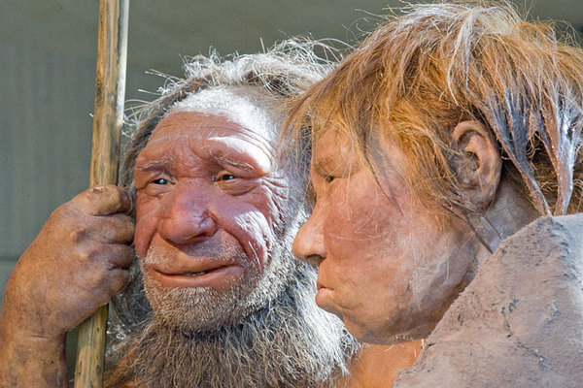
Figure 1 This Friday, March 20, 2009 file photo shows reconstructions of a Neanderthal man, left, and woman at the Neanderthal museum in Mettmann, Germany.
Ever since geneticists sequenced the first Neanderthal genome in 2010, researchers have been reporting just how related humans are to their ancient, extinct cousins. Since then, there's been more research. And more. And more.
As it turns out, non-African modern humans have Neanderthals to thank for 1 to 4 percent of their DNA. The two species were thought to have interbred around 50,000 to 60,000 years ago, based on the Neanderthal DNA found in anatomically modern human specimens and people living today.
But scientists had yet to find a signature of such mating interactions in Neanderthal DNA, until now.
"Instead of leaving fragments of Neanderthal DNA in modern humans, we find fragments of modern human DNA in the Neanderthal genome," says Adam Siepel, a computational biologist who heads the quantitative biology program at Cold Spring Harbor Laboratory in Cold Spring Harbor, N.Y.
Dr. Siepel, as part of an international team of geneticists, anthropologists, and computer scientists, found that a Neanderthal specimen from Siberia shared at least 1 percent of its DNA with modern humans. And that mating event happened some 100,000 years ago. Their results were published Wednesday in the journal Nature.

Long, long ago
"Humans and Neandertals must have met considerably earlier than we thought previously," Siepel tells The Christian Science Monitor in an interview.
The researchers' analysis suggests that the interaction that gave this Neanderthal some modern human DNA may have occurred 100,000 years ago. And that date pushes interaction between the two groups back 40 to 50 thousand years.
But here's the catch: Homo sapiens supposedly didn't trek out of Africa until around 60,000 years ago. And Neanderthal DNA appears in living modern humans with heritage from every part of the world except Africa, suggesting the groups did not mix until they left the continent.
So these new findings suggest that some modern humans might have left Africa before 100,000 years ago.
There have already been other hints of an earlier migration out of Africa in previous studies. For example, last year, archaeologists unearthed Homo sapien teeth in southern China that they dated to between 80,000 and 120,000 years old. And in 2014, scientists discovered artifacts in the Arabian desert that they dated to more than 100,000 years ago.

Shared genes
Why is it significant that the gene flow goes in both directions?
It may seem obvious because when two people mate both parents' DNA ends up in their offspring. But this individual, with just 1 to 7 percent modern human DNA, was not the direct result of such an interaction. So this Neanderthal was a descendant of that event.
"I think the fact that we see it in both directions is notable, because of the inherent asymmetry of these interbreeding events," Siepel says.
He explains that, because children usually stay with their mother, that means that a human male probably mated with a Neanderthal female to produce this lineage. The hybrid offspring was then raised in a Neanderthal community. Or perhaps, in a more unlikely scenario, the interspecies family was integrated into the Neanderthal community as a unit.
"Obviously these are only speculations, but the fact that we see both types of gene flow does suggest that neandertal/human hybrids were successfully integrated into both human and neandertal societies," Siepel adds in an email to the Monitor.

An interspecies love affair?

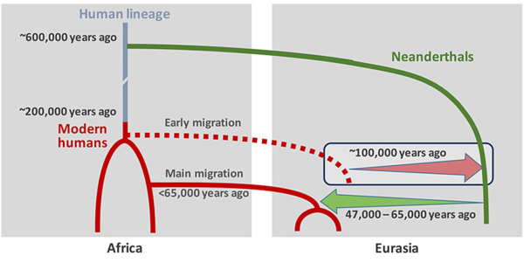
Figure 2 Scenario of interbreeding between modern humans and Neanderthals: Neanderthal DNA in present-day humans outside Africa originates from interbreeding that occurred 47,000 - 65,000 years ago (green arrow). Modern human DNA in Neanderthals is likely a consequence of earlier contact between the two groups roughly 100,000 years ago (red arrow).
In addition to pushing back the dates of a modern human-Neanderthal intermingling, this research suggests a more complex story about the relationship between the groups.
Years ago, scientists thought that when modern humans spread across the land, they completely replaced the Neanderthals, says Fred Smith, an anthropologist studying Neanderthals and early modern humans at Illinois State University. But, he tells the Monitor, "Now we see that this was a much more complex population phenomenon."
As Siepel describes, "This suggests that Neandertals were not a thriving group that abruptly went extinct, but instead were dwindling for thousands of years and perhaps teetering on the edge of extinction."
And adding to the complexity, says Dr. Smith, who was not part of the new study, is the issue of species.
Neanderthals (homo neanderthalensis) and modern humans (homo sapiens) are designated as separate species. Interspecies mating is generally thought to be unable to produce viable, fertile offspring. But here there is a Neanderthal that is many generations removed from such an interaction but still retains modern human DNA.
So maybe it wasn't an interspecies love affair, suggests Smith. "It's another piece of evidence that suggests to me that Neanderthals are not a different species than us," he says. "They look different, they're differently adapted, but from my perspective, I don't believe that they were a different species."
Instead, Smith suggests, they're a subspecies.
When asked in an email about this, Siepel says, "well, it is clear now that modern humans are part neandertal and neandertals were part modern human, so the classical idea of species as groups incapable of interbreeding is clearly not true in this case."
But, he adds, "there are some indications that neandertal/human hybrids may have had somewhat reduced fertility."
As David Reich, a geneticist at Harvard University, told The Washington Post in 2014, "There’s strong evidence that when the two met and mixed, they were at the edge of biological compatibility ... The people who eventually survived and thrived had quite a bit of hurdles to overcome."
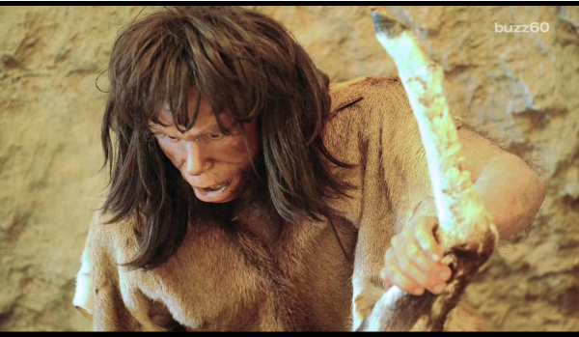
Figure 3 You have allergies because your ancestors had sex with Neanderthals

