Is the Pope Catholic Enough for Conservatives?

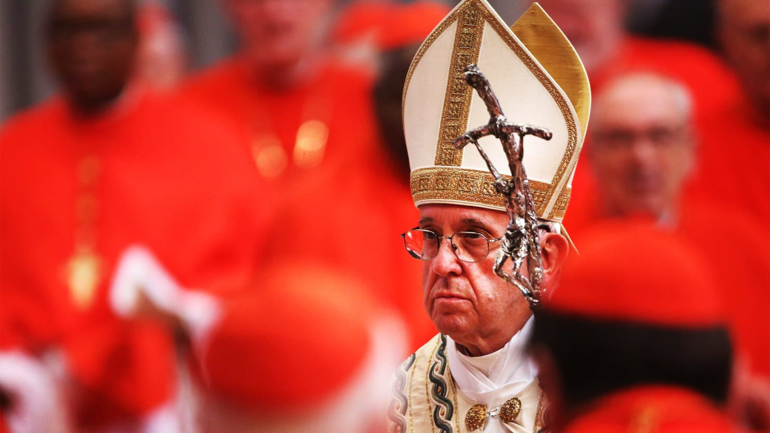

Pope Francis is under attack from conservative fringe groups who would have been ignored in the past. Now, as they imply he’s heretical, they are a voice to be reckoned with.
Barbie Latza Nadeau 09.26.17
ROME—Popes have had many enemies over the centuries. They have been poisoned, strangled, clubbed to death, and one supposedly was smothered with a pillow.
Even in our supposedly more civilized era the last two popes of recent memory had detractors. It was just that the whispers of dissent were often just that, low voices from fringe groups that no one took very seriously.
Now, in the era of fake news and alternative facts that has brought organizations like Breitbart to the mainstream (and has former Trump adviser Steve Bannon critiquing church doctrine), even fringe groups in Catholic circles are increasingly making their voices heard.
That’s exactly what happened over the weekend when a group of theologians and academics, bolstered by a handful of previously unknown but apparently very conservative clergy, issued what amounts to an online petition that accused Francis of propagating heresy.
Let’s repeat that: “Heresy.”
The accusations come in the form of a 25-page letter called a “Correctio filialis de haeresibus propagatis” which, for those whose Latin is a little rusty, translates to a “filial correction concerning the propagation of heresies.” It is a tool in the conservative Catholic’s arsenal that apparently was last used officially in 1333‍ and was meant to allow cardinals to override an errant pope by correcting him on doctrine if he is wrong.
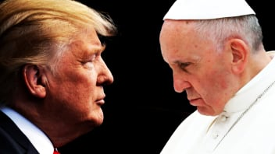
A hard copy of the letter was sent to Francis at his Santa Marta home inside Vatican City on Aug. 11 with just 40 signatures, but 22 more were added when it was published over the weekend on its own website aptly titled www.correctiofilialis.org with an option to add new signatures. It also was published on the conservative Catholic website Rorate Cæli which has posted voluminous anti-Francis rhetoric since he was elected.

Figure 1 Pope Francis Makes Everything Trump & Bannon Say Sound Silly
“There will [be] many Catholics, even traditionalists, whose first defeatist reaction will be to belittle this effort. But the wise, the learned in history, will understand that this is just the first part, the first piece of the puzzle, with next steps still to come in a long and extended process,” Rorate Cæli editors write at the top of the letter. “This first step is an initiative of a theological nature that will likely lead, God willing, to an initiative of a canonical nature from those who have the mandate to act.”
Some of the letter’s signatories are known to be part of the breakaway Catholic group known as the Society of St. Pius X that adheres to what they call “doctrinal purity,” with its members rejecting many of the reform measures instituted by the Second Vatican Council. In fact, the highest ranking Catholic figure on the 25-page petition is the group’s superior general Bishop Bernard Fellay from Switzerland.
At issue are what the group considers seven heresies Francis is propagating by not clearing up what he really meant regarding civilly married divorced Catholics and their access to Holy Communion in Francis’ apostolic exhortation Amoris laetitia or The Joy of Love published in April 2016, which can be downloaded from the Vatican website.
“Scandal concerning faith and morals has been given to the Church and to the world by the publication of Amoris laetitia and by other acts through which Your Holiness has sufficiently made clear the scope and purpose of this document. Heresies and other errors have in consequence spread through the Church; for while some bishops and cardinals have continued to defend the divinely revealed truths about marriage, the moral law, and the reception of the sacraments, others have denied these truths, and have received from Your Holiness not rebuke but favour,” the letter states.
The letter did not accuse him of actual heresy per se, just propagating it, though it does state: “The signatories make no judgment about Pope Francis’s culpability in propagating the 7 heresies that they list, since it is not their task to judge whether the sin of heresy has been committed.” The sin of heresy, that is, formal heresy, is committed when a person departs from the faith by doubting or denying some revealed truth with a full choice of the will. “It should however be noted that others who have spoken up in defense of the Catholic faith have been subject to reprisals. Thus, the signatories speak for a large number of clergy and lay faithful who lack freedom of speech.”

It’s not the first time conservative Catholics have asked Francis for clarification on his writing of this exhortation in particular. Last year, four cardinals led by American Raymond Burke led a charge by presenting similar questions in the form of “dubia.”
Two of those cardinals have since passed away, but Burke, who has not yet signed the filial correction, has not stopped condemning the pope, telling the Australian Catholic Outlook publication that Francis has not united the church.
“I find universally that there’s a great deal of confusion, also people feeling that the Church is not a secure point of reference. Some are feeling even a certain bewilderment,” he said. “They are looking for a much stronger presentation of the Church’s doctrine. Certainly, as good Catholics they love the Pope with complete obedience to the office of Peter. At the same time they don’t accept these questionable interpretations.”
The filial correction letter seems to back up the originators of the dubia. “Those cardinals, by contrast, who have submitted dubia to Your Holiness, in order that by this time honoured method the truth of the gospel might be easily affirmed, have received no answer but silence,” they write.
One of the most recognizable signatures on the original filial correction is that of Gotti Tedeschi, the president of the Institute for the Works of Religion, the Vatican Bank, who was ousted just before Pope Benedict XVI resigned and who said he “feared for his life.”
Perhaps by odd coincidence, the bank’s Auditor General Libero Milone, who quit suddenly in June, summoned a group of Vatican reporters in Rome to explain that he really left because he found evidence of “possible illegal activity” which was met by threats and fabricated charges against him. His tell-all interview was quickly eclipsed by the opportunity to use “heresy” in headlines and has largely been forgotten.
Vatican expert John Allen, writing in the Catholic online journal Crux, also added to the mix a bit of gossip that an Argentine journalist had publicly accused Francis of suffering from “narcissistic personality disorder” which has defined his papacy. But Allen says he worries all this noise will cover the real news. “Specifically, there’s a risk that the very serious suggestions being made by Milone about the state of Francis’s much-ballyhooed financial reform will be drowned out by the noise generated by everything else.”
No matter, the Vatican has its own way of dealing with things. For some reason, the Vatican web server which controls access to the internet and public computers used by the press in the Holy See press room had strangely blocked certain websites that published the full version of the filial correction letter, and all the functions of the online petition, sending Vatican journalists to internet cafes to try to get a read on any new signatories.
Vatican spokesman Greg Burke told reporters that the block was not censorship. “On some computers in the Press Room, as in any company, there are filters that are automatically triggered for various online content, from pornography to malware to advertising that serve to regulate free internet surfing.”
There is no sign the naysaying will end any time soon. In fact, this is apparently the sixth such criticism of Francis for similar perceived indiscretions. Writing in the National Catholic Register, Vatican journalist Edward Pentin outlines them all, starting with a September 2015 petition that apparently garnered some 800,000 signatures even before Francis wrote his exhortation, and following through various other acts that didn’t make headlines outside the fringe groups themselves.
Francis can easily choose to ignore the mad chatter against him, even as it grows louder. In fact, there are whispers of a schism and deep fractures within the clergy. But the bottom line is that Francis still enjoys considerable popularity among regular Catholics who quite like the fact that the circumstances of their complicated lives at least seem to be more easily

