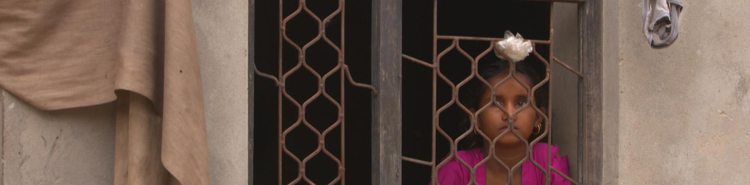

India's slave brides - Sold like cows and goats

Thousands of girls and women in India are sold into marriage and often face a lifetime of abuse and hardship.

By Liz Gooch
The first time Muklesha was sold, she was just 12 years old. Her buyer was a man in his 70s.
Marriage and a baby quickly followed. But, three years later, the man died and Muklesha was again put up for sale.
This time, her buyer was a horrific abuser.
"He didn't feed me. He'd take me to the fields and stuff my mouth with mud and then beat me," she says.
Muklesha is one of thousands of India's slave brides - girls and women sold into marriage, often destined for a lifetime of abuse and hardship, as this 101 East documentary reveals.

A dangerous demand for brides
In India, sex-selective abortions and female infanticide, due to a preference for male babies, has created one of the most severe gender imbalances in the world.
Now, the shortage of women is generating a dangerous demand for brides among men desperate to marry, especially in states like Haryana, which has one of the country's worst gender ratios.
Traffickers are stepping in to meet this demand, kidnapping women from other states and selling them to men in Haryana.
A survey of 10,000 households in this northern state found more than 9,000 married women had come from other states.
Al Jazeera discovered that some women living in villages in Haryana have been sold as many as three times.
The villagers call them "Paros", a derogatory term implying they've been purchased.
Sanjida was trafficked to Haryana when she was just 10 years old. She says an older girl from a village near her family's home in the north-eastern state of Assam drugged and kidnapped her.
"I was made to do field work, cut grass, feed cows, do all the work. I cried for a year. I was in captivity for four years," she says.
She says she was then sold into marriage.
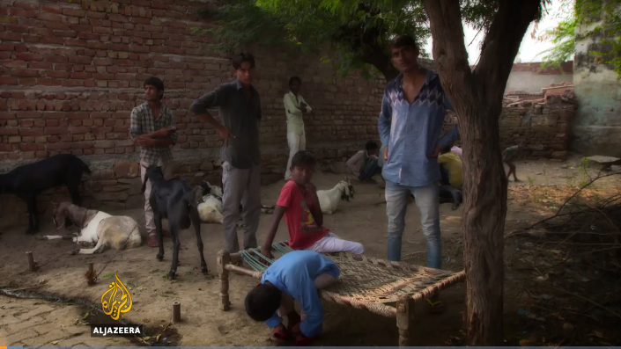
Figure 1 Due to the gender imbalance, there are men who are desparate to get a wife, so they purchase them.
"I couldn't run away or bring my life to an end. There was nobody whom I could ask for help," she says.
But Sanjida was luckier than most other Indian women sold into marriage. She says her husband has always treated her well. Sanjida now works for an NGO helping other women.
"All people in Haryana are disrespectful towards women like us. Everybody says we have no self-respect ... and that we are sold like cows and goats. We feel very bad when we hear all this because we are human beings and we belong to India, just like them," she says.
Sanjida is now helping Muklesha, the girl first sold when she was 12, after she was rescued from her abusive husband.
Muklesha now lives in a safe house with her 18-month-old daughter, but Sanjida says she's still so traumatized she hasn't been able to tell anyone where she comes from.
"Her second husband was so cruel. He beat her so badly that her mouth was damaged and she was affected mentally. She struggles to speak and to be understood," Sanjida explains.
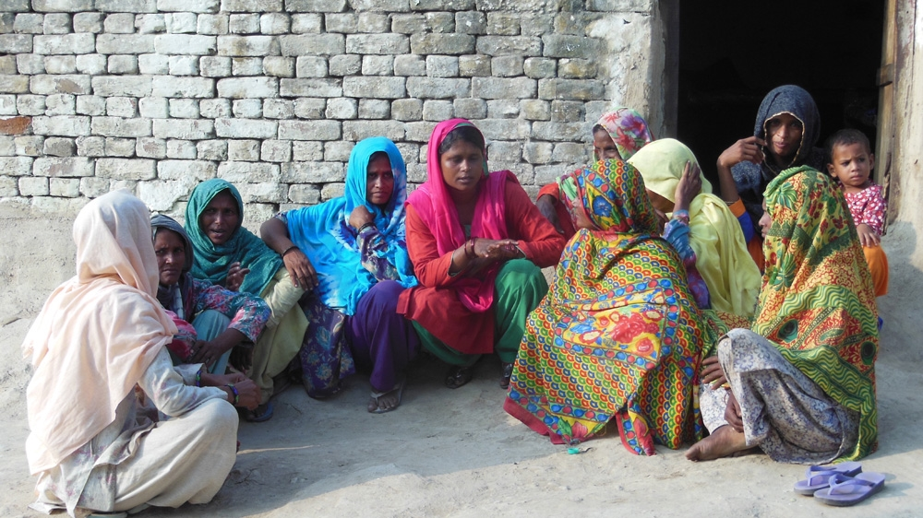
In India, a preference for male babies has created one of the world's most severe gender imbalances and now the shortage of women is fuelling a dangerous demand for brides among men desperate to marry [101 East/Al Jazeera]

'Commodities that can be recycled and resold'

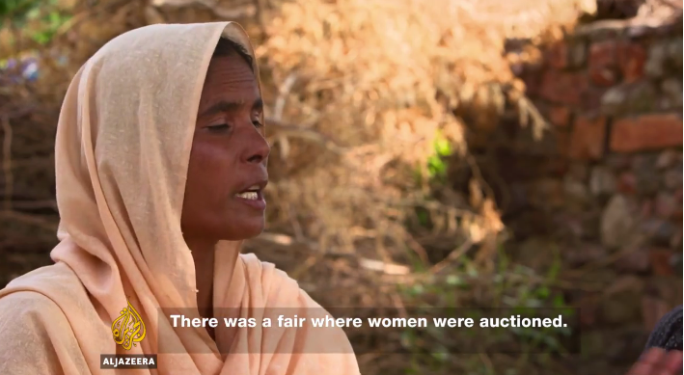
For the brides who manage to escape their husbands, pursuing a criminal case against them can be near impossible, according to Narender Singh, a local district chief magistrate in Haryana.
"She's brought before the court to depose against the trafficker, who is a powerful person who has strong links in the community and the community is supporting him," he says. "So in these circumstances, it's very tough for that lady to stand by her statement."
He says the women have no rights, including when it comes to inheritance.
"I'm yet to see a case where they have legally inherited some land in their name. They are not accepted as a member of the family," he says.
Poonam Muttreja, executive director of the Population Foundation of India, says the bride trade reflects a cultural lack of respect for women.
"It's not just about sex selection and foeticide. It's about infanticide; it's about lack of value for girls," says Muttreja, a government adviser on family issues.
"It's a continuum where girls are not valued before they're born, but the girls are not valued or treated well even after they're born."
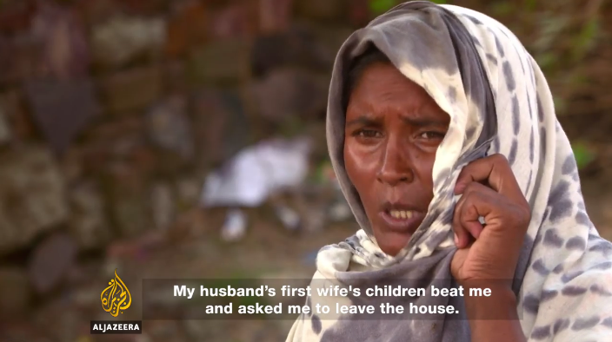
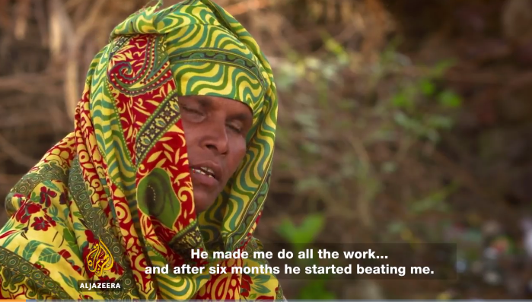
Muttreja says a shortage of women in Haryana has meant that it has become normal for men to buy brides from other states.
"They could marry their boys to girls from other parts of the country in the normal, respectful way, but it is the extreme lack of respect for women that they do sex trafficking," she says. "It's not as though they treat them as respected married partners. They treat them as commodities that can be recycled and resold."
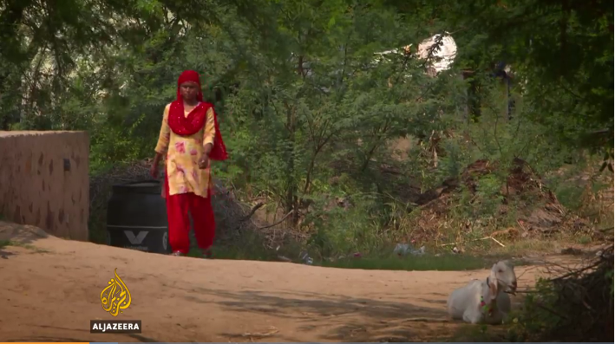
Figure 2 Drugged, kidnapped, sold, and married at age 10. Has spent most of her life doing field work.
The Indian government is drafting the country's first comprehensive anti-trafficking laws, but some activists say this will not be enough to stop the sale of brides.
"Unless you change social norms and the way people view girls, you're not going to be able to change either the sex ratios or the lack of respect for women," says Muttreja. "Buying brides is a lack of respect for women and lack of any value that a woman has."
For Sanjida, life has become all about her four children. She is determined that in her family at least, the practice of selling girls into marriage will end with her.
"I don't expect much for myself, but I work hard to educate my daughters so that they have a better life. Whatever I went through, they should not have to suffer that."
Source: Al Jazeera

