Ancient structures found in cave couldn't have been built by modern humans

Constructions date to 176,000 years ago.
Bryan Nelson May 30, 2016,
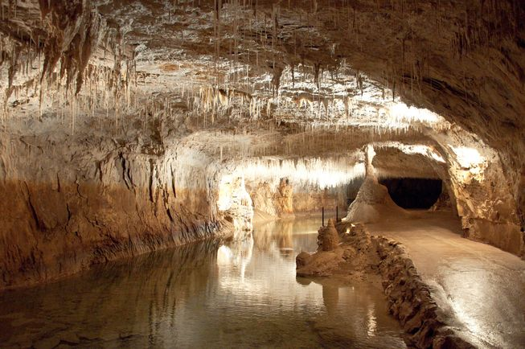
A cave in southern France. (Photo: M.Maselli/Flickr)
Some of the oldest constructions ever discovered were recently found and dated in a cave in southern France, and they're so old that it's impossible for them to have been built by modern humans, reports Nature.
The structures were first identified back in 1990 when a group of spelunkers first broke into a cave chamber that had likely been sealed for tens of thousands of years. They noticed odd ringed semicircles assembled from broken stalagmites that seemed too ordered to be a natural formation. The cave explorers couldn't be certain, however, and they reported their discovery so experts could investigate. But it wasn't until 2013 — more than two decades later — that researchers finally descended into the cave to witness the legend for themselves, and their findings have finally been published.
Sure enough, researchers do not believe these structures are natural. But here's where the mystery deepens: The structures were dated, using a variety of techniques, at about 176,000 years old. That's old ... too old for them to have been built by us.
So who or what could have built them? Modern humans weren't around yet, but some of our ancient brethren were: Neanderthals. It seems reasonable to suspect that Neanderthals built these cave structures, since they were the only humans around in this part of France at the time. Some charred bones — likely from a bear or large herbivore — found within one of the constructions also hints at Neanderthals, who probably cooked them.
Taken together, all of the evidence points toward a far more sophisticated social structure and technological prowess than some researchers have been willing to grant to ancient hominins. The Neanderthals would have required a thorough control of fire, not just for cooking but also to explore such an elaborate cave system.
Since such ancient structures are so rarely preserved this well, little is known about Neanderthal culture. The cave constructions and their surrounding context could provide a wealth of insight into the lives of these little-understood humans through further research. It's a fascinating opportunity, as well as a humbling one. Though we're probably not the direct descendants of Neanderthals, they may be far more like us than some have been previously inclined to believe.
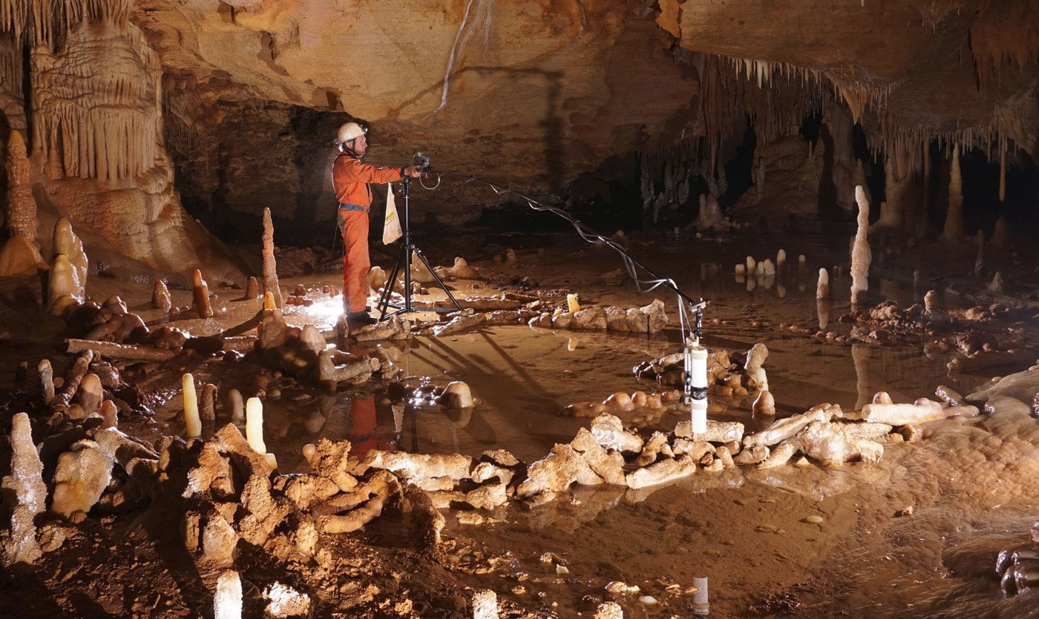

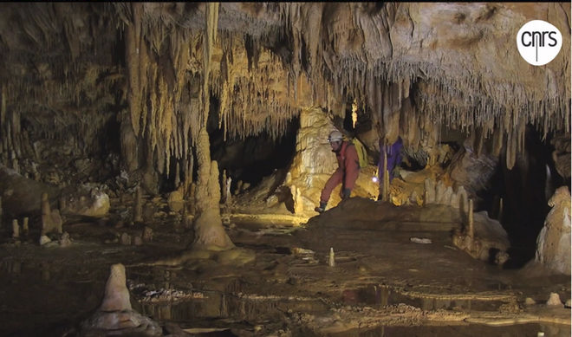
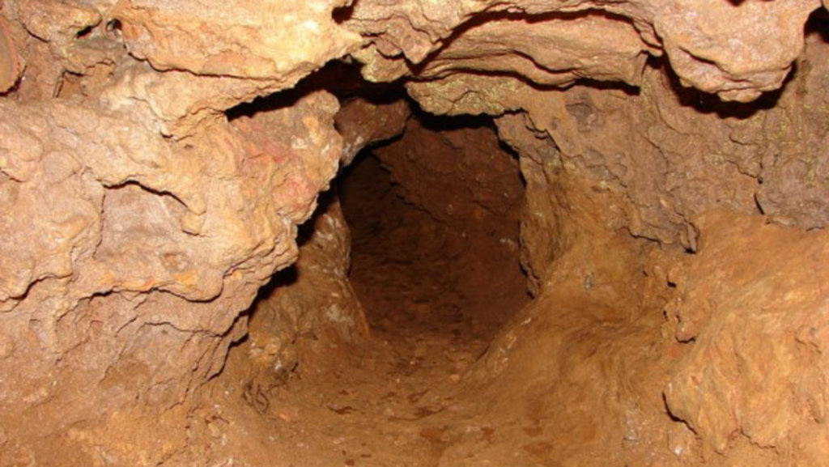
Entrance to the formerly sealed-off section of the cave
