A little-known Pakistani tribe that loves wine and whiskey fears its Muslim neighbors
By Tim Craig August 16 at 8:00 AM
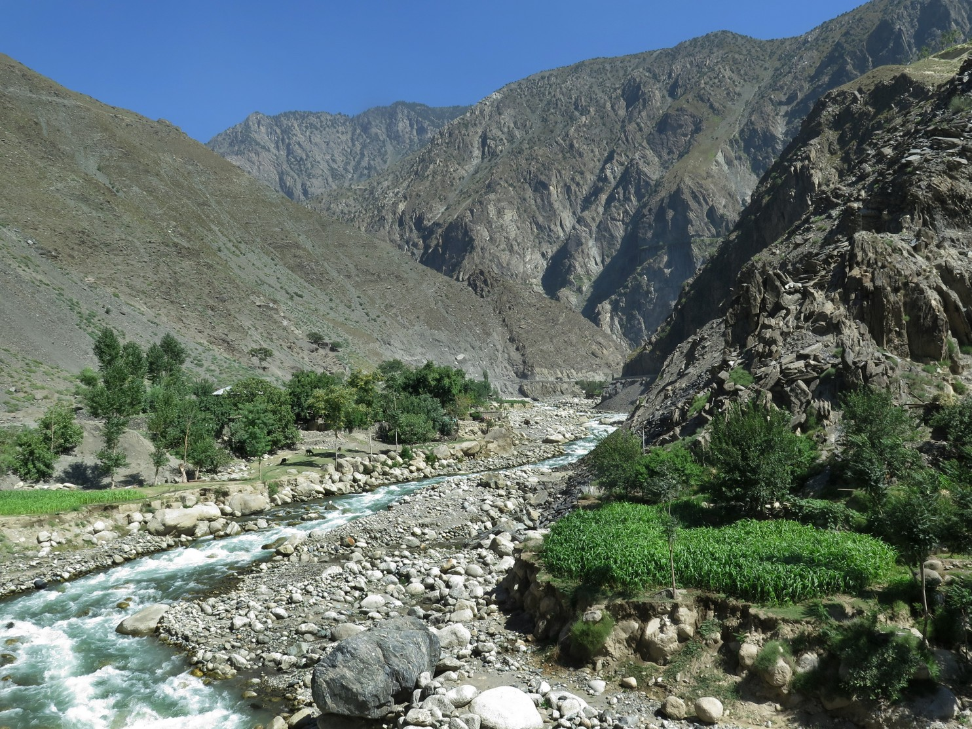
A stream flows through the Kalash Valley in Pakistan’s northwestern Khyber Pakhtunkhwa province. (Tim Craig/The Washington Post)
KALASH VALLEY, Pakistan — Hidden up in the mountains near Pakistan’s border with Afghanistan, the Kalash tribe loves homemade wine and whiskey, dances for days at colorful festivals, and practices a religion that holds that God has spirits and messengers who speak through nature.
Long before the campaign of GOP presidential nominee Donald Trump, the villagers fretted over whether they needed walls or do-not-enter lists to protect them from their more-conservative Muslim neighbors — ultimately deciding that the towering heights of the Hindu Kush would protect them.
But over the past century, Muslims from modern-day Pakistan and Afghanistan began moving in. Now villagers say their Kalash culture and religion are threatened by forced conversions, robberies and assaults.
“We are scared,” said Yasir Kalash, the manager of a hotel here in Pakistan’s northwestern Khyber Pakhtunkhwa province. “They capture our lands, our pastures and our forests, and sometimes take our goats and women. . . . We are afraid in the next few years we will be finished.”
Though the area is called the Kalash Valley, Kalash settlers actually live in three separate valleys that make up an eastern prong of Pakistan’s 1,000-square-mile Chitral Valley.
The Kalash religion was once widespread in Central Asia, but the 4,200 villagers who live here in the Chitral Valley make up the last known Kalash settlement in the world. And now those villages are yet another test of Muslimdominated Pakistan’s tolerance for minorities and cultural diversity.
The Kalash tribe is so fearful of being overrun that its members are considering packing up their children and goats and embarking on a modern-day pilgrimage in search of a new country.
“The younger generation think they cannot live here anymore,” said Zahim Kalash, 34.
In June, a two-day riot erupted on this plateau after Kalash villagers said a 15-year-old girl was tricked into converting to Islam. Last month, two Kalash goatherds were killed in a mountain pasture, the latest in a series of attacks on the tribe. And heated arguments are erupting over practices as simple as using the local spring water.
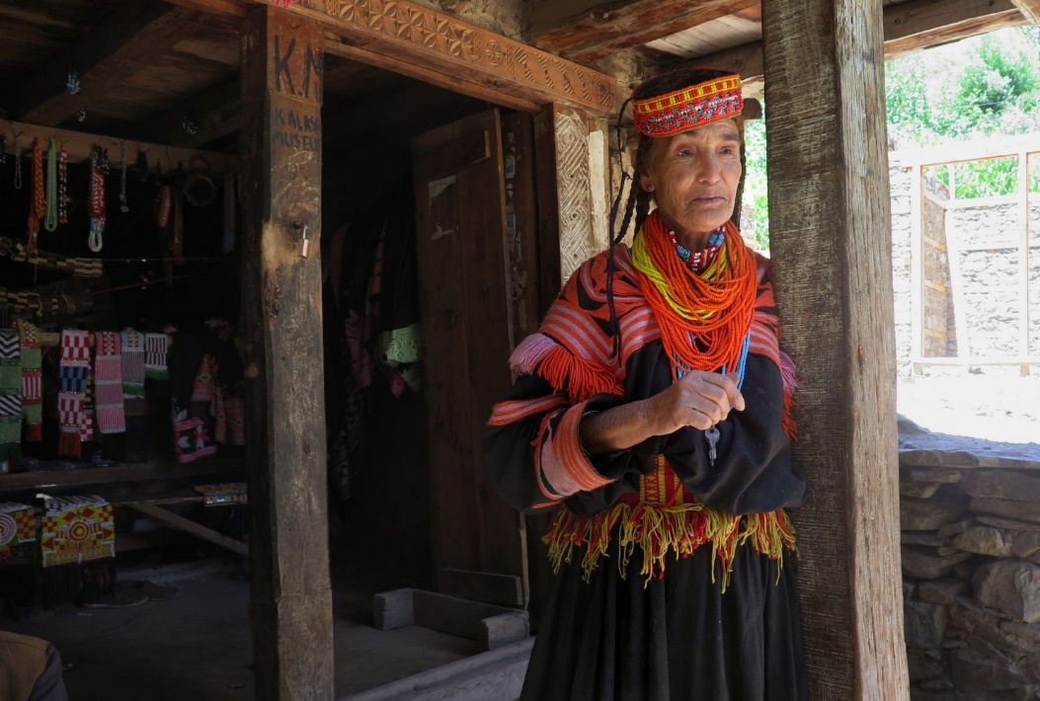
Kalash women and girls wear colorful clothes, make purses and jewelry, and tend to crops in the fields of the Kalash Valley. (Tim Craig/The Washington Post)
Figure 1 Kalash women and girls wear colorful clothes, make purses and jewelry, and tend to crops in the fields of the Kalash Valley. (Tim Craig/The Washington Post)
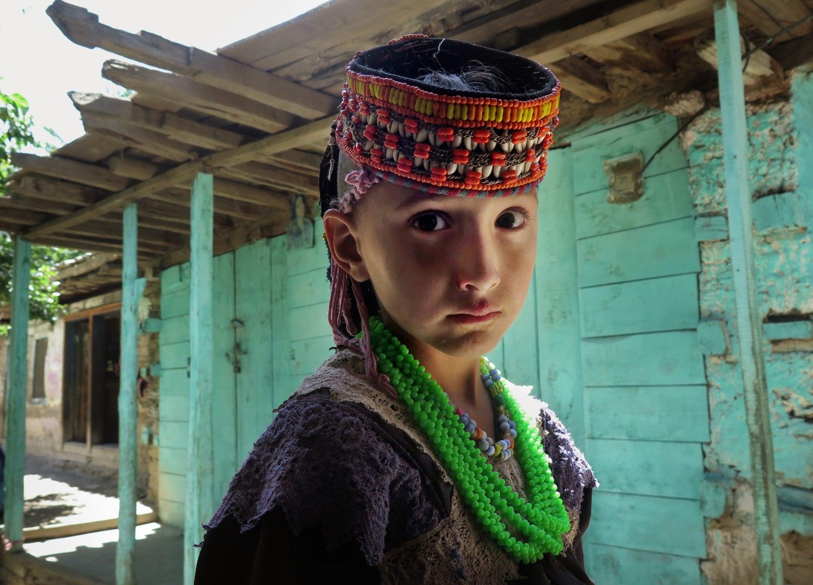
A girl in the village of Bumberet in the Kalash Valley. In June, a two-day riot erupted after Kalash villagers said a 15-year-old girl was tricked into converting to Islam. (Tim Craig/The Washington Post)
“According to our traditions, we consider all the springs to be holy,” said Imran Kabir, who lives in the valley and acts as an unofficial spokesman for the tribe. “We don’t allow anyone to wash clothes or take baths in the springs.”
Last month, several of their Muslim neighbors started doing just that — bathing and washing clothes in the cool, emerald waters that flow from the nearby heights.
“We said, ‘Please don’t do that. People drink from those springs,’ ” Kabir said. “They said, ‘You people are stupid.’ ” And then a scuffle broke out.
The Kalash villages are accessible only by one-lane jeep trails, and residents live in wood-and-mud houses that contain few furnishings except for cots. They eat mostly what they can produce, including hundreds of pounds of butter each year.
The Kalash believe in one god with several messengers. To communicate with them, the tribe erects altars where worshipers offer sacrifices, usually goats.
Some scholars say the Kalash religion originated during Alexander the Great’s conquest of South Asia around 300 B.C. But other scholars and villagers are skeptical, noting that neither the tribe’s written history nor its oral traditions, including song and poetry, include any reference to Alexander.
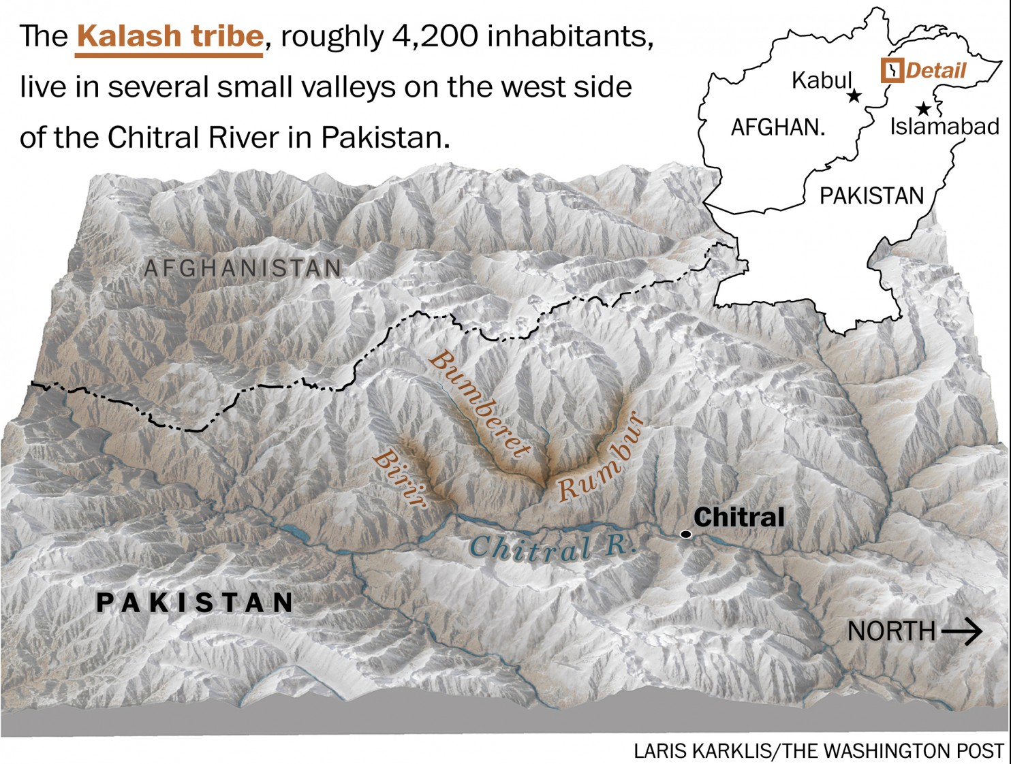
The Kalash religion at one time flourished in the Hindu Kush region. Over the centuries, however, armies and members of competing faiths moved in, and many Kalash were converted. Others fled into the mountain passes, largely left alone when the area was a western frontier of British colonial India.
After Pakistan became a country in 1947, Muslim families began moving into the Kalash Valley, drawn by the crisp climate, undisturbed forests and rich grazing lands.
Salamat Khan, who does not know his age but estimates it to be at least 75, said that for much of his life, the Kalash and their new neighbors lived in relative harmony.
But he and other villagers said the mood has changed over the past decade as a less-tolerant form of Islam began taking hold here.
Traveling Islamic scholars are increasingly showing up in the valley, and after each visit, villagers say, their Muslim neighbors appear less tolerant.
“They will say, ‘Why do you people make wine?’ ” recalled Yasir Kalash. “We make wine because it’s our culture. We use wine in our rituals, we use wine to cook, and we use wine because, in our mind, wine is purification.”
In June, according to police and local officials, a 15-year-old girl named Rina wandered away from home and ended up at a local Islamic seminary.
After a few hours, the cleric declared that Rina had converted to Islam. She later returned to her village, saying she had not intended to convert.
But angry Muslim villagers began pelting Kalash villagers with bricks and stones, arguing that a conversion to Islam cannot be undone. A judge agreed, effectively severing ties between the girl and her parents.
“The conversion rate is very high, and we are afraid if this goes on, our culture will be finished within the next few years,” Yasir Kalash said.
[Afghan Taliban opens door for quake aid, but clashes raise security concerns]
Kalash villagers also are fearful of violent attacks, including raids by Taliban militants.
Zabir Shah, 26, a Kalash villager, said that two years ago, Taliban militants from Afghanistan sneaked into Bumberet, the unofficial capital of the valley, and stabbed a 15-year-old boy to death.
“I saw 25 Taliban, from a distance, surrounding the guy and killing him,” Shah said. “There can be no reason for them to kill him except that he was a non-Muslim.”
Villagers say the recent killing of two Kalash goatherds underscores the threats to the tribe’s way of life.
“If we cannot take our goats high up in the pasture, then our culture cannot survive,” said one Kalash villager, who spoke on the condition of anonymity because he feared for his safety. “The goats are part of [our] religion, and we sacrifice our goats, and down in the valley there is not enough grazing land.”
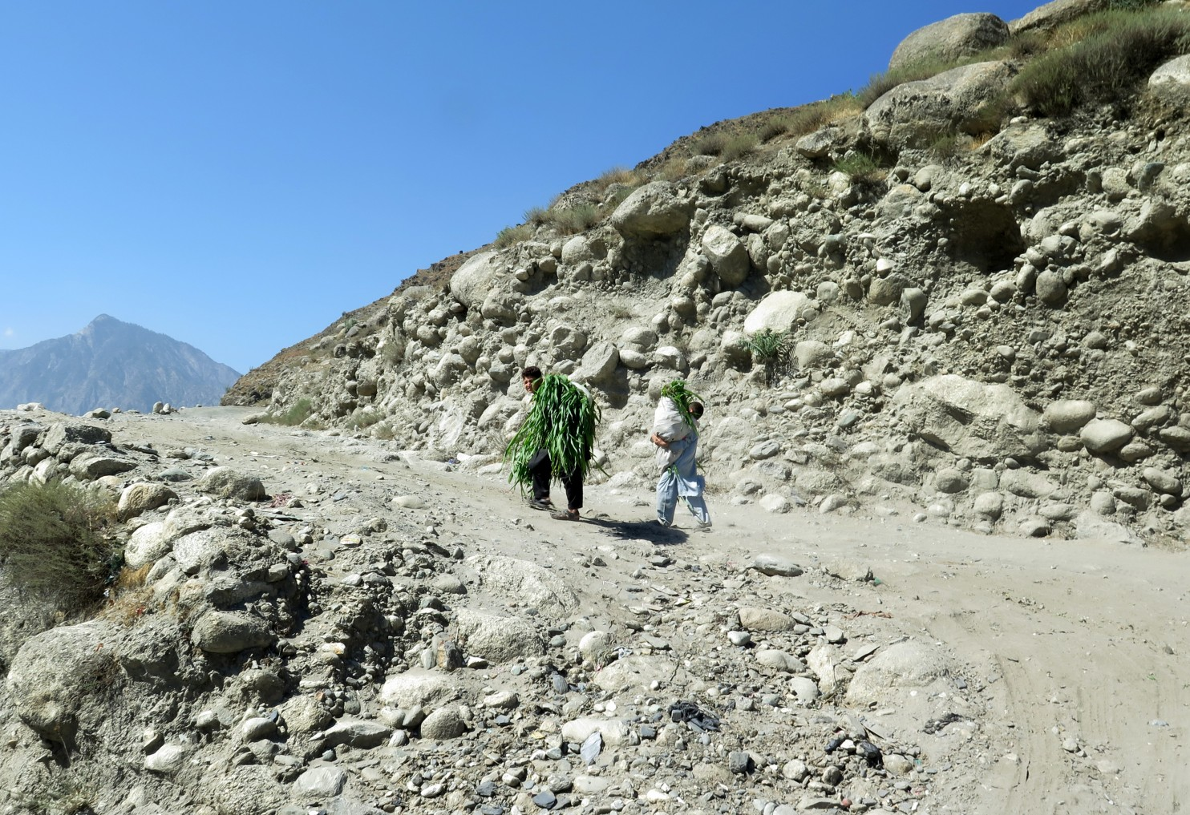
A young man carries freshly cut hay. (Tim Craig/The Washington Post)
Kalash men use goat blood in religious cleansing rituals.
Not everyone believes tensions are rising between the Kalash and their neighbors.
Qimat Shah, 24, a local Muslim man who spends his day making flatbread in a wood-fired oven, noted that young Muslim and Kalash villagers go to school together. He said that whatever problems exist stem from a lack of education among village elders.
“We are people from both religions living together,” Shah said.
But Michael Javed, chairman of the Karachi-based Pakistan Minorities Front, said the problems facing the Kalash community are a subset of the intolerance that afflicts minority groups throughout Pakistan.
Thousands of Christians, Hindus, Sikhs, Buddhists and non-Sunni Muslims have fled the country, fearing persecution or state-sponsored policies, including harsh laws on blasphemy.
“No minorities in this country are safe,” said Javed.
What makes the Kalash community especially frightened is a feeling of being “isolated and alone,” Yasir Kalash said.
He said Christians can turn to the Vatican or the West for support, while Hindus can look to India, and Shiite Muslims can seek some protection from Iran. Kalash villagers, he added, feel as if no other country cares about them.
“We request to the world, preserve us,” he said.

