Flu-stricken pope issues 'catalog of virtues' to Curia
By NICOLE WINFIELD
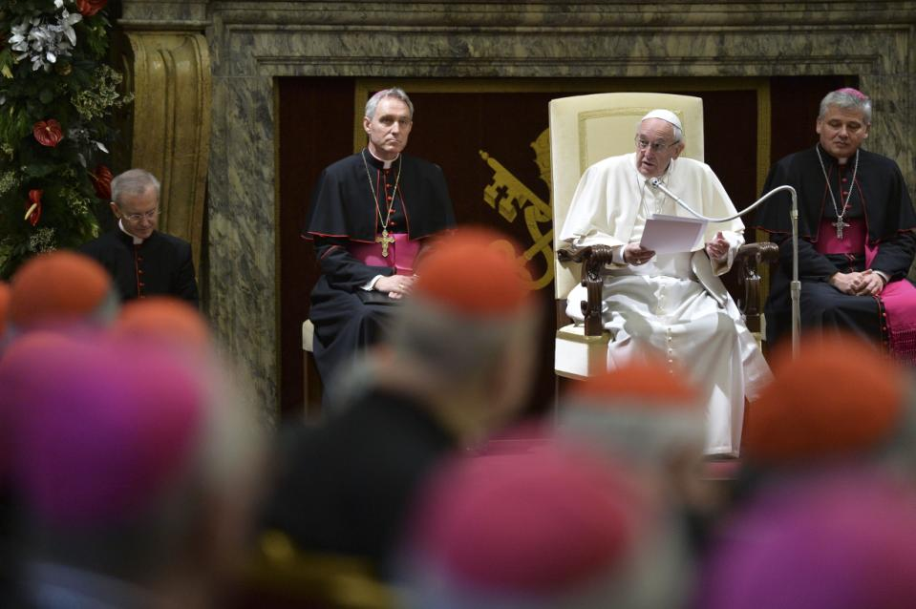
Figure 1 Pope Francis speaks during the annual Christmas greetings to the Vatican bureaucracy in the Clementina Hall, at the Vatican, Monday, Dec. 21, 2015. Francis has issued a Christmas-time "catalogue of virtues" for his closest collaborators to follow after having excoriated them last year for a host of sins that he said were compromising the Catholic Church's work.
VATICAN CITY (AP) — Pope Francis urged Vatican bureaucrats on Monday to show more honesty, humility and sobriety as he issued a Christmas-time "catalog of virtues" for them to follow after having excoriated them last year for a host of sins.
A flu-stricken Francis referred repeatedly to scandals that have been convulsing the Vatican in recent months during his annual Christmas greeting to the Vatican administration, showing he was keenly aware of the impact they were having in the broader Catholic world.
At the start of his speech to the cardinals and bishops who run the Holy See, Francis joked that after last year's public diagnosis of the "15 ailments of the Curia" he should have come up this year with the "Curial antibiotics" to treat them.
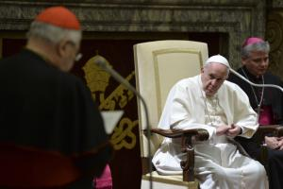
In a way he did, issuing a list of virtues he said should guide their work, including honesty, sobriety, respect and humility. While the speech was more encouraging than last year's astonishing dressing down, it nevertheless implied that problems remained.
He reminded the prelates, for instance, they shouldn't take bribes. He said an honest person "does not act virtuously only when he or she is being watched; honest persons have no fear of being caught since they never betray the trust of others."
Figure 2 Pope Francis attends during the annual Christmas greetings to the Vatican bureaucracy in the Clementina Hall, at the Vatican, Monday, Dec. 21, 2015. Francis has issued a Christmas-time "catalogue of virtues" for his closest collaborators to follow after having excoriated them last year for a host of sins that he said were compromising the Catholic Church's work
It was at the usually jovial affair last year that Francis accused the cardinals and bishops of the Vatican bureaucracy of using their careers to grab power and wealth, of living "hypocritical" double lives and of forgetting — due to "spiritual Alzheimer's" — that they're supposed to be joyful men of God.

The past year has seen two blockbuster books based on leaked internal documents detailing waste and mismanagement in parts of the Vatican, the greed of some cardinals and bishops and Francis' efforts to clean it up. A high-ranking Vatican monsignor is among five people on trial over the leaks.
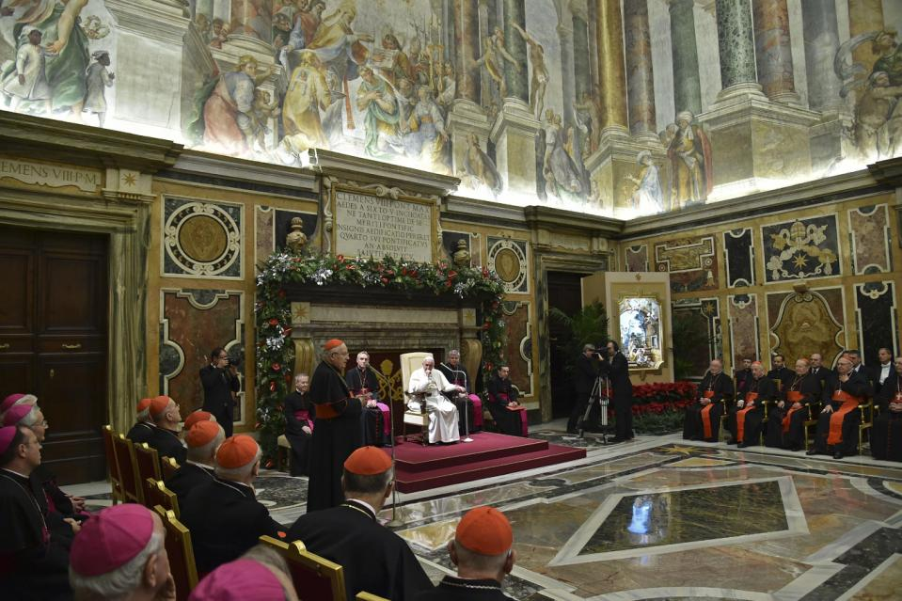One of the most egregious scandals that emerged was that the Vatican-owned Bambino Gesu pediatric hospital paid 200,000 euros to renovate the apartment of the former Vatican No. 2. This past weekend, the cardinal involved again insisted he knew nothing of the payment but pledged a 150,000 euro donation to the hospital to make amends.
The 79-year-old Francis delivered his remarks sitting down, telling the sober-faced prelates gathered in the marbled Clementine Hall that had been suffering from the flu for the past several days "and I don't feel very strong."
He said the same thing to the rank-and-file Vatican employees and their families who gathered for their own brief audience with the pope. In that greeting, Francis asked forgiveness "for the scandals in the Vatican" and urged them to pray "for the people involved, so that those who made a mistake can mend their ways and find the right path."
In his speech to the Curia, Francis highlighted the key themes he wants them to follow in the coming year.
Francis reminded the cardinals that respectful people "always try to show genuine respect for others, for their own work, for their superiors and subordinates, for dossiers and papers, for confidentiality and privacy, who can listen carefully and speak politely."
He also noted Curial officials are called upon to be examples for the entire church, "avoiding scandals, which harm souls and impair the credibility of our witness."
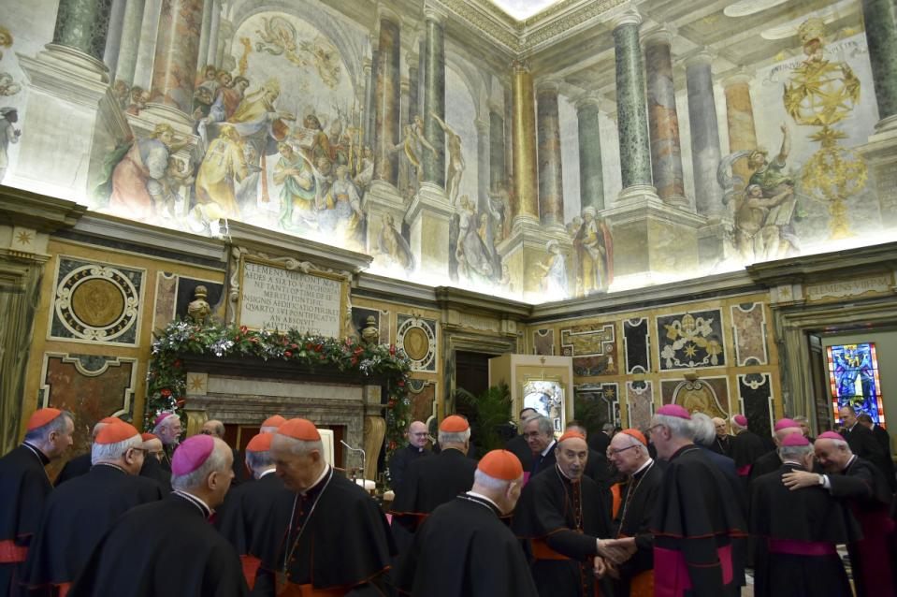
Figure 3 Prelates exchange greetings during the annual Christmas greetings from Pope Francis to the Vatican bureaucracy in the Clementina Hall, at the Vatican, Monday, Dec. 21, 2015. Francis has issued a Christmas-time "catalogue of virtues" for his closest collaborators to follow after having excoriated them last year for a host of sins that he said were compromising the Catholic Church's work.

