40 Sentences that are Important to Tell Your Kids!
Much of our childhood memories are of small and important moments, that we have remembered not because of what actually happened but because of how they made us feel. Some of them made us angry, sad or lonely, while others aroused hope, laughter, and optimism. As adults, we often forget the weight words hold for children.
Words of encouragement and compliments have a lasting effect on how our children see the world, and some of the simplest and shortest expressions can make them feel better and help them succeed during difficult times. Whether you want to tell them how well they did in the soccer game or encourage them to overcome failures, these are the 40 compliments you should not forget to tell them. For us, these are simple words, but for kids, they’ll be remembered always.

1. You make me proud of you every day.
2. Your ideas are great.
3. I’m happy to be your parent.
4. You don’t have to be perfect to be a great person.
5. It is important for me to hear what you think about the subject.
6. I believe in you.
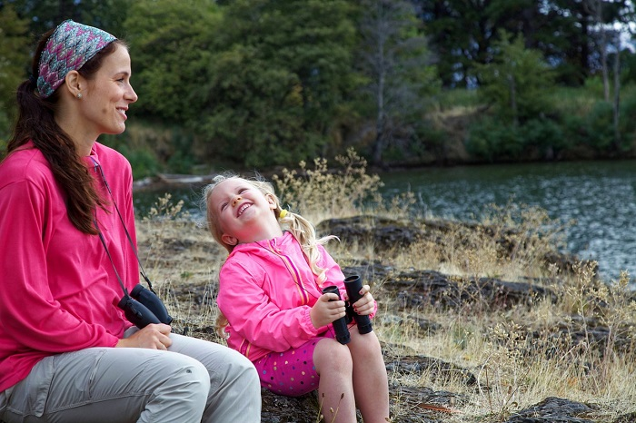
7. I believe in your abilities
8. Our family wouldn't be the same without you.
9. I know you did your best.
10. I accept you for who you are.
11. Even if you didn't succeed, you were on the right path.
12. You are very helpful to me.
13. You’ve made me happy today.
14. I love your creative way of thinking.
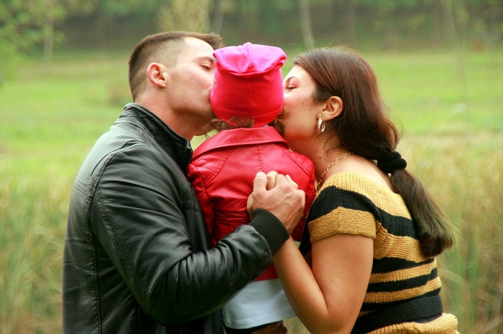

15. It's fun to be by your side.
16. Your ideas are great, never be afraid to voice them!
17. You can do anything you put your mind to.
18. I can’t wait for us to spend time together.
19. Your stories really interest me.
20. I like to see the world through your eyes.
21. Never stop being so curious.
22. I appreciate your ability to make decisions for yourself.
23. That was a great question.
24. Your friends are lucky to know you.

25. That was a smart choice.
26. It makes me happy to see you happy.
27. Being your parent is my favorite job.
28. I learn new things from you every day
29. You make me a better person.
30. I'm glad you're here
31. I understand you even if I disagree with you.
32. I feel that you’re maturing every day.
33. That was very brave of you
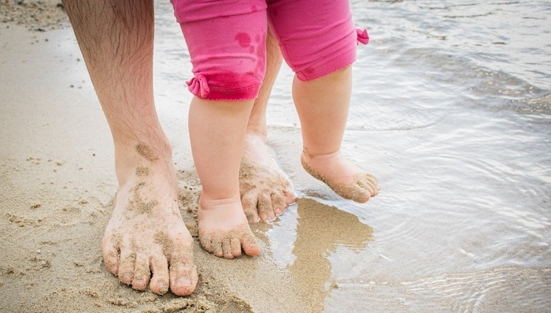

..
34. The way you asked for forgiveness makes me realize how mature you are.
35. I am proud of you for realizing that you were wrong.
36. I knew you would succeed.
37. I am very happy that you decided to try again.
38. it’s always important for me to listen to you.
39. Your existence fills my heart.
40. Remember that I'll never stop loving you.

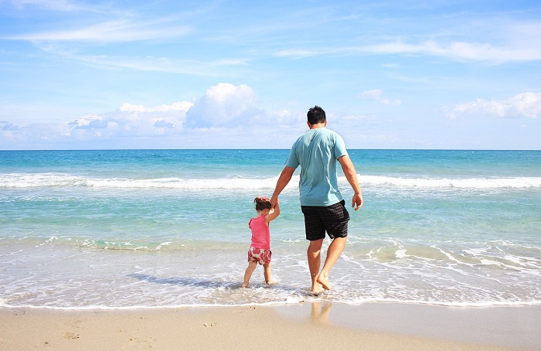

Remember: everything else in life, you have to know when and how to say these sentences and compliments, but remember to say them and don't assume that your children know how we feel about them. The greatest advantage of using these compliments is that they will help your children and grandchildren understand exactly what you think and feel, improve your relationship with them, and help them cope with any challenges they face.

