Yet more global heat records fall in August
WASHINGTON (AP) — The globe smashed more heat records last month, including Earth's hottest August and summer, federal meteorologists said Thursday.
May, June and August all set global heat records this year. Meteorologists at the National Oceanic and Atmospheric Administration said the average world temperature in August was 61.36 degrees Fahrenheit (16.35 degrees Celsius), breaking a record set in 1998.
Scientists at NASA, who calculate global temperature a tad differently, also found August as the hottest on record.
August was especially hot in the Pacific and Indian oceans and Africa, but cooler in parts of the United States, Europe and Australia. The world's oceans in August effectively tied June for the seas' all-time heat record.
The United States ranked barely above its 20th century average in August, with a cool East balancing out a warm West. For the U.S., it was the coolest August and summer since 2009.
National Oceanic and Atmospheric Administration records go back to 1880.
But it's more than just one month. It was the warmest meteorological summer — June, July and August — on record for the globe, again beating out 1998.
This year so far is the globe's third warmest on record.
"It's not a done deal, but we are increasingly moving" toward breaking the hottest year record set in 2010, said NOAA climate monitoring chief Derek Arndt. "This is the outcome of warming over the long-term."
August was the 354th consecutive month that global temperatures were above the 20th century average. The last time the world set a monthly cold record was in 1916, but all monthly heat records have been set since 1997.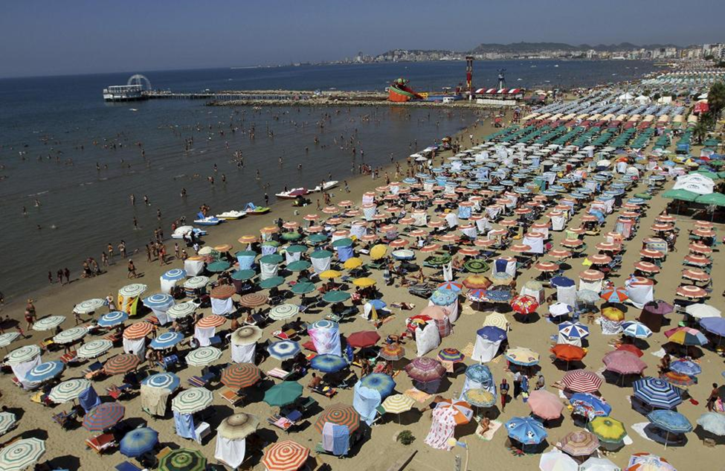
Figure 1 A general view of the crowded beach is seen in the city of Durres, August 13, 2014. Albania has been gripped by hot weather with temperatures reaching 100 degrees Fahrenheit. (REUTERS/Arben Celi)
Meteorologists are predicting a weak El Nino weather event will occur— a warming of the central Pacific that changes climate worldwide. If that's the case, it may add to the chances of breaking 2010's record for the hottest year, said NOAA climate scientist Jake Crouch.
But because it is likely to be a weak El Nino it is unlikely to bust the drought in California and Nevada, said Alan Haynes, a NOAA hydrologist in the California-Nevada River forecast center.
___
Online:
NOAA August state of the climate http://www.ncdc.noaa.gov/sotc/

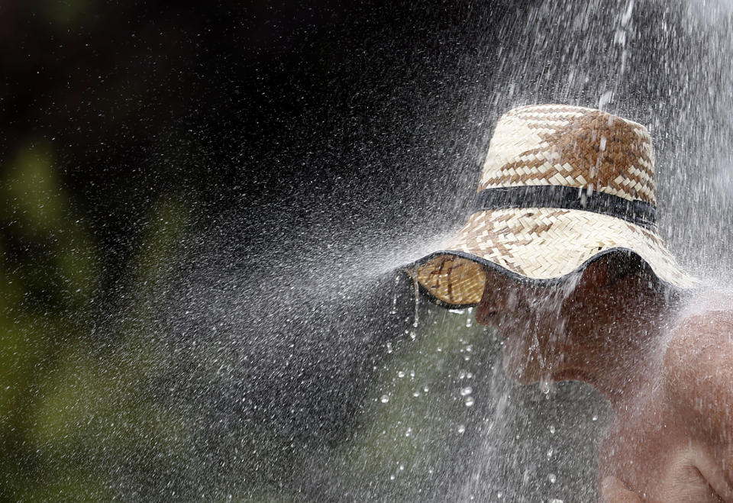
Figure 2A man takes a cold shower in order to refresh herself at Ada Ciganlija lake in Belgrade, Serbia, Monday, July 21, 2014. Hot weather has set in with temperatures rising up to 35 Celsius (95 Fahrenheit) in Belgrade. (AP Photo/Darko Vojinovic)

Scenes From the California Drought
An unprecedented 82 percent of California is in an “extreme drought,” according to the latest U.S. Drought Monitor report released last week. Of that, 58 percent of the state is in an “exceptional drought” — the driest conditions possible. Record-low rainfall has sent rivers, lakes and water reservoirs to their lowest levels in decades—threatening the water supply of many cities. The unusually dry conditions have increased the risk of wildfires, which have already ravaged parts of the state — most recently an area near Yosemite National Park. But the drought’s biggest victim could be California’s Central Valley, the source of fully half the nation’s fruits and vegetables, where roughly 500,000 acres of farmland have been left barren this season because of a lack of water. In three of the hardest-hit counties — Fresno, Kern and Tulare — farmers are worried the drought could drive them out of business. (Photos by Holly Bailey/Yahoo News)

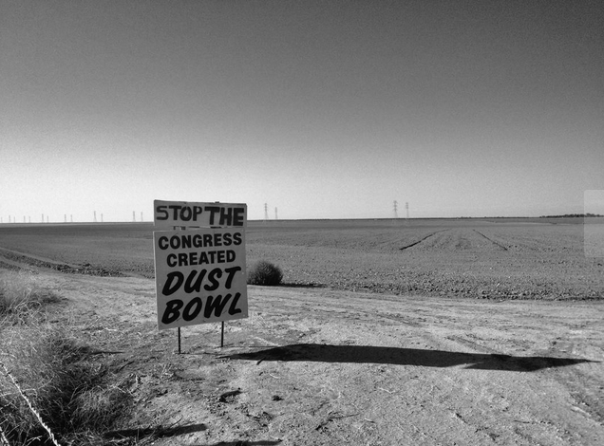
Figure 3 A sign alongside barren farmland outside Mendota, Calif. (Holly Bailey/Yahoo News)

