Pink snow - pretty, but a troubling sign of a melting Arctic
Susanna Heller,Susanna Heller Thu, Jun 23, 2016 – Yahoo & Huffington Post
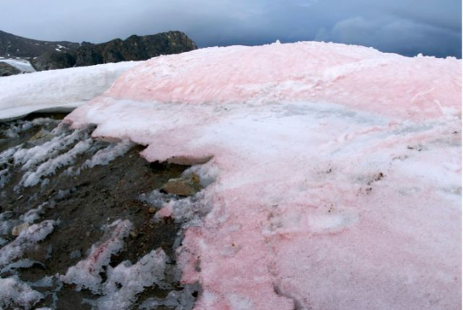
Figure 1 Red-pigmented snow algae in the Arctic. (Liane G. Benning/GFZ)
Pink snow may be aesthetically pleasing, but scientists have found that it is indicative of the rapid pace of global warming.

This snow, which thrives in high-latitude and high-altitude regions, is found in areas comparable to the Arctic, where Chlamydomonas nivalis algae, which is normally green, has a chemical reaction to the UV rays from the sun and takes on a reddish-pink hue.

Scientists have been aware of rose-tinted snow since 1818, but they initially misunderstood its origins, believing it came about as a result of iron deposits left behind by a meteor. However, subsequent findings from the same year suggested that a kind of algae, not extraterrestrial iron, is to blame for the nontraditional hues. More contemporary findings have corroborated this notion.

This pink snow, sometimes referred to as blood or watermelon snow in the Arctic regions, is harmful despite its quirky facade. The algae expedites the melting of the Arctic, which is already happening at a faster rate than expected, due, in part, to global warming, a new study shows.

This study, which is included in the Nature Communications journal and published Wednesday, contains findings based on 40 samples taken from 16 Arctic glaciers in regions like Greenland, Norway and Iceland. It shows that the red algae darkens the snow, causing it to melt at a faster rate because it absorbs more light and heat. This is due to the algae-laden-snow’s low albedo, which relates to a surface’s ability to reflect and absorb light and heat. The lighter a surface, the higher the albedo. White surfaces, like pure snow, have a high albedo and can therefore maintain a cooler temperature. Lower albedo is responsible for accelerating the melting of ice caps and the discomfort you feel when you wear black on a summer day.

The red snow caused the albedo in the arctic regions to decrease by 13 percent and subsequently increased the amount of melted ice and snow, the study found. The biological effects of albedo had not been previously factored into global climate concerns, but scientists are now pushing for their inclusion.

“Our results point out that the ‘bio-albedo’ effect is important and has to be considered in future climate models,” Lutz said in a statement.

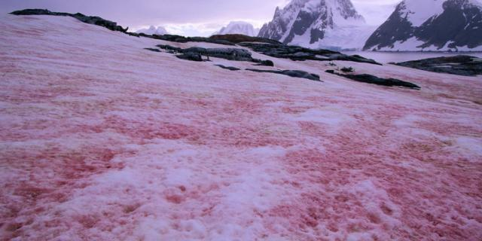
At the present time, scientists are unsure of what kind of long-term ramifications the bio-albedo effect will have on the glacial melting. In the meantime, the scientists are wrestling with concerns that the albedo will contribute to a positive feedback loop, a detrimental cycle in which — hypothetically speaking — algae blooms, snow thaws and the melted ice provide the algae with more fodder to bloom. In any case, the confirmation of the bio-albedo effect sheds light on the fact that global warming’s reach extends to even the smallest organisms.
Figure 2 pink snow looks awesome, but is another climate change indicator

