'Monster' El Nino could usher in decade of more and stronger events
By Luc Cohen
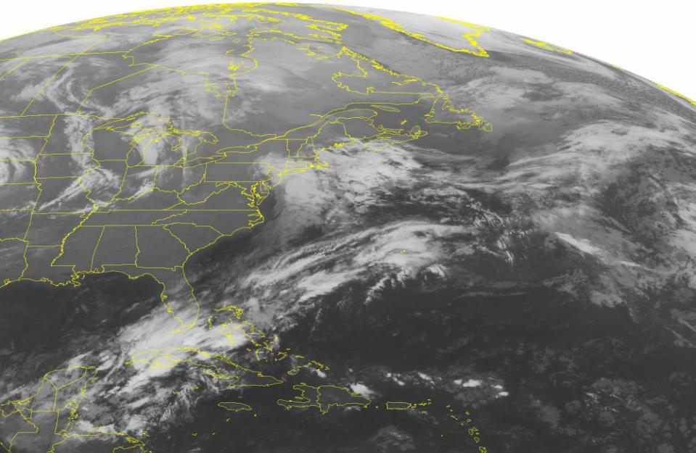
NEW YORK (Reuters) - In Buffalo, it hasn't snowed yet this year. A Duluth, Minnesota, newspaper reported that the temperature was 40 degrees above zero, not below. And in Miami, beachgoers are staying indoors during what's already the third-wettest December in local history. What's going on with the weather?
Figure 1 This NOAA satellite image taken Tuesday, Dec. 8, 2015, at 12:45 a.m. EST shows an area of low pressure developing just to the south of Long Island. This low pressure system will bring some rain and colder temperatures to Long Island and far southern New England. Some light showers will affect the western Great lakes due in part to a trough of low pressure. A stationary front will bring showers to southern Florida while the Mississippi River Valley will see sunny skies under an area of high pressure.
It's the phenomenon called El Nino, which is happening now as ocean water temperatures rise above normal across the central and eastern Pacific, near the equator. Its effects will leave the U.S. Northeast warmer than usual, the Midwest drier, and the West and the South wetter. And scientists have a message for everyone bracing for one of the strongest El Nino events on record: get used to it.
While El Nino oscillates on a more or less yearly cycle, another dynamic in Pacific Ocean water temperatures, known as the Pacific Decadal Oscillation (PDO), has the potential to accelerate global warming and increase the severity of El Nino episodes, scientists said. The last time the PDO was, as it may be now, in a prolonged positive, or "warm" phase, it corresponded with two of the strongest El Ninos on record.
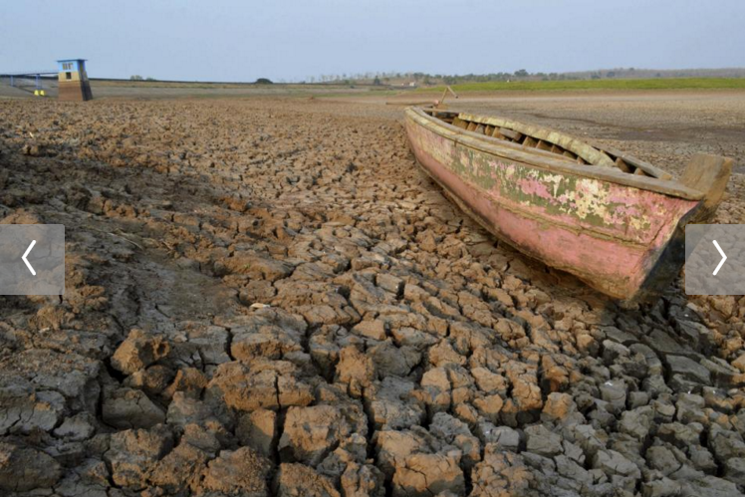
"When you really have a monster El Nino, it could be enough to flip the PDO into a new phase for a decade or so," said William Patzert, a climatologist at NASA's Jet Propulsion Laboratory in California. "Keep your eyeballs peeled because maybe we're in for a decadal shift."
Figure 2 A wooden boat is seen stranded on the dry cracked riverbed of the Dawuhan Dam during drought season in Madiun, Indonesia's East Java province, October 5, 2015 in this picture taken by Antara Foto. Crop failures caused by an El Nino drought presage more pain for Southeast Asia's largest economy, which is already growing at its slowest pace in six years, by squeezing incomes, fanning inflation and pushing more people into poverty. To match story INDONESIA-ELNINO/ Picture taken October 5, 2015.
Previous warm phases have also coincided with increased precipitation on the U.S. West Coast, signaling potential relief for California from a severe drought.
Before January of 2014, the world experienced a 15-year period of mostly negative values for the Pacific oscillation, according to data maintained by Nathan Mantua, an atmospheric scientist at the National Oceanic and Atmospheric Administration's (NOAA) Joint Institute for the Study of the Atmosphere and Oceans.
That period saw only weak or moderate El Nino events. During the 21 years before that, the Pacific oscillation values trended mostly positive, a period that coincided with the 1982-83 and 1997-98 El Nino events, two of the strongest on record.
Now, scientists are beginning to wonder if the 15-year period of relative El Nino calm is coming to a close, marking the start of a warmer, stormier era akin to the 1980s and 90s.
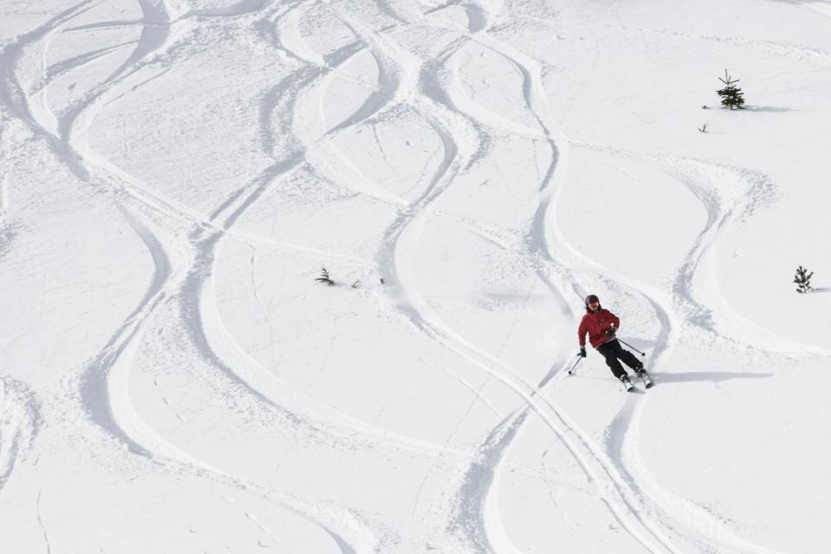
The PDO index has been positive for 22 months through October, the longest such streak since a 26-month positive period between 2002 and 2004. Scientists are not sure if the current streak marks a longer-term turnaround or just a temporary blip like the 2002-2004 streak.
Figure 3 A skier enjoys fresh powder at Squaw Valley in Olympic Valley, California, December 5, 2015. An El Nino is forecasted for California, and regular precipitation has been welcomed after years of drought. Picture taken December 5.
"It's more likely that we'll have a change in phase and we'll remain in positive territory," said Kevin Trenberth of the National Center for Atmospheric Research in Boulder, Colorado, noting that while a decadal shift was far from a guarantee, the odds in favor are approximately 2-to-1.
A WARMER BASE STATE
In many ways, the weather of the 15 years before 2014 has resembled that of the mid-1940s to mid-1970s, the last prolonged period of a negative Pacific oscillation cycle, with drought in the American West and very few El Ninos, Patzert said.
The recent period saw several moderate La Nina events, a counterpart to El Nino defined as cooler than normal sea surface temperatures in the eastern and central tropical Pacific that dumps rain on Australia and Indonesia but leaves the Southwest United States dry, including episodes in 1998-99, 1999-2000, 2007-08 and 2010-11.
The warmer sea surface temperatures in the northern Pacific during the positive PDO phase tend to amplify El Nino's effects, Trenbirth said.
Several scientists said the current El Nino could contribute to more positive PDO conditions at the moment and in the future.
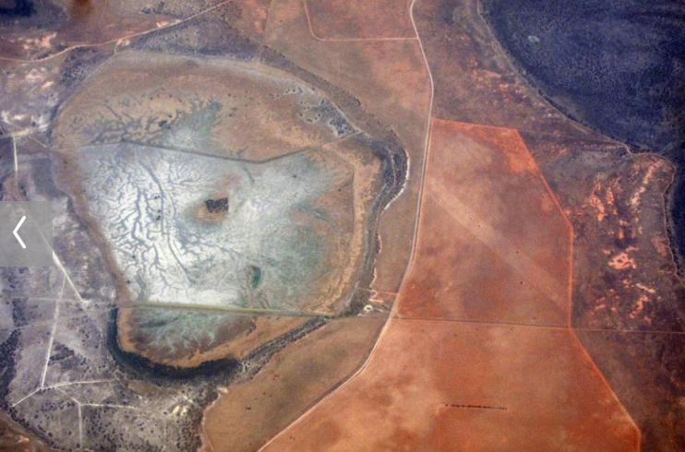
"The key ingredient is the strong El Nino," said NASA's Veronica Nieves, noting that strong episodes have historically triggered decadal shifts. She has submitted a paper to an academic journal noting arguing that the Pacific may be in store for another 20 years or more of warmer sea surface temperatures.
Figure 4 A salt-affected water catchment area can be seen amongst drought affected farmland in south Australia, November 26, 2015. This year will be the hottest on record and 2016 could be even hotter due to the El Niño weather pattern, the World MeteorologicalOrganization said on Wednesday, warning that inaction on climate change could see global average temperatures rise by 6 degrees Celsius or more. Global ocean temperatures were unprecedented during the period, and several land areas, including the continental United States, Australia, Europe, South America and Russia, broke temperature records by large margins.
To be sure, the two-year period of positive Pacific oscillation values that happened from 2002 to 2004, which saw weak and moderate El Ninos, is still fresh in scientists' minds, preventing them from being certain that the world is truly on the cusp of a decadal shift.
But so far in these past two years, the values have been more sharply positive than the 2002-04 streak. This has implications beyond El Nino: the recent decade has been referred to as a 'hiatus' in global warming, with the negative PDO value seen as limiting global temperature gains.
"If [PDO] transitions back into positive, we'd see a resumption in these more rapid rates of global warming," said Gerald Meehl, a climate scientist at the National Center for Atmospheric Research in Boulder, Colorado. "Having that shift in the background base state means that the peaks of the El Nino are going to be higher."
(Reporting by Luc Cohen, editing by John Pickering)

