Greenland’s melting is ‘feeding on itself,’ scientists say
By Chris Mooney March 3
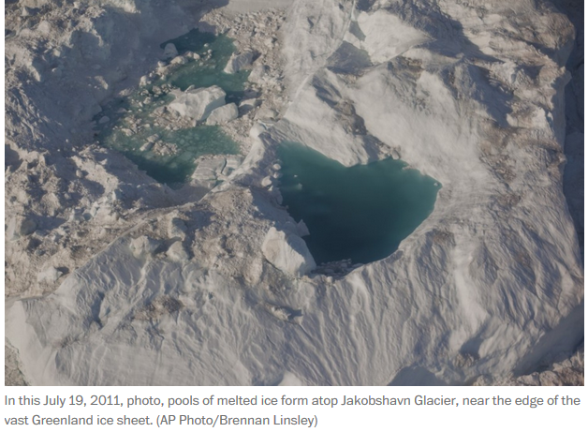
In this July 19, 2011, photo, pools of melted ice form atop Jakobshavn Glacier, near the edge of the vast Greenland ice sheet. (AP Photo/Brennan Linsley)
A new scientific study released Thursday has delivered yet another burst of bad news about Greenland — the vast northern ice sheet that contains 20 feet of potential sea level rise. The ice sheet is “darkening,” or losing its ability to reflect both visible and invisible radiation, as it melts more and more, the research finds. That means it’s absorbing more of the sun’s energy — which then drives further melting.
“I call it melting cannibalism. You have melting feeding on itself,” says Marco Tedesco, the lead author of the study and a researcher with Columbia University’s Lamont Doherty Earth Observatory. The research was published in The Cryosphere by Tedesco and five other authors from U.S. and Belgian universities.
Scientists have long feared that when it comes to the Greenland ice sheet’s melt, there are a number of so-called “positive feedbacks,” or self-amplifying processes, that could make it worse. For instance, one of the best known of these involves simple elevation, a crucial feature for an ice sheet that is well over a mile high into the atmosphere in places.
If the ice sheet melts, it also slumps and becomes lower in the atmosphere. But air temperatures are warmer lower in the atmosphere. So the ice sheet melts more. And so on, and so on.
In the new study, however, researchers examined a different so-called feedback — this one involving a property called the ice sheet’s “albedo,” or simply its overall reflectivity.
Bright white snow, falling atop the ice sheet, reflects light away, preventing it from being absorbed and thus blocking its heat energy from melting ice. However, there are many different hues and properties of ice and snow (and water), not all of which are equally reflective of either visible or non-visible radiation. (The “darkening” in question here refers both to changes that we can all see with our eyes, and also important changes that we can’t see).
For instance, melting and refreezing increases the grain size of particles of snow or ice, and near-infrared radiation then has a tougher time bouncing away, as opposed to being absorbed. Similarly, pools of standing water on the ice sheet surface also absorb more solar radiation, and warm up. And once melting gets through snow layers and into what researchers call “bare ice,” that too is darker than snow. “This bare ice is very dark, it melts much faster,” says Tedesco.
But there’s another factor, the study suggests, that prior research has omitted. This is that the more melting there is due to rising Arctic air temperatures or less cloudy conditions, the more “impurities” in the ice sheet, like particles of atmospheric dust, get exposed to the surface. And these, too, lessen the ice sheet’s reflectivity.
After all, the Greenland ice sheet contains not only eons worth of snow, but also long records of atmospheric dust or even meteorite residue which have blown onto it from the atmosphere over many thousands of years, and thus pepper the ice throughout its many layers.
“It’s a dirty atmosphere, it blows everywhere, it also blows on the ice sheet,” says Tedesco.
In the new study, the researchers confirmed that since 1996, Greenland’s ice sheet has been getting subtly darker and losing its albedo. This can be measured from satellites, but the question is why it is happening — because if darkening is a trend, then ice loss should follow, as should, ultimately, sea level rise.
And the research finds that the impurities in the ice sheet are not only playing a key role, but also are probably involved in a positive feedback.
“You have impurities stored in the snowpack, and as you start melting in the snow, part of the impurities will be flushed away, and the other part will be basically standing on the surface,” Tedesco explains. “Snow acts really like a filter. So the idea here is, the more you melt the snowpack, the more you will release these impurities on the surface of the snow, or the ice.”
The study postulates that this is indeed a positive feedback, saying that these impurities “have a positive feedback on albedo decline through increased melting, grain growth and darkening.”
Another intriguing factor could also be contributing to the ice sheet’s darkening, although the paper calls this one “essentially un-studied.” The idea is that as the ice melts and pools of water form on its surface, it becomes a more hospitable habitat for tiny algae. They, too, do a poorer job of reflecting sunlight back to space than white snow. So again, the ice sheet darkens.
However, the paper rejects another prominent idea for what could be behind Greenland’s darkening — namely, that worsening wildfires around the globe are pouring more dark soot particles in the air, and that some of these are falling on Greenland at an increased rate. The study finds “no statistically significant increase” in black carbon from fires in northern regions, and in a region where they are increasing, temperate North America, that the change is probably too small to matter much, it says.
The idea that fires are depositing soot that is darkening Greenland has been advanced by Jason Box, a prominent Greenland researcher who runs the “Dark Snow” project. The project describes itself as seeking to “quantify the distant snow/ice melting impact of industrial and wildfire black carbon soot; mineral dust; and microbes, each melt factor having some human driven enhancement.”
Box said by email that he was traveling and unavailable to comment on the new study. But he recently blogged in response to another study challenging the contribution of wildfires, “as to the role of black carbon in Greenland’s albedo decline, I would say there is more to the story…Stay tuned.”
But as that debate continues, the current study projects that with or without fires, “continued darkening” of Greenland is expected — “driven solely by a warming climate.”
Chris Mooney reports on science and the environment.

