Pope Francis’ speech to United Nations
BY Larisa Epatko September 25, 2015
Mr President,
Ladies and Gentlemen,
Thank you for your kind words. Once again, following a tradition by which I feel honored, the Secretary General of the United Nations has invited the Pope to address this distinguished assembly of nations. In my own name, and that of the entire Catholic community, I wish to express to you, Mr. Ban Ki-moon, my heartfelt gratitude.
I greet the Heads of State and Heads of Government present, as well as the ambassadors, diplomats and political and technical officials accompanying them, the personnel of the United Nations engaged in this 70th Session of the General Assembly, the personnel of the various programs and agencies of the United Nations family, and all those who, in one way or another, take part in this meeting. Through you, I also greet the citizens of all the nations represented in this hall. I thank you, each and all, for your efforts in the service of mankind.
This is the fifth time that a Pope has visited the United Nations. I follow in the footsteps of my predecessors Paul VI, in1965, John Paul II, in 1979 and 1995, and my most recent predecessor, now Pope Emeritus Benedict XVI, in 2008. All of them expressed their great esteem for the Organization, which they considered the appropriate juridical and political response to this present moment of history, marked by our technical ability to overcome distances and frontiers and, apparently, to overcome all natural limits to the exercise of power. An essential response, inasmuch as technological power, in the hands of nationalistic or falsely universalist ideologies, is capable of perpetrating tremendous atrocities. I can only reiterate the appreciation expressed by my predecessors, in reaffirming the importance which the Catholic Church attaches to this Institution and the hope which she places in its activities.
The United Nations is presently celebrating its 70th anniversary. The history of this organized community of states is one of important common achievements over a period of unusually fast-paced changes. Without claiming to be exhaustive, we can mention the codification and development of international law, the establishment of international norms regarding human rights, advances in humanitarian law, the resolution of numerous conflicts, operations of peace-keeping and reconciliation, and any number of other accomplishments in every area of international activity and endeavor. All these achievements are lights which help to dispel the darkness of the disorder caused by unrestrained ambitions and collective forms of selfishness. Certainly, many grave problems remain to be resolved, yet it is clear that, without all those interventions on the international level, mankind would not have been able to survive the unchecked use of its own possibilities. Every one of these political, juridical and technical advances is a path towards attaining the ideal of human fraternity and a means for its greater realization.
For this reason I pay homage to all those men and women whose loyalty and self-sacrifice have benefitted humanity as a whole in these past seventy years. In particular, I would recall today those who gave their lives for peace and reconciliation among peoples, from Dag Hammarskjöld to the many United Nations officials at every level who have been killed in the course of humanitarian missions, and missions of peace and reconciliation.
Beyond these achievements, the experience of the past 70 years has made it clear that reform and adaptation to the times is always necessary in the pursuit of the ultimate goal of granting all countries, without exception, a share in, and a genuine and equitable influence on, decision-making processes. The need for greater equity is especially true in the case of those bodies with effective executive capability, such as the Security Council, the Financial Agencies and the groups or mechanisms specifically created to deal with economic crises. This will help limit every kind of abuse or usury, especially where developing countries are concerned. The International Financial Agencies are should care for the sustainable development of countries and should ensure that they are not subjected to oppressive lending systems which, far from promoting progress, subject people to mechanisms which generate greater poverty, exclusion and dependence.
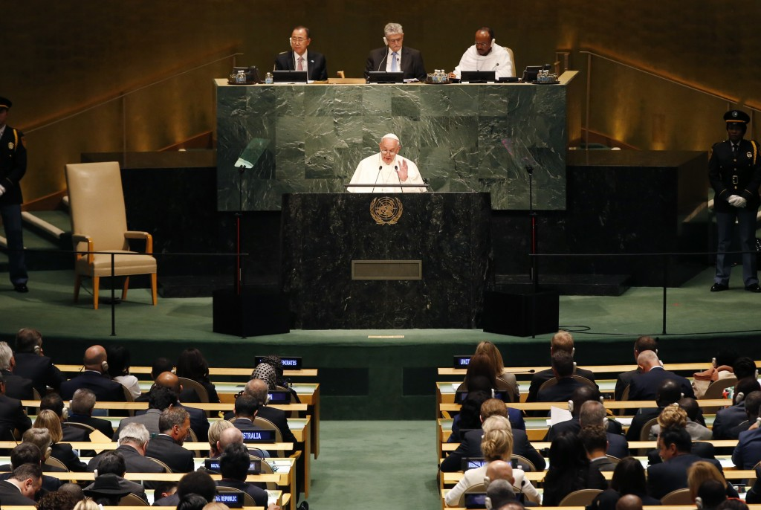
Pope Francis addresses a plenary meeting of the United Nations Sustainable Development Summit 2015 at United Nations headquarters in Manhattan, New York, Sept. 25. Photo by Mike Segar/Reuters
The work of the United Nations, according to the principles set forth in the Preamble and the first Articles of its founding Charter, can be seen as the development and promotion of the rule of law, based on the realization that justice is an essential condition for achieving the ideal of universal fraternity. In this context, it is helpful to recall that the limitation of power is an idea implicit in the concept of law itself. To give to each his own, to cite the classic definition of justice, means that no human individual or group can consider itself absolute, permitted to bypass the dignity and the rights of other individuals or their social groupings.
The effective distribution of power (political, economic, defense-related, technological, etc.) among a plurality of subjects, and the creation of a juridical system for regulating claims and interests, are one concrete way of limiting power. Yet today’s world presents us with many false rights and – at the same time – broad sectors which are vulnerable, victims of power badly exercised: for example, the natural environment and the vast ranks of the excluded. These sectors are closely interconnected and made increasingly fragile by dominant political and economic relationships.
That is why their rights must be forcefully affirmed, by working to protect the environment and by putting an end to exclusion.
First, it must be stated that a true “right of the environment” does exist, for two reasons. First, because we human beings are part of the environment. We live in communion with it, since the environment itself entails ethical limits which human activity must acknowledge and respect. Man, for all his remarkable gifts, which “are signs of a uniqueness which transcends the spheres of physics and biology” (Laudato Si’, 81), is at the same time a part of these spheres. He possesses a body shaped by physical, chemical and biological elements, and can only survive and develop if the ecological environment is favorable. Any harm done to the environment, therefore, is harm done to humanity.
Second, because every creature, particularly a living creature, has an intrinsic value, in its existence, its life, its beauty and its interdependence with other creatures. We Christians, together with the other monotheistic religions, believe that the universe is the fruit of a loving decision by the Creator, who permits man respectfully to use creation for the good of his fellow men and for the glory of the Creator; he is not authorized to abuse it, much less to destroy it. In all religions, the environment is a fundamental good (cf. ibid.).
The misuse and destruction of the environment are also accompanied by a relentless process of exclusion. In effect, a selfish and boundless thirst for power and material prosperity leads both to the misuse of available natural resources and to the exclusion of the weak and disadvantaged, either because they are differently abled (handicapped), or because they lack adequate information and technical expertise, or are incapable of decisive political action. Economic and social exclusion is a complete denial of human fraternity and a grave offense against human rights and the environment. The poorest are those who suffer most from such offenses, for three serious reasons: they are cast off by society, forced to live off what is discarded and suffer unjustly from the abuse of the environment. They are part of today’s widespread and quietly growing “culture of waste”.
The dramatic reality this whole situation of exclusion and inequality, with its evident effects, has led me, in union with the entire Christian people and many others, to take stock of my grave responsibility in this regard and to speak out, together with all those who are seeking urgently-needed and effective solutions. The adoption of the 2030 Agenda for Sustainable Development at the World Summit, which opens today, is an important sign of hope. I am similarly confident that the Paris Conference on Climatic Change will secure fundamental and effective agreements.
Solemn commitments, however, are not enough, even though they are a necessary step toward solutions. The classic definition of justice which I mentioned earlier contains as one of its essential elements a constant and perpetual will: Iustitia est constans et perpetua voluntas ius sum cuique tribuendi. Our world demands of all government leaders a will which is effective, practical and constant, concrete steps and immediate measures for preserving and improving the natural environment and thus putting an end as quickly as possible to the phenomenon of social and economic exclusion, with its baneful consequences: human trafficking, the marketing of human organs and tissues, the sexual exploitation of boys and girls, slave labor, including prostitution, the drug and weapons trade, terrorism and international organized crime. Such is the magnitude of these situations and their toll in innocent lives, that we must avoid every temptation to fall into a declarationist nominalism which would assuage our consciences. We need to ensure that our institutions are truly effective in the struggle against all these scourges.
The number and complexity of the problems require that we possess technical instruments of verification. But this involves two risks. We can rest content with the bureaucratic exercise of drawing up long lists of good proposals – goals, objectives and statistical indicators – or we can think that a single theoretical and aprioristic solution will provide an answer to all the challenges. It must never be forgotten that political and economic activity is only effective when it is understood as a prudential activity, guided by a perennial concept of justice and constantly conscious of the fact that, above and beyond our plans and programs, we are dealing with real men and women who live, struggle and suffer, and are often forced to live in great poverty, deprived of all rights.
To enable these real men and women to escape from extreme poverty, we must allow them to be dignified agents of their own destiny. Integral human development and the full exercise of human dignity cannot be imposed. They must be built up and allowed to unfold for each individual, for every family, in communion with others, and in a right relationship with all those areas in which human social life develops – friends, communities, towns and cities, schools, businesses and unions, provinces, nations, etc. This presupposes and requires the right to education – also for girls (excluded in certain places) – which is ensured first and foremost by respecting and reinforcing the primary right of the family to educate its children, as well as the right of churches and social groups to support and assist families in the education of their children. Education conceived in this way is the basis for the implementation of the 2030 Agenda and for reclaiming the environment.
At the same time, government leaders must do everything possible to ensure that all can have the minimum spiritual and material means needed to live in dignity and to create and support a family, which is the primary cell of any social development. In practical terms, this absolute minimum has three names: lodging, labor, and land; and one spiritual name: spiritual freedom, which includes religious freedom, the right to education and other civil rights.
For all this, the simplest and best measure and indicator of the implementation of the new agenda for development will be effective, practical and immediate access, on the part of all, to essential material and spiritual goods: housing, dignified and properly remunerated employment, adequate food and drinking water; religious freedom and, more generally, spiritual freedom and education. These pillars of integral human development have a common foundation, which is the right to life and, more generally, what we could call the right to existence of human nature itself.
The ecological crisis, and the large-scale destruction of biodiversity, can threaten the very existence of the human species. The baneful consequences of an irresponsible mismanagement of the global economy, guided only by ambition for wealth and power, must serve as a summons to a forthright reflection on man: “man is not only a freedom which he creates for himself. Man does not create himself. He is spirit and will, but also nature” (Benedict XVI, Address to the Bundestag, 22 September 2011, cited in Laudato Si’, 6). Creation is compromised “where we ourselves have the final word… The misuse of creation begins when we no longer recognize any instance above ourselves, when we see nothing else but ourselves” (ID. Address to the Clergy of the Diocese of Bolzano-Bressanone, 6 August 2008, cited ibid.). Consequently, the defense of the environment and the fight against exclusion demand that we recognize a moral law written into human nature itself, one which includes the natural difference between man and woman (cf. Laudato Si’, 155), and absolute respect for life in all its stages and dimensions (cf. ibid., 123, 136).
Without the recognition of certain incontestable natural ethical limits and without the immediate implementation of those pillars of integral human development, the ideal of “saving succeeding generations from the scourge of war” (Charter of the United Nations, Preamble), and “promoting social progress and better standards of life in larger freedom” (ibid.), risks becoming an unattainable illusion, or, even worse, idle chatter which serves as a cover for all kinds of abuse and corruption, or for carrying out an ideological colonization by the imposition of anomalous models and lifestyles which are alien to people’s identity and, in the end, irresponsible.
War is the negation of all rights and a dramatic assault on the environment. If we want true integral human development for all, we must work tirelessly to avoid war between nations and between peoples.
To this end, there is a need to ensure the uncontested rule of law and tireless recourse to negotiation, mediation and arbitration, as proposed by the Charter of the United Nations, which constitutes truly a fundamental juridical norm. The experience of these seventy years since the founding of the United Nations in general, and in particular the experience of these first fifteen years of the third millennium, reveal both the effectiveness of the full application of international norms and the ineffectiveness of their lack of enforcement.
When the Charter of the United Nations is respected and applied with transparency and sincerity, and without ulterior motives, as an obligatory reference point of justice and not as a means of masking spurious intentions, peaceful results will be obtained. When, on the other hand, the norm is considered simply as an instrument to be used whenever it proves favorable, and to be avoided when it is not, a true Pandora’s box is opened, releasing uncontrollable forces which gravely harm defenseless populations, the cultural milieu and even the biological environment.
The Preamble and the first Article of the Charter of the United Nations set forth the foundations of the international juridical framework: peace, the pacific solution of disputes and the development of friendly relations between the nations. Strongly opposed to such statements, and in practice denying them, is the constant tendency to the proliferation of arms, especially weapons of mass distraction, such as nuclear weapons. An ethics and a law based on the threat of mutual destruction – and possibly the destruction of all mankind – are self-contradictory and an affront to the entire framework of the United Nations, which would end up as “nations united by fear and distrust”. There is urgent need to work for a world free of nuclear weapons, in full application of the Non-Proliferation Treaty, in letter and spirit, with the goal of a complete prohibition of these weapons.
The recent agreement reached on the nuclear question in a sensitive region of Asia and the Middle East is proof of the potential of political good will and of law, exercised with sincerity, patience and constancy. I express my hope that this agreement will be lasting and efficacious, and bring forth the desired fruits with the cooperation of all the parties involved.
In this sense, hard evidence is not lacking of the negative effects of military and political interventions which are not coordinated between members of the international community. For this reason, while regretting to have to do so, I must renew my repeated appeals regarding to the painful situation of the entire Middle East, North Africa and other African countries, where Christians, together with other cultural or ethnic groups, and even members of the majority religion who have no desire to be caught up in hatred and folly, have been forced to witness the destruction of their places of worship, their cultural and religious heritage, their houses and property, and have faced the alternative either of fleeing or of paying for their adhesion to good and to peace by their own lives, or by enslavement.
These realities should serve as a grave summons to an examination of conscience on the part of those charged with the conduct of international affairs. Not only in cases of religious or cultural persecution, but in every situation of conflict, as in Ukraine, Syria, Iraq, Libya, South Sudan and the Great Lakes region, real human beings take precedence over partisan interests, however legitimate the latter may be. In wars and conflicts there are individual persons, our brothers and sisters, men and women, young and old, boys and girls who weep, suffer and die. Human beings who are easily discarded when our only response is to draw up lists of problems, strategies and disagreements.
As I wrote in my letter to the Secretary-General of the United Nations on 9 August 2014, “the most basic understanding of human dignity compels the international community, particularly through the norms and mechanisms of international law, to do all that it can to stop and to prevent further systematic violence against ethnic and religious minorities” and to protect innocent peoples.
Along the same lines I would mention another kind of conflict which is not always so open, yet is silently killing millions of people. Another kind of war experienced by many of our societies as a result of the narcotics trade. A war which is taken for granted and poorly fought. Drug trafficking is by its very nature accompanied by trafficking in persons, money laundering, the arms trade, child exploitation and other forms of corruption. A corruption which has penetrated to different levels of social, political, military, artistic and religious life, and, in many cases, has given rise to a parallel structure which threatens the credibility of our institutions.
I began this speech recalling the visits of my predecessors. I would hope that my words will be taken above all as a continuation of the final words of the address of Pope Paul VI; although spoken almost exactly fifty years ago, they remain ever timely. “The hour has come when a pause, a moment of recollection, reflection, even of prayer, is absolutely needed so that we may think back over our common origin, our history, our common destiny. The appeal to the moral conscience of man has never been as necessary as it is today… For the danger comes neither from progress nor from science; if these are used well, they can help to solve a great number of the serious problems besetting mankind (Address to the United Nations Organization, 4 October 1965). Among other things, human genius, well applied, will surely help to meet the grave challenges of ecological deterioration and of exclusion. As Paul VI said: “The real danger comes from man, who has at his disposal ever more powerful instruments that are as well fitted to bring about ruin as they are to achieve lofty conquests” (ibid.).
The common home of all men and women must continue to rise on the foundations of a right understanding of universal fraternity and respect for the sacredness of every human life, of every man and every woman, the poor, the elderly, children, the infirm, the unborn, the unemployed, the abandoned, those considered disposable because they are only considered as part of a statistic. This common home of all men and women must also be built on the understanding of a certain sacredness of created nature.
Such understanding and respect call for a higher degree of wisdom, one which accepts transcendence, rejects the creation of an all-powerful élite, and recognizes that the full meaning of individual and collective life is found in selfless service to others and in the sage and respectful use of creation for the common good. To repeat the words of Paul VI, “the edifice of modern civilization has to be built on spiritual principles, for they are the only ones capable not only of supporting it, but of shedding light on it” (ibid.).
El Gaucho Martín Fierro, a classic of literature in my native land, says: “Brothers should stand by each other, because this is the first law; keep a true bond between you always, at every time – because if you fight among yourselves, you’ll be devoured by those outside”.
The contemporary world, so apparently connected, is experiencing a growing and steady social fragmentation, which places at risk “the foundations of social life” and consequently leads to “battles over conflicting interests” (Laudato Si’, 229).
The present time invites us to give priority to actions which generate new processes in society, so as to bear fruit in significant and positive historical events (cf. Evangelii Gaudium, 223). We cannot permit ourselves to postpone “certain agendas” for the future. The future demands of us critical and global decisions in the face of worldwide conflicts which increase the number of the excluded and those in need.
The praiseworthy international juridical framework of the United Nations Organization and of all its activities, like any other human endeavor, can be improved, yet it remains necessary; at the same time it can be the pledge of a secure and happy future for future generations. And so it will, if the representatives of the States can set aside partisan and ideological interests, and sincerely strive to serve the common good. I pray to Almighty God that this will be the case, and I assure you of my support and my prayers, and the support and prayers of all the faithful of the Catholic Church, that this Institution, all its member States, and each of its officials, will always render an effective service to mankind, a service respectful of diversity and capable of bringing out, for sake of the common good, the best in each people and in every individual.
Upon all of you, and the peoples you represent, I invoke the blessing of the Most High, and all peace and prosperity. Thank you.

