Quake knocks out power across Hawaii
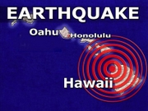
By GREG SMALL, Associated Press Writer October 15, 2006
A strong earthquake shook Hawaii early Sunday, causing a landslide that blocked a major highway on Hawaii Island and knocking out power across the state, authorities said.
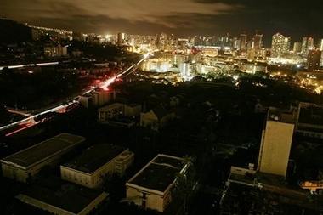
The state Civil Defense had unconfirmed reports of injuries, but communication problems prevented more definite reports. People were also trapped in elevators in Oahu, authorities said.
Figure 1 Parts of Honolulu were without power.
Gov. Linda Lingle said in a radio interview with KSSK from Hawaii Island that she had no report of any fatalities. She said boulders fell on highways, rock walls collapsed and television had been knocked off stands.
"We were rocking and rolling," said Anne LaVasseur, who was on the second floor of a two-story, wood-framed house on the east side of the Big Island when the temblor struck. "I was pretty scared. We were swaying back and forth, like King Kong's pushing your house back and forth."
The quake hit at 7:07 a.m. local time, 10 miles north-northwest of Kailua Kona, a town on the west coast of the Big Island, said Don Blakeman, a geophysicist at the National Earthquake Information Center, part of the U.S. Geological Survey.
The Pacific Tsunami Center reported a preliminary magnitude of 6.5, while the U.S. Geological Survey gave a preliminary magnitude of 6.3. It was followed by several strong aftershocks, including one measuring a magnitude of 5.8, the Geological Survey said.
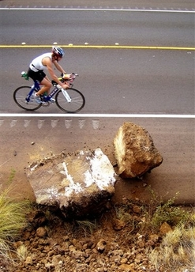
Blakeman said there was no risk of a Pacific-wide tsunami, but a possibility of significant wave activity in Hawaii.
On Hawaii Island, also known as the Big Island, there was some damage in Kailua-Kona and landslide along a major highway, said Gerard Fryer, a geophysicist at the Pacific Tsunami Center.
Officials were concerned there may be "structural integrity" problems at the big hospital in Kona in the Big Island, Lingle said. Rod Haraga, director of the state Transportation Department, told KSSK the hospital was being evacuated.
Figure 2 Rock that fell on the shoulder of the highway as the big Island experienced a landslide along a highway.
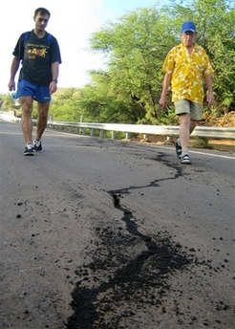
Betsy Garties, who lives in North Kohala, on the northern tip of Hawaii Island said she was lying in bed with one of her two young children when the quake struck.
Figure 3 Men examining a fisure in the road.
"First I heard a rumbling. Then the house started to shake. Then broken glass," Garties said. She first stood under a door frame as safety experts advise, then found that too wobbly for comfort and ran into the yard.
"It was strong enough that it was wobbling, so you almost lost your balance running out into the yard," Garties said. "The house was visibly rocking."
Peggy Cardoza, an assistant manager at a fast food restaurant in Hilo, said she was at work when the earthquake struck.
"We just felt the ground shaking," Cardoza said. "We just stood here and watched everything shake."
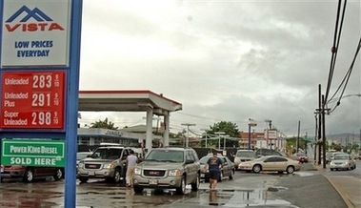
Power at least partially knocked out on every island, said Civil Defense spokesman Lani Goldman. On Oahu, 95 percent of customers were without power, he said.
Figure 4 Cars lined up at one of the few gas stations in Honolulu with power.
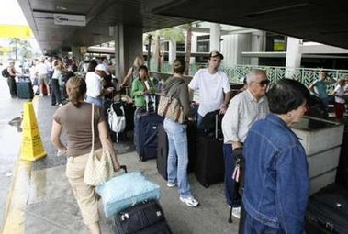
Airports were functioning despite the power outages.
Figure 5 Tourist passengers waiting for flights at Honolulu International Airport
"Planes are able to fly in and out," said Ian Gregor, a spokesman for the FAA in Los Angeles. "Our air traffic facilities at the airport appear to be unaffected, but the airport itself doesn't have power. There's no power for the screening machines."
Authorities said some of the power outages may have been due to heavy rainfall.
Associated Press writers Audrey McAvoy and Jaymes Song contributed to this report.

Hawaiians recover from strong earthquake
By MARK NIESSE, Associated Press Writer – October 16, 2006
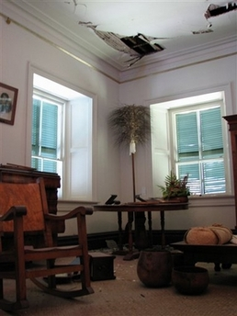
Aftershocks kept Hawaiians on edge following the strongest earthquake in more than two decades, a 6.6-magnitude quake that caused blackouts, landslides and prompted vacationers to flee their hotels.
There were no reports of fatalities, but the state Civil Defense had several reports of minor injuries. Gov. Linda Lingle issued a disaster declaration for the state.
The quake hit at 7:07 a.m. local time Sunday, 10 miles north-northwest of Kailua-Kona, a town on the west coast of Hawaii Island, also known as the Big Island, said Don Blakeman of the National Earthquake Information Center, part of the U.S. Geological Survey.
Figure 6 Huge chunks of the interior ceiling and museum items lie on the floor at the 168-year-olc Hulihee Palace in Kailua-Kona, Hawaii.
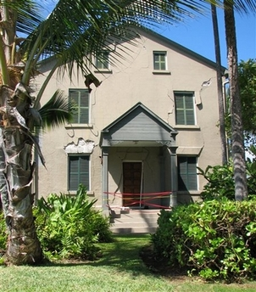
"We were rocking and rolling," said Anne LaVasseur, who was on the second floor of a two-story, wood-framed house on the east side of the Big Island when the temblor struck. "I was pretty scared. We were swaying back and forth, like King Kong's pushing your house back and forth."
Figure 7 Exterior damage to the Hulihee Palace.
Lingle, who was in a hotel near the epicenter of the quake 10 miles northwest of Kailua-Kona, said the most serious injury reported to her was a broken arm.
The Pacific Tsunami Center reported a preliminary magnitude of 6.5, while the U.S. Geological Survey gave a preliminary magnitude of 6.6.
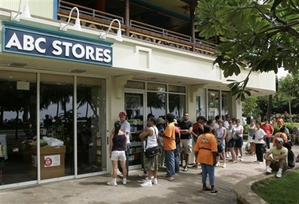
The earthquake was followed by several strong aftershocks, including one measuring a magnitude of 5.8, the Geological Survey said. Forecasters said there was no danger of a tsunami, though choppier-than-normal waves were predicted.
Figure 8 Tourists line up outside an ABC Store to purchase essentials.
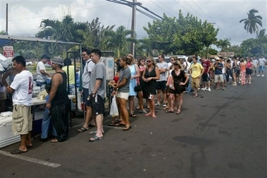
The quake caused statewide power outages, and phone communication was possible, but difficult. The outages were caused because power plants turned off automatically when built-in seismic monitors were triggered by the earthquake.
Figure 9 People wait in linen for food at a roadside chicken stand in Kihei, Hawaii on Sunday.
Some power had been restored late Sunday in Maui, parts of Honolulu and other places, but many remained in the dark. All electricity systems needed to be rebooted, which was expected to take several hours in more populated areas like Honolulu.
"I don't mind a clean up, because it could have been a lot worse," said Chris Bair, the owner of Killer Tacos, which had tiles tumble from its ceiling. "We're glad everybody is OK."
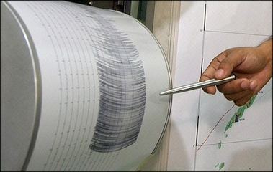
Kona Community Hospital on the western side of Big Island was evacuated after ceilings collapsed and power was cut off, according to a hospital spokeswoman.
Figure 10 The quake is said to have reached 6.6 on the Richter Scale.
At least 10 acute care patients were being evacuated across the island to a medical center in Hilo, said Terry Lewis, spokeswoman for the hospital. About 30 nursing care patients were being moved temporarily to a nearby conference center, she said.
"We were very lucky that no one got hurt," said Lewis.
Mayor Harry Kim estimated that as many as 3,000 people were evacuated from three hotels on the Big Island. Brad Kurokawa, Hawaii County deputy planning director, confirmed the hotels were damaged, but could not say how many people had left. They were being taken to a gymnasium until alternate accommodations could be found, he said.
The earthquake caused water pipes to explode at Aston Kona By The Sea, a condominium resort, creating a dramatic waterfall down the front of the hotel from the fourth floor, said Kenneth Piper, who runs the front desk.
"You could almost see the cars bouncing up and down in the parking garage," Piper said.
The USGS said Hawaii's largest quake on record was an 1868 magnitude-7.9 earthquake that triggered a tsunami and spawned numerous landslides that resulted in 31 deaths. The last strongest temblor was in 1983, registering a magnitude 6.7.
A FEMA computer simulation of the latest quake estimated that as many as 170 bridges on the Big Island could have suffered damage in the temblor, said Bob Fenton, FEMA director of response for the region. More than 50 federal officials were en route to the Big Island to assess damage and begin recovery work, he said.
Lingle told radio station KSSK that she toured the Kona area by helicopter to view the damage, including earth falling into Kealakekua Bay.
"You could see the water was turning brown," said Lingle.
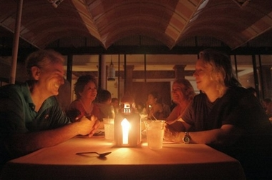
On Hawaii Island, there was some damage in Kailua-Kona and a landslide along a major highway, said Gerard Fryer, a geophysicist at the Pacific Tsunami Center. Officials also said there were reports of people trapped in elevators in Oahu.
In Waikiki, one of the state's primary tourism areas on Oahu, worried visitors began lining up outside convenience stores to purchase food, water and other supplies. Managers were letting tourists into the darkened stores one at a time.
Figure 11 Preparing to dine by candle light at the Royal Hawaiian Hotel in Honolulu. This buffet was at one of the few hotels that could offer some food service.
Karie and Bryan Croes waited an hour to buy bottles of water, chips and bread.
"It's quite a honeymoon story," said Karie, as she and her husband sat in lounge chairs surrounded by grocery bags beside a pool at ResortQuest Waikiki Beach Hotel.
Federal Aviation Administration spokesman Les Dorr said planes were arriving at Honolulu International Airport, but there were few departures. Security checkpoints were without power, so screeners were screening passengers and baggage manually.
Resorts in Kona were asked to keep people close to hotels, Kim told television station KITV. Cruise ships were told to keep tourists on board, and ships that were due to dock were asked to move on to their next location, he said.
"We are dealing with a lot of scared people," he said.
The Big Island has about 167,000 people, according to a 2005 Census estimate, and many of them live in and around Hilo, on the opposite site from where the quake was centered.
Earthquakes in the 6.0 magnitude range are rare in the region, which more commonly sees temblors in the 3- and 4-magnitude range caused by volcanic activity.
"We think this is a buildup from many volcanic earthquakes that they've had on the island," said Waverly Person, a geophysicist with the U.S. Geological Survey.
___
Associated Press writers Audrey McAvoy, Tara Godvin, Greg Small and Jaymes Song in Hawaii and Leslie Miller in Washington contributed to this report.

Aftershocks keep Hawaiians on edge
By MARK NIESSE, Associated Press Writer Mon Oct 16, 7:22 AM ET
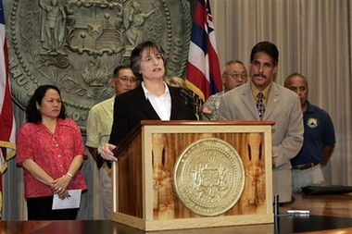
Aftershocks kept Hawaiians on edge following the strongest earthquake in more than two decades, a 6.6-magnitude quake that caused blackouts, landslides and prompted vacationers to flee their hotels.
Figure 12 Governor Linda Lingle addresses the problem.
Resorts in Kona were asked to keep people close to hotels. Cruise ships were told to keep tourists on board, and ships that were due to dock were asked to move on to their next location.
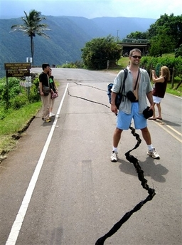
Federal Aviation Administration spokesman Les Dorr said planes were arriving at Honolulu International Airport, but there were few departures. Security checkpoints were without power, so screeners were screening passengers and baggage manually.
Mayor Harry Kim estimated that as many as 3,000 people were evacuated from three hotels on the Big Island. Brad Kurokawa, Hawaii County deputy planning director, confirmed the hotels were damaged, but could not say how many people had left. They were being taken to a gymnasium until alternate accommodations could be found, he said.
Figure 13 Tourist posing with earthquake damaged road.
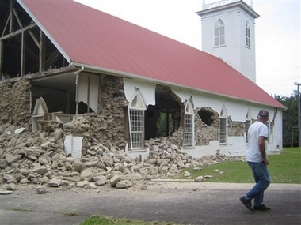
The quake hit at 7:07 a.m. local time Sunday, 10 miles north-northwest of Kailua-Kona, a town on the west coast of Hawaii Island, also known as the Big Island, said Don Blakeman of the National Earthquake Information Center, part of the U.S. Geological Survey.
Figure 14 Earthquake damaged church in Kapaau, Hawaii.
There were no reports of fatalities, but the state Civil Defense had several reports of minor injuries. Gov. Linda Lingle issued a disaster declaration for the state, but said the most serious injury reported to her was a broken arm.

The Pacific Tsunami Center reported a preliminary magnitude of 6.5, while the U.S. Geological Survey gave a preliminary magnitude of 6.6.
Figure 15 Cleaning up a bookstore in Hawi Town, Hawaii.
The earthquake was followed by several strong aftershocks, including one measuring a magnitude of 5.8, the Geological Survey said. Forecasters said there was no danger of a tsunami, though choppier-than-normal waves were predicted.
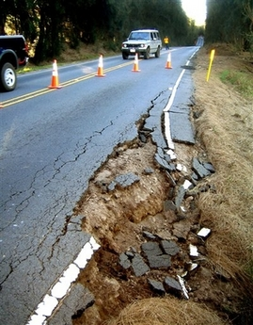
The quake caused statewide power outages, and phone communication was possible, but difficult. The outages were caused because power plants turned off automatically when built-in seismic monitors were triggered by the earthquake.
Figure 16 Earthquake damaged mountain road near Waimea, Hawaii.
Some power had been restored late Sunday in Maui, parts of Honolulu and other places, but many remained in the dark. All electricity systems needed to be rebooted, which was expected to take several hours in more populated areas like Honolulu.
"I don't mind a clean up, because it could have been a lot worse," said Chris Bair, the owner of Killer Tacos, which had tiles tumble from its ceiling. "We're glad everybody is OK."
Kona Community Hospital on the western side of Big Island was evacuated after ceilings collapsed and power was cut off, according to a hospital spokeswoman.
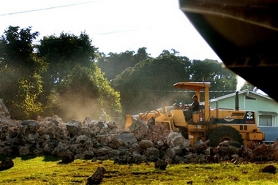
At least 10 acute care patients were being evacuated across the island to a medical center in Hilo, said Terry Lewis, spokeswoman for the hospital. About 30 nursing care patients were being moved temporarily to a nearby conference center, she said.
Figure 17 Cleaning up the remains of the historic Hawi Mill after it was totally destroyed.
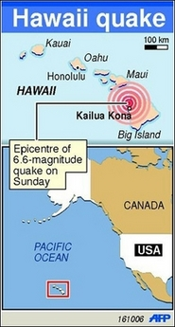
"We were very lucky that no one got hurt," said Lewis.
The earthquake caused water pipes to explode at Aston Kona By The Sea, a condominium resort, creating a dramatic waterfall down the front of the hotel from the fourth floor, said Kenneth Piper, who runs the front desk.
A FEMA computer simulation of the latest quake estimated that as many as 170 bridges on the Big Island could have suffered damage in the temblor, said Bob Fenton, FEMA director of response for the region. More than 50 federal officials were en route to the Big Island to assess damage and begin recovery work, he said.
Lingle told radio station KSSK that she toured the Kona area by helicopter to view the damage, including earth falling into Kealakekua Bay.
"You could see the water was turning brown," said Lingle.
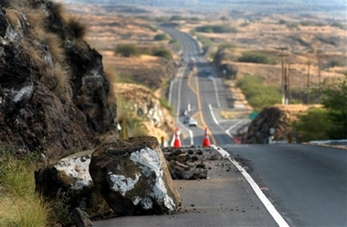
On Hawaii Island, there was some damage in Kailua-Kona and a landslide along a major highway, said Gerard Fryer, a geophysicist at the Pacific Tsunami Center. Officials also said there were reports of people trapped in elevators in Oahu.
Figure 18 Fallen rocks along the road on the Big Island.
In Waikiki, one of the state's primary tourism areas on Oahu, worried visitors began lining up outside convenience stores to purchase food, water and other supplies. Managers were letting tourists into the darkened stores one at a time.
Karie and Bryan Croes waited an hour to buy bottles of water, chips and bread.
"It's quite a honeymoon story," said Karie, as she and her husband sat in lounge chairs surrounded by grocery bags beside a pool at ResortQuest Waikiki Beach Hotel.
The Big Island has about 167,000 people, according to a 2005 Census estimate, and many of them live in and around Hilo, on the opposite site from where the quake was centered.
Earthquakes in the 6.0 magnitude range are rare in the region, which more commonly sees temblors in the 3- and 4-magnitude range caused by volcanic activity.
"We think this is a buildup from many volcanic earthquakes that they've had on the island," said Waverly Person, a geophysicist with the U.S. Geological Survey. ___
Associated Press writers Audrey McAvoy, Tara Godvin, Greg Small and Jaymes Song in Hawaii and Leslie Miller in Washington contributed to this report.
*** NOTICE: In accordance with Title 17 U.S.C. Section 107, this material is distributed, without profit, for research and educational purposes only. ***
Earthquake Hazards in Hawaii -- USGS
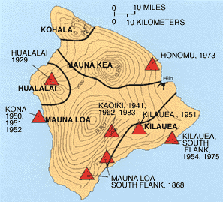
The Island of Hawaii experiences thousands of earthquakes each year; most are so small that they can only be detected by instruments, but some are strong enough to be felt, and a few cause minor-to-moderate damage. Most of Hawaii's earthquakes are directly related to volcanic activity and are caused by magma moving beneath the earth's surface. Earthquakes may occur before or during an eruption, or they may result from the underground movement of magma that comes close to the surface but does not erupt. A few of the island's earthquakes are less directly related to volcanism; these earthquakes originate in zones of structural weakness at the base of the volcanoes or deep within the earth beneath the island.
Strong earthquakes endanger people and property by shaking structures and by causing ground cracks, ground settling, and landslides. Strong earthquakes in Hawaii's past have destroyed buildings, water tanks, and bridges, and have disrupted water, sewer, and utility lines. Locally, such damage can be intensified where soft, water-saturated soils amplify earthquake ground motions. On steep slopes, such soils may fail during an earthquake, resulting in mudflows or landslides. An indirect hazard produced by some earthquakes is a tsunami, a large sea wave that can be far more damaging than any of the direct seismic hazards.
Figure 19 Generalized locations of damaging earthquakes of magnitude 6 or greater since 1868 on the Island of Hawaii. The same earthquakes are listed in the accompanying table. The magnitudes marked by an (*) are based on eyewitness accounts of the earthquakes' effects and on reports of damage. Since about 1950, the accuracy of location, magnitude, and depth determinations has continually improved as the capability of seismic instruments has increased.
The size of an earthquake is commonly expressed by its magnitude on the Richter scale, which is a measure of the relative size of the earthquake wave recorded on seismographs. An increase of one whole number on the Richter scale represents a tenfold increase in the amplitude of the seismograph recording. Earthquakes greater than about magnitude 3 usually can be felt by people near the source area, those greater than magnitude 5 are potentially damaging, and any earthquake of magnitude 7 or greater that occurs near populated areas is certain to cause widespread property damage.
The earthquakes directly associated with the movement of magma are concentrated beneath the island's active volcanoes, Kilauea and Mauna Loa. Very shallow earthquakes frequently precede or accompany an eruption. Hundreds of such earthquakes make up swarms that commonly occur over a period of several hours or days before an eruption as magma forces its way into a new area. These earthquakes are seldom large enough to cause widespread damage, but they may produce extensive ground fracturing close to the potential eruption site. Once an eruption begins, the earthquakes usually diminish.
Year | Date | Region | Magnitude | Depth (Mi)
1868 | Mar. 28 | Mauna Loa south flank | 6.5-7.0* | No data
1868 | Apr. 2 | Mauna Loa south flank | 7.5-8.1* | No data
1929 | Oct. 5 | Hualalai | 6.5* | No data
1941 | Sept. 25 | Kaoiki | 6.0* | No data
1950 | May 29 | Mauna Loa southwest rift | 6.2 | No data
1951 | Apr. 22 | Kilauea | 6.3 | 20
1951 | Aug. 21 | Kona | 6.9 | 5
1952 | May 23 | Kona | 6.0 | 5
1954 | Mar. 30 | Kilauea south flank | 6.5 | 5
1962 | June 27 | Kaoiki | 6.1 | 6
1973 | Apr. 26 | Honomu | 6.2 | 25
1975 | Nov. 29 | Kilauea south flank | 7.2 | 6
1983 | Nov. 16 | Kaoiki | 6.6 | 7
1989 | June 25 | Kilauea south flank | 6.1 | 9

Other earthquakes beneath the active volcanoes are generated by the pressures exerted by magma that never reaches the surface. Kilauea's east rift zone is continually being wedged apart by the injection of new magma, much of which is stored underground deep within the rift zone. Since the north flank of Kilauea is immobilized by the adjacent mass of Mauna Loa, the south flank, which faces the ocean, must move outward to make room for the additional magma. Periodically, Kilauea's south flank abruptly shifts seaward in response to this pressure, causing earthquakes. Most such earthquakes are small, but a few are large and can cause damage.
In 1975, Kilauea's south flank was the site of the magnitude 7.2 Kalapana earthquake, the highest magnitude event in this century. The Kalapana coast subsided as much as 11 feet, generating a huge tsunami that claimed two lives in Hawaii Volcanoes National Park, destroyed houses in Punaluu, sank fishing boats in Keauhou Bay, and damaged boats and piers in Hilo. The most recent large earthquake on Kilauea's south flank occurred in June 1989. With a magnitude of 6.1, this quake caused much less damage than the 1975 event.
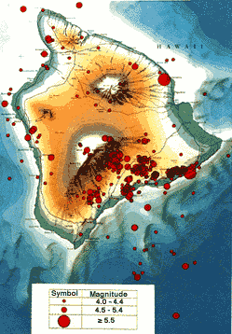
Earthquakes occur for similar reasons beneath Mauna Loa's southwest and southeast flanks. The Kealakekua fault zone on Hawaii's Kona coast was the site of an earthquake of about magnitude 6.9 in 1951 that may have been related to the 1950 eruption of Mauna Loa's southwest rift zone. The largest Hawaiian earthquake in recorded history occurred in 1868 beneath the Ka'u district on the southeast flank of Mauna Loa; it had an estimated magnitude of between 7.5 and 8.1. The 1868 earthquake caused damage across the entire island and was felt as far away as the Island of Kauai. The devastation was greatest in the Ka'u district, where an earthquake-triggered mudflow killed 31 people and coastal subsidence produced a tsunami that destroyed several villages. At least 79 people perished during this earthquake; most of these casualties resulted from the landslide and tsunami.
Figure 20 Recent earthquakes on and near the Island of Hawaii, 1962-1985.
Earthquakes in the Kaoiki region, centered between Kilauea and Mauna Loa, are also thought to be related to stresses in the earth's crust that are produced by the activity of the two volcanoes. In the last half century, earthquakes with magnitudes from 5.5 to 6.6 have shaken the Kaoiki region about once every 10 years. The latest large earthquake in this area had a magnitude of 6.6 and occurred in 1983. This event caused substantial damage to structures in Ka'u, Puna, and North and South Hilo districts. Ground cracking and settling led to temporary road closures, and landslides occurred on steep slopes. The financial losses caused by the earthquake were estimated at $7 million. Fortunately, there were only minor injuries because the earthquake struck early in the morning when most people were still in bed.
Large earthquakes unrelated to volcanic activity also occur at irregular intervals on the Island of Hawaii. In 1973, a magnitude 6.2 earthquake located 25 miles beneath Honomu, north of Hilo, injured 11 people and caused $5.6 million worth of damage. Such earthquakes have no known recurrence interval and are difficult to predict.
Defining hazard zones for the effects of earthquakes is more difficult than for eruptions and has not been attempted for the Island of Hawaii. For the most part, earthquakes on Hawaii are concentrated beneath Kilauea and Mauna Loa, particularly beneath the south flanks of both volcanoes, and in the Kaoiki region between them. The likelihood of a damaging earthquake on Kilauea or Mauna Loa probably increases with long-lived activity of the rift zones, but its precise time and magnitude are impossible to predict.
Small, non-damaging earthquakes will be felt more frequently by people living on the slopes of these volcanoes. The effects of a large earthquake under Kilauea or Mauna Loa, however, will not be limited to the immediate area and may cause damage over much of the island. Similarly, deep earthquakes, such as the 1973 Honomu earthquake, can take place under any part of the island and can produce damaging effects over a wide area.
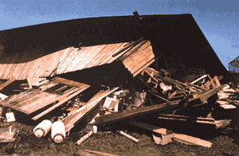
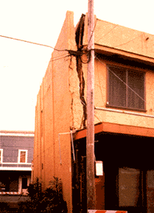
One problem in assigning seismic hazard zones to the island is that the ground shaking during a strong earthquake may vary within a small area. This variation is because the effects of earthquakes are closely related to the nature of the underlying ground; for example, whether it is mainly lava bedrock or soil. Two homes in the same neighborhood may suffer different degrees of damage depending on the properties of the ground upon which they are built. In addition, local topography strongly affects earthquake hazards. Steep slopes composed of loose material may produce large landslides during an earthquake.
Figure 21 House destroyed in June 25, 1989, earthquake in Kalapana. (Photograph by J.D. Griggs, USGS)
Figure 5 Hilo building damaged by the November 1983 Kaoiki earthquake. (Photograph by J.M. Buchanan-Banks, USGS)
The risk from living in a seismically active area, unlike that of living in an area prone to being covered by lava, also depends to a large degree on the type of construction used in a given home. Earthquake shaking may damage certain types of houses, while leaving other types of construction unscathed. For all of these reasons, earthquake hazards are highly localized, and it is difficult to define broad zones with the same relative degree of hazard.

