Leaking Siberian ice raises a tricky climate issue

By ARTHUR MAX, Associated Press Arthur Max, Associated Press – Mon Nov 22, 2010
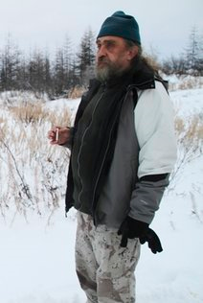
CHERSKY, Russia – The Russian scientist shuffles across the frozen lake, scuffing aside ankle-deep snow until he finds a cluster of bubbles trapped under the ice. With a cigarette lighter in one hand and a knife in the other, he lances the ice like a blister. Methane whooshes out and bursts into a thin blue flame.
Figure 1 AP – In this Oct. 23, 2010 photo, Russian scientist Sergey Zimov walks on a Siberian lake near the town of Chersky, Russia,

Gas locked inside Siberia's frozen soil and under its lakes has been seeping out since the end of the last ice age 10,000 years ago. But in the past few decades, as the Earth has warmed, the icy ground has begun thawing more rapidly, accelerating the release of methane — a greenhouse gas 23 times more powerful than carbon dioxide — at a perilous rate.

Some scientists believe the thawing of permafrost could become the epicenter of climate change. They say 1.5 trillion tons of carbon, locked inside icebound earth since the age of mammoths, is a climate time bomb waiting to explode if released into the atmosphere.

"Here, total carbon storage is like all the rain forests of our planet put together," says the scientist, Sergey Zimov — "here" being the endless sweep of snow and ice stretching toward Siberia's gray horizon, as seen from Zimov's research facility nearly 350 kilometers (220 miles) above the Arctic Circle.

Climate change moves back to center-stage on Nov. 29 when governments meet in Cancun, Mexico, to try again to thrash out a course of counteractions. But U.N. officials hold out no hope the two weeks of talks will lead to a legally binding accord governing carbon emissions, seen is the key to averting what is feared might be a dramatic change in climate this century.

Most climate scientists, with a few dissenters, say human activities — the stuff of daily life like driving cars, producing electricity or raising cattle — is overloading the atmosphere with carbon dioxide, methane and other gases that trap heat, causing a warming effect.

But global warming is amplified in the polar regions. What feels like a modest temperature rise is enough to induce Greenland glaciers to retreat, Arctic sea ice to thin and contract in summer, and permafrost to thaw faster, both on land and under the seabed.

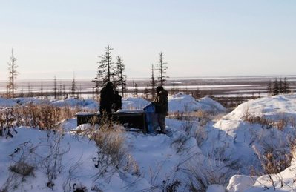
Yet awareness of methane leaks from permafrost is so new that it was not even mentioned in the seminal 2007 report by the Intergovernmental Panel on Climate Change, which warned of rising sea levels inundating coastal cities, dramatic shifts in rainfall disrupting agriculture and drinking water, the spread of diseases and the extinction of species.
Figure 2 In this photo taken Oct. 27, 2010, Russian scientists Sergey Zimov and his son Nikita Zimov extract air samples from frozen soil near the town of Chersky.

"In my view, methane is a serious sleeper out there that can pull us over the hump," said Robert Corell, an eminent U.S. climate change researcher and Arctic specialist. Corell, speaking by telephone from a conference in Miami, said he and other U.S. scientists are pushing Washington to deploy satellites to gather more information on methane leaks.

The lack of data over a long period of time casts uncertainty over the extent of the threat. An article last August in the journal Science quoted several experts as saying it's too early to predict whether Arctic methane will be the tipping point.

"Arctic Armageddon Needs More Science, Less Hype," was its headline.

Studies indicate that cold-country dynamics on climate change are complex. The Arctic Monitoring and Assessment Program, a scientific body set up by the eight Arctic rim countries, says overall the Arctic is absorbing more carbon dioxide than it releases.

"Methane is a different story," said its 2009 report. The Arctic is responsible for up to 9 percent of global methane emissions. Other methane sources include landfills, livestock and fossil fuel production.

Katey Walter Anthony, of the University of Alaska Fairbanks, has been measuring methane seeps in Arctic lakes in Alaska, Canada and Russia, starting here around Chersky 10 years ago.

She was stunned to see how much methane was leaking from holes in the sediment at the bottom of one of the first lakes she visited. "On some days it looked like the lake was boiling," she said. Returning each year, she noticed this and other lakes doubling in size as warm water ate into the frozen banks.

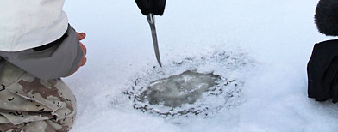
"The edges of the lake look like someone eating a cookie. The permafrost gets digested in the guts of the lake and burps out as methane," she said in an interview in Amsterdam, the Netherlands, en route to a field trip in Greenland and Scandinavia.
Figure 3 Some experts fear a substance oozing out of Siberia's frozen surfaces will soon redefine the climate fight

More than 50 billion tons could be unleashed from Siberian lakes alone, more than 10 times the amount now in the atmosphere, she said.

But the rate of defrosting is hard to assess with the data at hand.

"If permafrost were to thaw suddenly, in a flash, it would put a tremendous amount of carbon in the atmosphere. We would feel temperatures warming across the globe. And that would be a big deal," she said. But it may not happen so quickly. "Depending on how slow permafrost thaws, its effect on temperature across the globe will be different," she said.

Permafrost is defined as ground that has stayed below freezing for more than two consecutive summers. In fact, most of Siberia and the rest of the Arctic, covering one-fifth of the Earth's land surface, have been frozen for millennia.

During the summer, the ground can defrost to a depth of several feet, turning to sludge and sometimes blossoming into vast fields of grass and wildflowers. Below that thin layer, however, the ground remains frozen, sometimes encased in ice dozens or even hundreds of meters (yards) thick.

As the Earth warms, the summer thaw bites a bit deeper, awakening ice-age microbes that attack organic matter — vegetation and animal remains — buried where oxygen cannot reach, producing methane that gurgles to the surface and into the air.

The newly released methane adds to the greenhouse effect, trapping yet more heat which deepens the next thaw, in a spiraling cycle of increasing warmth.

Curbing man-made methane emissions could slow this process, said Walter Anthony.

"We have an incentive to reduce our fossil fuel emissions. By doing so, we can reduce the warming that's occurring in the Arctic and potentially put some brakes on permafrost thaw," she said.

The U.S. National Oceanic and Atmospheric Administration, in its 2010 Arctic Report Card issued last month, said the average temperature of the permafrost has been rising for decades, but noted "a significant acceleration" in the last five years at many spots on the Arctic coast.

One of those spots would be Chersky, an isolated town on the bank of the Kolyma River at the mouth of the East Siberia Sea.

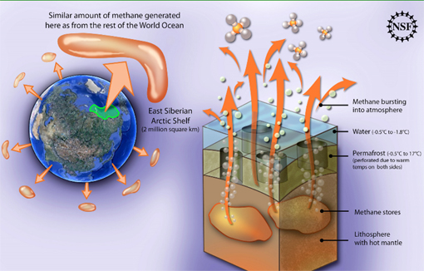
The ground in this remote corner of the world, 6,600 kilometers (4,000 miles) east of Moscow, has warmed about 2 degrees Celsius (3.6 Fahrenheit) in the last five years, to about -5 C (23 F?) today, says Zimov, director of the internationally funded Northeast Science Station, which is about three kilometers (2 miles) from town.
Figure 4 Methane is leaking from the East Siberian Arctic Shelf into the atmosphere at an alarming rate. The amount leaking from this locale is comparable to all methane from rest of the world's oceans put together. Methane is a greenhouse gas more than 30 times more potent than carbon dioxide.

The warming is causing the landscape to buckle under his feet.

"I live here more than 30 years. ... There are many (dirt) roads in our region which I used or built myself, but now I can't use anymore. Now they look like canyons," he says.

Buildings, too, collapse. The school in Chersky, a Soviet-era structure with a tall bronze statue of Karl Marx on its doorstep, was abandoned several years ago when the walls began to crack as the foundations gave way.

The northern Siberian soil, called yedoma, covers 1.8 million square kilometers (700,000 sq. miles) and is particularly unstable. Below the surface are vertical wedges of ice, as if 15-story-high icicles had been hammered into the soft ground, rich in decaying vegetation, over thousands of years.

As the air warms, the tops of the wedges melt and create depressions in the land. Water either forms a lake or runs off to lower ground, creating a series of steep hillocks and gullies. During summer, lakeside soil may erode and tumble into the water, settling on the bottom where bacteria eat it and cough up yet more methane.

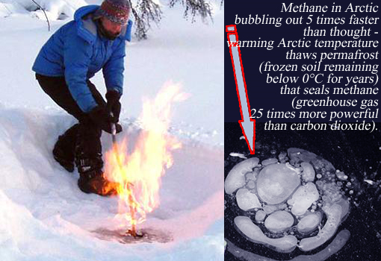
The process takes a long time, but Zimov has done a simulation by bulldozing trees and scraping off moss and surface soil from 1 hectare (2.5 acres) of former larch forest, rendering it as if it had been leveled by fire.
Figure 5 Left: Researcher ignites a pocket of methane. Right: methane bubbles trapped in lake ice in Siberia in early autumn.

Seven years later the previously flat terrain is carved up with crevices 10 to 15 feet (3 to 5 meters) deep, creating a snowy badlands.

Gazing across a white river to the apartment blocks on a distant hill, Zimov said, "In another 30 years all of Chersky will look like this."
*** NOTICE: In accordance with Title 17 U.S.C. Section 107, this material is distributed, without profit, for research and educational purposes only. ***

