UMSL HR TEAM PROCEDURES

Organizational Charts
Contents
Purpose 1
Effective and Ineffective Designs 1
Instructions 2
Org Chart HR Checklist 3

Created: 09/13/2026
Updated:
Confirmed by: Melinda Adams

Purpose
An organizational chart provides a visual representation of a department's structure, reporting relationships, staffing levels, and areas of responsibility. An effective organizational chart helps support decision-making and effective communications related to the full life cycle of positions and the department, such as:
- New employee onboarding and training
- Support justification committee requests.
- Support PCQ requests for new positions and reclassifications.
- Clarify reporting relationships and accountability.
- Identify staffing gaps and workload imbalances.
- Plan for and document organizational changes.
- Identify career pathways and development opportunities.
- Enhance communication within and across departments.

Effective and Ineffective Designs
COMMON ERRORS TO AVOID
❌ Missing position numbers
❌ Misleading working titles
❌ Inconsistent formatting
❌ Multiple direct supervisors for one employee
❌ Misrepresented reporting relationships
❌ Employee-driven rather than position-driven
❌ Missing effective date

An effective organizational chart should:
- Reflect the current organizational structure.
- Make it easy to identify decision makers, administrative supervisors, functional areas, and accountability
- Clearly identify direct reporting relationships.
- Accurately depict budgeted vacant and filled positions.
- Be easy to read and understand.
- Focus on structure rather than individuals whenever possible.
- Align with approved university titles and/or working titles.\

USE THIS LAYOUT
NOT THIS LAYOUT

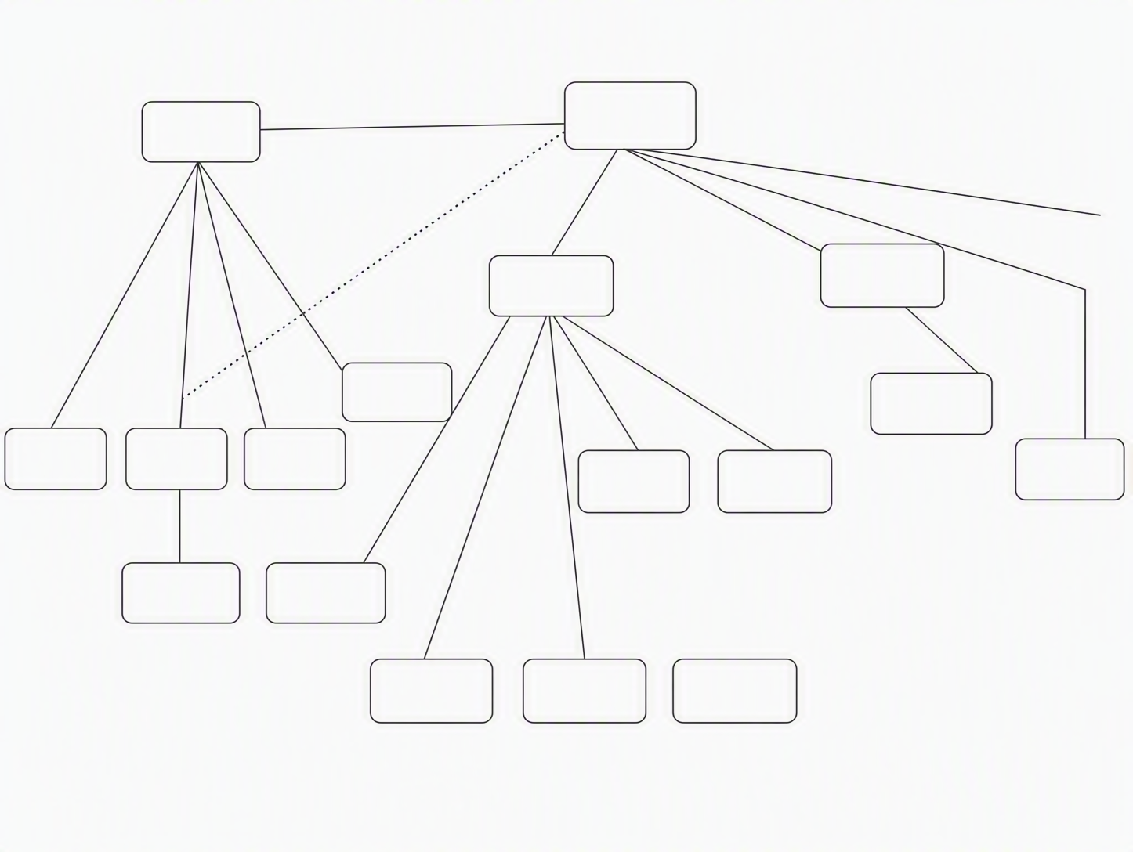

WRONG LAYOUT

VS

Instructions
Organizational charts can be developed using different software depending on what units have access to. Recommendations in order of effectiveness: 1) Visio, 2) PowerPoint, and 3) Microsoft Word.

- Each position box should contain
  - University or Working Title
EXAMPLE
Strategic HR Partner
Heather Floden
00066961

  - Employee name
  - Position number
  - If non-benefit eligible, add “Part-Time”
  - If position is vacant, add “VACANT” in place of the name

- Use consistent formatting
  - All position boxes should:
    - Be the same font size when possible.
    - Use consistent title formats.
    - Follow a left-to-right or top-to-bottom structure.

  - Reporting relationships, including
    - Use a solid line to reflect administrative reporting relationship
    - Use a dotted line to reflect:
      - A matrix reporting relationship
      - Project oversight
      - Functional team lead guidance

  - Connecting lines do not need an arrow; however, if an arrow is used, it should start from the supervisor pointing to the employee

- Organizational Layout Considerations
  - When designing an organizational chart, position functions in a logical manner that helps readers quickly understand how the organization delivers value and supports its mission.
  - Arrange functions from left to right based on primary purpose, with customer-facing or mission-delivery units on the left and operational, administrative, and support functions on the right.
  - Left-to-Right: Customer-Facing / Mission Delivery → Shared Operations → Internal Support

Left Side | Middle | Right Side
Faculty instructors | Centers | Faculty Affairs, HR, IT, Finance
Advancement Development Officers | Special Events | Data and Reporting Analytics
Physician or clinical therapists | Patient Check-In Services | Office staff, Marketing, Finance

Org Chart HR Checklist
☐ Effective date and unit name included
☐ All budgeted positions are included
☐ Reporting relationships are accurate
☐ Position numbers are listed
☐ Vacancies are identified
☐ Working titles are appropriate and are aligned with PeopleSoft
☐ Structure matches actual operations
☐ Chart is easy to read and professionally formatted

Future state - If a unit is considering organizational changes, a current state and future state org charts are necessary. In addition to the above checklist,

☐ Proposed changes are clearly identified
☐ Current and future state charts are included (if applicable)

UPDATED ORG CHARTS SHOULD BE SENT TO HR TO RETAIN ONFILE.

