Editing a VoiceThread for Group Assignment
You will always go to Voicethread via the special link set up in your Canvas course. Never go directly to Voicethread outside of Canvas. The link will be in on Group page. Note: Your work will be saved in this link; no need to turn in the URL.
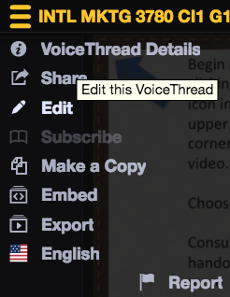
Enter Editing Mode: Select Edit from beneath the icon in the upper left corner of the Voicethread video presentation template:

Step 1: Now you are in “Editing Mode.” Select “+” or “Add Media” to upload additional slides to this presentation. You may upload PowerPoint slides, images, or PDFs as you have exported them from Google Slides$Type equation here.$. After your uploaded media has been processed (this may take some time), you can drag your slides around, delete unwanted slides, add additional slides later, etc.
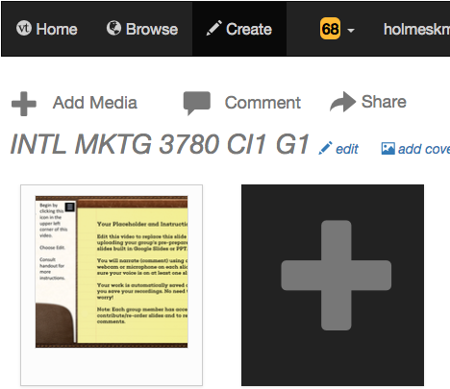
Search your computer to find the folder where the files are stored for your VoiceThread (images, PPT slides, PDF files, etc.): (Please note that if you upload PPT, your slides will flatten removing any animations you’d included). Pro Tip: From Google Slides or PPT, save your files as images first. It’ll save you time when uploading into Voicethread.
There is no submission necessary. Your uploads are saved automatically. You are now ready to move to Step 2 to record your narration on your slides. You may also return to this presentation later.
If you want to remove any slides, follow these instructions to remove the slides one at a time: https://wp.voicethread.com/howto/deleting-a-slide-2/
NEVER delete the whole Voicethread because it’s interlinked elsewhere in the course.

Recording Comments
Step 2: The next step is to add your comments. You and your team members can add comments now or later. If you are returning to this presentation after previously uploading your slides, navigate to the slide where you would like to leave a comment and hover over the slide to see the talk bubble with a + inside. There are FIVE ways to leave a comment (below), and we will discuss the three most common options in this guide. For this assignment, only use the Webcam or Microphone method.

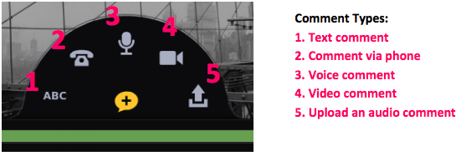

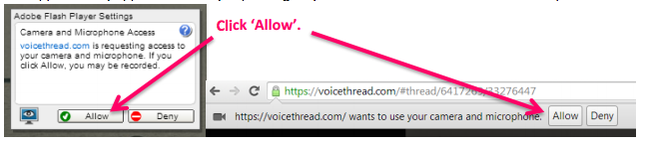
Audio comment
Video comment
Audio (mic) comment

The first time that you insert a video comment, you will be asked to give VoiceThread access to your webcam (if so, just click Allow):
When you are finished recording your video comment, select
Your recorded comment will then be played back for your approval. If you are satisfied with its quality, select Save.
If you’d like to re-record, select Cancel:
When you click save, the comment will appear next to the VoiceThread slide and your video will play on the left.

The first time that you insert an audio comment, you will be asked to give VoiceThread access to your microphone (if so, just click Allow):
When you are finished recording your audio comment, select
Your recorded comment will then be played back for your approval. If you are satisfied with its quality, select Save.
If you’d like to re-record, select Cancel:
Each new comment is identified by an icon in the sidebar of the image.

Tip: There is much more to do in VoiceThread when you are editing your presentation. For a full set of instructions, visit this website: http://VoiceThread.com/support/howto/VoiceThreads/Editing/
There is no submission necessary. Your work is saved automatically, and your instructor already has access.
(Your instructor started the file and named it already to make submission simpler for you. )

