About the Instructor

Contact information:
Name: Dr. Perry D. Drake
Phone number: 914-299-4879 (mobile)
Email address: drakep@umsl.edu
Campus office: ABH 217

On campus office hours: Tuesdays 11-1 pm, Thursdays 12-3 pm (but please contact me ahead of time to reserve my calendar)
Virtual office houses: Arranged any time with 24 hours notice. Zoom link to be provided.

Welcome
Welcome to Social Media Strategies! I am thrilled to guide you through this dynamic and cutting-edge course offered by the University of Missouri–St. Louis. You are part of a program that stands out nationally for its robust selection of digital and social media marketing courses—an offering very few universities can match.
This course is more than just an academic experience; it’s a real-world exploration of one of the most transformative forces in modern marketing and communication. Social media has disrupted industries, reshaped how businesses connect with audiences, and redefined what it means to build relationships in the digital age. Regardless of whether your major is in marketing, education, finance, accounting, or communications, the skills and strategies you’ll learn here will be invaluable in navigating the challenges and opportunities created by these emerging technologies.
Expect a fast-paced, immersive, and exciting journey into the world of social media marketing and communication. You’ll gain insights into the latest tools, platforms, and strategies while developing hands-on experience that will give you a competitive edge in the job market. Together, we’ll explore how to craft compelling campaigns, build brand communities, and measure the success of your social media efforts.
This is your opportunity to master a field that is reshaping our professional and personal lives. Let’s make this an inspiring and impactful learning experience. Get ready for an awesome adventure—because the world of social media doesn’t wait, and neither should we!

Instructor Background
Perry Drake is currently the Co-Chair and Associate Teaching Professor of Marketing at the University of Missouri in St. Louis. He is also the faculty advisor to the UMSL Marketing Advisory Board and the Executive Director of the Marketing and Sales Leadership Institute at the University of Missouri in St. Louis. Prior to this role he was an Assistant Professor of Integrated Marketing at New York University for 14 years.

He has been responsible for creating some of the very first courses dealing in web analytics, social media analytics and SAS data mining certifications at the university level. In addition, he was among the first faculty to use Adobe Sitecatalyst in the classroom (then known as Omniture).
At UMSL Perry has implemented a certification program in Digital and Social Media Marketing at the graduate level and within Continuing Education. He offers courses in advanced Facebook advertising, CRM strategies, Google Analytics and

Tagging, video production and editing, LinkedIn Strategy, and more.
Dr. Drake is also the founder of the Midwest Digital Marketing Conference (MDMC) featuring speakers from Google, Facebook, Twitter, Linkedin, Microsoft and more. It is held annually at Union Station in St. Louis with attendance well over 1,700. Session tracks cover digital, social, tech, data, analytics and more. Visit www.bestmarketingconference.com for more information. It is now in its 10th year.
Perry is a regular on the speaking circuit. He is passionate about everything digital and social. He embraces all disruptions that are occurring in the world of marketing and communications.
Last but not least, Perry, in his spare time, is also a competitive runner. Typically finishing in the top 8%. He has run the New York City Marathon many times. He also cycles when needing a change of pace and does triathlons.
For more information here is Dr. Drake’s linkedin profile: https://www.linkedin.com/in/perrydrake/

Teaching Philosophy

My teaching philosophy is grounded in the belief that education should prioritize understanding and application over rote memorization, particularly in a dynamic field like marketing. In today's world, where information is readily accessible, the value lies not in memorizing facts but in developing the skills to apply knowledge meaningfully. I focus on helping students become fluent in core marketing principles, equipping them to analyze real-world situations, think critically, and communicate their ideas effectively.

With a blend of 15 years as a marketing practitioner and 25 years in academia, I bring both practical experience and academic rigor to the classroom. I strive to make learning relevant and engaging by incorporating current articles, case studies, and videos to enrich the foundational material provided by textbooks. This approach not only keeps content timely but also illustrates the real-life applications of marketing strategies.

Ultimately, my goal is to foster a learning environment where students can grow as knowledgeable and articulate professionals who can confidently navigate the challenges of today's ever-changing marketing landscape. I am committed to nurturing their curiosity, honing their analytical skills, and guiding them in becoming effective, adaptable marketers.

About this Course

Official Course Catalog Description:

Prerequisites: MKTG 5700. This course teaches students how to create a brand presence on social networks, understand the differences between earned and paid media, understand the various tools used to listen and engage with consumers, how we manage healthy communities, techniques used to identify influencers, crisis management, rules of engagement for high profile individuals and corporations, the importance of transparency, and the various ways engagement is measured. Students will also learn how to create various forms of content for consumption by consumers on various social media platforms, including livestreaming, video, blogs, podcasts, and memes, and will become Hootsuite Certified by the end of the semester.

Additional Course Description:

Social media marketing has revolutionized how businesses connect with customers, build brand loyalty, and drive growth. This course explores how marketers use social media platforms to increase brand awareness, engage key audiences, generate leads, and create meaningful customer relationships. By leveraging relevant, consistent, and valuable content, businesses can gain a competitive edge in today’s digital landscape.

However, many companies struggle to prepare for the rapidly evolving future of social media marketing. While businesses may have established Facebook, Twitter, LinkedIn, or Instagram accounts, few possess the comprehensive strategies needed to truly harness these platforms' potential. As future professionals, it is no longer sufficient to rely on general theories or basic platform knowledge. Success requires mastery of innovative, data-driven, and dynamic social media strategies that drive measurable results.

This course is designed to equip you with the knowledge, skills, and certifications to excel in the fast-paced and ever-changing world of social media marketing. Through hands-on experience, strategic planning, and cutting-edge tools, you will emerge prepared to shape the future of marketing in any industry.

Course Goals:

By the end of this course, students will:

- Critically analyze the impact of social media on traditional marketing paradigms and identify specific opportunities for innovation, engagement, and business growth.
- Evaluate and demonstrate the strategic importance of social media in achieving business goals, driving competitive advantage, and addressing global market challenges.
- Develop and refine a distinctive personal brand that positions them as thought leaders in their industries and fields.
- Design and implement advanced, data-driven social media marketing plans that align with organizational objectives and target measurable KPIs.
- Build, manage, and optimize professional business accounts across key networks, including Facebook, Instagram, Twitter, Pinterest, LinkedIn, YouTube, and emerging platforms, and assess their effectiveness.
- Utilize and evaluate tools such as blogs, vlogs, podcasts, and webinars to create dynamic, multi-channel content marketing campaigns.
- Plan, execute, and evaluate advanced social media marketing campaigns with a focus on innovation and performance optimization.
- Develop and apply influencer marketing frameworks and employee advocacy programs to enhance brand reach, build trust, and foster loyalty.
- Create and implement comprehensive social media policies and crisis management plans to protect brand integrity and mitigate reputational risks effectively.
- Leverage advanced advertising tools and strategies to maximize ROI and target precise audience segments across platforms.
- Analyze and synthesize complex social media performance metrics to optimize strategy, improve ROI, and drive continuous improvement.
- Conduct in-depth research on social media echo chambers and analyze their implications for business, society, and consumer behavior, culminating in a professional-grade report with actionable recommendations.
- Earn both beginner and advanced HubSpot Social Media Marketing Certifications, demonstrating expert-level proficiency in industry-standard tools, analytics, and strategies.

This MBA course is designed to empower you with cutting-edge skills and a nuanced understanding of social media marketing's complexities and opportunities. Graduates will emerge as leaders capable of crafting innovative strategies, addressing modern digital challenges, and delivering measurable results that contribute to organizational success.

Required texts and other course materials:
Required text is: “Essentials of Social Media Marketing” by Michelle Charello -- a Stukent publication.

This is an all-digital textbook featuring the latest in social media strategy. Stukent is an international publisher of digital and social media materials.

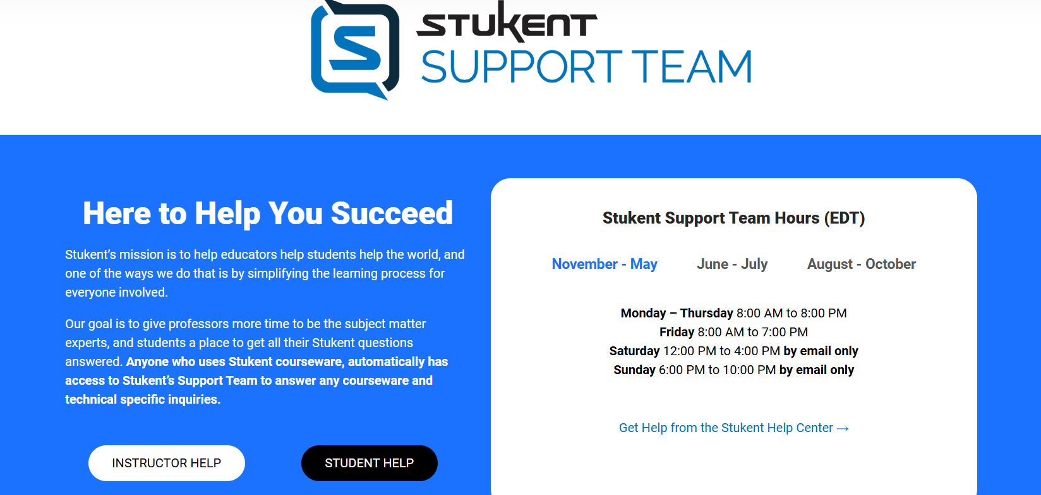

Stukent Website

Time Requirements:
6 hours per week on average will be required for this course. Please plan accordingly.

Technology Requirements:
As a student in an online course, you are expected to have reliable internet access almost every day. Please reach out to your academic advisor or student success network if you need hardware or access to the Internet. If you have computing problems, it is your responsibility to address these through the ITS Helpdesk (helpdesk@umsl.edu) or to use campus computing labs. Problems with your computer or other technology issues are not an excuse for delays in meeting expectations and missed deadlines for the course. If you have a problem, get help in solving it immediately. At a minimum, you will need the following software/hardware to participate in this course:

- Computer with an updated operating system (e.g. Windows, Mac, Linux)
- Updated Internet browsers (Google Chrome or Mozilla Firefox)
- Ability to navigate Canvas (Learning Management System)
- Minimum Processor Speed of 1 GHz or higher recommended.
- Reliable and stable internet connection.
- Adobe Reader or alternative PDF reader (free)
- A webcam and/or microphone is highly recommended.

How to Succeed in This Course
I am dedicated to your success in this course and committed to adapting my teaching methods to support your learning. To ensure you have a strong foundation in marketing and practical guidance along the way, I use a range of instructional methods:
- Supplemental Recorded Lectures: All core lectures are pre-recorded to complement course materials, allowing you to review and deepen your understanding at your own pace.
- Relevant, Up-to-Date Content: I carefully select current articles and case studies to include in lectures, connecting course topics to real-world trends and developments in marketing.
- Guidance for Major Projects: I’ll provide comprehensive support for your major team project, offering resources and feedback to help you succeed.
- Prompt Feedback: Homework and quizzes are graded promptly, ensuring you always know where you stand and can track your progress effectively.
- Accessibility: I am available to meet face-to-face or virtually, with a minimum of 24 hours' notice, to discuss questions, clarify concepts, or offer guidance as needed.
These methods are designed to foster a supportive and engaging learning environment, ensuring you gain not only a strong grasp of marketing principles but also the confidence to apply them effectively.

Instructional Technology: The following tools will support the instructional strategies for this course: (web searches, PowerPoint and other web and computer-aided instruction, etc.)

If you are new to or unfamiliar with Canvas, consult the Canvas Online Overview course site where you can learn about and practice with tools that will be used in this course. Follow this link to temporarily leave our course and learn more about Canvas: https://umsystem.instructure.com/courses/83642. You’ll learn about technologies and learning strategies to help you be successful in this course. If you’ve already completed the orientation, you do not have to retake it but you can refer to it at any time.

Course Plan for the Unexpected

Please stay informed about university policies, instructions and resources as they relate to the campus closures https://www.umsl.edu/safety/police/closures.html. It is important to me that you stay on track toward your degree completion. This section presents our course continuity plans for how we will handle situations to avoid disruption to your learning.

Since this class is asynchronous, we do not need to worry about closures.

Assessment/Grading

Grade Composition:
Under no circumstances does this instructor allow for extra credit for just one student. If extra credit is offered, it will be for all, not one. So please stay current with homework and quizzes. The instructor is more than happy to assist if you are falling behind to help ensure the best outcome.
We will be covering 15 chapters of the above mentioned book. Most every chapter will involve a quiz and a video case to watch/engage with. There will also be one Case Study Project that will be team based. This is your Final Exam.
Chapter Homework, 15 total, 100 each, 1,500 points.
Chapter Quizzes, 15 total, 100 each, 1,500 points.
You have exactly 60 minutes for each chapter quiz
Chapter Expert Session Quizzes, 10 total, 100 each, 1,000 points.
You have exactly 60 minutes for each expert quiz
HubSpot Certification for Beginners, 250 points
HubSpot Advanced Certification, 250 points
Social Media Team Project, 250 points
Social Media Echo Chamber Research Paper, 250 points
TOTAL POINTS = 5,000

Grading Scale:
The grade value for each letter grade is as follows:
92.00% of eligible points or higher A
90.00 to 91.99 A-
88.00 to 89.99 B+
82.00 to 87.99 B
80.00 to 81.99 B-
78.00 to 79.99 C+
72.00 to 77.99 C
70.00 to 71.99 C-
68.00 to 69.99 D+
62.00 to 67.99 D
60.00 to 61.99 D-
Below 60.00 F

Therefore to get an A in this class you need at least 92% of the 3,500 points or 4,600 points.

Feedback and Grading Timeline:
All homework and quizzes will be graded within one week of the submission date. If you would like to discuss your score, please email me—I’m happy to respond via email, Zoom, or an in-person meeting. I typically reply to these inquiries within 24-48 hours. If you don’t hear back promptly, please feel free to follow up, as your email may have been missed among many others.

Online Etiquette:
In this course, practicing respectful and professional online etiquette when interacting with your peers is essential. Remember that clear and considerate communication is key to creating a positive learning environment. Approach discussions with an open mind, valuing diverse perspectives and showing courtesy in all exchanges. Use respectful language, avoid interrupting or dominating conversations, and aim to support others’ ideas as well as express your own. Be mindful of tone, especially in written messages where meaning can sometimes be misunderstood. Constructive feedback should be given thoughtfully, focusing on ideas rather than individuals. By fostering a respectful, collaborative atmosphere, we can all benefit from a richer learning experience.

Course Schedule

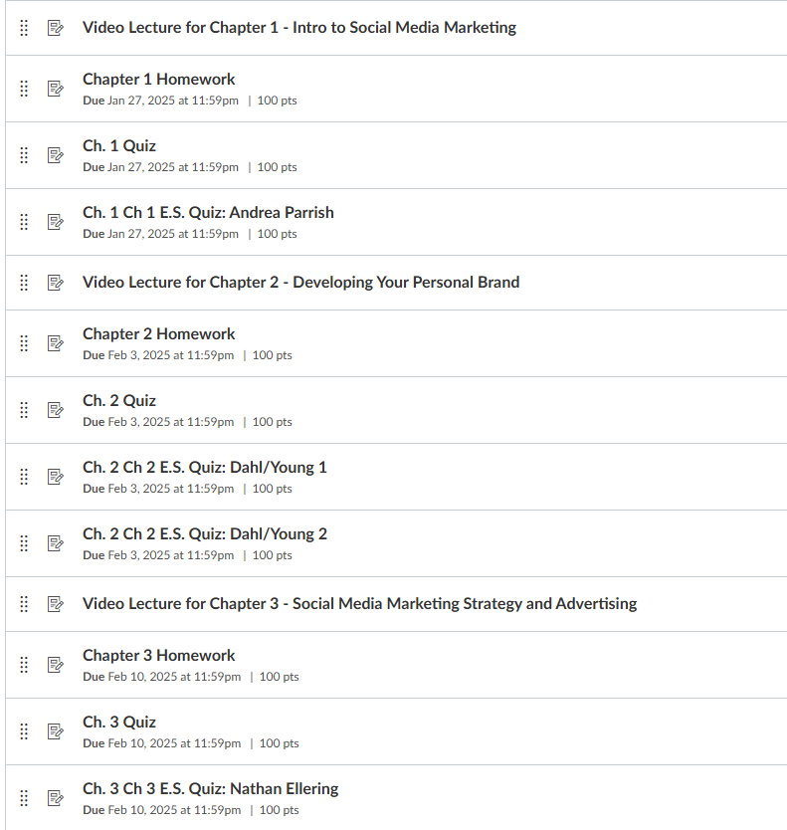

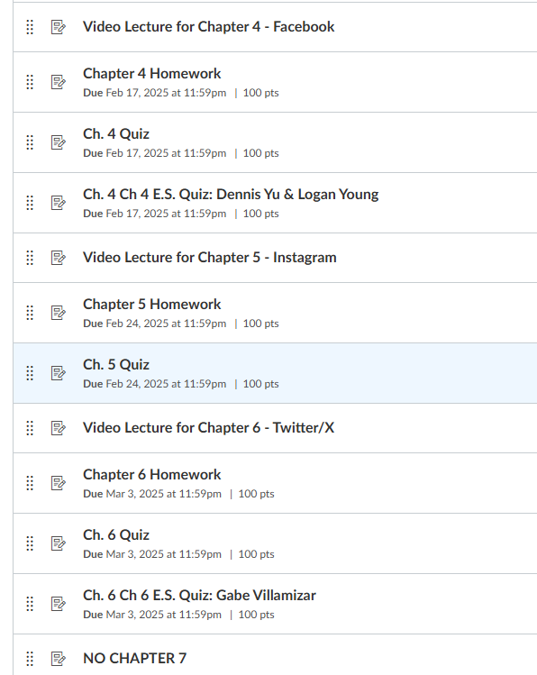

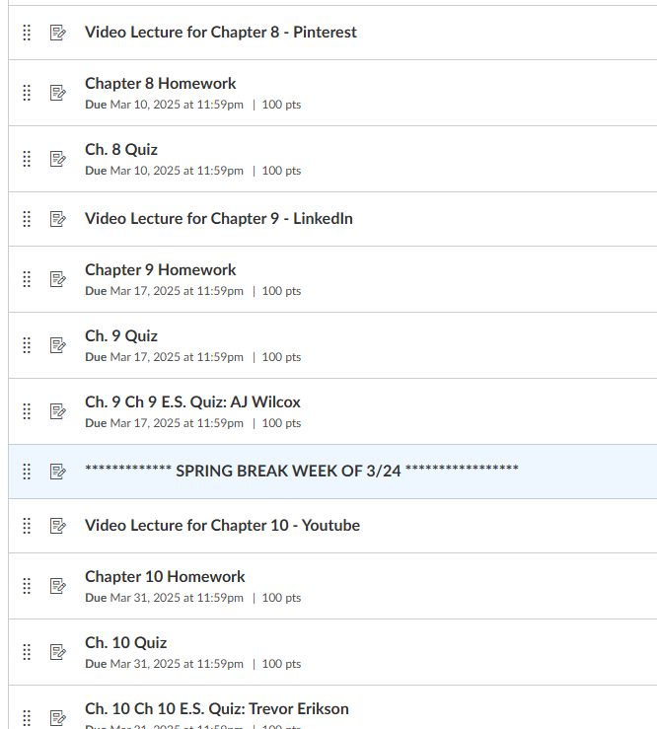

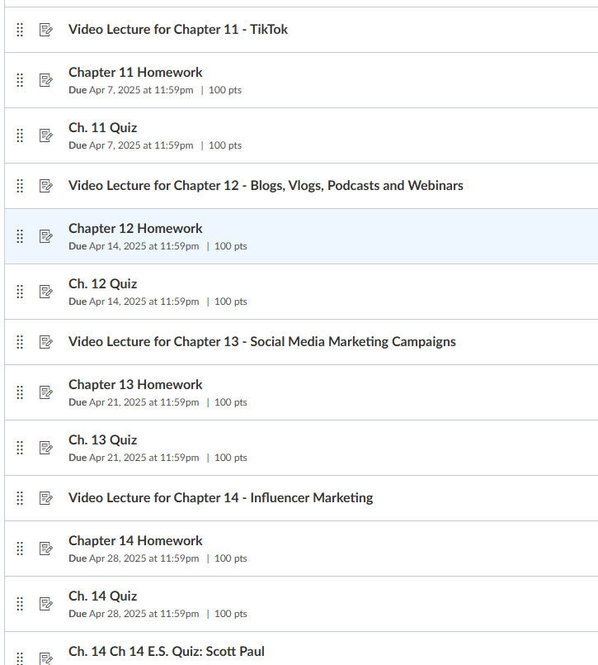

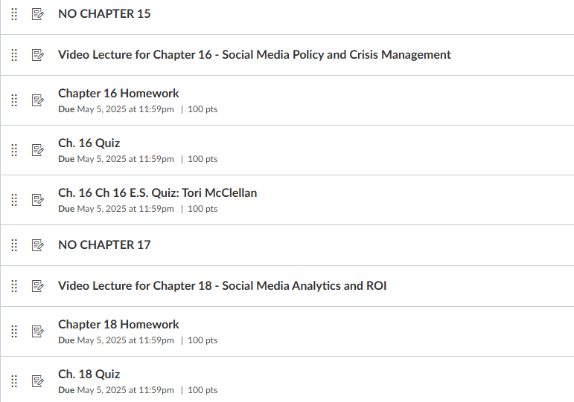

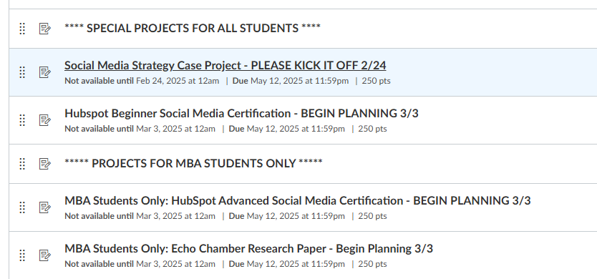

Course Policies

Participation (expectations)

- Building a classroom environment that promotes respectful exchange of ideas is important to me. This entails being sensitive to the views and beliefs expressed during discussions whether in class or online.
- Please speak with me before recording any class activity. It is a violation of University of Missouri policy to distribute such recordings without my authorization and the permission of others who are recorded.
- Timely participation in online discussions and assignments is a very important part of this course and will be vital to your success in the class.

Online Discussion Guidelines

- For any online discussions, I will not respond to each post but will be monitoring each discussion.
- You are expected to prepare and post to discussions in a timely manner consistent with the requirements contained within the course syllabus and discussion rubric.
- Postings should be evenly distributed during the discussion week.
- Postings should be a minimum of three sentences, or one short paragraph, and a maximum of two paragraphs.
- Responses should be well written with proper punctuation, spelling and grammar.
- Avoid short one-word postings, for instance, “I agree,” unless accompanied by supporting statements from the readings or prior knowledge (work and life experience).
- Stay focused on the topic.
- Ask questions when you see other postings that lack supporting evidence or present incorrect information.
- Encourage further discussion by building on current threads.
- Check your postings for responses from others and respond in kind.
- Use proper “netiquette”.

Attendance Policies

- Present for online courses is determined by participation in an “academically related activity,” i.e. submission of an assignment, assessment or discussion forum posting. The last day of attendance is the last day a student is academically participating in the online course.
- Documentation that a student has logged into an online class is not sufficient by itself to demonstrate academic attendance.
- Lack of attendance in class activities or submission of work in Canvas could result in an automatic course drop. Please let me know right away if you have any concerns about keeping up with the pace of the course or if you are unable to attend in person or engage online for any period of time.
- If you expect to miss a class or have a deadline conflict with class work due to a religious observance, let me know early in the semester so that we can discuss your responsibilities and plan so that you meet course obligations and requirements.

Academic Integrity/Plagiarism
We want our learning environment to be honest and fair. The assessments in our course provide you with an opportunity to showcase what you know and learn from what you may not yet have mastered. When you submit work with your name on it, this is a written statement that credit for the work belongs to you alone. If the work was a product of collaboration (such as a group project), each student is expected to clearly acknowledge in writing all persons who contributed to its completion.

Each assignment and exam in our course will include clear guidelines about the rules around each assessment including what materials are appropriate to use. It is always required that the work you submit is your own, uses proper citation, avoids collusion or falsification. The Writing Center can also advise on citing to avoid plagiarism.

If you have a question about an assignment, do not hesitate to contact me for clarification. You are responsible for being attentive to and observant of University policies about academic honesty as stated in the University’s Campus Policies and Code of Student Conduct found in the UMSL Bulletin.

- Plagiarism, collusion, cheating, and falsification may be terms that are new to you and so I want to be completely clear here as to what I mean by these terms.
  - Plagiarism: representing the ideas or work of another as your own, intentionally or unwittingly, without proper, clear, explicit acknowledgement.
    - Facilitation/Collusion: supporting malpractice by another student, for example, allowing your work to be copied.
  - Duplication of Work: presenting the same work for a different assessment.
  - Cheating: using, possessing or distributing any unauthorized sources of information (such as previous or existing exams for this course) and providing or receiving unauthorized assistance on any form of academic work or engaging in any behavior specifically prohibited by the faculty member (e.g., uploading or using test or online homework questions on study sites such as Chegg.com, using AI tools such as ChatGPT to write without alteration discussion posts or assignments, copying someone else’s answers on tests and quizzes, copying/pasting exam or online homework questions from this semester for your peers or publicly in online forums, stealing another student’s work, and unauthorized entry or use of material in a computer file).
  - Falsification: any untruth, either verbal or written, in one’s academic work including presenting fabricated/made up data or presenting someone else’s work as your own. Unless the instructor explicitly states otherwise, it is dishonest to collaborate with others when completing any assignment or test, performing laboratory experiments, writing and/or documenting computer programs, writing papers or reports and completing problem sets.

  - Academic dishonesty is a serious offense that may lead to probation, suspension, or dismissal from the University. All instances of academic dishonesty will be reported to the Office of Student Conduct and Academic Integrity in the Division of Student Affairs who will hold an initial conduct meeting and then determine possible administrative sanctions such as a warning, probation, or dismissal from the university.
  - In all cases of academic dishonesty, the instructor shall make an academic judgment about the student's grade on that work and in that course, which shall not be considered a sanction for prohibited conduct under this rule. The instructor shall, consistent with other policies, report the alleged academic dishonesty to the Primary Administrative Officer.

Title IX & Equity

- Mandatory Reporting: Under Title IX, all UMSL faculty, staff, and administrators (with limited exception) are obligated to report any incidents of sexual harassment, sexual misconduct, sexual assault, or gender discrimination to the Student Affairs office and/or other University officials. This ensures that all parties are protected from further abuses and that victim(s) are supported by trained counselors and professionals. Note: There are several offices at UMSL (e.g., Counseling Services, Health Services, Community Psychological Service, Center for Trauma Recovery, and Student Social Services) whose staff are exempt from Title IX mandated reporting, when the information is learned in the course of a confidential communication.

Student Resources

Student Advocacy & Care
Provides students with case management and other support and services to address unmet basic needs and other challenges they may be facing outside of the university that impacts their ability to succeed academically. These challenges may include things like food insecurity, housing instability, lack of childcare, counseling needs, and financial emergencies.
- Location: 144 Millennium Student Center
- LINK to request assistance or help
- Website: https://www.umsl.edu/studentadvocacy/

Access, Disability and Communication
Your academic success is important to me. We all learn differently and bring different strengths and needs to the class. If there are aspects of the course that prevent you from learning or make you feel excluded, please let me know as soon as possible. Together we’ll develop strategies to meet both your needs and the requirements of the course.

If you have a documented disability that may have an impact upon your work in this class, please contact Disability Access Services (DAS) immediately. Students must provide documentation of their disability to the office of Disability Access Services in order to receive official University services and accommodations. The staff is available to answer questions regarding accommodations or assist you in your pursuit of accommodations. Information about your disability is confidential. Once DAS reviews your medical documentation, they will provide you with the information and steps to inform me about the accommodations to which you are entitled. Your accommodations will begin as soon as we discuss your approved accommodations.
  - Location: 131 Millennium Student Center (MSC)
  - Phone: (314) 516-6554
  - Email: das@umsl.edu
  - Website: http://www.umsl.edu/services/disability/

Office of International Students and Scholar Services
If you have difficulty communicating in English with the instructor of this course, contact ISS.
- Location: 362 Social Sciences & Business Building (SSB)
- Phone: (314) 516-5229
- Email: iss@umsl.edu
- Website: http://www.umsl.edu/~intelstu/contact.html

Student Enrichment and Achievement
SEA provides comprehensive success coaching services to targeted populations (i.e., new First Time College & Transfer, current UMSL students with less than a 2.500 GPA).
- Location: 107 Lucas Hall
- Phone: (314) 516-5300
- Email: umslsea@umsl.edu
- Website: https://www.umsl.edu/services/sea/

TRIO Student Support Services
TRIO provides a holistic support model through Success Coaching for targeted populations (i.e., transfer students who are first-generation college students, have a documented disability, or have demonstrated economic need).
- Location: 180 MSC
- Phone: (314) 516-4332
- Email: umsltrio@umsl.edu
- Website: https://www.umsl.edu/outreach-and-support/trio/

University Student Support (USS)
USS provides comprehensive success coaching services to targeted student populations (i.e., new First Time College & Transfer, current UMSL students with at least a 2.500 GPA).
- Location: 225 Millennium Student Center (MSC)
- Phone: (314) 516-6807
- Email: uss@umsl.edu
- Website: https://www.umsl.edu/outreach-and-support/uss/

Technical Support
UMSL and UM-System provide students with a variety of technology support on campus and virtually. The information listed below connects you with the most commonly sought supports.

Academic technologies (Canvas, VoiceThread, Honorlock, Zoom, etc.)
- Location: virtual and via website chat
- Phone: (855) 675-0755
- Email: teachingtools@umsystem.edu
- Website: https://online.missouri.edu/learning

Login and network issues (SSOID, email, campus wifi, password changes, etc.)
- Location: 190 Millennium Student Center (MSC)
- Phone: (314) 516-6034
- Email: helpdesk@umsl.edu
- Website: http://www.umsl.edu/technology/tsc

Electronic textbooks (AutoAccess, Cengage, McGrawHill Connect, etc.)
- Location: Millennium Student Center (MSC) Bookstore 2nd floor
- Phone: (314) 516-5763
- Email: autoaccess@umsystem.edu
- Website: https://missouri.qualtrics.com/jfe/form/SV_0eXnXJy1QpRUc7j

Academic Support

University Tutoring Center (UTC)
The University Tutoring Center (UTC) is here to transform your learning with one-on-one support. UTC offers many options for tutoring, and all of them are free for UMSL students:
- Walk-in Tutoring: On-the-spot, in-person assistance. No appointment required.
- Triton Online Tutoring: Live virtual assistance over Zoom. No appointment required.
- Paired Peer Tutoring: We’ll match you with a tutor to work together all semester long.
- NetTutor: Another online, flexible tutoring option.

- Location: 225 Millennium Student Center (MSC)
- Phone: (314) 516-6807
- Email: tutoring@umsl.edu
- Website: https://www.umsl.edu/tutoring/

The Online Writing Center (OWC)
At the OWC Canvas site, students can send their papers to our tutors, who will read them and send them back with suggestions. Students can also access Turnitin, which identifies quoted material in their essays.
- Location: 222 Social Sciences and Business Building (SSB)
- Website: https://www.umsl.edu/~umslenglish/Writing Center/
- Visit the OWC course site on Canvas to submit drafts online. To find the OWC course, click on Courses All Courses. Then click to join this course
- The OWC usually responds within 48 hours. Please allow ample time.

Math Academic Center (Math Lab)
The Math Academic Center offers free individual assistance on a walk-in basis to students needing help with any mathematics from basic math through calculus or any course involving mathematical skills.
- Location: 222 Social Sciences and Business Building (SSB)
- Website: http://www.umsl.edu/mathcs/math-academic-center/

A final note: this syllabus will be subject to change at the instructor’s discretion.

