

UM –St. Louis Online Credit Card Transaction Service

(OCCTS)

Design Document

October 3, 2003

Contents

Title Page

- Introduction 3
- Terminology 3
- OCCTS Functional Overview 4
- Sample OCCTS - Client Overview 8
- Application Design Considerations and Details 10
- Software Overview 15
- Supporting OCCTS 17
- Appendix A 20

1. Introduction

The UM – St. Louis Online Credit Card Transaction Service is a project designed and implemented by the staff of the University of Missouri for the use of the University of Missouri. This application will allow qualified University E-commerce applications to accept payment for goods and services via the Internet. In designing this system an attempt was made to balance security and privacy requirements against the need of some E-commerce sites to frequently update their inventory. After a brief introduction of some terminology in section 2, the architecture that was selected and implements is describe in section 3. Sections 4 and 5 describe a typical client of the UM – St. Louis Online Credit Card Transaction Service. Section 6 provides a detailed l description of the software.

2. Terminology

Throughout this document we use OCCTS as A generic acronym referring to the hardware and software components of the UMSL Online Credit Card Transaction Service. A SHOPPING CART might be any external system that accesses the OCCTS for Credit Card validation. This could be anything from a full-fledged on-line store or simply a Web Page that offers the possibility of paying an application fee through E-commerce.

3. OCCTS Functional Overview

In designing the OCCTS, security was the major concern. For this reason it was designed as a generic system, running on a single application platform. In particular, it is separate from the SHOPPING CARTs that call it. This allows strict control over access to the OCCTS server, while allowing less restricted access to the servers housing the various SHOPPING CARTs. Interfaces between the OCCTS and SHOPPING CARTs are controlled by Information Technology Services at UMSL. A good deal of thought has been put into providing safeguards that ensure that transactions are valid and that all personal information is kept secure. However, at no point does the OCCTS keep or log any credit card numbers, expiration dates, names, addresses, or other personal data. Specifically, thought a transaction is correctly marked as paid, it is not possible to determine the payee from data kept on UM - St. Louis servers. One may know that an application fee has been successfully charged for a particular applicant, but one cannot determine whose credit card was used, bases on UM - St. Louis data.

The OCCTS Server

The present server hardware is a Sun Microsystems Netrax1 running Solaris 8. The Web Server is Apache 1.3/Tomcat 4.1. The server is tightly wrappered. Besides the communications services necessary for E-commerce, there are only a handful of secure maintenance utilities are enabled, and these can only be used from three specific ITS systems.

The OCCTS Software

OCCTS software is written in the Java™ programming language. The core APIs are:
- The Java Servlet API. (Web access)
- The JDBC API (Database Connectivity)
- The SAX API (Simple API for XML)
- The Java SSL API (Secure Sockets)
- The SurePay API

Returned HTML WebPages are dynamically generated using a simple text template rewriting protocol and targeted for any browser capable of understand HTML 3.x. The software is written so as to support alternative client E-commerce strategies. The three areas that were specifically targeted are:

- Data transfer integrity – Does the data that the OCCTS receives represent a valid potential transaction from an approved SHOPPING CART application?
- Transaction validation records – How does the OCCTS provide feedback to the SHOPPING CART application?
- Receipt generation – How does the e-commerce customer receive notification of a successful transaction.

The following 2 diagrams are meant to give some insight as to how the OCCTS software provides simultaneous support for alternative E-commerce strategies.

Java is a registered trademarks of Sun Microsystems, Inc.
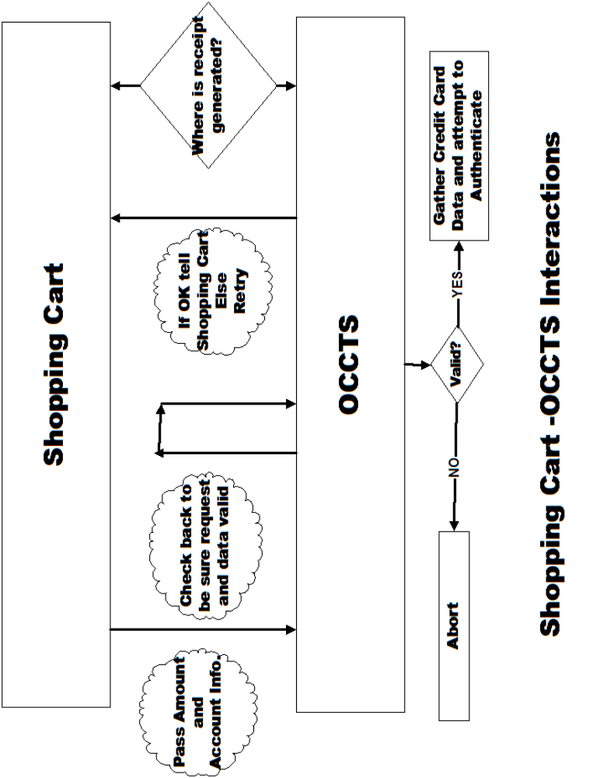

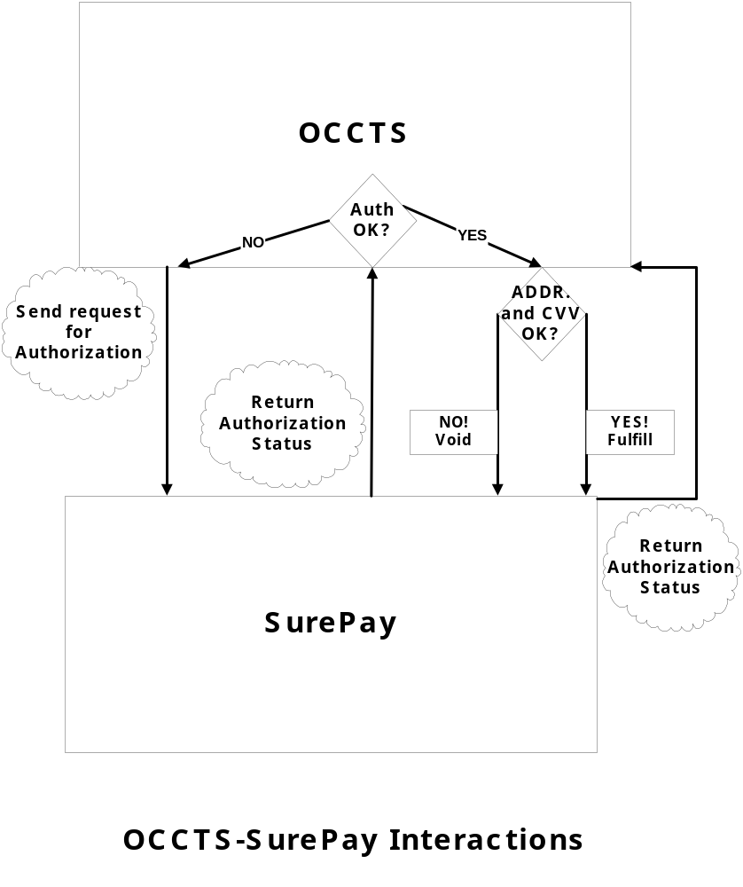

4. Sample OCCTS - Client Overview

When the user goes to make payment for a good or service they will click on a link from the client site that will send them to a page that will look similar to this:
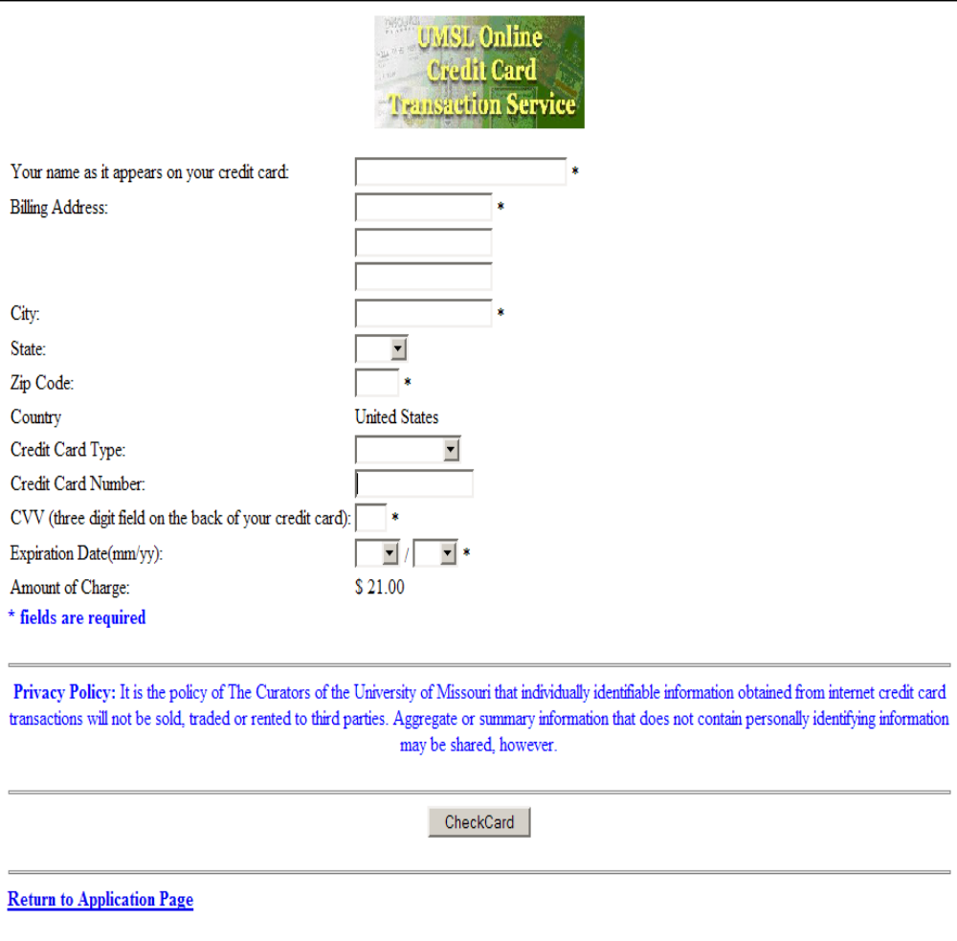
All fields are checked by Javascript functions on the client side for SurePay conformance before submittal is allowed. This check is a convenience for the user. They are rechecked and certain hidden fields are checked against the SHOPPING CART database to verify that this is a legitimate Form submission. Failure to pass either test results in the session being aborted. The user sees a screen similar to

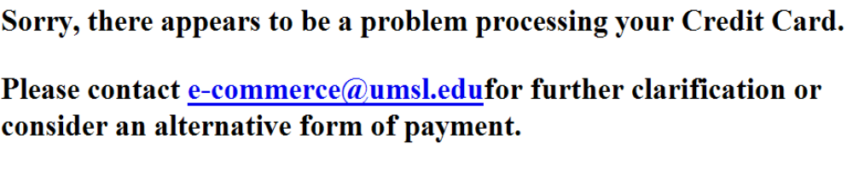

In addition:
- The time and IP address of the submitter is logged.
- A Real Time Alert is sent to monitoring systems.

Assuming the request for authorization appears to be legitimate, the data is sent through a secure socket to the 3rd party credit card authorization service currently used by the University of Missouri. A response comes back as either authorized or declined from that service. If the authorization is OK then the user is referred to a receipt page and the OCCTS logs the transaction references and sends another request for fulfillment of payment back to the 3rd party credit card authorization service. If the authorization is declined then user is referred back to OCCTS to attempt to re-enter valid credit card information to make payment. The user is allowed 9 chances to receive authorization over a 5 minute period before the session is aborted.

5. Application Design Considerations and Details

The Choice of Java-Apache–Tomcat

The choice of Java was certainly driven by familiarity with the environment. Another important factor was the existence of a mature set of APIs to other software technologies that would be needed to implement the OCCTS (See Section 3 - The OCCTS Software). Finally, high-level support for Threads is a critical element in any project of this type. Robust support for Threads is available in the java.lang API. The Threaded nature of the OCCTS will be discussed in more detail in the next section.
The choice of Tomcat as an Application Server followed from the choice of Java as the development language. Tomcat is the Servlet container that has been designated as the official Reference Implementation for the Java Servlet and JavaServer Pages technologies. As such there is the promise of portability to other platforms, should such a need arise.
While Tomcat could stand alone as a Webserver, Apache has historically provided a more secure production platform. Indeed, in the OCCTS environment, all requests for service are passed through Apache to Tomcat. In particular, Apache acts like a proxy server. Apache, itself, never directly returns Web Pages, “htdocs” is “Forbidden.” Finally, the choice of Apache 1.3 over Apache 2.0 was based on the maturity of 1.3 as well as the fact that it was only being asked to support a single application.

Portability

The OCCTS software was written with the possibility of moving to other platforms and providing service to additional vendors in mind. Two Objects support this objective, web.xml and the class Mdata.
web.xml is the standard configuration file for a Tomcat/Sun “web-app.” For OCCTS actual values would be substituted in appropriate places.

<?xml version="1.0" encoding="UTF-8"?>
<!DOCTYPE web-app PUBLIC "-//Sun Microsystems, Inc.//DTD Web Application 2.2//EN"
"http://java.sun.com/j2ee/dtds/web-app_2_2.dtd">
<web-app>
<display-name>Ecommerce TAGS AND SERVLETS</display-name>
<description>
This is the collection Ecommerce UMSL-Specific Tags and Servlets </description>
<servlet>
<servlet-name>
CreditCardServlet
</servlet-name>
<servlet-class>
CreditCardServlet
</servlet-class>
<init-param >
<param-name >file_base</param-name>
<param-value>location of various template files used to generate return pages</param-value>
</init-param>
<init-param >
<param-name >log_base</param-name>
<param-value>location of OCCTS logs</param-value>
</init-param>

<init-param >
<param-name >URLHost</param-name>
<param-value>The Credit Card validation service host </param-value>
</init-param>

<init-param >
<param-name >SSLHost</param-name>
<param-value>The real time potential attack alert host</param-value>
</init-param>

<init-param >
<param-name >ssl_base</param-name>
<param-value>location of ssl certificates</param-value>
</init-param>
<load-on-startup >1</load-on-startup>
</servlet>

<servlet-mapping>
<servlet-name>
CreditCardServlet
</servlet-name>
<url-pattern>
/CreditCardServlet
</url-pattern>
</servlet-mapping>

</web-app>

Interpretation: Tomcat will only accept a single URL for OCCTS,
<host>/ecommerce/CreditCardServlet

All other classes in the ecommerce classes directory are shielded from inappropriate access. This limits possible attacks on the web-app.

Six parameters are passed to the web-app on startup. There name and role are explained in the XML document above.

The “load-on-startup” tag enhances performance after reboot.

Mdata is a container merchant specific data such a account identifiers, passwords, and database access methods. Its class summary is,

Field Summary
java.lang.String | appl_id

Constructor Summary
Mdata(java.lang.String appl_id)

Method Summary
java.lang.String | getMerchant()
java.lang.String | getPassword()
java.lang.String | getTheDataSource()
java.lang.String | getUserName()
java.lang.String | getUserPassword()
void | record_adjustment(java.lang.String tr, AdjustResponse[] ajsp)

Interpretation: ap_prefix identifies the merchant. The first two methods provide the data necessary to access the credit card validation service. The next three methods provide the data necessary to access local data stores. Finally, the final method provides and electronic paper trail to verify that the Adjustment step for the credit card transaction was completed.

Ecommerce Server Logs

Three logs are maintained on the on the e-commerce server to track transaction activity.

request.log – provides 4 coordinates for a transaction. An example of a line in this file is

June 11, 2002 12:58:04 PM GMT-06:00 - 134.124.48.29 - CE1363 - CC_FV2B68920E30

Where –
  - The time stamp is computed early in the credit card validation process.
  - The IP address is that of the client system.
  - The third entry is the order number passed by the SHOPPING CART application.
  - The fourth entry is the transaction ID passed by SurePay.

response.log – records the two XML documents returned by SurePay to complete the transaction. An example of the documents are

<?xml version="1.0" encoding="UTF-8"?>
<!DOCTYPE pp.response PUBLIC "-//IMALL//DTD PUREPAYMENTS 1.0//EN" "http://www.purepayments.com/dtd/purepayments.dtd">
<pp.response>
<pp.authresponse merchant="1001" ordernumber="96" transactionid="CC_FV2B68920E2F" authcode="OK2062" avs="YYY" cvv2result="X" authstatus="AUTH"/>
</pp.response>

<?xml version="1.0" encoding="UTF-8"?>
<!DOCTYPE pp.response PUBLIC "-//IMALL//DTD PUREPAYMENTS 1.0//EN" "http://www.purepayments.com/dtd/purepayments.dtd">
<pp.response>
<pp.authresponse merchant="1001" ordernumber="96" transactionid="CC_FV2B68920E30" authcode="OK2063" avs="YYY" cvv2result="X" authstatus="AUTH"/>
<pp.adjustresponse merchant="1001" ordernumber="96" transactionid="CC_FV2B68920E2F"/>
</pp.response>

error.log – contains records of system software errors such as socket timed out, connection refused, and possible intrusion.

6. Software Overview

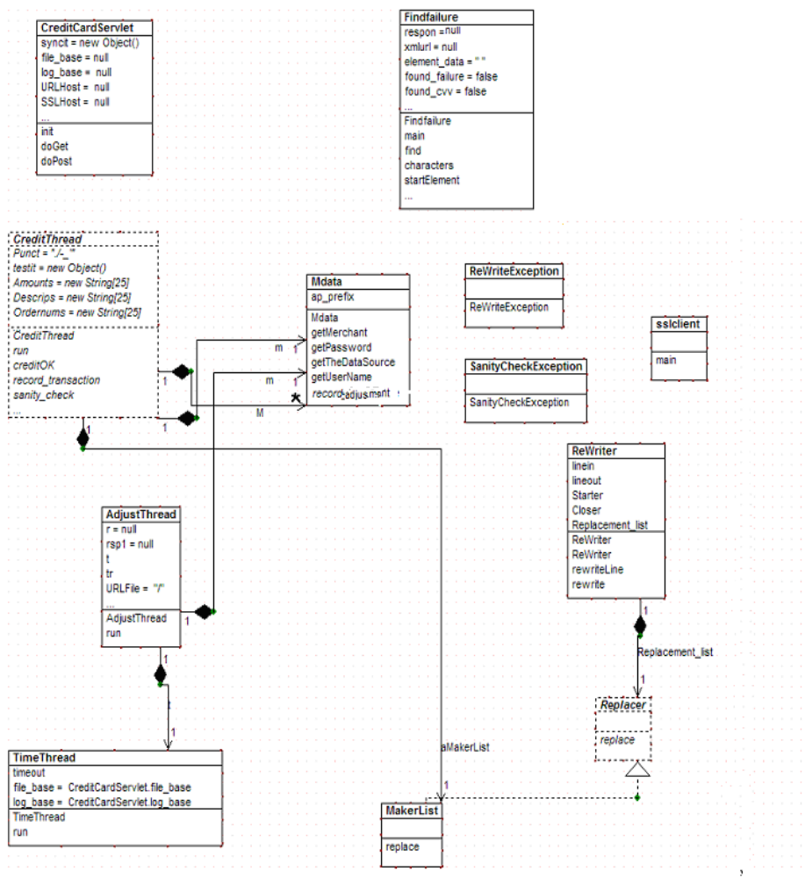

Software Narrative

CreditCardServlet has two major responsibilities. Firstly, it processes all service requests to determine the appropriate application specific logic. Based on the appl_id, it instantiates and calls the run() method of the appropriate sub-class of CreditThread. The second major responsibility is to start a background Thread, TimeThread, during init().

TimeThread also has two major responsibilities, canceling stall sessions and starting background Threads (AdjustThread) to perform the Adjustment step for Authorized Credit Card transactions.

CreditThread is an abstract class and must be subclassed to be instantiated. In point of fact, CreditThread, provides the core logic for the Authorization step in Credit Card transactions. The methods of CreditThread are overridden to provide application specific processing, Graduate Application, Continuing Education, etc. The methods that most likely to be application specific, hence candidates to be overridden are

- sanity_check() – This method is meant to capture the logic of Field value retrieval and analysis. An issue here is that SurePay uses a DTD rather than the XML Schema that it really needs .In particular, the processing of POST data. The expectation is that if inappropriate data is detected a SanityCheckException is thrown and the session is aborted.

- record_transaction() – The expectation is that this method will be used to record appropriate transaction data in an external database.

- creditOK() – The expectation is that this method will be used as a gateway back to the SHOPPING CART or, perhaps, to return a receipt to the client.

- theKey() - This abstract method is an artifact of the Java programming language. Its function is simply to force CreditThread to be subclassed, a programmer design decision.

Other Classes

- Findfailure – Used to parse the XML documents that are returned by the Credit Card transaction service. The decision as to whether or not to accept the Transaction will be determined by the result.

- Replacer, ReWriter, ReWriteException – A simple template rewriting system. Essentially, }}name{{ gets replaced by value, where name is the name of a Field.

- sslclient - A simple SSL broadcast tool to alert monitoring systems of abnormal activity of the OCCTS sever.

- Supporting OCCTS

Moving the Application
Issues:
- JSE 1.4.1 – The application was developed with Java Standard Edition 1.4.1, which incorporates support that was previously only available in separate APIs. For example, moving to a 1.3 would require making sure that the certain SSL libraries are available.
- Servlet Context – web.xml Tomcat provides a convenient mechanism for establishing a Servlet Context. Moving to a different Application Server will require understanding how Servlet Contexts are established. Incidentally, there is nothing application specific about the various paths in web.xml. Any paths visible to the server will do.
- Libraries – Under Tomcat 4.1, the lib directory under WEB-INF provides a convenient place to put .jar files that must be available to the “webapp.” A simple solution that would work on any Application Server is to unzip them in the classes directory.

Adding a Merchant

Three .java files must be visited in order to add a Merchant. The files must be recompiled and Tomcat restarted. In all probability the required changes would be minimal, involving the identification of appropriate databases and SQL statement.

CreditCardServlet – A new “appl-id” is required. By convention, this a two character identifier for the new Merchant. To this point the only Merchant using the OCCTS is the Graduate School and its appl-id is “GA”. The “appl-id” is used throughout the credit card transaction process to identify the appropriate logic for the Merchant on whose behalf the transaction is In CreditCardServlet it is used to select the appropriate subclass of CreditThread, instantiate that class and invoke its the run() method. Note that it is the run() method rather than the start(). This is because of the fact that while it is strictly true that each instance of a subclass of CreditThread runs in its own Thread. It is the Thread of the doPost() responsible for the particular request for service.

Mdata – This is basically a store for the various IDs and passwords associated with the Merchant. The code is simple and self-documenting. There is one method, record_adjustment(), that requires some discussion. In the first version of this software it was found in AdjustThread and had the responsibility of recording the fact that the adjustment phase of the credit card transaction was completed in the Shopping Cart database. In point of fact, the best and most complete source of this information can be found on the SurePay site. Whether or not, other Shopping Carts will wish to provide a non-trivial implementation is unclear. This is reflected in the fact the the present implementation is of the form

if(appl_id.equals(“GA”){
//record something
}else{
//do nothing
}

–A new class ec<newMerchant> (see ecGrad) This class overrides four methods of CreditThread

- theKey() – In CreditThread this is an abstract method. This method is never called. Its only role is to support developers by separating the SurePay logic in CreditThread , from merchant-specific logic.
- retrieve_amount() and
- record_transaction () - These methods are used to communicate with the Shopping Cart database. Tailoring these methods probably can be accomplished by identifying the database instance and substituting the appropriate SQL statements. One additional point is that, as written, retrieve_amount() also checks to be sure that the Application fee has not already been paid. It will not allow a second, accidental, payment to be processed.
- creditOK() – This method is called at the very end of the CreditThread run() method As such, this is a place suitable for generating a return Page for the user. In ecGrad the Page is generated by a “redirect” to the ShoppingCart. This overrides a method in CreditThread that provides the appropriate code for generating a receipt within the OCCTS itself.

Appendix A



