Improving Chiller Health: IBM and Intel Show the Value of Real Time Edge Connectivity in Applications of Predictive Maintenance and Quality

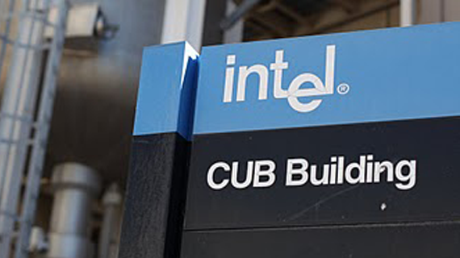
Fabricating the most powerful chips on the planet is a serious industry. At Fab 11x in New Mexico, the whole process hinges on a sophisticated utilities system managed in the Central Utilities Building. From electricity to ultra-pure water cooling to compressed air and atmosphere conditioning, if the utilities break down it could spell disaster for the hyper sensitive equipment of the Fab.

Keeping the 380,000 square foot Fab cool falls to the job of a very sophisticated network of cooling systems: chillers, water towers, fans, and heat exchange systems. The chiller systems – responsible for cooling water used for driving the entire plant, are massive machines which run continually and work together to deliver adequate cooling.
“You can’t take your eye off the ball for a moment,” says Glen Kilcup, Managing Engineer at Fab 11 “if we don’t keep these systems running at optimal levels, we risk plant shutdowns.” The network of 22 chillers run on traditional automated PLC based controls – and can be turned on and off based on plant requirements or to perform maintenance.
Intel’s Fab 11 Central Utilities Building, in the heart of New Mexico
Taking a chiller offline for a full reconditioning is a tall order, but necessary; these are half million dollar pieces of equipment, installed over weeks in an intricate plant setup. Each rebuild costs $50,000 -- and the plant rebuilds at least 5 chillers annualy to keep them running reliably and efficiently. Unplanned downtime can put strain on systems that may be due for reconditioning. But even when things aren’t failing – or about to fail – the CUB has its workplate full. Running a plant this interconnected is one thing; running one efficiently is another.

Intel’s Fab 11 is reknown not only for the sophistication of the plant, but for its approach to supporting the environment. On an annual basis, energy saving efforts save 2.2 million kilowatt-hours. “We are challenged to continuously improve our energy consumption. A poorly running chiller consumes more energy -- if we can save just a few points of energy, and understand what makes certain chillers less efficient, we can make the whole plant more efficient.

Intel turned to its own Internet of Things group to look for answers. Data from sensors on all of the equipment in the central utilities building is captured on a robust closed network – completely isolated from the outside world. Data is transferred via PLCs to industry standard real time monitoring systems. These systems come preconfigured with lots of information. “We have lots of raw data – but as is common in this sector, alerts from industrial equipment are good at telling you when things have gone wrong—but we want to get ahead of problems before they happen.”

Intel has been a long time partner with IBM, and the two companies were already at work looking for test cases for its new edge computing devices, the IoT Gateway, and IBM’s leading Predictive Maintenance & Quality (PMQ) solution. The Intel Gateway family is a low cost technology device that intelligently connects to systems via common protocols (like Bluetooth Low Energy or Zigbee) – and after performing embedded filtering specific to the industry, streams this data to the cloud for analysis. IBM’s PMQ solution blends its leading cloud-based integration services and advanced analytics to identify problems with assets and recommend corrective actions.

“We knew right away, “ says Jen Bossin, of Intel’s IoT Strategy group, “that the Utilities efficiency process was something to pursue.”

Industrial chillers, like many PLC controlled systems, are designed to be self-contained. While they do have mechanisms for extracting data individually, chillers at the fab are part of a much broader network. Data is representative of the way machines talk. Unlike traditional enterprise systems in, say marketing or customer relationship management, machines communicate by relaying bus register settings. Data can be monitored at almost any granularity – from once every 5-10 minutes, to many times per second. Monitoring systems traditionally let an operator see the running state, but looking back in time – or predicting the future, is well beyond the scope of most systems. Fortunately, Intel had extended a data capture platform using the HVAC industry standard MODBUS to capture historical performance.
Jimmy Meyers, an Intel Technician checks on Chiller 4 at Intel Fab 11

IBM and Intel partnered together to examine a chiller. Leveraging the data archives from a representative chiller, a team of data scientists led an effort to differentiate between what makes a chiller run efficiently, and what leads to problems. Forecasting chiller efficiency can help the team save energy and take steps to improve overall chiller health.

Rob Risany, Worldwide Innovation Executive for IBM’s Analytics Solutions observes, “Imagine going to the doctor and having that doctor not know what was important to look for when diagnosing an illness. That’s what operators at the CUB deal with everyday when it comes to chiller health. We set out to find the key issues which would tell us when a chiller was going to perform poorly so that the operators could make changes to drive efficiency”

The analytics in IBM’s PMQ platform found a high relationship between motor power consumption, heat buildup, and evaporator / condenser pressures. More importantly, it discovered that, much like the stock market, the current values showing on the monitoring equipment weren’t as important as their relationship to the historical moving averages of key values. “This is a fluid system – previous states directly impact current state.”

Time of chiller runs is as major factor in chiller efficiency. Like starting and stopping your car is bad for your engine, so short runs of a chiller degrade performance. But, eventually over-running the system degrades performance. It turns out that running a chiller for 20 hours will generate the best cumulative chiller efficiency.

So armed with insights from modeling, and the factors to watch for, Intel’s IoT team now had specific items to filter in the real time data pull with the gateway. “We chose a 5 minute poll to limit network impact – and we’re pulling only the 40 variables needed by IBM PMQ to predict chiller performance and alert operators to upcoming risks, ” observes Jen Bossin. The Intel Gateway seamlessly plugs into the MODBUS architecture and can transform that data from register-based gibberish to a cleanly understood JSON message structure, delivered over MQTT, the high speed messaging protocol.

IBM’s IoT Foundation receives the messages and passes them to IBM PMQ where a real time modeling services assesses current state, displays a realtime dashboard of critical values, and archives the message for future model improvement.

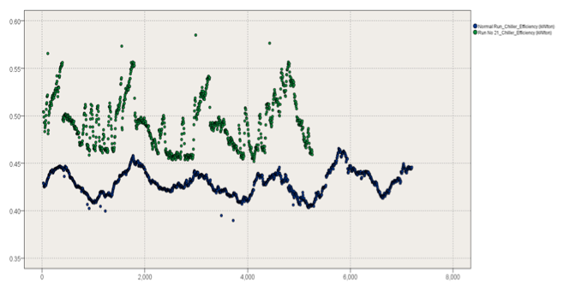
“This system continually improves,” says Rob Risany. “We’re not just watching the bouncing ball on a monitor – we’re actively pushing the data from the chiller through the predictive models – this tells us whether we have a healthy run or an unhealthy run underway, and we can alert an operator on issues which are impacting performance.”
A PMQ dancing dashboard highlighting real time data received from the Intel Gateway against what the models have deemed normal for a healthy chiller. The green line shows a chiller that is not efficient versus normal.
The first stages of deployment are focused on providing new levels of insights to the managers of the utilities building. By seeing information and relationships they’ve never seen before, the team will be able to tune chiller settings to optimize energy efficiency.

Says Glen Kilcup, looking at a view of the key measures the integrated Intel / IBM system provides to his team, “It’s like you’ve created a giant flashlight and are shining a light on things we’ve never seen before.”

The work is far from over. As described, a single chiller lives in a network of 22. And those 22 chillers are in a complex integrated facility which includes power conditioning, water management, air circulation, and heat exchangers. Once the chiller system is in place for awhile, extending the system to deal with all of these variables will be a fun challenge for the Intel and IBM PMQ team.

ABOUT THE INTEL GATEWAY

Acquire, Analyze, and Proactively Act with Intel® IoT Gateways and IBM Predictive Maintenance and Quality (PMQ)

Across industries, enterprises are looking for new ways to gain insights from the massive amount of data being collected across their systems to optimize the use of their physical assets, operations and processes, maximize return on investment (ROI), and exceed service level agreement (SLA) expectations. The opportunity to gain better insights in every industry comes from the explosion of connected devices that enterprises must secure and manage on their networks.
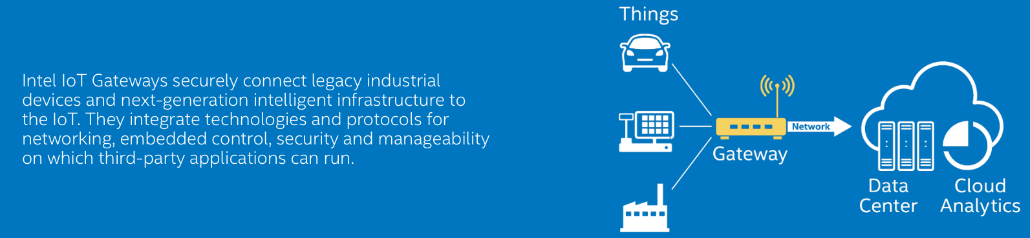
Intel® IoT Gateways with IBM Predictive Maintenance and Quality (PMQ), available either on-cloud or on premise, acquires real-time data from various types of sensors and helps you to monitor, maintain, and optimize assets for better availability, utilization and performance. From monitoring factory machine conditions to detecting anomalies in wind turbines, Intel IoT Gateways connect all of your THINGS to the analytics which can detect failure conditions and automatically trigger maintenance resources to fix problems before outages occur .

With enhanced, secured, and actionable insight at the edge and at the cloud, Intel IoT Gateways with IBM PMQ help asset-intensive businesses to proactively detect failure patterns to maximize utilization and performance, while minimizing costly unscheduled downtime

Real-time Data Management
With the range of available processors from Intel® Quark™ and Intel® Atom™ processors at the edge, Intel IoT Gateways help turn information into action by locally aggregating data from multiple edge devices. Together with IBM’s PMQ, the real-time information can be integrated with existing static data and historical profiles to provide optimized recommended decisions to people and systems

Advanced Security for Trusted Data from Edge to Cloud
With integrated McAfee security software, IoT Gateways and Intel® Xeon™-based servers combined with IBM SoftLayer cloud enable a secure, and protected, infrastructure from the edge to the cloud

Manageability
Intel IoT Gateways pre-integrate the Wind River Edge Management System via an available agent, providing cloud connectivity to facilitate device configuration, file transfers, data capture, and rules-based data analysis and response

Scalable Architecture
With Intel® Inside, Intel IoT Gateways and Intel Xeon-based servers provide an inherently flexible and scalable infrastructure from the edge to the data center. IBM PMQ extends the scalable architecture and data integration with out-of-the box connectors and API’s to link to many systems, and data sources (structured and unstructured)

Capabilities of Intel IoT Gateways
Aggregate and filter data from several types of sensors, PLCs, and robotics using several protocols at the edge (on the factory floor)
Analyze and act upon critical information in near real time
Reduce data transmission, storage, and analysis costs by performing some analysis at the edge
Tightly integrate critical hardware-based security of Intel processors with operating system and application software security
Flexible and scalable infrastructure from the edge to the datacenter
Flexible architecture to ingest various types of data, and performance to meet varying workload requirements and varying environmental conditions
Preconfigured to provide cloud connectivity to facilitate device configuration, file transfers, data capture, and rules-based data analysis and response
Support a wide range of operating systems and ecosystem applications
Out of the box support for the IBM IoT Foundation for data delivery via TCPIP (hardwired or WiFi) or cellular (3G or 4G)

An On-ramp to Real Time Predictive Analytics and
Intel Gateways make integrating real-time data into IBM PMQ easier than ever. With open connection via multiple protocols, and proven methodologies to enable predictive insights and prescriptive actions, the combination of the Intel IoT Gateway and the IBM PMQ Solution is the fastest way to deliver actionable insight to decision makers.

About IBM PMQ

IBM’s PMQ approach is logical and straight – forward, yet fundamentally flexible and changeable.

First we help you connect to data from the things that make your business tick. Our experience includes systems both large and small. As one of the early pioneers in edge connected computing, we have clients who have been leveraging our technology to capture and analyze data from tractors to satellites, from planes to trains, and from mobile devices to large scale supercomputers.

Once we connect to data, we leverage world-class analytics at the core of our solution to analyze what matters most inside your data. Beyond basic transaction analytics – which are fine for identifying unusual data changes or variance through basic techniques like anomaly detection – we leverage a host of advanced and predictive analytics. With the largest math department in the world, our innovations in mathematics enable us to find new ways to identify and exploit patterns in data. From machine based learning, to segmentation and forecasting, to optimization and cognitive computing, IBM’s platform of analytics gives clients insights far beyond what is possible with simple statistical testing techniques.

All the insights in the world don’t help if they can’t be deployed to the people that need them most. IBM provides open services for creating mobile applications and sophisticated monitoring and notification systems. As opposed to starting from scratch, IBM has created accelerators that can get you operating your business in new ways fast.

All of our capabilities are dual deployable; we build our technology cloud-enabled, and on-premise ready. From multi-tenant to private cloud, to hybrid deployment configurations, we can ensure your data is maintained securely and in compliance with regulations specific to your needs. One size need not fit all.

The IBM PMQ Solutions Platform
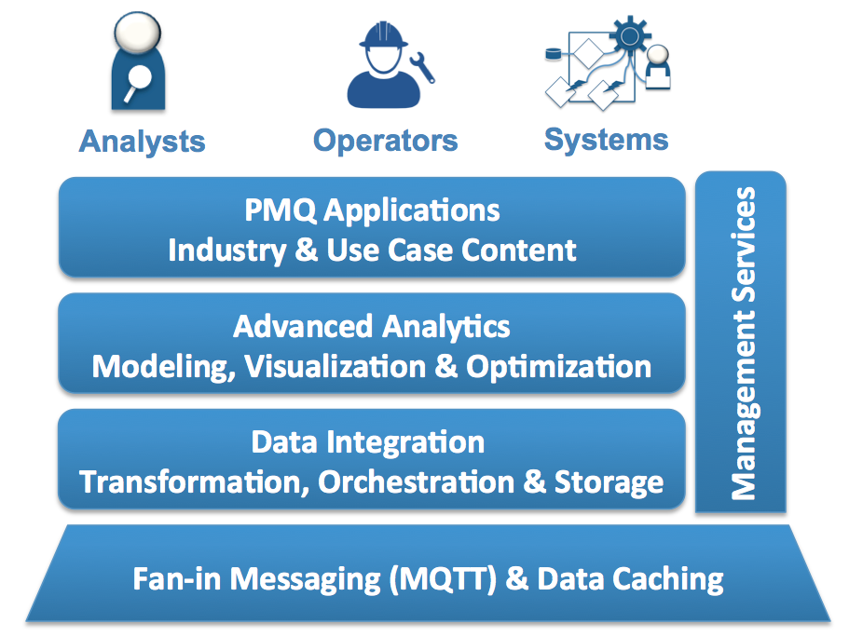
PMQ is possible because of the robust platform on which applications are built. First and foremost, PMQ integrates cleanly to the Internet of Things, making source data available in real time through an openly messaging and data caching facility, hosted in the cloud. Data integration facilities ensure that data is made available to the right places at the right level of granularity and security.

Secondly, the PMQ platform is tightly integrated with IBM’s Advanced Analytics suite of technologies. Real time Visualization and standard reporting on sensors in the field is an out of the box capability.
Beyond basic visualization, which has been available for many years, the PMQ Platform includes IBM’s award winning data mining technologies (e.g. SPSS Modeler) as well as decision support optimization capabilities (e.g. CPLEX). Practitioners with appropriate skills can customize predictive models and forecasts for use in a wide array of operational use cases.
The IBM PMQ Platform

Finally, PMQ’s reference platform is designed to be extended with client specific Intellectual Property. IBM can work with you to provide focused analytic applications built on the PMQ platform which are focused on your use cases for your own use or for delivery to your own clients. From pre-defined predictive models, mobile applications, adapters to target control systems (e.g. MODBUS) or data standards (e.g. IATA).

Capabilities of IBM Predictive Maintenance and Quality (PMQ)
APIs and connectors to integrate with systems of record and engagement, sensors, PLC, SCADA, EAM, MES, ERP
Historical views of maintenance and operational data to identify root causes of asset failure
Predictive models: asset- & industry-specific, maintenance, sensor health, top failure reasons, integrated health, quality early warning system, optimization, custom, automated model refresh
Early warning analysis -- Identify minute changes in material, process or product quality well in advance of traditional statistical process control methods
Apply predictive models to real-time operational data to assess asset or process health
Automated decision management and recommendations based upon analysis of historical operational data and current asset health score
Configurable dashboards & reports: site overview, product quality, real-time and historic performance, quantitative & qualitative KPIs, recommendations
Native integration with IBM Maximo to automatically initiate work orders and include recommendations based upon asset health

About the PMQ Alliance

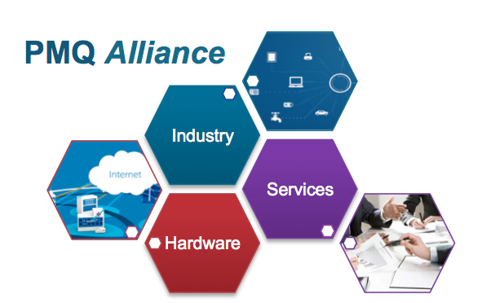
Intel is a member of the IBM PMQ Alliance.

IBM is investing significantly in the Industrial Internet – from data gathering to systems integration, to analytics and visualization, to work order management and systems intervention. We recognize that the opportunity is much bigger than a set of enabling technologies.

True innovation requires a symbiotic view of the relationship between data, hardware, and services. We are committed to an open view of how clients will solve problems in this next phase of connected computing.

The PMQ Alliance is a manifestation of that commitment. We bring together leading hardware, services and data partners together to criss-cross industry knowledge and expertise. As the largest supporter of open-source systems, IBM is creating an ecosystem where new ideas can flourish, and new businesses can emerge.

IBM’s PMQ Alliance provides flexible options for creating and extending your value proposition with IBM Technology. Best of all, we can facilitate interconnections with other PMQ Alliance partners who may have value to broaden or deepen solution vision. Working closely with special focus on client objectives, we support flexible options for creating and marketing PMQ based solutions.

