Study suggests Earth is heading toward a second catastrophic hot-house event
By Chris Mooney The Washington Post • Sunday March 27, 2016
If you dig deep enough into the Earth's climate change archives, you hear about the Palaeocene-Eocene Thermal Maximum, or PETM. And then you get scared.
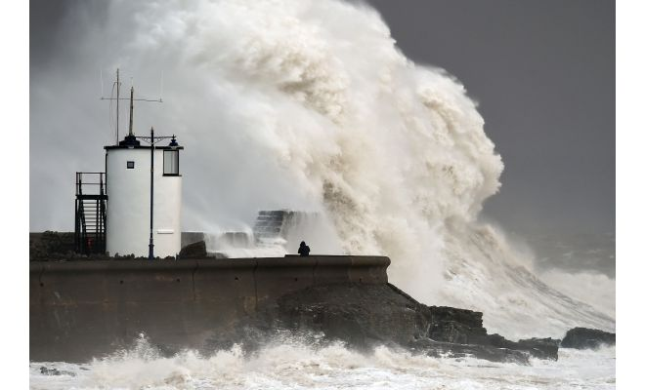
That was a time period, about 56 million years ago, when something mysterious happened — there are many ideas as to what — that suddenly caused concentrations of carbon dioxide in the atmosphere to spike, far higher than they are right now.
Figure 1 Waves crash over the sea wall at Porthcawl in Wales. Winds of nearly 100 mph battered Britain in February after Storm Imogen slammed into Britain's south coast. Some experts say more-intense storms are a sign of climate change due to global warming
The planet proceeded to warm rapidly, at least in geologic terms, and major die-offs of some marine organisms followed due to strong acidification of the oceans.
The cause of the PETM has been widely debated. Some think it was an explosion of carbon from thawing Arctic permafrost. Some think there was a huge release of sub-sea methane that somehow made its way to the atmosphere — and that the series of events might have been kickstarted by major volcanic eruptions.
In any case, the result was a hothouse world from pole to pole, some 5 degrees Celsius warmer overall. But now, new research suggests, even the drama of the PETM falls short of our current period, in at least one key respect: We're putting carbon into the atmosphere at an even faster rate than happened back then.
Such is the result of a new study in Nature Geoscience, led by Richard Zeebe of the University of Hawaii at Manoa, and colleagues from the University of Bristol in the United Kingdom and the University of California-Riverside.
"If you look over the entire Cenozoic, the last 66 million years, the only event that we know of at the moment that has a massive carbon release and happens over a relatively short period of time is the PETM," Zeebe said. "We actually have to go back to relatively old periods, because in the more recent past, we don't see anything comparable to what humans are currently doing."
That's why this time period is so crucial to study — as a possible window on our own.
There's no doubt that a lot of carbon — about as much as is contained in the fossil fuel reserves that humans have either already burned or could still burn combined — made its way into the atmosphere during the PETM. The result was a major warming event that lasted more than 100,000 years. But precisely how rapidly the emissions occurred is another matter.
"If anthropogenic emissions rates have no analogue in Earth's recent history, then unforeseeable future responses of the climate system are possible," the authors write.
To examine what happened in the PETM, the researchers used a deep ocean core of sediment from off the coast of New Jersey. The goal was to determine the ratios between different isotopes, or slightly different elemental forms of carbon and oxygen, in the sediments during the PETM.
The relationship between the two lets researchers determine how atmospheric carbon dioxide levels, as reflected in the ratio of carbon 12 to carbon 13, influenced temperatures, which can be inferred based on oxygen isotopes in the ocean.
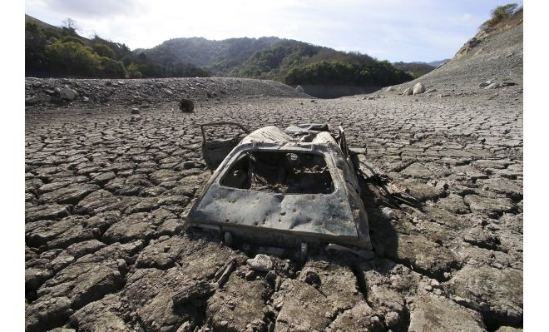
"In terms of these two systems, the first shows us when the carbon went into the system and the second tells us when the climate responded," Zeebe said.
Figure 2 A car is mired in muck at the bottom of the Almaden Reservoir in San Jose, exposed by the drought in California, now into its fifth year
It turns out that there is a lag time between massive pulses of carbon in the atmosphere and subsequent warming because the oceans have a large thermal inertia. Therefore, a large lag would indicate a greater carbon release, whereas the lack of one actually means that carbon dioxide came out more slowly.
The geologic evidence from the new core did not show a lag, the new study reports. That means, the authors estimate, that while a gigantic volume of carbon entered the atmosphere during the PETM — between 2,000 and 4,500 billion tons — it played out over some 4,000 years. So only about 1 billion tons of carbon were emitted per year. In contrast, humans are now emitting about 10 billion tons annually — changing the planet much more rapidly.
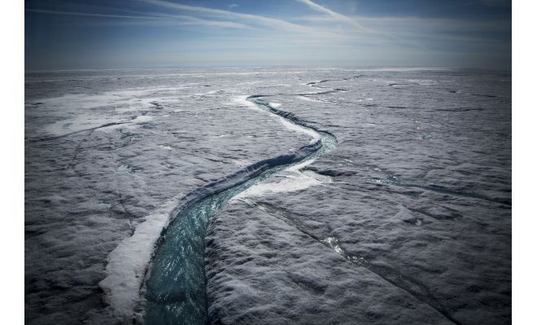
"The anthropogenic release outpaces carbon release during the most extreme global warming event of the past 66 million years by at least an order of magnitude," writes Peter Stassen, an Earth and environmental scientist at KU Leuven in Belgium, in an accompanying commentary on the new study.
Figure 3 Meltwater flows along a supraglacial river on the Greenland ice sheet. The ice sheet is one of the biggest and fastest-melting chunks of ice on Earth
The analogy between the PETM and the present, then, is less than perfect — and our own era might be worse in key ways.
"The two main conclusions is that ocean acidification will be more severe, ecosystems may be hit harder because of the rate" of carbon release, Zeebe said.
And not only have we only begun to see the changes that will result from current warming, but there may be other changes that lack any ancient parallel, because of the current rate of change.
"Given that the current rate of carbon release is unprecedented throughout the Cenozoic, we have effectively entered an era of a no-analogue state, which represents a fundamental challenge to constraining future climate projections," the study concludes.

