New global heat records set for October and year-to-date (2015)
Figure 1 Last month was the hottest October in modern history and the first 10 months of the year have also been record warm, US government scientists (AFP Photo/Peter Parks)
Miami (AFP) - Last month was the hottest October in modern history and the first 10 months of the year have also set new records for worldwide warmth, US government scientists said Wednesday.
The latest data means that 2015 is firmly on pace for being the most scorching since 1880, as global warming concerns mount ahead of key climate talks in Paris starting later this month.
October marked the sixth month in a row that heat records were shattered across the planet, said the monthly report by the US National Oceanic and Atmospheric Administration.
"The globally averaged temperature over land and ocean surfaces for October 2015 was the highest for October since record keeping began in 1880," said NOAA.
"The year-to-date (January-October) was also record warm." 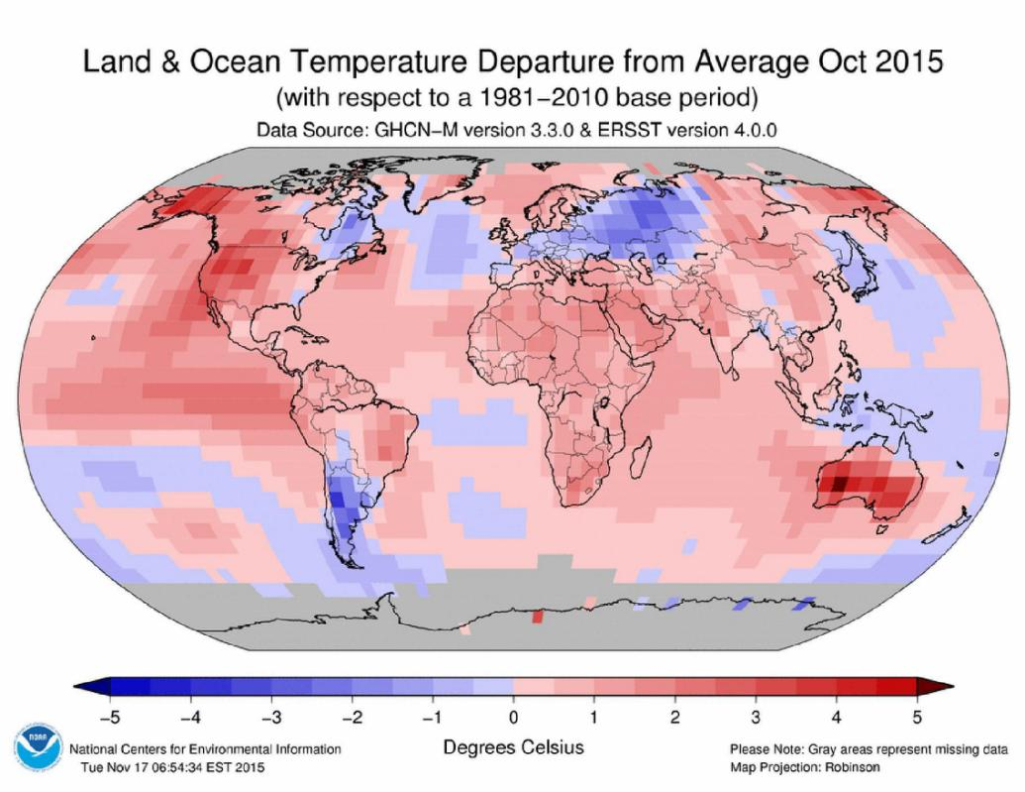
Figure 2 This graphic provided by National Oceanic and Atmospheric Administration (NOAA) shows land and ocean temperatures for October 2015. Even for a record breaking hot year for Earth, October stood out as absurdly warm. The hottest October on record by a third of a degree over the old mark, a large margin for weather records. (NOAA via AP)
So far this year, the average temperature across land and ocean surfaces has been 1.55 Fahrenheit (0.86 Celsius) above the 20th century average.
"This was the highest for January-October in the 1880-2015 record, surpassing the previous record set last year by 0.22 F (0.12 C)," said NOAA.
"Eight of the first ten months in 2015 have been record warm for their respective months."
The United States saw its warmest October since 1963, and Australia experienced its hottest October since 1910. Africa had its warmest October on record, said the report.
Parts of southern South America, Eastern Europe and Russia were cooler than average. 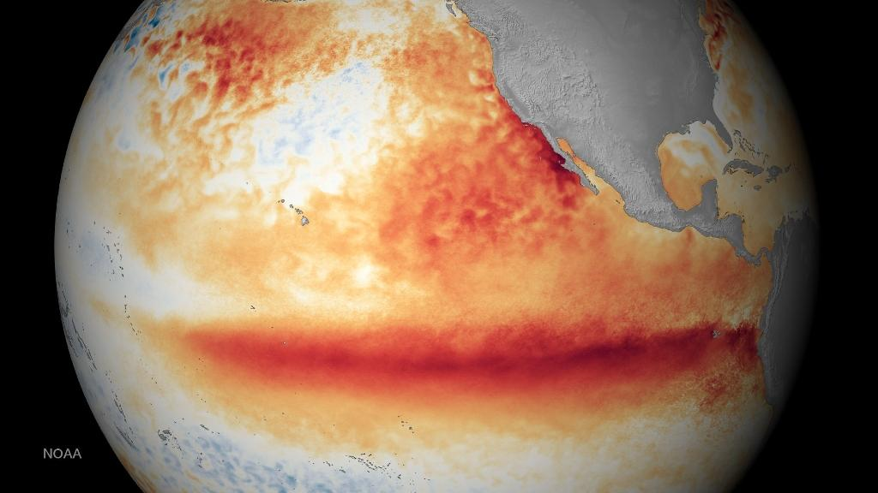
Figure 3 A National Oceanic and Atmospheric Administration satellite image shows the sea surface temperature for the month of October 2015, where the orange-red colours are above normal temperatures and indicative of El Niño (AFP Photo/)
Arctic sea ice was at its sixth lowest level since 1979.
Strong El Nino conditions helped propel global sea surface temperatures to 1.53 Fahrenheit (0.85 Celsius) above the 20th century average, "the highest departure for October on record," said NOAA.
Yahoo News
It's official: This is the biggest El Niño on record, and a killer La Niña is coming – check the web article: http://www.businessinsider.com/biggest-el-nio-killer-la-nia-coming-2015-11

