El Nino worst in over 15 years, severe impact likely: UN
By Nina Larson in the Essential California Newsletter
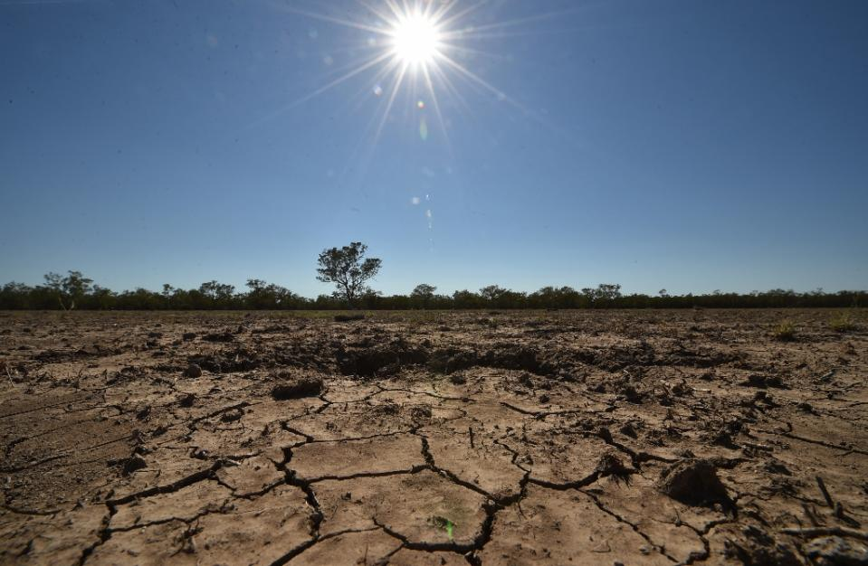
Figure 1 © AFP/File / by Nina Larson | El Nino, a global weather pattern that periodically wreaks havoc, is expected to last until early 2016, leaving some parts of the world in drought and bringing heavy rains and flooding to others
GENEVA (AFP) -
The "El Nino" phenomenon, which sparks global climate extremes, is this year the worst in more than 15 years, the UN weather agency said Monday, warning it was already causing severe droughts and flooding.
The World Meteorological Organization said El Nino, which occurs every two to seven years, had resurfaced a few months ago, become "mature and strong", and was expected to become even more powerful by the end of the year.
"Severe droughts and devastating flooding being experienced throughout the tropics and sub-tropical zones bear the hallmarks of this El Nino, which is the strongest in more than 15 years," WMO chief Michel Jarraud said in a statement.
El Nino is triggered by a warming in sea surface temperatures in the Pacific Ocean. It can cause unusually heavy rains in some parts of the world and drought elsewhere.
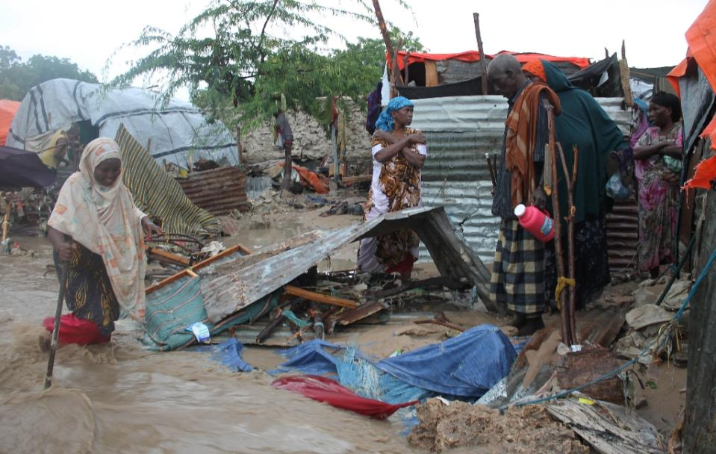
Figure 2 El Nino is triggered by a warming in sea surface temperatures in the Pacific Ocean. It can cause unusually heavy rains in some parts of the world and drought elsewhere (AFP Photo/Abdulfitah Hashi Nor)
The UN agency said this year's event was expected to push water surface temperatures in the east-central Pacific Ocean more than two degrees Celsius above normal, making it one of the four strongest El Ninos since 1950.
Previous particularly strong El Ninos occurred in 1972-73, 1982-83 and 1997-98.
Typically, El Nino events reach their maximum strength between October and January, but often continue to wreak havoc through the first quarter of the year.
- Climate change impact -
The phenomenon usually leaves countries like India, Indonesia and Australia drier, increasing chances of wildfires and lower crop production.
In recent months, bone-dry conditions caused by the El Nino have sparked some of the worst forest fires in Indonesia's history.
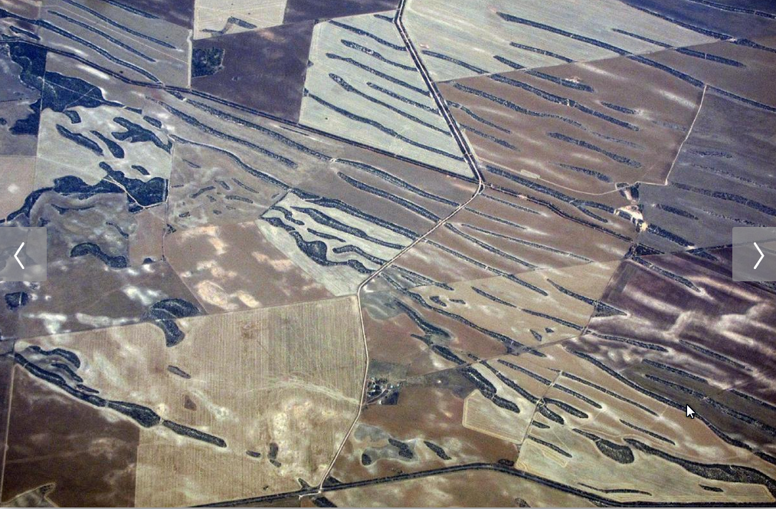
Figure 3 Lines of trees can be seen amongst drought effected farmland in South Australia, November 12, 2015. A pioneering Australian scheme to improve the management of water in the world's driest inhabited continent is facing its first real test as an intensify El Nino threatens crops and builds tensions between farmers and environmentalists.
The phenomenon also often leads to heavier rainfall in the eastern Pacific and South American nations, raising the spectre of floods and landslides.
WMO linked this year's El Nino to the "very active tropical cyclone season" in the Pacific, including the record-breaking Hurricane Patricia that hit Mexico last month.
The UN meanwhile warned last week that El Nino could significantly increase the number of people going hungry, as countries like Sudan, Eritrea, Ethiopia and Djibouti are expected to see drier conditions, and others, including Kenya, Somalia and Uganda are at risk of floods.
While El Nino will certainly have severe impacts in many parts, Jarraud said the world was far better prepared for the event than in the past.
"The level of international, national and local mobilisation is truly unprecedented," he said, pointing out that a wide range of disaster management campaigns were expected to "save lives and minimise economic damage and disruption."
But while scientific understanding of the phenomenon has increased, Jarraud warned that due to climate change it could be "playing out in uncharted territory."
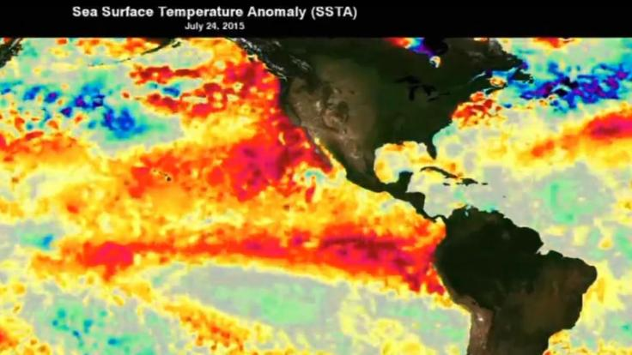
Figure 4 The red areas are the areas of greater warming.
While scientists say climate patterns like El Nino are not caused by climate change, rising ocean temperatures caused by global warming is believed to impact their intensity and frequency.
"This naturally occurring El Nino event and human induced climate change may interact and modify each other in ways we have never before experienced," Jarraud said.
"Even before the onset of El Nino, global average surface temperatures had reached new records. El Nino is turning up the heat even further," he added.
WMO published its El Nino update ahead of a conference in New York Tuesday on the climate pattern, and just weeks before a global summit in Paris tasked with sealing a climate rescue pact.
El Niño 'is here, and it is huge,' as officials race to prep for winter
El Niño continues to gain strength in the Pacific Ocean, climate experts said, with unusually wet conditions expected to hit California between January and March -- and perhaps into May.
The latest forecast increased the urgency for both government agencies and property owners to prepare for possible flooding.
Local flood control agencies are busy clearing out storm drains, catch basins and other waterways.
In Los Angeles, the California Department of Transportation is increasing its maintenance staff by 25% through the winter months to deal with El Niño. The agency is stockpiling sandbags, readying plows and earth-moving equipment, and pruning trees and brush.
"January and February are just around the corner. If you think you should make preparations, get off the couch and do it now. These storms are imminent," said Bill Patzert, a climatologist for NASA's Jet Propulsion Laboratory in La Canada Flintridge. "El Niño is here. And it is huge.... At this point, we're just waiting for the impacts in California."
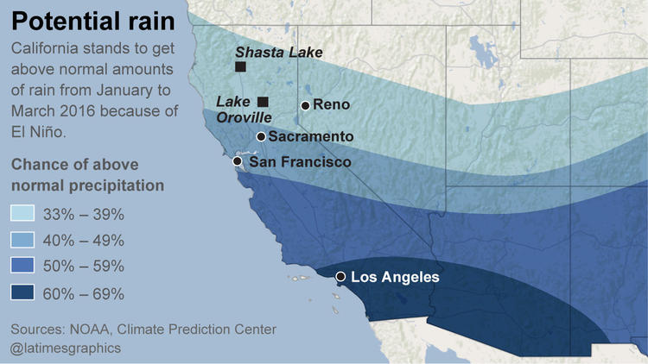
Potential rain from El Nino.
The National Weather Service's Climate Prediction Center said El Niño is already strong and mature, and is forecast to continue gaining strength. It is expected to be among the three strongest on record since 1950.
Generally, El Niño doesn't peak in California until January, February and March, Patzert said. That's when Californians should expect "mudslides, heavy rainfall, one storm after another like a conveyor belt."
On Nov. 4, sea surface temperatures in a benchmark area of the Pacific Ocean west of Peru hit 5 degrees Fahrenheit above average, outpacing the abnormally warm temperatures seen at this time of year in 1997, which developed into the strongest El Niño on record.
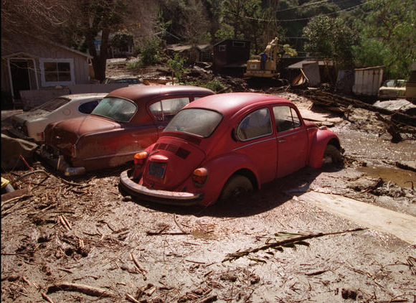
The importance of the El Niño storm of 1997-1998 is now coming into focus as scientists say the weather pattern is returning to Southern California with a vengeance.
El Niño has already caused major effects across the world, fueling an active and unusually powerful hurricane season in the eastern Pacific Ocean, including Hurricane Patricia, which hit Mexico last month.
Chile, home to one of the world's driest deserts, is now blooming with flowers from unusually high rainfall. But in other regions, El Niño means drought, which is already being reported in Indonesia and the Philippines. Earlier this week, the United Nations Children's Fund warned that "11 million children are at risk from hunger, disease and lack of water due to El Niño in eastern and southern Africa alone."
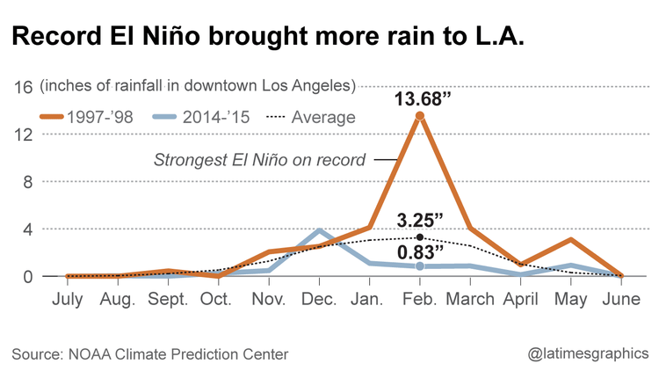
On Thursday, the United Nations warned that more than 2 million people in Central America will need food aid due to a drought worsened by El Niño, which has caused significant failure in crop harvests. The storms that usually keep the jungles of southern Mexico and Central America wet shift northward to California and the southern United States during strong El Niño winters.
The Climate Prediction Center has forecast above-average precipitation for much of California between January and March.
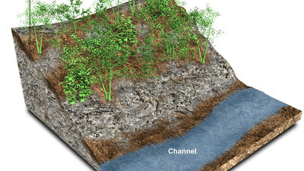
How debris flows happen (check this web site!)
Patzert said one of the upsides in the forecast is epic surfing. Past El Niños have brought winters that went down in surfing history, and "it was one great set after another," he said.
"But the other side of epic surf is battered beach communities. That's the flip side of it. The epic surf years also meant that beach communities were battered from Northern to Southern California."
Despite all the talk of El Nino, Gov. Jerry Brown remains cautious.
Brown said Friday that Clifornia's urban areas should prepare to keep conserving water until at least next fall.
In a new executive order, the governor said that if the drought continues through January, mandatory water cuts will remain in effect until October.
Brown's original order, issued in April, was effective only until February.

