Beyond record hot, February was 'astronomical' and 'strange'
SETH BORENSTEIN,Associated Press
WASHINGTON (AP) — Earth got so hot last month that federal scientists struggled to find words, describing temperatures as "astronomical," ''staggering" and "strange." They warned that the climate may have moved into a new and hotter neighborhood.
This was not just another of the drumbeat of 10 straight broken monthly global heat records, triggered by a super El Nino and man-made global warming. February 2016 obliterated old marks by such a margin that it was the most above-normal month since meteorologists started keeping track in 1880, according to the National Oceanic and Atmospheric Administration.
The old record was set just last December and the last three months have been the most above-normal months on record, said NOAA climate scientist Jessica Blunden. And it's not just NOAA. NASA, which uses different statistical techniques, as well as a University of Alabama Huntsville team and the private Remote Sensing System team, which measure using satellites, also said February 2016 had the biggest departure from normal on record.
NOAA said Earth averaged 56.08 degrees (13.38 degrees Celsius) in February, 2.18 degrees (1.21 degrees Celsius) above average, beating the old record for February set in 2015 by nearly six-tenths of a degree (one-third of a degree Celsius). These were figures that had federal scientists grasping for superlatives.
"The departures are what we would consider astronomical," Blunden said. "It's on land. It's in the oceans. It's in the upper atmosphere. It's in the lower atmosphere. The Arctic had record low sea ice." 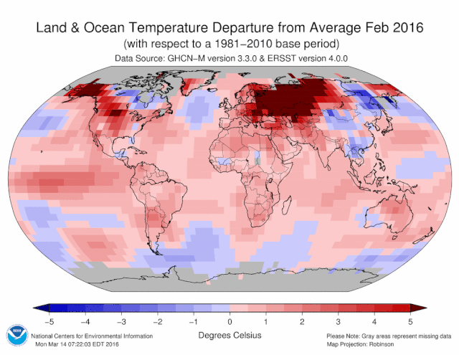
"Everything everywhere is a record this month, except Antarctica," Blunden said. "It's insane."
In the Arctic, where sea ice reached a record low for February, land temperatures averaged 8 degrees above normal (4.5 degrees Celsius), Blunden said. That's after January, when Arctic land temperatures were 10.4 degrees above normal (5.8 degrees Celsius).
Worldwide, February 2016 was warmer than about 125 of the last 136 Marches.
It was also the warmest winter — December through February — on record, beating the previous year's record by more than half a degree (0.29 degrees Celsius).
Georgia Tech climate scientist Kim Cobb said she normally doesn't concern herself much with the new high temperature records that are broken regularly.
"However," she added in a Thursday email," when I look at the new February 2016 temperatures, I feel like I'm looking at something out of a sci-fi movie. In a way we are: it's like someone plucked a value off a graph from 2030 and stuck it on a graph of present temperatures. It is a portent of things to come, and it is sobering that such temperature extremes are already on our doorstep."
Scientists at NOAA's National Centers for Environmental Information in Asheville, North Carolina, were astonished by the "staggering" numbers, said Deke Arndt, the centers' global monitoring chief.
"Usually these are monthly reminders that things are changing," Arndt said. "The last six months have been more than a reminder, it's been like a punch in the nose."
NASA's chief climate scientist Gavin Schmidt usually discounts the importance of individual record hot months, but said this month was different, calling it "obviously strange."
This was due to the long-term warming from heat-trapping gases and the powerful El Nino, so these types of records will continue for a few more months, but probably will not be a permanent situation, Schmidt said in an email.
But other were not so sure, including Arndt, who compared it to moving into a new hotter neighborhood.
"We are in a new era," Arndt said. "We have started a new piece of modern history for this climate."
Jason Furtado, a meteorology professor at the University of Oklahoma who wasn't part of any of the government teams, simply wrote in an email: "Welcome to the new normal."
___
Online:
NOAA: www.ncdc.noaa.gov
___
Follow Seth Borenstein at http://twitter.com/borenbears and his work can be found at http://bigstory.ap.org/content/seth-borenstein

Earth crushed temperature milestones this winter, edging closer to climate guardrail
Andrew Freedman,Mashable
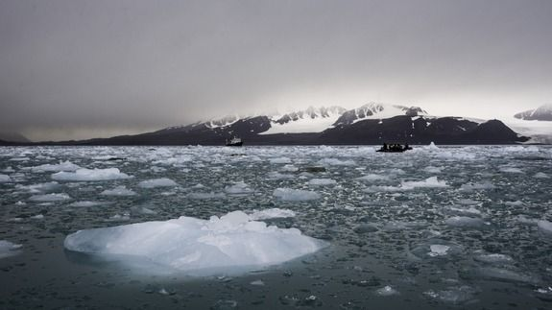
More all-time global heat records bit the dust this winter than were initially suspected, according to a new and shocking National Oceanic and Atmospheric Administration (NOAA) report released Thursday.
Due to a combination of human-caused global warming and a powerful El Niño event in the Pacific Ocean, the month of February ranked as the most unusually warm month in the 137-year period of record, with global average surface temperatures running at 1.21 degrees Celsius, or 2.18 degrees Fahrenheit, above the 20th century average.
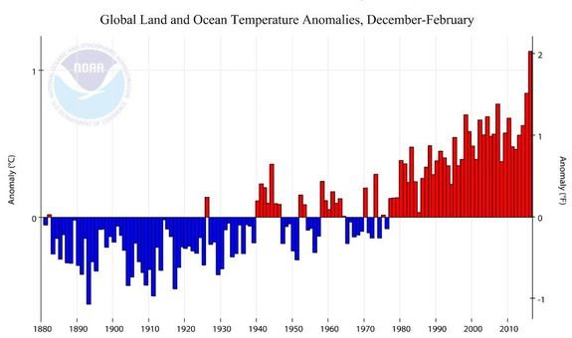
Global average surface temperature anomalies during the December 2015 to February 2016 period.
Image: NOAA
This blew away the previous record for the most unusually mild month, which was set just two months ago in December, by 0.09 degrees Celsius, or 0.16 degrees Fahrenheit.
"Overall, the six highest monthly temperature departures in the record have all occurred in the past six months," the NOAA report stated.
In addition, February 2016 was the 10th-straight month to set a monthly temperature record.
When compared to average temperatures early in the industrial revolution, it becomes clear that global average surface temperatures — or at least temperatures in the northern hemisphere — have been flirting with the internationally-defined climate guardrail of 2 degrees Celsius, or 3.6 degrees Fahrenheit, above the preindustrial average.
Limiting warming to well below this level is the official goal enshrined in the 2015 Paris agreement on climate change, but it seems that at least for now, the warmth already circulating in the climate system, from the depths of the ocean to the upper atmosphere, may be outpacing the ability for countries to slash emissions.
Warm lands, oceans and a skipped winter in the Arctic
According to NOAA, most of the world's land surfaces were either warmer than average or much warmer than average for the month, including much of southern Africa, southern and eastern Europe, most of Southeast Asia and Australia, and from central Russia into eastern Europe. In addition, most of Alaska was unusually mild.
Parts of Russia, eastern Europe and Alaska saw temperatures that were more than 5 degrees Celsius, or about 9 degrees Fahrenheit, above the 1981-2010 average, NOAA found. This was "beyond the upper bounds" of NOAA's temperature anomalies map, meaning that the agency ran out of colors to communicate the freak warmth.
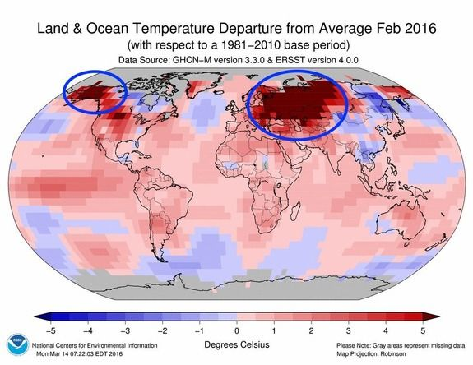
Temperature departures from average during February 2016. Circled areas indicate areas exceeding NOAA's upper bounds for temperature anomalies.
Image: NOAA NCEI
In the U.S., Alaska reported its warmest February in its 92-year period of record, at 6.9 degrees Celsius, or 12.4 degrees Fahrenheit, higher than the 20th century average.
The oceans, too, were record warm for the month, at 0.81 degrees Celsius, or 1.46 degrees Fahrenheit, above the 20th century average. This beat previous records set in 1998 and 2015 by a long shot — by 0.36 degrees Celsius, or 0.20 degrees Fahrenheit.
The ocean temperatures also made February the sixth-highest departure from average in 1,646 months of NOAA's records. Notably, the nine highest monthly global ocean temperature departures have all occurred in the past nine months (since July 2015).
During El Niño events, the waters in the equatorial tropical Pacific Ocean heat up, adding heat to the atmosphere and altering weather patterns worldwide.
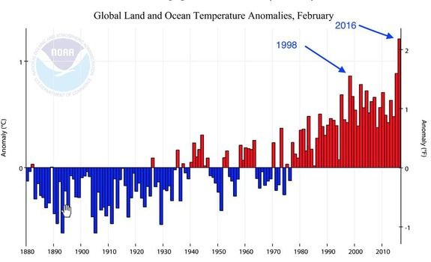
Global average temperature anomalies during Feb. 2016. Arrows point to difference between 2016 El Niño and 1998.
Image: NOAA/NCEI
However, in an indication that the record warmth seen in February, as well as in 2015, has not solely been the work of El Niño, NOAA found that other major ocean basins, such as parts of the eastern Indian Ocean, western North Atlantic, and western Pacific were also record warm for the month.
In addition, there's the fact that this El Niño-related temperature spike has reached far higher levels compared to previous events of similar intensity.
In fact, as a general rule, both El Niño and its cooling-effect sibling, La Niña, are getting milder over time as human-caused global warming continues to accelerate.
"Yes, of course El Niño has a hand in the February and other monthly temperatures records we've been observing, but not the only hand, not even the winning hand," Jessica Blunden of the National Center for Environmental Information in Asheville, told Mashable in an email on March 14, in the wake of new NASA temperature data.
"During the last big El Niño event of 97/98, temperatures departures from average were much lower compared with what we're seeing now with this comparable event, which shows us that general warming is occurring over time," she said.
Typically, El Niño's strength, which is measured in sea surface temperature anomalies, peaks in the oceans a few months before the warming influence is maximized in the atmosphere.
This year, the oceans hit their mildest levels in November, before cooling off slightly.
This means that the atmospheric warming effect from El Niño was stronger in February, giving global average surface temperatures an additional boost on top of long-term human-caused global warming.
The NOAA data is backed up by NASA's findings, which also ranked February as the most unusually mild month on record, as well as satellite data showing the same results.
Record warm winter
The December to February seasonal global average temperature anomalies also stand out from the historical records.
These months are defined by meteorologists as the winter months, and this year, the period was 1.13 degrees Celsius, or 2.03 degrees Fahrenheit, above average for the globe, making it by far the mildest such three-month period since 1880 as well as the highest 3-month departure from average for any 3-month period on record.
Much of Central America and northern South America, southern Africa, southern Europe, north-central Siberia, and parts of south and southeast Asia were record warm, NOAA found.
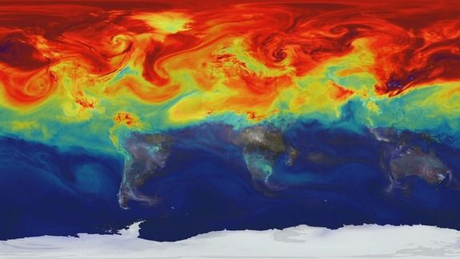
Visualization of carbon dioxide emissions around the world.
Image: NASA
There were 115 weather stations in 38 countries across all continents except Antarctica that set new February high temperature records, NOAA found. No land areas saw significantly cooler or record cold conditions during the period.
The lower 48 states had their warmest winter on record, with six northeastern states all having a record warm such period. Alaska had its second warmest winter on record, at 5.9 degrees Celsius, or 10.6 degrees Fahrenheit above average.
The world's oceans also set a record high for December through February.
The warmth was especially pronounced in the Arctic, where some areas experienced average winter temperatures of more than 9 degrees Fahrenheit above average and the near total absence of sea ice.
Massive areas of the globe, stretching from Alaska, across Canada, throughout the Arctic Ocean and into Russia, had average February temperatures that were at least 4 degrees Celsius or 7.2 degrees Fahrenheit, above average. These mild conditions were both related to the low sea ice conditions and also made it more difficult for sea ice to recover.
The Barents and Kara Seas, north of Scandinavia and northwest of Russia, were especially mild this winter.
Georgia Tech climate scientist Kim Cobb said the February statistics, combined with the other recent record warm months, are a preview of the climate of the future as global warming continues.
"When I look at the new February 2016 temperatures, I feel like I'm looking at something out of a sci-fi movie. In a way we are: it's like someone plucked a value off a graph from 2030 and stuck it on a graph of present temperatures," she told the AP. "It is a portent of things to come, and it is sobering that such temperature extremes are already on our doorstep."
Snow and sea ice
The average Arctic sea ice extent for the month of February was 450,000 square miles below the 1981-2010 mean, according to the National Snow and Ice Data Center. This departure from average is about the size of the states of Texas, Arizona and Kansas combined.
This was the lowest on record for the month, although the period of records is not long, dating back to 1979. The NSIDC has not yet announced with another record low seasonal ice maximum has been set in the Arctic, as occurred last year.
February marked the second month in a row to see a record low Arctic sea ice extent.
In addition, northern hemisphere snow cover extent during February was 800,000 square miles below average for the month, making it the third-smallest in the 50-year period of record.

