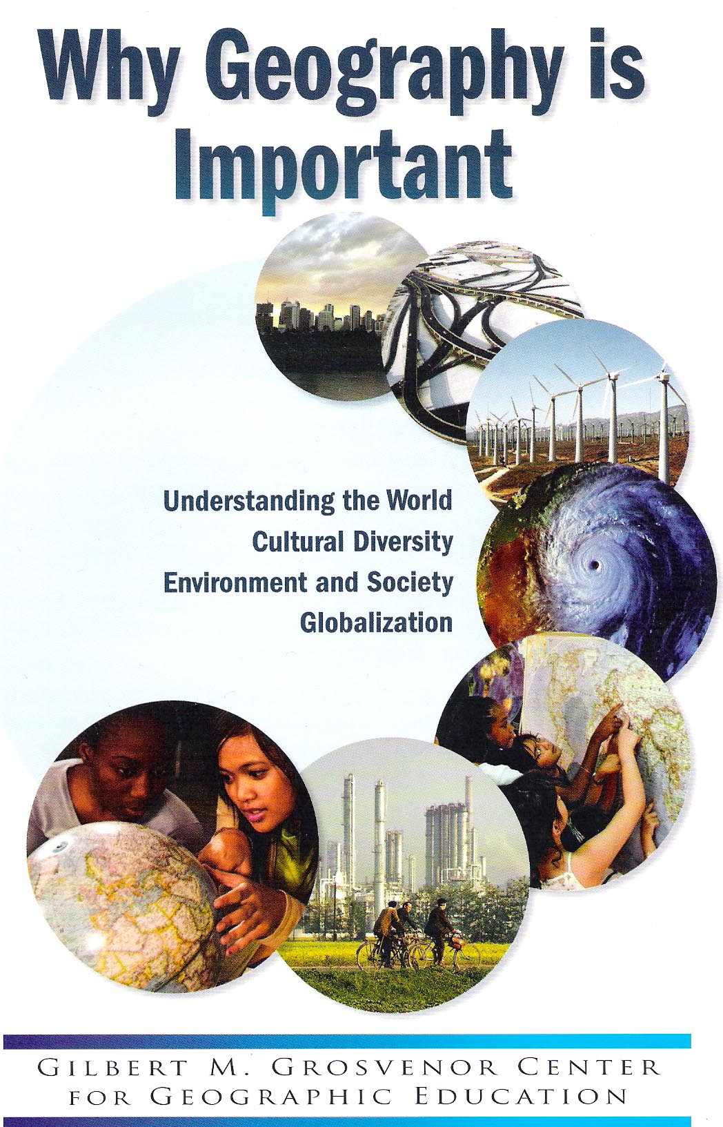

This is a project of the Gilbert M. Grosvenor Center for Geographic Education, Department of Geography, Texas State University-San Marcos, funded through a grant from the National Geographic Society Education Foundation. Writing committee members include:
Kristin J. Alvarez, New Hampshire Geographic Alliance, Keene
State College
Marci Smith Deal, K-12 Social Studies Curriculum Coordinator,
Hurst-Euless, Bedford ISD (Texas)
Gary M. Gress, Oklahoma Alliance for Geographic Education,
University of Oklahoma
Charles F. Gritzner, South Dakota Geographic Alliance, South
Dakota State University
Robert W. Morrill, Virginia Geographic Alliance, Virginia Tech
University
Zoran Pavlovic, Independent Scholar
Chris Shearer, National Geographic Society Education Foundation Joseph P. Stoltman, Michigan Geographic Alliance, Western
Michigan University
William R. Strong, Alabama Geographic Alliance, University of
North Alabama
Richard G. Boehm (Organizer and Chair), Texas Alliance for
Geographic Education, Jesse H. Jones Distinguished Chair in
Geographic Education, Texas State University

Local arrangements and publication preparations were handled by Judy Behrens, Grosvenor Center for Geographic Education.
Layout and print assistance was provided by John Ballay and Audrey Mohan, National Geographic Society.

Cover photos courtesy of (front to back):
Students using globe. Jen Caito. My Wonderful World
Refinery in Ploiesti, Romania. Winfield Parks, National Geographic Society
Students using a world map. National Geographic Education and Children's Programs
Hurricane Katrina approaches New Orleans on August 25. 2005. Photo courtesy of Ray Sterner and Steve Babin, Johns Hopkins
University Applied Physics Laboratory; NOAA
Wind turbines atTehachapi Pass. California. U.S. Department of Energy
Highway overchange in Montreal, Quebec. Emory Kristof, National Geographic Society
Brisbane, Australia. Audrey Mohan

Why Geography is Important
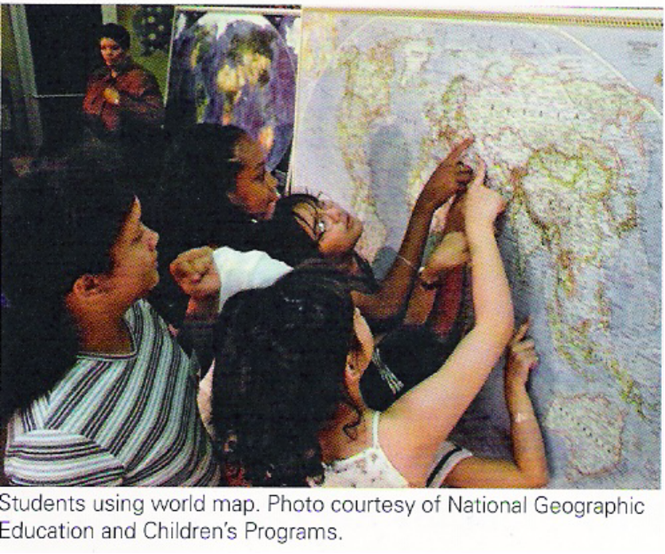
Geographic literacy is crucial for the future of America. We are now far behind. The 2002 National Geographic/ Roper poll indicated that of nine major countries, the United States ranked second to last, above only Mexico, in a recent survey (2006), only one out of ten Americans, aged 18-24, could find Afghanistan on a map of Asia. Seven out of ten could not locate North Korea, and six out of ten could not find Iraq or Saudi Arabia. These are simple map location questions, further suggesting that Americans may not know much about the economic, political, cultural, or military importance of these areas.
More and better geography in our schools can correct this deficiency. Learning geography will create citizens who are able to understand and do something about some of the major issues and problems facing the United States and the world, including climate change, energy dependence, war and regional conflicts, globalization, and international terrorism. American decision makers need geographic knowledge to maintain our moral, political, and economic leadership in a world of complex cultural and environmental relationships.
As a measure of its importance, geography has been included as a "core" subject area in the three most recent national education plans-America 2000, Goals 2000, and No Child Left Behind. Since 1985, the National Geographic
Society has supported a state-by-state program to return geography to its rightful place in U.S. schools (see back cover) .

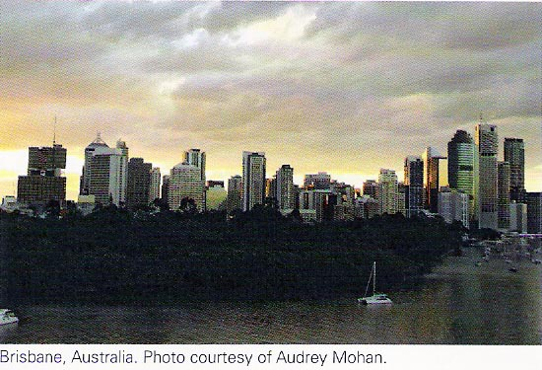
1. Globalization

Americans increasingly travel and work in areas beyond our communities, states, and nation. We interact with people, companies, and even governments around the world. The widespread Internet, and other information technology systems allows us to experience the world as a smaller and more interactive place. Economic globalization and job mobility require that Americans understand the nature of foreign cultures who represent, on the one hand, a labor force, and, on the other, a market area for our products. Geographic knowledge, skills, and technology provide a means to comprehend the rapidly changing physical and cultural environments of the world, and thus, prepare us to be better global citizens.
-

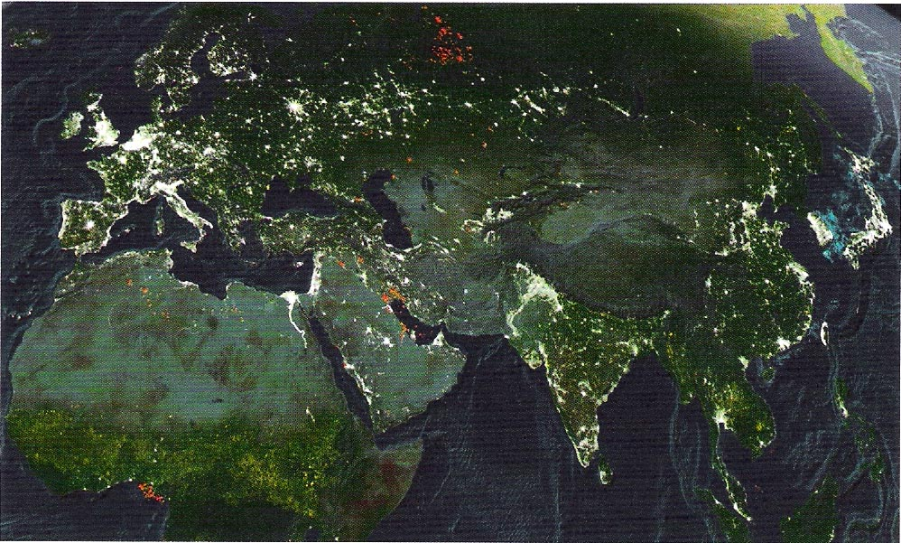

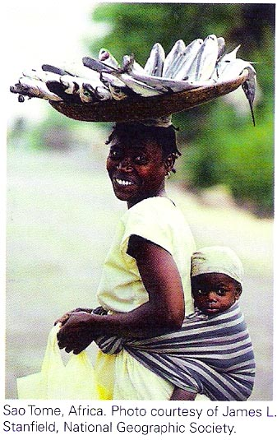
2. Cultural Diversity
Geography requires awareness of the importance of cultural diversity-that is, area differences in language, race, religion, and politics; generally, how and why people live the way they do. When American citizens appreciate cultural diversity, many issues and problems may be addressed in a positive manner. This awareness is valuable when we try to make sense of worldwide situations, as well as those in our own country. Our political, diplomatic, military, and economic leaders need to be well versed in cultural diversity, and geography offers a sensitive pathway to such understanding.
3. Technology and the Internet
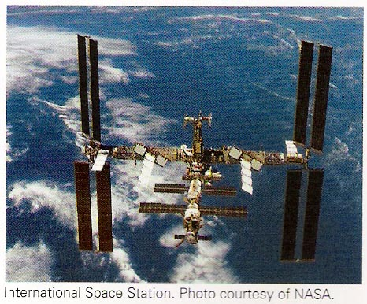
The information revolution expands our geographic horizons from local to global. Today, use of the Internet, Geographic Information Systems (GIS), Global Positioning Systems (GPS), and other mapping technologies give Americans access to a world of spatial (geographic) information. Whether obtaining and mapping geographic data, finding our way from one location to another, or learning more about specific places, technology has become an integral part of daily life. Many economic, political, and personal decisions now rely on sophisticated networks of computers and satellites. These high-tech systems form a global web that links people and places. Geography provides the key to understanding and effectively using these systems,

4. Business, Industry, and Social Services
Geographers have long recited the three most important factors in selecting sites for businesses and industry – location, location, location! Many large firms employ geographers who specialize in assisting businesses and industries to find suitable locations. The widespread use of GIS is helping to identify the best locations for many economic activities. Properly located industries are able to reduce the costs of transporting raw materials and marketing their products. Retail outlets, restaurants, shopping centers, and local businesses may find that a good location results in higher profits and more convenience and accessibility for the general public. Sensible locations for social services, such as health-care facilities, community centers, clinics, and day-care centers, benefit the users of these facilities by providing more efficient delivery of public services.

5. Climate Change
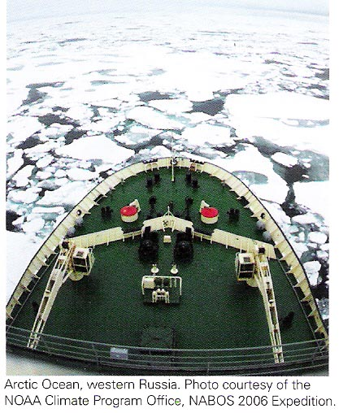
Climatic change is continuous. It affects global, regional, and local environmental conditions. Long-term changes in temperature and rainfall can disrupt ecosystems on land and in the water, and require human adaptation to varying conditions. EI Nino, La Nina, and reports of global warming are recent evidence of regional and worldwide climate change. Geography is the study of the interaction between people, places, and environments. How climate is changing and what we need to do is a central emphasis of geography. Environmental understanding means good decision making by informed and responsible global citizens.

6. Energy
Critical resources vital to all of us are not distributed equally across Earth's surface. This leads to foreign trade, but also to the reality that one country or region is highly dependent on another. For example, Japan and Western Europe rely

heavily on the energy resources of Southwest Asia (Middle East). The United States imports large quantities of oil from Canada, Venezuela, and Mexico. These important resource linkages sometimes become strained when political and economic alliances shift. Geographic knowledge is essential for understanding these complex trade relationships.
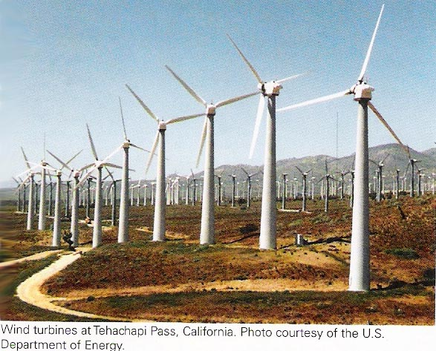
Learning about geography results in an understanding of how the United States is developing alternatives to heavy reliance on imported oil. Wind power and solar power are on the rise. More cropland is being used to grow corn for ethanol production. Hybrid automobiles are being built and expanding the use of nuclear power is again being discussed. Also, researchers are trying to find techniques for cleaner use of the world's abundant coal reserves. These are complicated matters with no easy solutions. For example, when land is transferred to corn production for ethanol, acreage devoted to other food crops declines and food prices increase around the world. There are important spatial and environmental aspects to these vital economic and political policy decisions. Geography students are well prepared to understand the complexities of such societal issues.
7. Natural and Technological Hazards
Nearly everyone is exposed to natural hazards, including hurricanes, floods, earthquakes, wildfires, landslides, volcanic eruptions, and drought. Some hazard events are much more devastating than others. The Indonesian tsunami in 2004 and Hurricane Katrina in 2005 provided vivid testimony to the dire consequences of living in the pathways of destructive natural hazards. By better understanding these catastrophic events, those who study geography realize the importance of early warning systems and effective local, state, national, and international emergency management and recovery strategies.
Human-generated technological hazards, such as air pollution, solid- and toxic-waste materials, and water pollution, challenge us to better manage our interaction with the natural environment. Geography students, at an early age, learn about ways to conserve and preserve our resources, and how important it is to keep our air, water, and land suitable for future generations. Geography challenges citizens to become better environmental stewards.
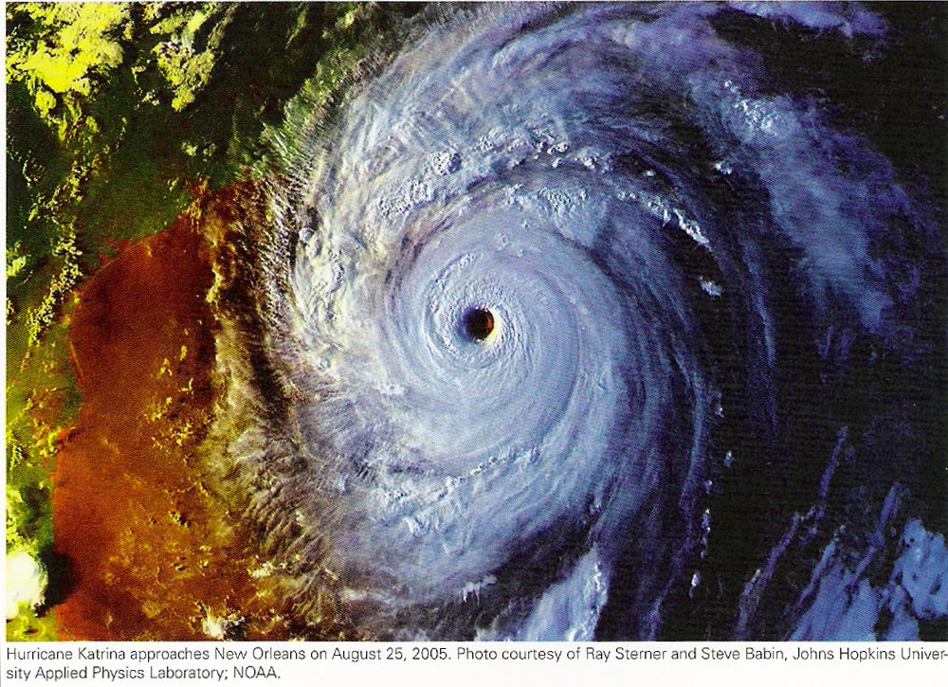
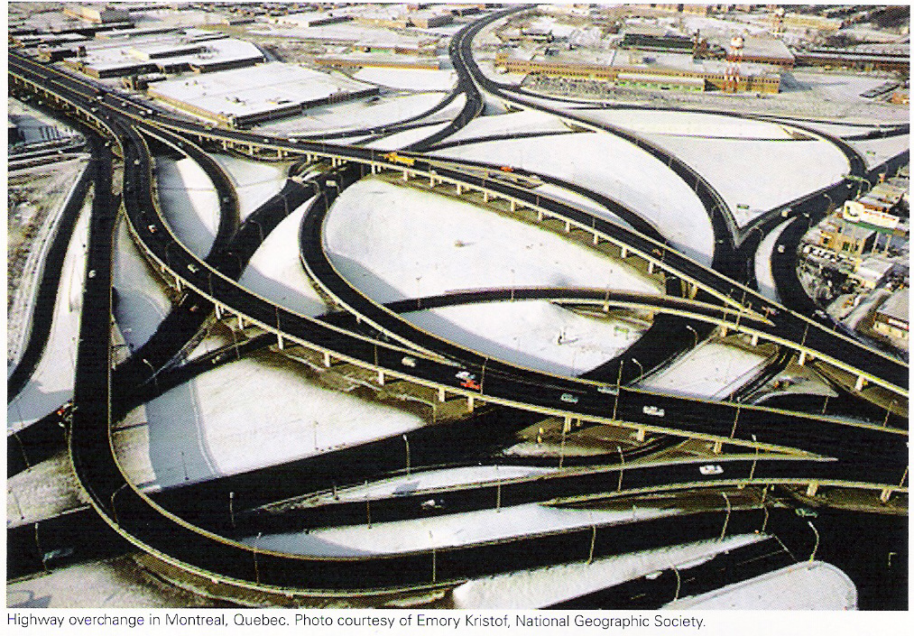
8. Transportation

Humans depend upon transportation-the movement of materials, ideas, products, and people-in countless ways. Highways, railroads, airports, seaports, and pipelines are essential linkages that tie people and places together in an increasingly interdependent world. In the United States, the automobile has encouraged urban sprawl and the growth of suburbs. The interstate highway system provides truckers with quality links between origins and destinations. In Europe and Asia, people rely on commuter trains to get from home to work and back again. Intercontinental travel most often depends on airliners, soon to carry almost a thousand passengers. Geography, with a focus on the spatial interaction between people and places, helps us to understand the need for modern transportation and enables us to plan for the future.
9. Employment: Business, Industry, and Government
Career and job opportunities for those with an interest in geography are widespread and challenging. Geospatial technology (GIS, GPS) is one of the most dynamic and rapidly expanding workforce categories identified by the Department of Labor. In addition, jobs are available in environmental fields (water, land, solid waste); social services (health planning, community services); real estate (appraisers, brokers, property managers); travel (tours, travel agents, hotel and resort consultants); teaching (K-12 and university); and various government jobs, such as transportation planner, remote sensing specialist, environmental compliance officer, area specialist for the United States Department of State, regional analyst for the Central Intelligence Agency, and the military. Geographers work in hundreds of businesses and industries, and their knowledge and skills have high value in the workplace.
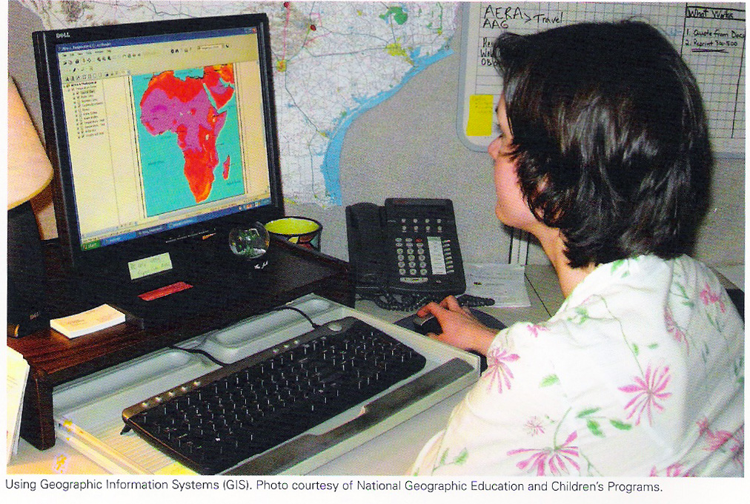
Conclusion

Our daily lives are interwoven with geography. Each of us lives in a unique place and in constant interaction with our surroundings. Geographic knowledge and skills are essential for us to understand the activities and patterns of our lives and the lives of others. We move from place to place, aided by transportation and navigation systems. We communicate using global networks of computers and satellites. We strive to live in healthy physical and social environments. We work to avoid the negative consequences of exposure to natural and technological hazards. We search for interesting destinations for recreation and vacations. We observe and learn about our own culture and other cultures around the world. We want to lead satisfying lives and contribute to the welfare of our communities. Geographic knowledge and understanding is fundamental to reaching our goals, and in attaining a higher quality of life.
For more information about geography, visit these websites:
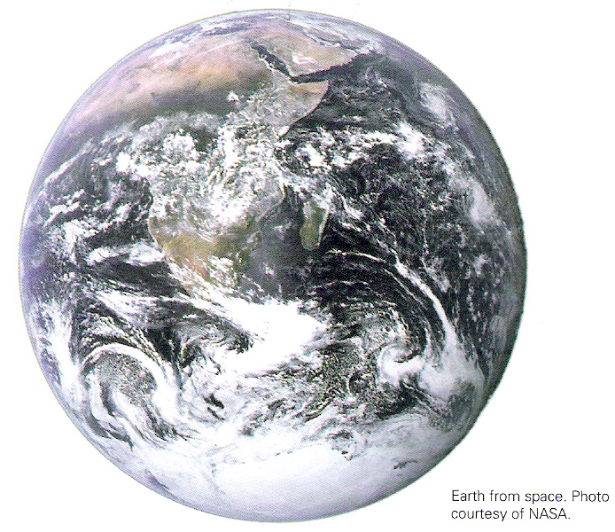
National Geographic Society - www.nationalgeographic.com Association of American Geographers - www.aag.org National Council for Geographic Education - www.ncge.org

NATIONAL GEOGRAPHIC SOCIETY
ALLIANCE FOR GEOGRAPHIC EDUCATION NETWORK
The National Geography Society (NGS) maintains a grassroots network of state alliances devoted to improving the quality and quantity of geography taught in the schools of America. These alliances, on a state-by-state basis, represent a partnership between university geographers and school teachers cooperating to improve geographic teaching and learning.
The NGS Alliance network is an amazing educational resource for individual states. But it remains for school officials to include geography in the school curriculum, either as a stand-alone subject or as an important part of the social
studies requirement. .

Alabama | Illinois | Montana | Rhode Island
Alaska | Indiana | Nebraska | South Carolina
Arizona | Iowa | Nevada | South Dakota
Arkansas | Kansas | New Hampshire | Tennessee
California | Kentucky | New Mexico | Texas
Canada | Lousiana | New York | Utah
Colorado | Maine | North Carolina | Vermont
Connecticut | Maryland | North Dakota | Virginia
Delaware | Massachusetts | Ohio | Washington
District of Columbia | Michigan | Oklahoma | West Virginia
Florida | Minnesota | Oregon | Wisconsin
Georgia | Mississippi | Pennsylvania | Wyoming
Hawaii | Missouri | Puerto Rico

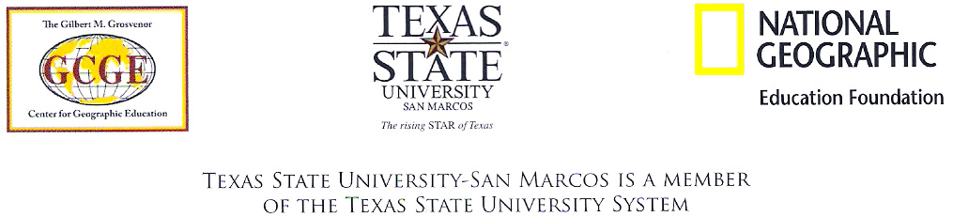
For more information on the Alliance Network visit: www.ngsednet.org

