The Shocking Truth About Child Brides Around The World
Natalie Gil,Refinery 29 UK 16 hours ago
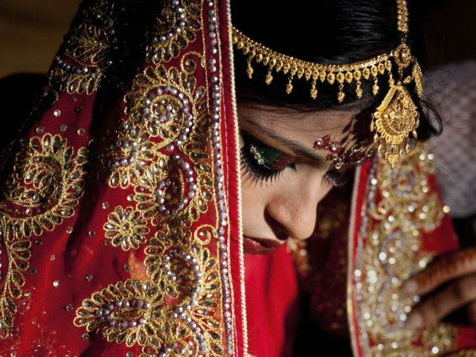Photo: Allison Joyce/Getty Images.
One girl under 15 becomes a child bride every seven seconds, according to a new report.
The report, by charity Save the Children, found that even 10-year-olds are forced to marry much older men in countries including Afghanistan, Yemen, India and Somalia.
The report is particularly poignant today as the 11th of October is the International Day of the Girl, a UN initiative founded to promote girls' rights around the world and to highlight that gender equality is beneficial for the whole of society.
Save the Children said marrying young can have devastating consequences, triggering a "cycle of disadvantage across every part of a girl's life".
Girls affected by conflict, poverty and humanitarian crises are particularly at risk of being married off, the report found.
Many refugee families force their daughters to marry in an attempt to protect them against poverty and sexual assault and rape. A quarter of 15 to 17-year-old girls among the Syrian refugees in Jordan in 2013 were married, for instance.
The report, called Every Last Girl, ranked countries based on levels of child marriage, schooling, teen pregnancy, maternal deaths and the number of female MPs.
Niger, Chad, Central African Republic, Mali and Somalia were among the countries at the bottom of the list.
The highest-ranked countries in which to be a girl included Sweden, Finland, Norway, Netherlands and Belgium, while the UK ranked 15th out of 144 countries.
Helle Thorning-Schmidt, CEO of Save the Children International, said: "Child marriage starts a cycle of disadvantage that denies girls the most basic rights to learn, develop and be children," the BBC reported.
"Girls who marry too early often can't attend school, and are more likely to face domestic violence, abuse and rape. They fall pregnant and are exposed to STIs (sexually transmitted infections) including HIV."
More than 700 million women worldwide today were married before they reached 18 and a third were married before age 15, the report said. Unicef estimates this figure will grow to 950 million by 2030.

