The Indus Valley civilization is 2,500 years older than previously believed

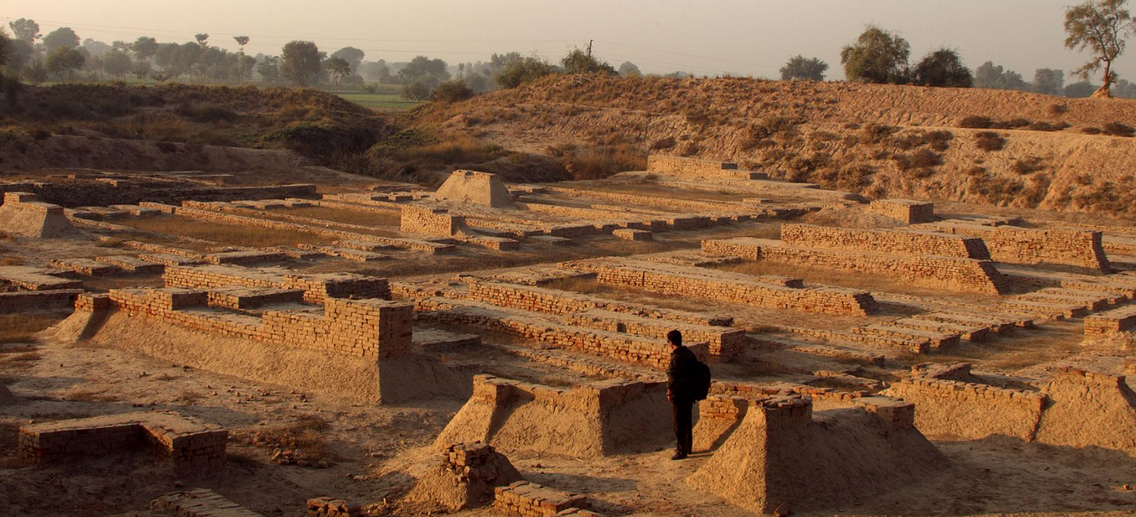
The Indus Valley civilization may be even older than initially thought.
A group of researchers in India have used carbon dating techniques on animal remains and pottery fragments to conclude that the Indus Valley settlements could be 8,000 years old—2,500 years older than previously believed.
That could make the Indus Valley settlements, which were spread across Pakistan and northern India, even older than the Mesopotamian and Egyptian civilisations.
“Our study pushes back the antiquity to as old as 8th millennium before present and will have major implications to the evolution of human settlements in Indian sub-continent,” Anindya Sarkar, a professor at the department of geology and geophysics at IIT-Kharagpur, said in a statement.
Sarkar, who worked with researchers from the Archaeological Survey of India, the Physical Research Laboratory in Ahmedabad and Pune’s Deccan College, used a technique known as the Optically Stimulated Luminescence, which measures the amount of light emitted from mineral grains to date past events.
The study, published in Nature on May 25, focused on the ancient settlements in Bhirrana in northern Indian state of Haryana:
Based on radiocarbon ages from different trenches and levels, the settlement at Bhirrana has been inferred to be the oldest (>9 ka BP) in the Indian sub-continent. To check its validity we dated archaeological pottery from two cultural levels using optically stimulated luminescence (OSL) method and thus investigated the interrelationship between the cultural levels and climate change that occurred right at the settlement, a critical gap in information that exists in our present understanding of the Harappan civilization.
Archaeological studies had earlier suggested that the civilisation was centred around Harappa and Mohenjo-Daro in Pakistan, and Lothal, Dholavira, and Kalibangan in India, Sarkar explained. The researchers from India now say it was actually spread over a much larger part of India, alongside River Saraswati, which is believed to have disappeared some 4,000 years ago.

The decline
Researchers have also proposed a new theory for the decline of the civilisation, which was earlier believed to have been caused by climate change.
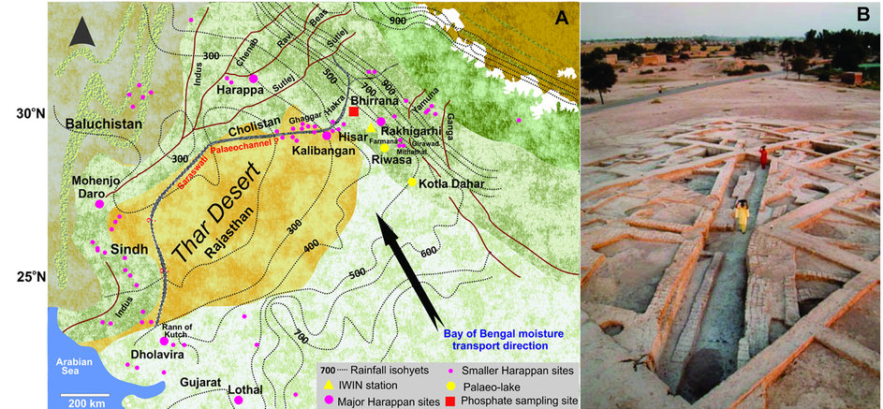
The new study argues that although shifting monsoon patterns played a role in the eventual decline of the civilisation, it had more to do with the change in cropping patterns and storage of grains.
“Our study suggests that the climate was probably not the cause of Harappan decline,” the researchers said in a statement. “Increasing evidences suggest that these people shifted their crop patterns from the large-grained cereals like wheat and barley during the early part of intensified monsoon to drought-resistant species of small millets and rice in the later part of declining monsoon and thereby changed their subsistence strategy.”
But that shift in agriculture turned out to be fatal, the researchers explained:
Because these later crops generally have much lower yield, the organised large storage system of mature Harappan period was abandoned giving rise to smaller more individual household based crop processing and storage system and could act as catalyst for the de-urbanisation of the Harappan civilisation rather than an abrupt collapse.

