Scientists now think they know how life as we know it began
By Mike Wehner, BGR October 3, 2017 | 12:59am
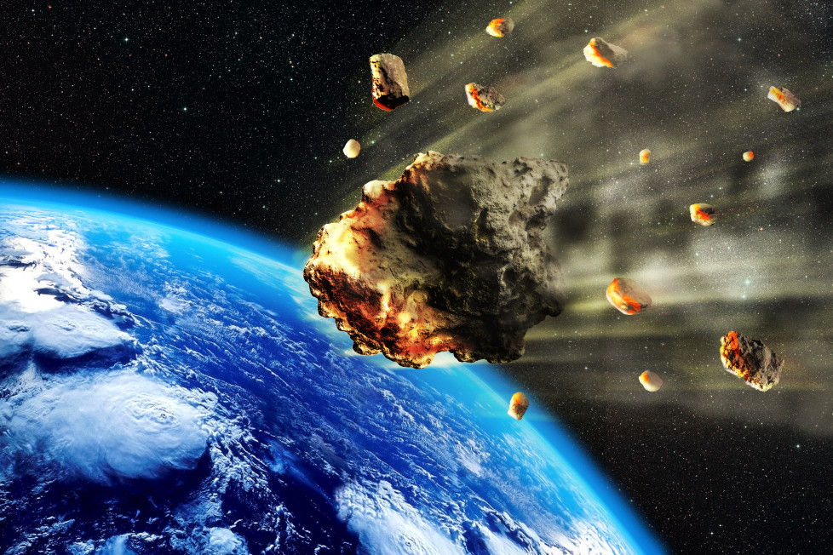
Shutterstock
Humanity has long wondered where we came from, or why life itself even exists in the first place. It’s the ultimate question for many, and countless scientists have devoted their lives to getting closer to the answer. Now, researchers from Canada’s McMaster University, in tandem with scientists from Germany’s Max Planck Institute, believe they may actually have the answer, and it all began some 4 billion years ago, give or take.
Drawing on previous research in a number of different scientific fields, the researchers played connect-the-dots, and arrived at a very interesting conclusion. According to the researchers, the most plausible answer to how life initially formed seems to be that meteorites slammed into ponds here on Earth, prompting the formation of self-replicating RNA molecules thanks to ideal nutrients in the water.
This particular theory has been around for some time, but as the lead authors of the study explain, nobody has ever provided enough evidence that it was indeed possible. “No one’s actually run the calculation before,” author Ben K.D. Pearce says. “This is a pretty big beginning. It’s pretty exciting.”
As the team’s paper explains, one major reason why the research doesn’t support the hypothesis that life began in Earth’s oceans is that the formation of RNA polymers would have required wet and dry cycles. Surface ponds could provide those conditions thanks to precipitation and evaporation, while the deep ocean wouldn’t have.
The team’s calculations support the theory that RNA could have formed some 4.2 billion years ago, or slightly earlier, with the eventual formation of DNA following much later thanks to the wonders of evolution.

New Study Suggests Life Was Brought to Early Earth on Meteorites
Jay Bennett,Popular Mechanics Mon, Oct 2, 2017
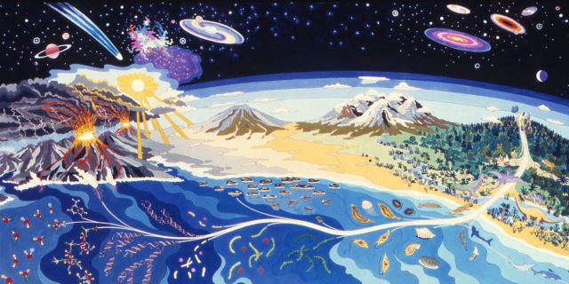
(Image: A mural that hangs in NASA Ames Research Center depicting the emergence of life on Earth.)
How the first organic chemicals came to make copies of themselves and spark the first reproductive life remains perhaps the greatest mystery in all of science. Chemistry, biology, geology and astronomy are all fundamentally interested in answering this great question, and elements of each scientific field will be required to crack the code. What chemical process were involved to transform inanimate substances into living organisms? Did this process happen in one place or multiple? Was the first life on Earth on the surface, or deep in the hot subterranean realms of the planet?
A study published today by the Proceedings of the National Academy of Sciences (PNAS) could bring us closer to answering some of these questions fundamental to existence. The paper, authored by researchers from the Max Planck Institute for Astronomy in Germany and McMaster University in Ontario, combines existing astronomical, geological, chemical and biological models to predict how and when life formed on Earth.
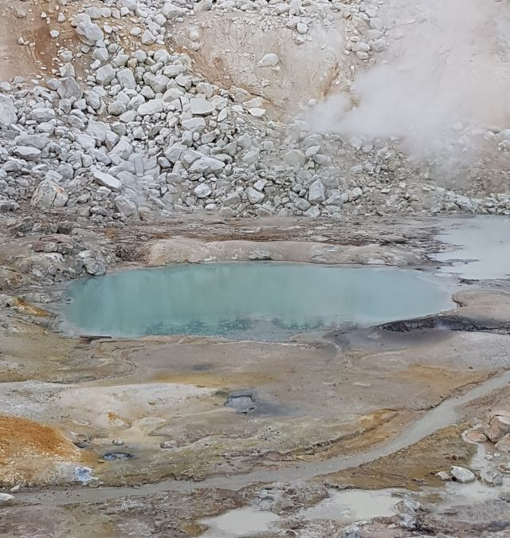
The new survey supports two common theories regarding the emergence of life on Earth. First is that the initial building blocks of life were not present on proto-Earth, but were brought to this planet by impacting meteorites shortly after the formation of the solar system. The second is the so-called "warm little pond" hypothesis. The new model suggests meteorites impacting small ponds of hot surface water generated the first self-replicating RNA molecules-the first life on Earth.
"Because there are so many inputs from so many different fields, it's kind of amazing that it all hangs together," said Ralph Pudritz of McMaster University, a co-author of the new study. "Each step led very naturally to the next. To have them all lead to a clear picture in the end is saying there's something right about this."
"No one's actually run the calculation before," says lead author Ben Pearce of McMaster. "It's pretty exciting."
One of the most surprising things to come out of the new study is an estimate that the first life on Earth formed incredibly early in the planet's 4.5-billion-year history. The model suggests life sprung from meteorites and warm little pools only a few hundred million years after the planet cooled enough to allow surface water. Previous estimates suggest life did not take root on the planet for half a billion years or more.
"In order to understand the origin of life, we need to understand Earth as it was billions of years ago," says Thomas Henning of the Max Planck Institute for Astronomy."As our study shows, astronomy provides a vital part of the answer. The details of how our solar system formed have direct consequences for the origin of life on Earth."
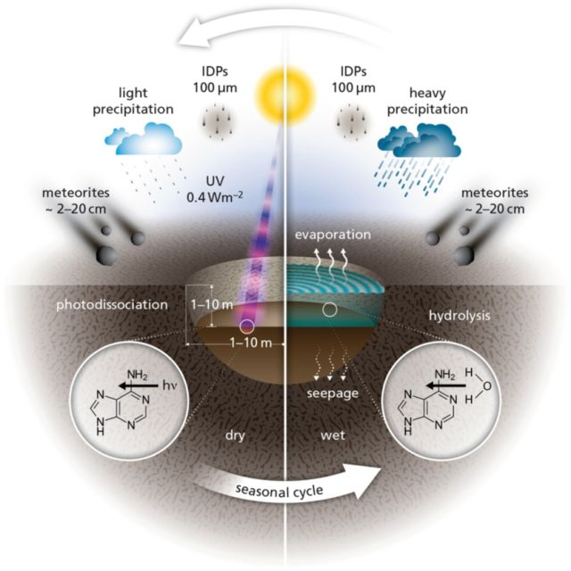
The exact chemical process to jumpstart life is still unknown, although the new study suggests little warm pools that periodically dried out and refilled could have created the right conditions for the first life. Nucleobases, which are the protein building blocks of nucleic acids including RNA and DNA, could have been transported to Earth in abundance by impacting meteorites that hit pools around the globe. At some point, the evaporation and refilling cycle led to the creation of self-replicating RNA in at least one pool.
If the new model is correct, the implications would be significant across the scientific community. This is the first time so many scientific models from different fields of study were combined to study abiogenesis, and the disparate science models came together to create a surprisingly cohesive picture of how life emerged on our planet. The resulting model points to meteors as the source of life's building blocks, which implies similar self-replicating molecules could form on other planets. The creation of the solar system itself and the distribution of chemical elements across the ancient, dust-filled area around our sun is crucial to understanding how life caught on this single rock-and nowhere else that we know of.
The next step is to conduct experiments to test the theories of the model. If scientists can actually replicate the process of abiogenesis, the spark of life from dead matter, then we might finally discover how life came to be, a mystery as old as science itself.
Source: Max Planck Institute for Astronomy

