Our Ancient Ancestors Were Forced From Africa 60,000 Years Ago by Climate Change
By Meghan Bartels On 10/6/17
NEWSWEEK Tech & Science Prehistoric Climate Change
Lots of us complain about the weather—but it's another thing entirely to pick up and relocate because of it. Yet according to a new study published in the journal Geology, an unpleasant climate in Africa may have driven the earliest humans north, starting their spread around the globe.
Scientists have speculated for a while now that climate may have played a role in the migration, but in general they have focused on ways the climate could have made the journey itself easier, such as by bringing rain to the vast Sahara. The new study tracked down evidence of the climate itself, then compared that timeline with what archaeologists know about human migrations—and saw a very different picture.
"We really wanted to figure out if we could find a way to reconstruct the climate at this time using geologic archives," lead author Jessica Tierney, who studies past climate change at the University of Arizona, told Newsweek. "It seemed like the migration lines up with this really dry and cold time." That might have been enough to push early humans north, she and her colleagues conclude.
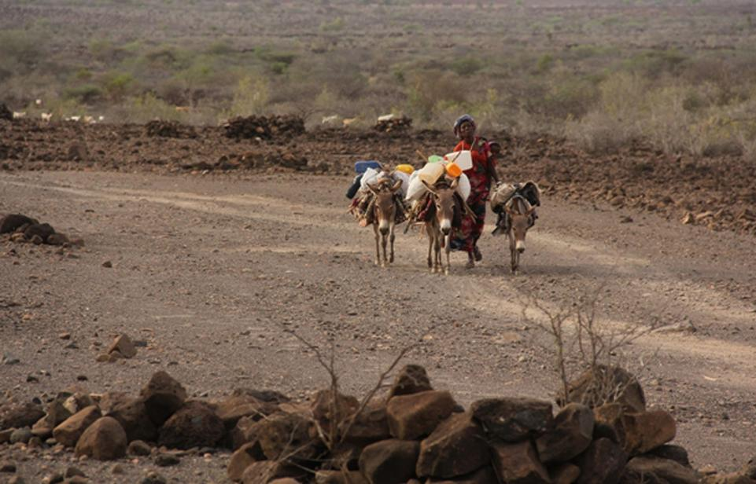
The team's first challenge was simply finding climate records old enough, since humans began migrating between 55,000 and 70,000 years ago. Eventually they tracked down a sediment core—"essentially a tube of mud," as Tierney describes it—collected in 1965 from the seafloor in the Gulf of Aden, off the Horn of Africa. Within that core, for every four inches deeper into the sediment the scientists could look 1,600 years earlier into the past, as far as 200,000 years before the present.
Figure 1 Northern Djibouti, near the gulf where the studied sediment core was collected. Abdourazak Ali/AFP/Getty Images
They analyzed two types of chemical fingerprints contained in that core to understand precipitation and temperature levels around the time of the migration. Of course, sediment cores don't record thermometer readings; in both cases, the scientists used surrogate measurements to understand climate.
For precipitation, they analyzed the composition of wax particles, produced on land by plants to protect their leaves from the environment and carried to the bottom of the sea by the wind. When plants grow in a wet environment, their leaf wax carries a different proportion of types of hydrogen atoms pulled from water. "These wax compounds are really well preserved actually in these cores, so they're easy for us to isolate and analyze," Tierney says.
And for temperature, they studied compounds called alkenones, which are produced by marine algae and settle into the sediment below. Like leaf wax changing with precipitation, the precise composition of alkenones changes depending on how warm or cool the algae's environment is.
Taken together, the results sugges that when humans were moving northward, the Horn of Africa was relatively cold and dry. "What surprised me was our ultimate finding, which was that the 'out of Africa' migration seemed to fall during a dry period," Tierney says. "I sort of expected to find that the climate would have been wetter when Homo sapiens left."
That could mean early humans were pushed out by the unfavorable climate, says Tierney. But scientists who study the genetics of moving populations may quibble with how much climate can push individuals to move, says John Stewart, who studies ancient ecology at the University of Bournemouth in the U.K.: "I am not aware that species are thought of as being pushed out of areas as often they simply go extinct instead of moving."

