92 percent of World's Population Breathes Toxic Air

By Nadia Prupis – Common Dreams – 9/28-16
More than 90 percent of people on the planet live in places where air pollution levels are dangerously high, and millions of people are dying as a result of the exposure, according to new research from the World Health Organization (WHO) released Tuesday.
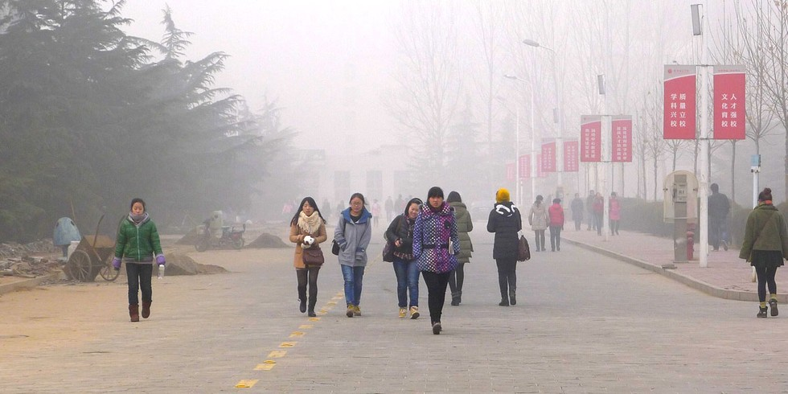
A polluted Christmas Day at Anyang Normal University, China.V.T. Polywoda / Flickr
Using an air quality model based on satellite data and other ground and air monitors in 3,000 locations, the WHO found that fully 92 percent of people worldwide live in regions where the pollution exceeds the organization's safety limits.
"To date, air pollution—both ambient (outdoor) and household (indoor)—is the biggest environmental risk to health, carrying responsibility for about one in every nine deaths annually," the report states. "Air pollution continues to rise at an alarming rate, and affects economies and people's quality of life; it is a public health emergency."
The organization created an interactive map showing where in the world, both in rural and urban areas, the air is contaminated by toxins that can seep into the lungs and cause cardiovascular diseases, stroke, chronic obstructive pulmonary disease, and lung cancer, among other illnesses.
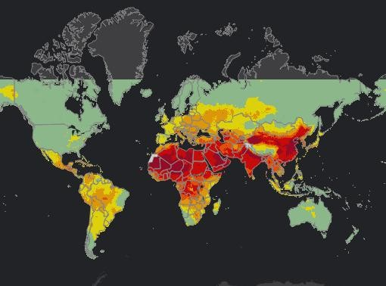
Screenshot of WHO's interactive map of global ambient air pollution.World Health Organization
The majority of those locations are in developing counties, largely in the regions of Southeast Asia and the Western Pacific, with "vulnerable populations" at a particularly high risk, the report states. More than 6 million people die every year due to exposure to indoor and outdoor air pollution, according to an International Energy Agency study released in June.
"Air pollution continues take a toll on the health of the most vulnerable populations—women, children and the older adults," said WHO assistant director general Dr. Flavia Bustreo. "For people to be healthy, they must breathe clean air from their first breath to their last."
Much of the pollution is human-caused, created through household waste and fuel burning, inefficient transportation, industrial activities and coal-fired power plants, the report states. Particulate matter that emanate from those activities like black carbon, sulphates, nitrates, ammonia, sodium chloride, and mineral dust and water can penetrate and coat the lungs and cause health issues with even short-term exposure. (Other air pollution can have natural causes, such as dust in the air in regions near deserts.)
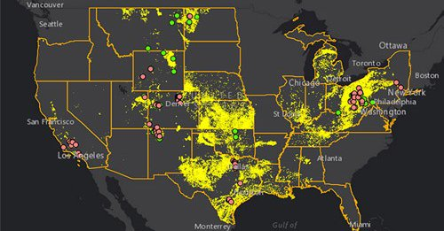
Figure 1 Map Shows Where Toxic Air Pollution From Oil and Gas Industry Is Threatening 12.4 Million Americans
Dr. Maria Neira, WHO director of the Department of Public Health, Environment, and Social Determinants of Health, said the new data confirms there is no time to waste to address toxins in the atmosphere.
"Fast action to tackle air pollution can't come soon enough," Neira said. "Solutions exist with sustainable transport in cities, solid waste management, access to clean household fuels and cook-stoves, as well as renewable energies and industrial emissions reductions."
The new data follows recent studies linking air pollution to everything from Alzheimer's to economic slowdowns. In the U.S., air pollution is especially high in minority and low-income communities, which a study published in Social Science Research last year referred to as "sacrifice zones."
Increasing and improving studies of dangerous air pollution, particularly in low-income areas, is "crucial" to curtailing its toxic impacts, the WHO said. And strengthening the capacity of developing cities to "monitor their air quality with standardized methods, reliable and good quality instrumentation, is key," the report concludes.
Reposted with permission from our media associate Common Dream.

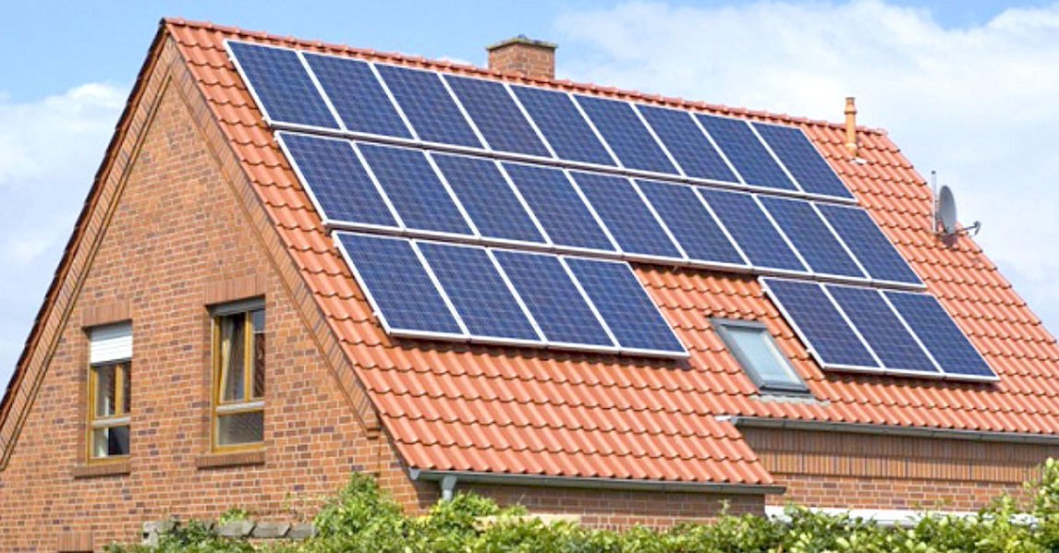
Figure 2 50% of EU Residents Could Be Generating Their Own Renewable Energy by 2050

RELATED ARTICLES
20 Plants That Improve Air Quality in Your Home
IARC Scientist Reaffirms Glyphosate’s Link to Cancer as Monsanto’s Requests to Dismiss Cancer Lawsuits Denied
6.5 Million People Die Each Year From Air Pollution, IEA Says
- Email
Over 90 percent of the world's population lives in areas with levels of air pollution that exceed the World Health Organization's limits, the group said today in what the WHO described as itsmost detailed report on global outdoor air pollution ever published.
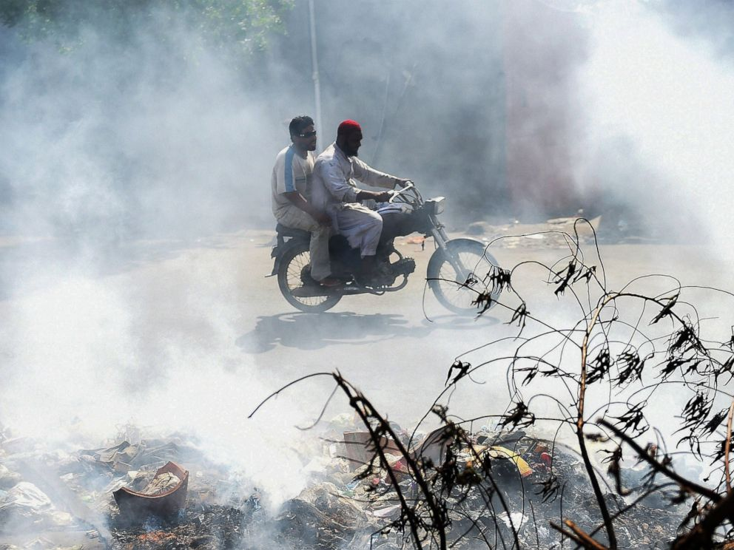
Figure 3 Pakistani motorcyclists ride through smoke on a street in Karachi, Pakistan, Sept. 27, 2016.
While the WHO’s standards for air quality are not legally binding, they are generally accepted by many in the international community.
About 3 million deaths are linked to outdoor air pollution exposure each year, according to the report, and of those deaths, nearly 90 percent occur in low- and middle-income countries.
The U.S. has a relatively low number of deaths attributable to ambient (outdoor) air pollution, with 7 deaths per 100,000 people every year, according to the report. But in China, that number is 70 deaths per 100,000, and Turkmenistan has the highest rate with 108 deaths per 100,000.
Exposure to outdoor air pollution has been linked to cardiovascular disease, stroke, chronic obstructive pulmonary disease and lung cancer, as well as an increase in the risk for acute respiratory infections, according to the WHO.

"Air pollution continues take a toll on the health of the most vulnerable populations -- women, children and the older adults," WHO Assistant Director General Dr. Flavia Bustreo said in a statement. "For people to be healthy, they must breathe clean air from their first breath to their last."
Inefficient modes of transport, household fuel and waste burning, coal-fired power plants and industrial activities are the major sources of air pollution, according to the WHO. Air pollution, however, can also be influenced by natural causes, such as dust storms, the WHO noted.
Dr. Patrick Kinney, a professor of Environmental Health Sciences at Columbia University, told ABC News today that fine air pollution particles affect chronic health conditions, "similar to the way cigarette smoking affects people."
Kinney added that there are a lot of adverse health conditions that air pollution is associated with in addition to those outlined in the WHO report.
"You can think of this as kind of an underestimate of the health outcomes of air pollution," Kinney said.
"Air pollution is kind of a risk-multiplier," Kinney said, "For example, if there is a high percentage of heart disease in a population, air pollution will make this worse."
While "everybody is at risk" for the health impacts of excess air pollution, Kinney said some groups, including the elderly, young children, people who work outside, and people living in a lower economic status, tend to be at a slightly greater risk.
People living in areas with particularly dangerous levels of air pollution can use air purifiers, which tend to be effective for cleaning indoor air, Kinney said.
However, the best way to combat dangerous air pollution levels is "just to control the sources and reduce the emissions that are causing this air pollution, which we have done very successfully in the U.S. over the last 40 years," Kinney said.
"The Clean Air Act has been quite successful. It sets goals based on air quality standards and then states have to meet those goals, and it has gradually been achieved over the past 40 years," Kinney said, explaining why the U.S. has a much lower level of air pollution in comparison to other countries.
Tony Wexler, director of the UC Davis Air Quality Research Group, added that a major factor in producing dirty air is "development."
"When the U.S. was developing and going from now what we would say a 'developing country' to a 'developed country' in the fifties, we had incredibly bad air pollution," Wexler said.
Wexler added that he hopes other parts of the globe that are just starting to develop will skip using energy that contributes to dirty air, such as fossil fuels, and "go straight to solar and wind" to power their industries.

Asia's poor choking on filthy air
AFP Tue, Sep 27 6:46 AM PDT
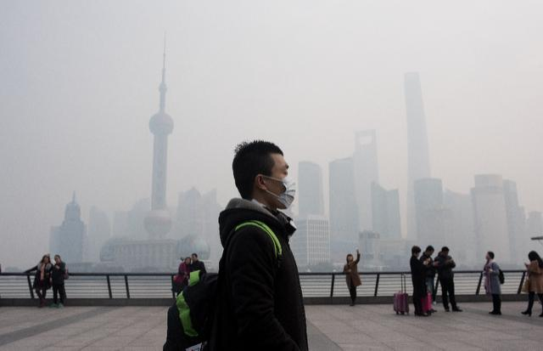
Polluted air is a "public health emergency", the World Health Organization said Tuesday, adding nine out of 10 people globally breathe bad air that is blamed for more than six million deaths a year.
And the WHO warned that nearly 90-percent of air pollution-related deaths occur in low and middle-income countries.
Southeast Asia and the Western Pacific region -- including China -- are the hardest hit, the data showed.
South Asia is also badly affected, with the WHO saying poor air quality is responsible for the deaths of more than 600,000 people in India and 37,000 people in Bangladesh every year.
Pakistan too is suffering, with experts blaming unplanned and unsustainable development and warning that proposals for more coal-fired power stations will further worsenair quality.
Smog is a perennial problem across China, where pollution from heavy industry and a rapidly growing fleet of cars brews a toxic haze that, in the winter, can wreathe whole regions in a choking miasma.

Giant air purifier aims to raise smog awareness in China, artist says
September 29, 2016
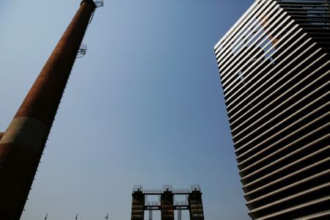
Figure 4 The Smog Free Tower, the world's largest smog vacuum cleaner designed by Dutch artist and innovator Daan Roosegaarde is seen at former industrial zone, now D-751 art district, as the artist presents his The Smog Free Project in Beijing September 29, 201
By Doris Liu
BEIJING (Reuters) - A Dutch artist opened what he calls the world's largest air purifier in Beijing on Thursday, beginning the first leg of a China tour to raise awareness of environmental problems.
The seven-metre-high (7.66-yard-high) Smog Free Tower, part of the Smog Free Project started by artist and innovator Daan Roosegaarde, creates a "bubble of clean air enabling citizens to experience clean air for free," according to his website.
The tower captures and collects more than 75 percent of airborne smog particles that have diameters of 2.5 microns and 10 microns and releases clean air around the structure.
"The Smog Free Project is about the Smog Free Tower providing clean air, but it's also about the Smog Free Ring creating an engagement and making the people in China part of the solution, instead of just feeling part of the problem," Roosegaarde told Reuters.
In his campaign, the artist also collects smog particles from the tower and compresses them into jewelry, such as a ring and cufflinks.
Decades of growth-at-all-costs economic development in China has spawned massive problems of air, water and soil pollution that the ruling Communist Party has only in recent years begun to tackle.
Nationwide, China has earmarked 17 trillion yuan ($2.6 trillion) for investment in environmental protection between 2016 and 2020, according to state news agency Xinhua.
Beijing itself has promised compensation to firms closed on pollution grounds.
One resident said she would like to see more projects like the tower to raise awareness of air pollution in Beijing.
"My whole family was coughing due to the smog the other day," said Wang Aili, 34, adding that her son could not play outside when air pollution levels were high.
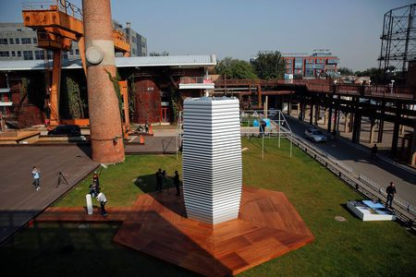
"I hope there can be more equipment or artwork that can raise people's awareness of smog in Beijing," she said. "I hope we can have more blue skies."
Figure 5 view of the smog cleaner.
The Smog Free Project will travel to four major Chinese cities in the coming year, according to the website.
(Editing by Darren Schuettler)

