How sea ice is making the Southern Ocean less salty — and what that might mean for the rest of the world
By Chelsea Harvey August 31 at The Washington Post
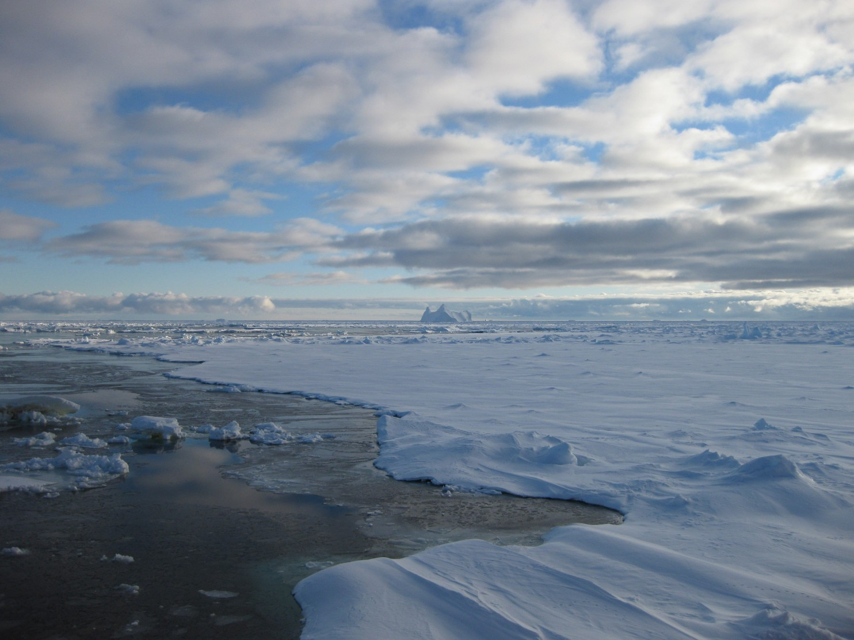
A melting sea-ice floe in the Southern Ocean in late summer. At the horizon: An ice berg that broke off from the ice shelf of the Antarctic continent. (Image credit: K. Leonard)
The ocean surrounding Antarctica has become substantially less salty over the past couple of decades — and until now, scientists weren’t really sure why. But because changes in the Southern Ocean’s salinity have the potential to affect all kinds of important processes, including ocean circulation and its transport of heat and nutrients around the world, researchers have been eager to figure it out.
Now, a new study, published Wednesday in Nature, suggests that sea ice may be one of the major culprits. Using satellite data and models, the authors have shown that Antarctic sea ice has been moving farther and farther away from the continental coastline by strengthening winds in recent years, pouring fresh water farther out into the ocean as it melts.
In the past, scientists have raised several theories about what could be causing the freshening, which has been particularly pronounced in specific regions of the Southern Ocean. These have included both precipitation patterns and an increasing influx of meltwater from Antarctic glaciers. But studies have indicated that neither of these processes could fully explain the region’s salinity changes.
“On the other hand, we saw that there are actually quite some changes going on in the sea ice in that area,” said Alexander Haumann, a Ph.D. student at the Swiss Federal Institute of Technology in Zurich and the new study’s lead author. “So we thought, well, let’s see if this might be maybe a reason for changing ocean salinity.”
It’s already well known that sea ice has an important influence on salinity around Antarctica. Sea ice forms when ocean water freezes, typically very close to the continent’s icy shoreline, where temperatures tend to stay coldest. When it freezes, the water expels its salt back into the water below. In the meantime, sea ice tends to drift away from the coast once it’s formed, and later melts and pours fresh water back into the sea.
These processes are important drivers of ocean currents all over the world. The salty water created by sea ice formation is denser than fresh water, so it has a tendency to sink to the bottom of the ocean. In doing so, it helps push the water below it forward along the sea floor, creating a current that runs north toward the equator. As the water warms up, it rises to the surface and eventually runs back toward the poles. This process helps carry heat and nutrients around the world.
In order to investigate the contributions of sea ice to the Southern Ocean freshening, Haumann and his colleagues used data collected by various satellites between 1982 and 2008, as well as sea ice reconstructions built from both ice models and direct observations of the region. They used this information to make estimates about the production of sea ice, changes in its movement and its associated influx of fresh water into certain parts of the Southern Ocean.
The researchers did note an increase in the production of sea ice in some areas around the coast. But most importantly, they estimated that the northward, wind-driven transport of sea ice increased by about 20 percent between 1982 and 2008. This translated into a steady freshening trend in the Southern Ocean, particularly in the Ross Sea. The researchers’ estimates of where and by how much the ocean had freshened closely aligned with on-site observations of salinity changes in the region.
The researchers believe that a strengthening of the winds over the Ross Sea are responsible for the increased northward transport of the sea ice. But what exactly is causing the wind changes remains another mystery, entirely. They could be the result of natural atmospheric variations, Haumann said — or they could have been caused by an increase in greenhouse gas emissions and other human influences.
“This is something that we are currently not really sure of, and there’s arguments that are in the one direction or the other,” Haumann said.
Still, there are a few important potential consequences of the ocean’s freshening.
For one thing, the region right at the edge of the sea ice, where most of the melting and freshwater input is happening, also happens to be a part of the ocean where a key aspect of the ocean’s overturning occurs, in which deep water wells up from the bottom of the sea, carrying both carbon dioxide and a variety of nutrients with it.
“When you add fresh water there, you actually suppress the upwelling of the deeper waters into the surface layer,” Haumann said. This is because the less dense fresh water has a tendency to get stuck on the surface of the ocean, trapping the warmer, deep water beneath it. It’s a process known as “stratification,” and it could cause big problems for Antarctica and possibly the rest of the world, according to some experts.
A recent paper, led by Columbia professor and former NASA scientist James Hansen, suggested the stratification could help force the trapped warm water right up to the bases of marine-terminating glaciers on the Antarctic continent, melting them from the bottom up and leading to an even faster influx of fresh water into the ocean.
This could cause significant increases in sea-level rise, he suggested — but the freshwater influx could also cause additional problems for the oceans’ overturning circulation. The meltwater could cause the typically salty water around the coastline to freshen and become less dense, weakening the downward sinking motion that helps drive the ocean’s currents. In fact, recent research has suggested that this may already be happening in certain parts of Antarctica.

Additionally, stratification — and the prevention of deep-water upwelling in the Southern Ocean — could prevent both nutrients and carbon dioxide from being carried to the surface. And while it’s good for the climate if as much carbon stays out of the air as possible, an increase in dissolved carbon dioxide is also the prime cause behind ocean acidification. Any major changes in the region’s carbon flux would also need to be incorporated into current climate models, Haumann added.
Of course, all of these consequences are mere speculation for now. The new study doesn’t actually document any of these effects taking place. And in the future, the trends it describes may even be reversed by the continually warming climate.
“Anticipated future declines in ice extent and volume would suggest that sea-ice freshwater transport should decrease,” wrote Ted Maksym, a scientist with the Woods Hole Oceanographic Institution, in a comment on the new paper, also published Wednesday in Nature. But he added that these future reductions will also likely “play a prominent part in changes in the Southern Ocean’s overturning circulation.”
So uncertainties about the paper’s implications — and the future of the Southern Ocean, as a whole — do abound. But the study does generally speak to the idea that changes in important ocean processes can be initiated by a much wider variety of factors than scientists used to believe.
“Haumann and colleagues’ findings emphasize that Antarctic sea ice is not merely a passive indicator of climate change and variability, but also a driver of changes in the climate system,” wrote Maksym wrote in his comment. “…[S]ea ice might have a bigger role than previously thought.”

