Scientists Accidentally Discover Efficient Process to Turn CO2 Into Ethanol

The process is cheap, efficient, and scalable, meaning it could soon be used to remove large amounts of CO2 from the atmosphere.
Getty Space Images
By Avery Thompson Oct 17, 2016

Scientists at the Oak Ridge National Laboratory in Tennessee have discovered a chemical reaction to turn CO2 into ethanol, potentially creating a new technology to help avert climate change. Their findings were published in the journal ChemistrySelect.
The researchers were attempting to find a series of chemical reactions that could turn CO2 into a useful fuel, when they realized the first step in their process managed to do it all by itself. The reaction turns CO2 into ethanol, which could in turn be used to power generators and vehicles.
The tech involves a new combination of copper and carbon arranged into nanospikes on a silicon surface. The nanotechnology allows the reactions to be very precise, with very few contaminants.
"By using common materials, but arranging them with nanotechnology, we figured out how to limit the side reactions and end up with the one thing that we want," said Adam Rondinone.
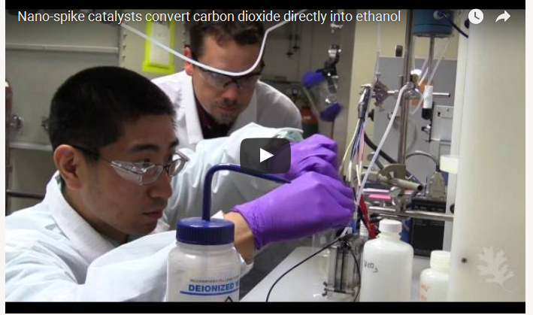
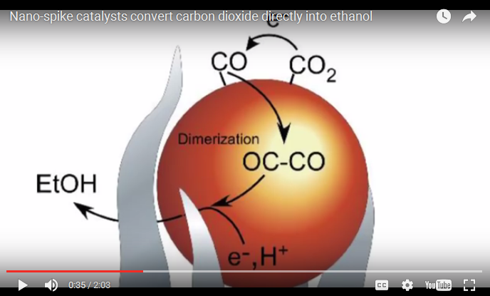
This process has several advantages when compared to other methods of converting CO2 into fuel. The reaction uses common materials like copper and carbon, and it converts the CO2 into ethanol, which is already widely used as a fuel.
Perhaps most importantly, it works at room temperature, which means that it can be started and stopped easily and with little energy cost. This means that this conversion process could be used as temporary energy storage during a lull in renewable energy generation, smoothing out fluctuations in a renewable energy grid.
"A process like this would allow you to consume extra electricity when it's available to make and store as ethanol," said Rondinone. "This could help to balance a grid supplied by intermittent renewable sources."
The researchers plan to further study this process and try and make it more efficient. If they're successful, we just might see large-scale carbon capture using this technique in the near future.
Source: Oak Ridge National Laboratory via New Atlas

