Saudi Arabia Is Changing
James Zogby, Contributor President, Arab American Institute; Author, “Arab Voices” 02/25/2017

Saudis have taken their future in their own hands and are making change their way.
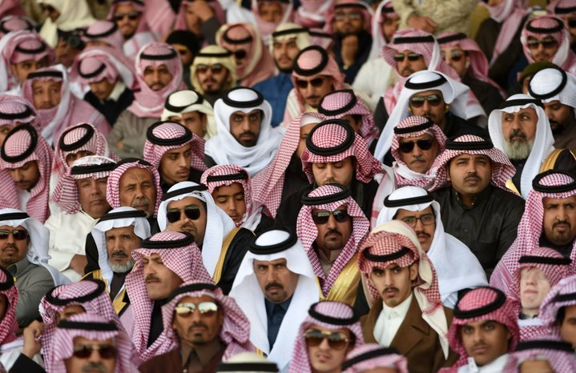
Something is happening in Saudi Arabia. The country is undergoing real change. Many commentators have written about it, but in some instances their observations have been based on a one-off visit comparing what they’ve just seen with the biases they’ve learned—without context or history.
I am by no means an expert on Saudi Arabia, but as someone who has visited the country over four dozen times in the past four decades and who has been able to conduct polling across the Kingdom for the past decade and a half, I want to share some conclusions from my just completed visit as well as some of my most recent public opinion polls.
In a real sense, Saudi Arabia is a new country that has always been changing. In the early 1950’s, for example, the population of Riyadh, the capitol, was in the tens of thousands. By 1980, when I made my first visit, it had grown to one million. Today Greater Riyadh is approaching seven million souls. There have been times when the city looked like a massive construction site with buildings or other infrastructure projects going up everywhere. Saudis have joked that their national bird was the crane.
Rapid urbanization came with a price. As rural people flooded into newly expanded urban areas, many experienced culture shock feeling a need to cling to the purity of the “old ways”—a not unexpected response.
With each passing year subtle but real changes have occurred. Some were the result of the tens of thousands of Saudis who studied abroad; others flowed from the transformations in daily life and social and economic relations that resulted from urbanization; still others reflected the impact globalization especially on Saudi youth. In any case, today’s Saudi Arabia is not the one I first visited a generation ago, with many Saudis living lives and connecting to the outside world in ways unimaginable to their grandparents. Traditions, however, remain and this is enough for some in the West to dismiss the country’s culture as frozen. It appears that if change doesn’t come at our pace, dressed in Western garb, and isn’t done “our way”—it’s not real change.
But even beyond this slow and steady evolution there is something new and significant taking place in the Kingdom. There is today a conscious and deliberate effort by Saudi leadership to speed up this process of transforming their society and to challenge some elements of the traditional culture that stand in the way of moving the country forward. Some of the impetus behind this effort is, no doubt, due to the need to move beyond dependence on oil revenues and government subsidized employment. Another important factor is the coming of age of a new generation of leaders who want to modernize their country, but to do so while being respectful of its traditions. Threading this needle is important since a significant segment of the population remains conservative and the young leadership is not inclined to totally upend the social order creating disruptive instability.
As part of this national effort at social and economic transformation, the number of Saudis studying abroad has increased to over two hundred thousand youngsters from all segments of Saudi society and all parts of the country. There are currently more women than men in college and women graduates are entering the workplace in ever increasing numbers. There has been a determined effort, working with international specialists, to modernize the education curriculum with changes on every level. On my most recent visit to Saudi Arabia, I received a briefing at the Ministry of Education, I was struck by: reforms in early childhood and elementary education; the new emphasis being given to math and science; the training programs that have been developed for teachers and aides preparing them to mainstream children with disabilities; and efforts to provide online and interactive educational opportunities for Saudis of all ages. These changes combined will no doubt produce even greater transformations in the years to come.
But what do Saudis think of their country and their own personal circumstances in this evolving social reality. There are dissidents, to be sure, both those who say change is not coming fast enough and those disgruntled souls who are repulsed by modernity and who condemn any threats to the old order. This is to be expected in any society experiencing change. But what our polling shows is that most Saudis are quite satisfied with their lives and are optimistic about the future. In a “quality of life” survey we conducted a few years ago in 22 countries, Saudi Arabia scored quite well—higher than the United States and most Western countries. More recent polling, since the launching of the national transformation program, have shown dramatic increases in both optimism and satisfaction ratings. There are concerns, to be sure, but on the whole, men and women, young and old, educated and less educated alike give life in their country good grades and have high expectation for the future. This confounds some American observers because they can only see Saudi Arabia through their own eyes, without paying attention to how the majority of Saudis see their own reality.
As ambitious and promising as the national transformation program is, it is also a risky undertaking. On the one hand, there are the expectations that promised change has created. This must be weighed against the backlash of Saudi conservatives who are already expressing concern with this orchestrated movement toward modernizing their society. I referred to it as “threading a needle” and it surely is.
Then there is the impact of the disastrous and costly war in Yemen. Saudi Arabia is deeply troubled by Iran’s aggressive ambitions and concerned with the destabilization of their southern neighbor. But their efforts to restore the legitimate government of Yemen that was deposed by an Iranian-backed movement, have not been successful. Reports of heavy civilian casualties have taken a horrific human toll on Yemenis and have contributed to tarnishing Saudi Arabia’s image in the West. And then there’s the cost—especially given declining oil revenues and the price tag associated with the national transformation effort.
Only a hardened cynic or a dyed-in-the-wool bigot would want to see the Saudi national transformation program fail. At the same time, it would naïve to assume that the coast is clear and all will inevitably work out in the end. Success is not assured, real problems remain and there will serious challenges in the future. But it should recognized that Saudis have taken their future in their own hands and are making change their way. They should be supported.
Follow @jjz1600 for more.

