Muslims help with church's homeless aid work so Christians can attend Christmas Eve service
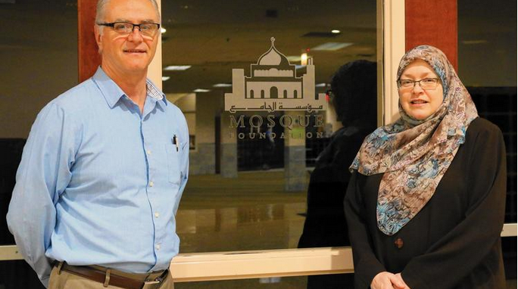
On Christmas Eve, Pastor Steve Hoerger and parishioners at Salem United Church of Christ in Oak Lawn will get help from Karen Danielson and members of the Bridgeview Mosque Foundation.
(Donna VickroyContact ReporterDaily Southtown

When a group of Oak Lawn Christians mentioned they needed a hand, a group of Bridgeview Muslims offered theirs.
With Christmas Eve falling on a Sunday this year, Steve Hoerger, pastor of Salem United Church of Christ, had a dilemma.
Like several other area churches, Salem serves as a BEDS Plus overnight shelter, opening its doors one night a week to those in need. Every Sunday, Salem provides food and bedding to some 25-30 homeless women and children, Hoerger said.
But this Sunday also is the eve of a Christian holiday, among the biggest of the year. It is an evening on which Hoerger typically leads two Advent services.
Hoerger was explaining how "I didn't know how we were going to be able to do both at the same time," during a recent meeting of the Oak Lawn Clergy and Religious Workers Association, when a welcomed solution arose.
Karen Danielson, a member of the Bridgeview Mosque Foundation and a leader in interfaith collaboration, offered the services of Muslim volunteers.
"We said, 'We're there for you guys; the task is on us,'" Danielson said. "So on Christmas Eve we'll provide meals for those coming into the church for homeless services, so the (church members) can be with their families and focus on their spiritual side."
The Mosque volunteers will prepare and serve dinner that evening as well as bring supplies for breakfast and lunch on Christmas Day, Danielson said.
Hoerger said the homeless guests also will be welcome to attend service if they want, before partaking in the meal.
"The whole Christmas season is about light and I can't think of a greater light than this kind of sharing across faith boundaries, especially in this time of darkness," Hoerger said. "This is very much in keeping with the Advent, or Christmas, season."
The takeaway message, Hoerger said, "is oneness and unity. We're all one. That is the deepest place religion can go and, unfortunately, quite often it short circuits getting to that place. Too often religion becomes the barrier to that, when it really should be the facilitator."
This is hardly the first time local members of both faiths have collaborated. Hoerger has dined with Muslims in the evening hours of Ramadan. Danielson has organized interfaith activities with other local churches.
Christians and Muslims may observe different customs and holidays, Danielson said, but when it comes to helping those less fortunate, their mission is one in the same.
Throughout the year, the Mosque Foundation joins forces with volunteers at St. Fabian Church in Bridgeview and Sacred Heart in Palos Hills to help the homeless, she said. And each summer, when the shelters are closed for the season, the foundation and several local churches, including Salem, come together to host a picnic for the homeless.
The interfaith work illustrates similarities between tenets of Christianity and Islam, in terms of mission and dedication to those in need, she said. Both religions, she said, are very service oriented.
As much as Christians cite the biblical idiom, "Do unto others as you would have them do to you," Danielson said, "There's a saying from the Prophet Mohammed that 'none are truly a believer unless they want for others what they want for themselves'."
Believers, she said, would not aim to have their stomachs full while their neighbors' go empty.
Hoerger added, "Muslims and Christians working together to help the homeless. You can't get more into the kingdom of God than that."
He said the Christmas Eve collaboration is a hopeful ending to a year that has been dark, difficult and turbulent.
"This is just a hard time. But this shows you just cannot give up. Those of us who are welcoming and affirming of those who are different from us cannot give in to the kind of hateful rhetoric that is coming from the top," Hoerger said. "We cannot give up the fight and simple things like this are a way to do that."
He said early Christians put Christmas as close as they could to the shortest, darkest day of the year on purpose.
"It's all about symbolism; it's a metaphor. Advent starts with one candle. So, as the nights are slowly getting longer and things are getting darker, we're lighting more and more candles until Christmas eve when the church is full of lit candles and we sing 'Silent Night.' The symbolism is that even now, when things are darkest, the light not only can't be put out, it's grown brighter," he said.
In addition to a warm, nutritious meal that Danielson said "will have a little bit of a Middle Eastern twist," the shelter overnighters will also receive gifts in the spirit of the holiday.
"The church does a nice job of trying to make the night that we have closest to Christmas a special one for the women and the kids," Hoerger said. "They're on the street all day we so can't really give them a lot of stuff to carry around — they're already carrying everything they own. But they'll get gift cards."
dvickroy@tribpub.com

