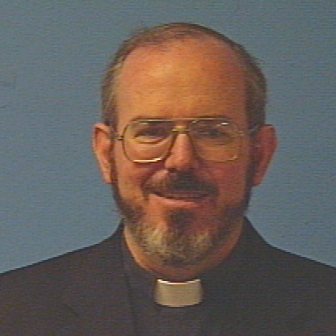
White House Retreat
August 12, to August 15, 2010
Retreat Master: Mike May, S.J.
Notes and Reflections from Joe Naumann
Friday evening – conference 1
Keep these points in mind:
A retreat is an encounter with God
Assume that God may be speaking to you through the Retreat Master
Retreatants should be open to suggestions from the Retreat Master
If you feel a connection with God, even if it isn’t from a suggestion of the Retreat Master, stick with it (you are making the retreat, the Retreat Master isn’t making it for you).

The first principle: God made all things good to lead us back to Him. God made the world god, let us rejoice in it!
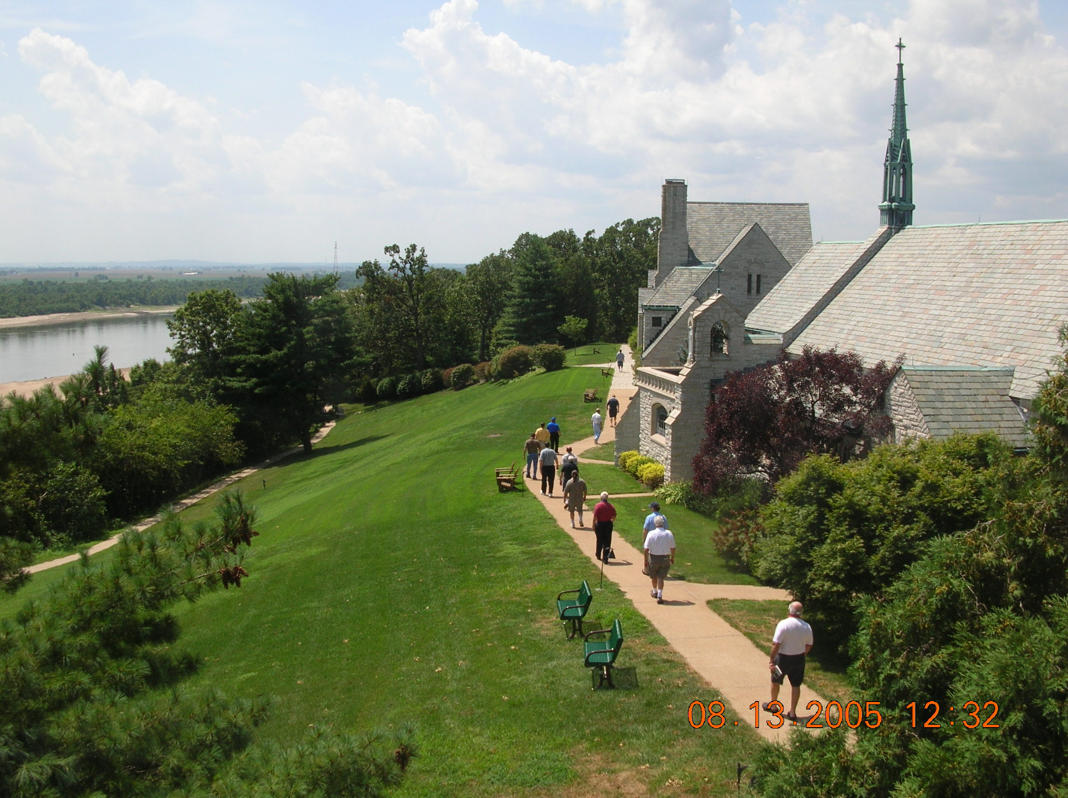
Figure 1 White House Retreat on the bluffs of the Mississippi River south of St. Louis

1st Homework (Mike is a mathematics professor at SLU): Make a thank you list (see handout 1)

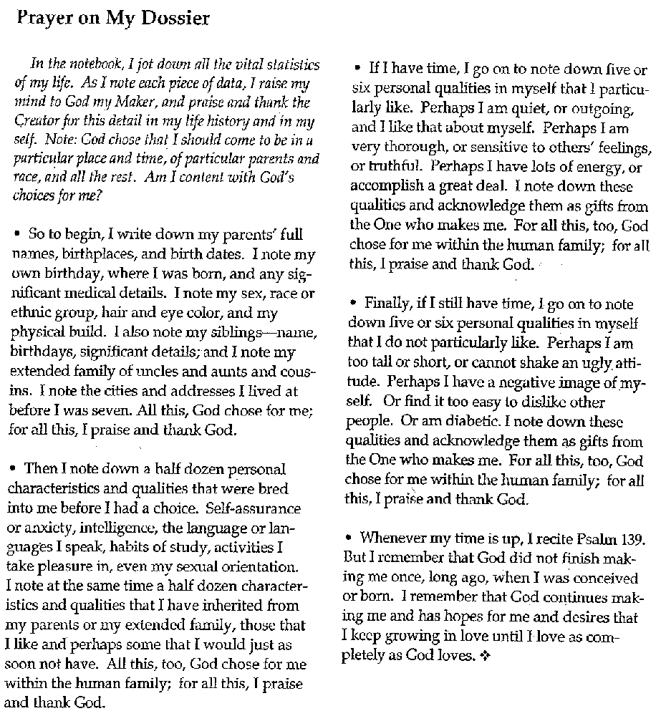
Helpful scriptures:
Genesis 1:1-31
Psalm 139:1-18
Isaiah 43:1-2
Psalm 91
Isaiah 49:1
Jeremiah 1:5
Beginning of prayer is gratitude
I am thankful for the people who . . .

My Response
Parents:
Joseph A. Naumann born 12/23/1916 or 17 in St. Louis
Leonarda Cunagunda Gengo born 10/11/1917 or 18 in St. Louis (only child
Me: Joseph A. Naumann Jr. born 12/14/1941 in St. Louis – Significant event – developed hernia at 6 weeks of age
Description of myself: Sicilian-German/American, Caucasian (as far as I know). I’m a male with brown hair and hazel eyes. I’m tall and obese.

Siblings: JoAnn 3/21/1947 and Carol Ann October 1958

Aunt: Loretta (father’s side)
Uncles: Fred, George, Harry (all on father’s side)
Cousins (don’t know most names): Richard, Billy Jo, Dennis, Karen, Frank

Where I lived up to the age of 13
2763 Bacon Street, St. Louis
>>> Maffitt Ave., St. Louis (only 1 year)
5856 Terry Ave. St. Louis
Characteristics I developed (nurture): Friendly, talkative, inquisitive, like stories, good language sills, imagination, hold on to hurts (chew on them)

Inherited characteristic (nature): weak knees, height, Mediterranean complexion, smile and singing voice.

What do I like about me: friendly, like to read, creativity, gifts of writing, speaking, & singing

What I don’t like about me: easily hurt, non-athletic, procrastinator (sometimes, and I don’t like confrontations

Friday 9:15 AM Conference 2

We’re in the “First Week” (week is a poor term – “period” might be better): Reality Check
Focus on sin, but the point isn’t to end on sin. A Christian meditation on shin should end with “God loves me anyway!”
Think of the parent’s with a baby - love without limit

The fact is that God loves me without limits.

Pre- and Post-Vatican II concepts of God
Pre-Vatican II was judicial – God as judge or accountant
Very task oriented
Focused on lists and legalities and semantics
Things are Right or Wrong – very little grey area
Post-Vatican II was therapeutic – God as friend
Focus on relationship
Church as the people (not the building)

List systems don’t really handle reality
Consider the “blind spots” in our culture
- Racism is wrong – so what can we do about it?
- Excessive consumerism is wrong – so what can we do about it?

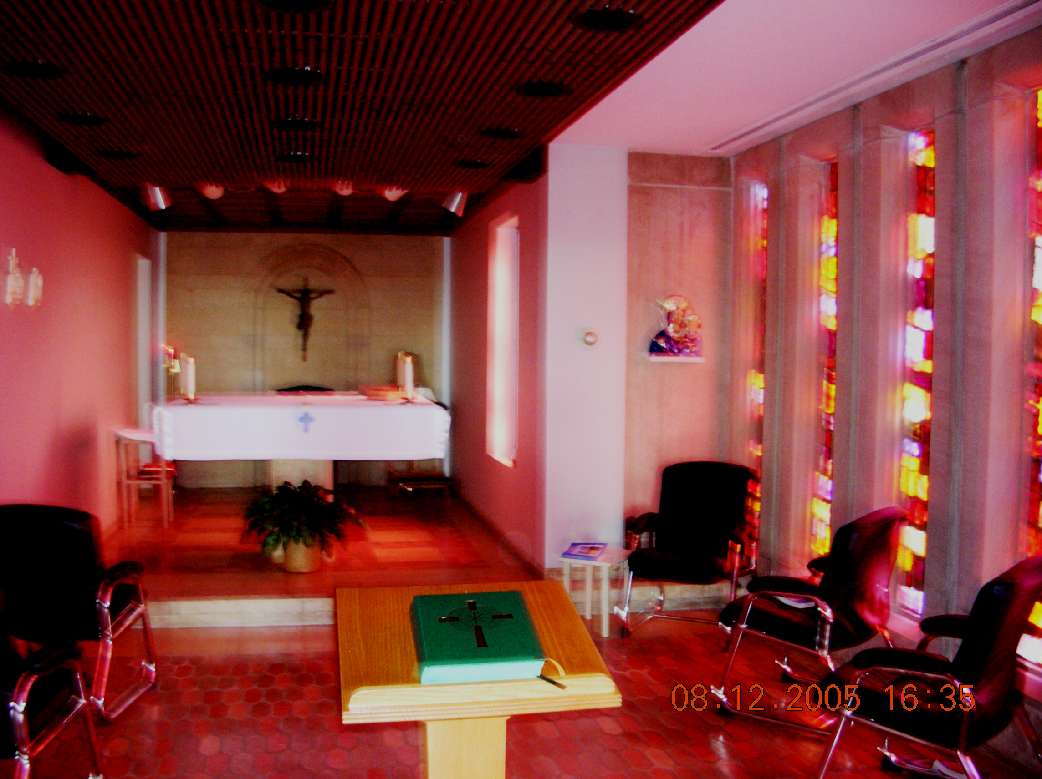
Figure 2 Chapel in Monighan Hall.

Homework 2 – Examen of Conscience (see handout #2)
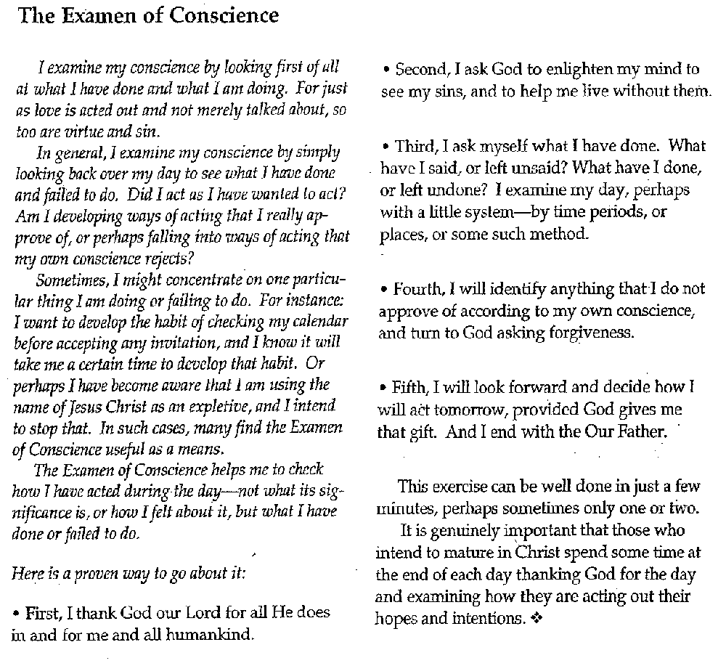
Useful Scriptures:
Luke 15:11-24 & 25-32
Matthew 18:21-35
Matthew 21: 33-46
Ezekiel 16:1-63
Penitential Psalms: 6, 32, 38, 51, 102, 130, 143
Baruch: 1:15-3:18
Romans 5:6-8

Meditation
- Gratitude
- Sin (ask for grace for conversion & change)
  - Sin of others
  - Sin of ourselves
- Effects of sin on the world
- What do I want to tell/ask God?

Fr. May’s thought of what Hell is: Hell is to be separated from God forever by one’s own choice. Existing forever with the realization of what was lost by that choice.

Friday 10:45 AM conference 3
You’ve got to unreasonably invest yourself in something! – Sacrifice for a greater good.

What are my hero stories? Stories to which I respond, “I’d like to do that . . . “or “I’d like to be like that”
Stephen Hawking
Pope John XXIII
Grandma Gengo
Nick Vujicic

What would I make great sacrifices for?
1st Meditation: Who would I follow?
2nd meditation: Be with Jesus and imagine Jesus’ call to me
Finish with what I want to say to Jesus.

Figure 3 Nick Vujicic, my hero - "No arms, no legs, no problems"
Homework 3 (see handout)
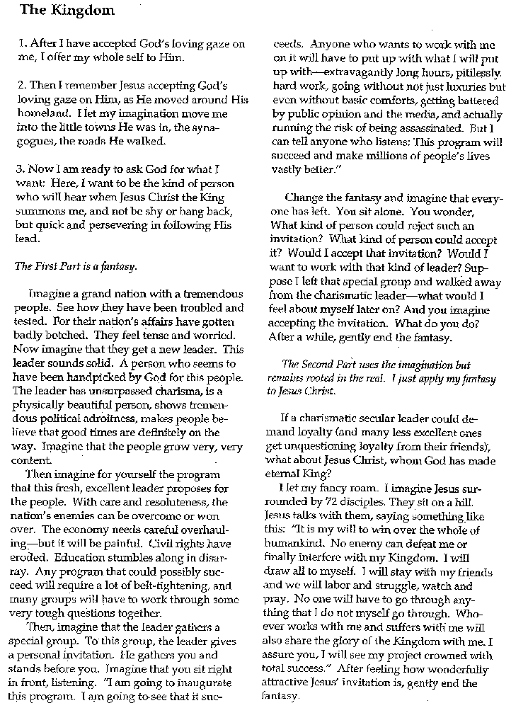
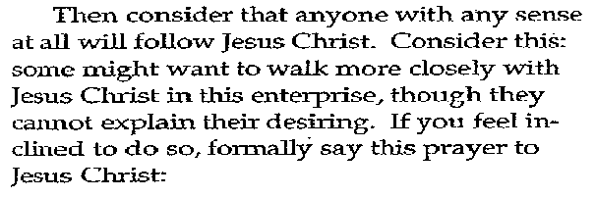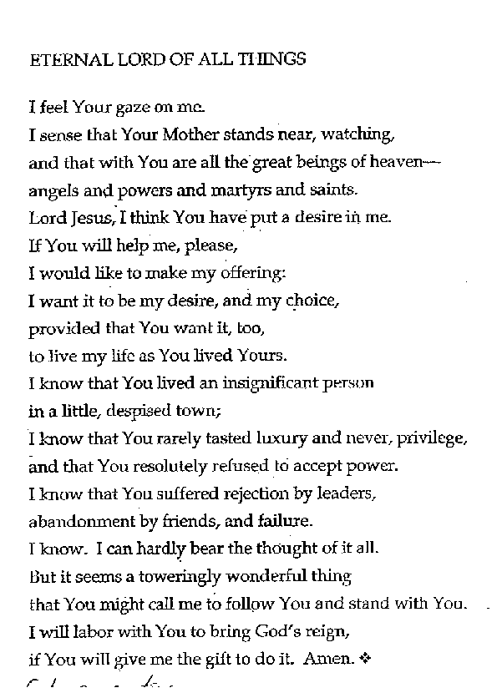
Helpful Scriptures:
Matthew 4:18-25
Deuteronomy 30:1-20
Psalm 110

Reflection of the tape played at lunch time:
God is the only “whole” who can fill my “bottomless hole.”
Non-Western mind – Semitic, Navajo, etc.
“Perfection” is not avoiding imperfection, but including (incorporating – learning from it and moving on) imperfection.

Friday 3:00 PM Conference 4
We’re beginning the second week (period) where we meditate on the life of Christ. Get to know Jesus through his family and friends.

Example of Paul – he was knocked down (Scripture never mentions a horse) Paul was knocked off his feet when he encountered Christ.
This meditation is meant to knock me off my feet . . . .
Meditate on the crèche – imagine the scene and try to fill in the blanks
Who was there?
Who stood where?
What do they look like?

For my meditation, try to get to know Jesus during his childhood – imagine and participate in it.
- Goal: to be led into prayer
- End with an Our Father

Fr. May on Joseph
Let me know Joseph as Jesus knew him, as “dad.”
Joseph was an older dad (30+) betrothed to Mary (12 to 14). Mary goes off to Elizabeth – older pregnant relative.

Joseph hears that Mary has returned by hearing comments in the street. He senses that something’s different or “not right.” Joseph goes to see her (5 months pregnant) and he thinks, “Oh, that’s why people won’t look at me.” Here’s a good place to meditate on Joseph’s reaction.

After a dream, Joseph decides not to divorce Mary but take her into his home and raise her child as his son. Joseph tries to be a good father.

Good meditation point: Trip to Bethlehem & birth of Jesus.
For the trip: do they have a donkey (not mentioned in scripture). Who rides and who walks? Do they both walk all the way (Mary’s ready to deliver)?
Strange visitors – astrologers, shepherds, etch
Another dream – flight into Egypt. Joseph must protect his family. Eventually returns to Israel but settles in a new town where no one knows them.

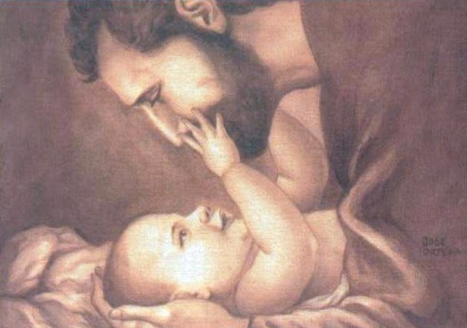
Figure 4 St. Joseph and the baby Jesus.

Homework 4 (see handout)
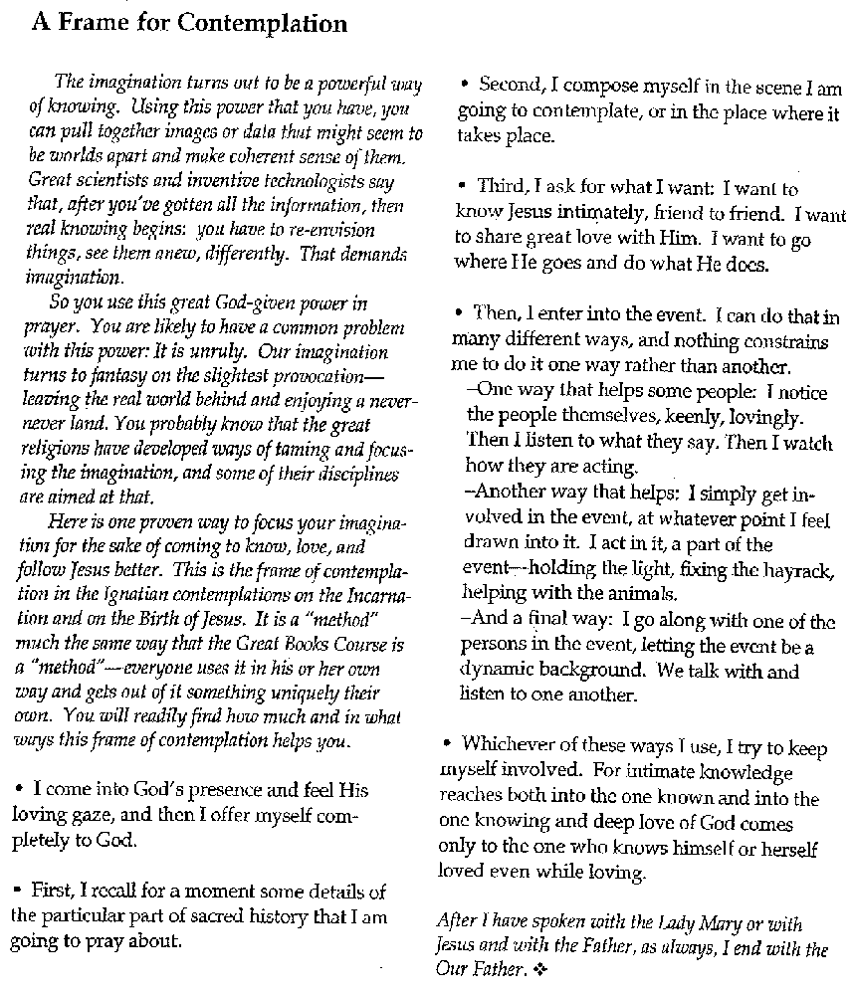
Helpful Scriptures
Matthew 1-2
Luke 1-2
Mark 3:21

My Reflection:
Question to Joseph: What was it like to be Jesus’ Father?

Answer: I could tell that Jesus wasn’t just your ordinary little boy. He minded, did his chores, learned my craft, but he had an above average inquiring mind. He read the Torah and the other sacred writings like the Prophet. Even as a teenager, he thought deeply about what he read. And there were the times he went off to be alone – I think to pray.

Don’t get me wrong. He fit in with the other boys, playing games and telling stories. I don’t know if his playmates noticed or not, but there just seemed to be a greater depth to him – so deep even he didn’t comprehend it. But, he kept trying to better understand himself.

You can imagine my feelings when we thought he was lost and we found him in the temple discoursing with learned men at their level. He came away with us and was obedient, but he just didn’t seem to see why he shouldn’t have done that at his age (not quite a man yet). Maybe because I was so much older than the other boys’ fathers, he just felt at ease with men while he hadn’t quite reached the age of manhood himself.

At times I’d think about Mary’s stories of how Jesus was conceived – beyond belief they were. But never before or after had Mary ever spoken anything but the truth. Never had I doubted he, so even this unbelievable story might be true. Had God chosen our son to be someone special? So I always looked at Jesus with love and also with a sense of wonder. To me, he was very wonderful.

Friday 8:15 PM Conference 5

Reminder: If something strikes you, go with it. Don’t worry whether it “fits” my presentation. If it leads you to prayer and relationship with God, that’s what you should be focusing on at that point.

Ways to pray with scripture:
Read it, paying careful attention – read slowly and “enter in”
Contemplation: Get the scene clearly in mind and fill in the “blanks” – flesh out the framework
Meditation – tie it all together and “enter in.”
What am I to learn from this?
Why do I care?
What does it mean to me?

Think about the apostles – quite a motley crew; however, they became the foundation of the Church
What does it mean to be a friend of Jesus?

Examine the Apostles and the Saints
At Lake Gennesaret Jesus was preaching about the Kingdom and repentance. Fishermen were mending their nets. Jesus get in Simon’s boat and says to row out a little way. How do the fishermen react? When Jesus tells them to row out and drop the nets, how do they react? When they get a huge catch, what is their response?

Consider having a conversation with Peter

Homework 5 (check the handout)
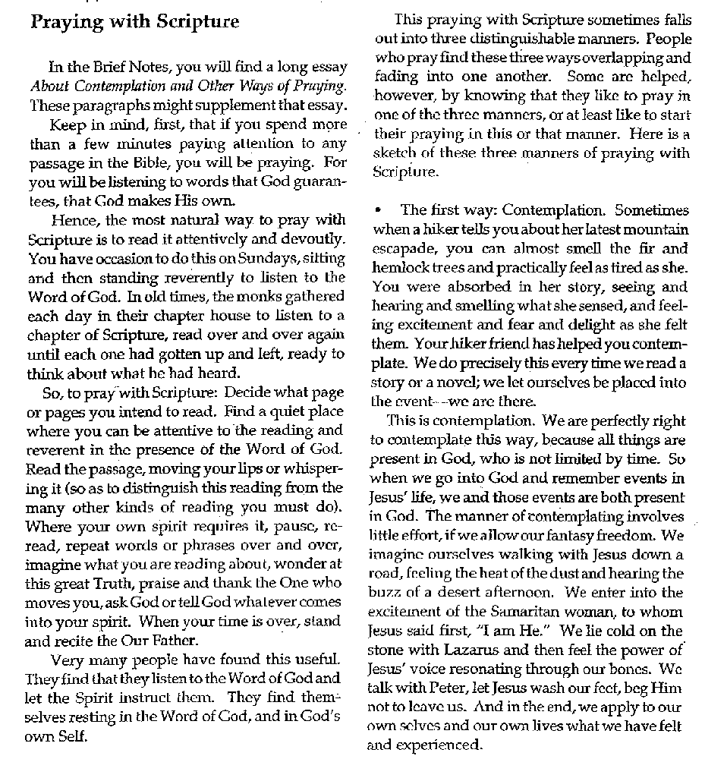

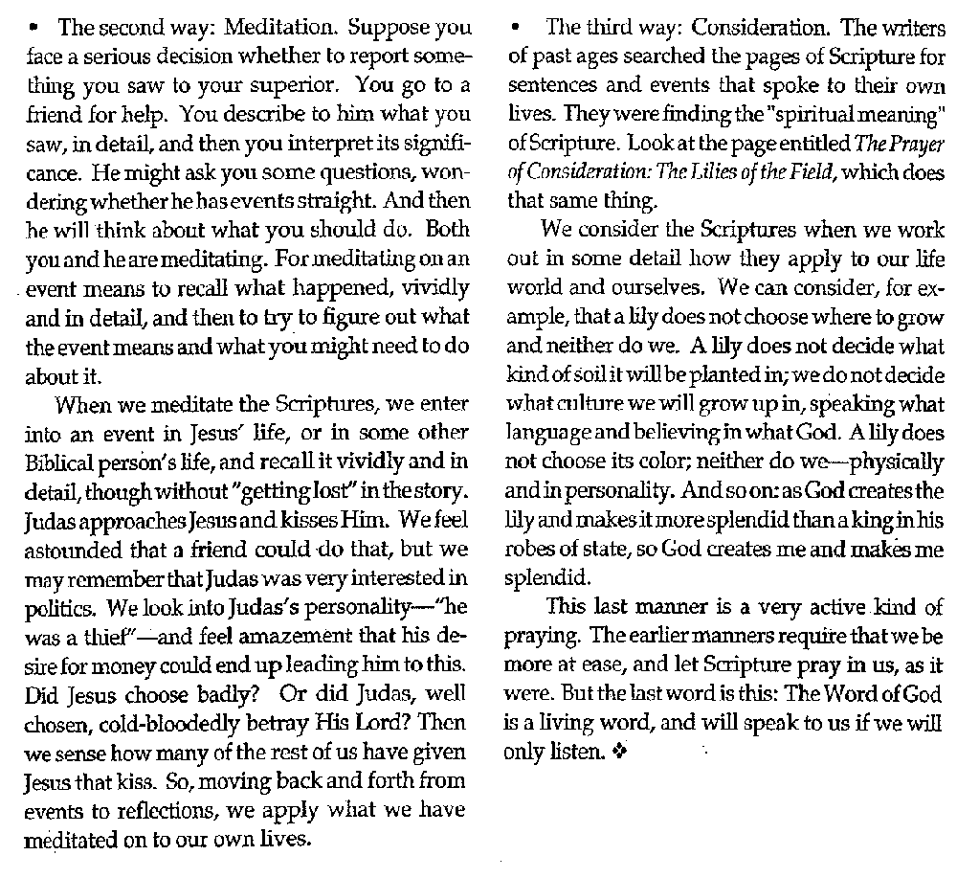
Useful Scriptures:
Matthew 4:18-22
John 21
Matthew 9:9-13
Mark 2: 12-17
John 1:43-51
1 Samuel 3
Acts 9
Ezekiel 1

My Reaction
Question to Peter: How do you live that close to the “light”?
Answer: You that until Pentecost it hadn’t been easy – I felt unworthy, confused, slow witted, and loved. People called me Peter because I was rather hard-headed and dense at times. I was so impulsive – ready to leap into action without thinking. I know Jesus was frustrated at times, but he was always patient and when I looked into his eyes, I could see that he loved me with all my shortcomings.

Can you imagine that Jesus cured the sick, drove out demons, and raised the dead without seeking any gain – His heart was just that full of compassion? And there was I who was slow to learn, with crude speech, and little impulse control. Why would he want me there, but he did – he really did. I wanted so much to please him, but I continually failed to make the “grade,” at least in my opinion.
- I wanted to walk on water to him, but I began to sink
- I wanted to build shelters on the mountain for him, Moses and Elijah, but he said “no” – Our mission was below – we couldn’t remain there holding on to that moment.
- I tried to talk him out of going to his death in Jerusalem, but he told me to “get behind him.” He was the leader, not me – my role was to trust and follow.
- I wanted to die with him, but I ran away and later denied him

And when he had risen from the dead, he didn’t scold but let me take back the renunciations when he asked me, “Peter, do you love me?” My heart almost burst with gratitude when I was able to say, “Yes, Lord, you know I love you.”

It wasn’t easy living with Jesus. But when he looked at me with love, I was able to remain with him. In the end, I did die for him, but it really was worth it. So just remember that no matter what you’ve done, Jesus loves you with an everlasting love. Draw upon that to keep on walking with Jesus – in the end, you won’t regret it.

Saturday 9:00 AM Conference 6
We’re still in the second week – walking with Jesus.

Considering the Real Presence – 4 ways
- Eucharist
- Scriptures
- Priest as presider
- The gathered flock

Thoughts on the Miracle Stories
- The point isn’t the miracles themselves
- The point is the faith that made it possible – “Your faith has saved you.”
- The point is reconciliation

Miracle Meditation: What role will I play? Luke 5:15-16
Homework #6 (see handout)
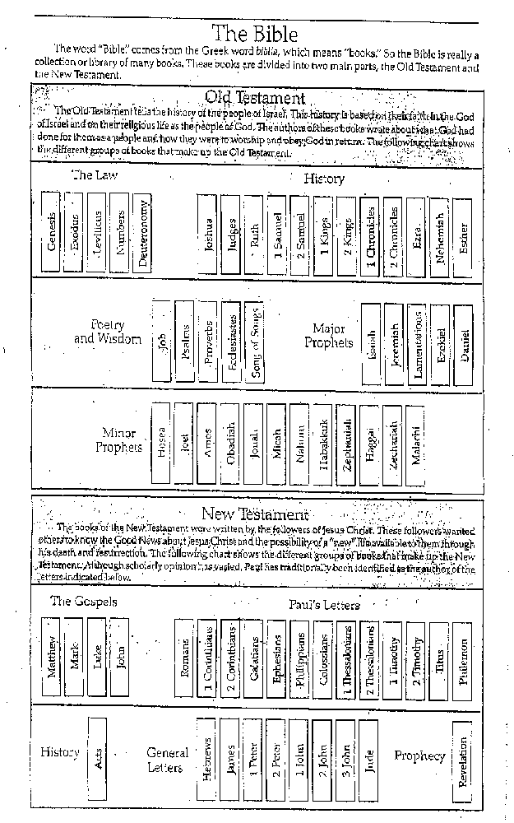
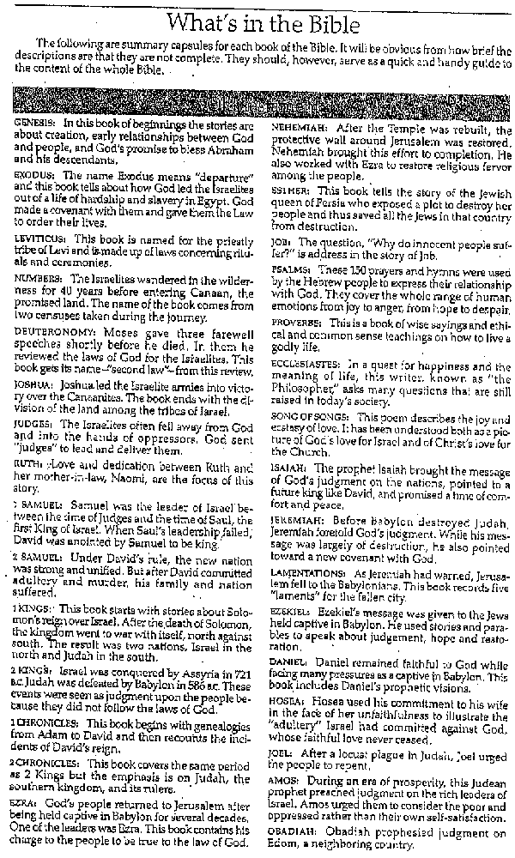
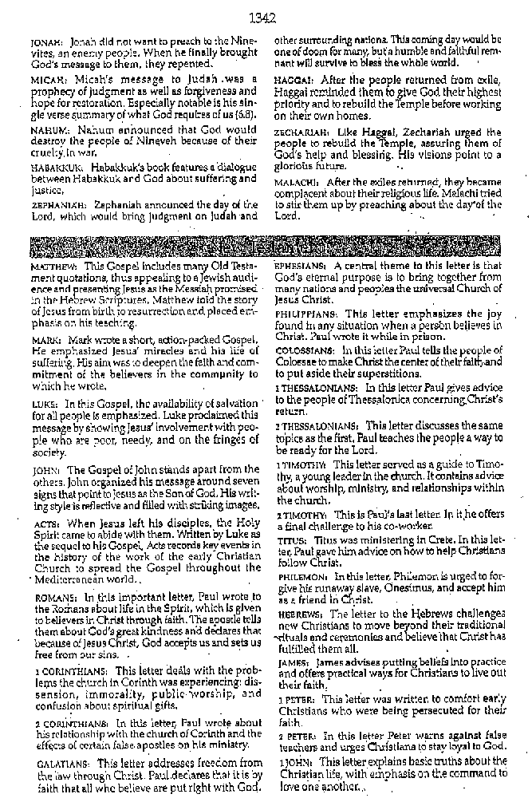
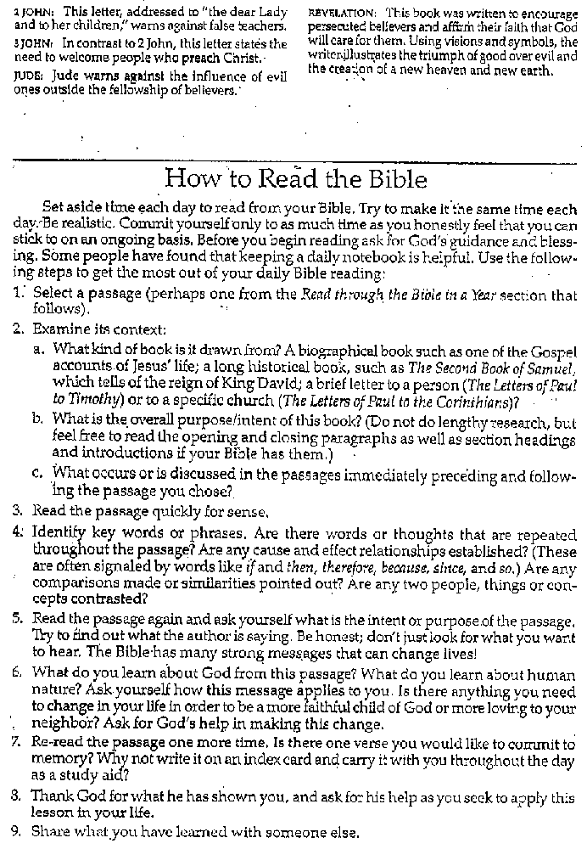
Helpful Scriptures:
Luke 5:17-26
Luke 7:1-10
Luke 8:40-56
Luke 13:10-17
John 5: 1-17
John 11

My Reaction:

Question: Jesus, remember when they lowered the lame man down through the roof? What was going on in your mind then?

Answer: Situations like that were always somewhat troubling, more than when I taught outside on a mountain side or just off the shore in a boat. The house was filled with the “important people” – the Pharisees, scribes, teachers of the “law,” etc. Most of them weren’t there to learn from me but to trick me or catch me saying something they could use against me. I still taught and hoped I’d reach some of them. What troubled me was that many of the people who might really be open to my message were outside the house because they weren’t “important” people.

And so while I was teaching, I heard sounds on the roof. It wasn’t unusual for people to use the roof of their home so I didn’t pay much attention, but the noise grew louder and then a shaft of light pierced through. Someone was removing parts of the roof. Were they dong it so they could hear me? Well, the opening got bigger and bigger. Small pieces of dried mud fell upon the people in the room. They were looking up and grumbling. Some even used some strong language. I tried to keep teaching, but I doubt that anyone in the room was paying attention to me.

I thought, “Wow, his friends must really care about him to do all that work.” And I thought, “They certainly must have a low of faith in me – in what I can do.”

I tried to use this as a teaching moment. I told the man not to worry – that his sins had been forgiven. I wanted to point out that the most serious infirmity we have is the sin which reduces and complicates our relationship with God. By the grumbling and facial expressions of the “important people,” I could see they were shocked and offended. They were thinking, “Is he claiming to be God?” I was sure they’d use that against me. So I said, “What is greater, to forgive sins or cure infirmities?” And to show them that I could forgive sins, I turned toward the man and said, “Get up and take your mat with you – you are healed.”

The man got up and left. The teaching moment was over. Some were greatly upset by me and others were awestruck from what had happened. Even those outside who weren’t on the roof knew a miracle had happened. They knew the man was lame when he arrived at the building and then they saw him walk out of the door carrying his mat. He couldn’t walk before he was brought into my presence, and now he was walking out of the door. They knew I had healed him.

And I wondered, “How many people got my real message that the infirmity of sin must be removed for there to be real, whole healing. Did any of the “important people” get it? How many of my disciples got it?

Prayer: Jesus forgive me my sins so that I may serve you better. Thanks for the help you’ve given me already. Thank you for your love and patience.

Saturday 3:00 pm Conference 7

Think about the miracles in my life
Now entering the 3rd week of the spiritual exercises: Jesus’ Passion and Death
Shift in the Grace sought: to feel sorrow & to feel compassion with Jesus & to feel shame (my sins)
Fr. Mike helps set up for visualizing the Last Supper
Imagine Jerusalem for the Passover – population doubled for the feast – people everywhere
Imagine the hospitality – people sharing their homes with visitors
Imagine the place – the upper room (describe it)
Imagine the disciples at the beginning – joyous and triumphant
- Remembering the reception Jesus received on Sunday
- Excited about the coming feast
- Small town men in the “big City”

Jesus has been talking strangely
- Jerusalem, the city that kills prophets
- His immanent death
  - Surely the “crowd” that had hailed him would protect him, wouldn’t it?
- When he meets the High Priest
- Events after he has “risen”
The Seder meal takes a strange twist
- Washing their feet – do you see what I’ve done?
- Talk of betrayal
- Adding strange new words
  - Break = his body
  - Wine = his blood (which will be shed)
    - This is the last time I’ll drink of the cup until my Kingdom comes . . .

Trip to the garden at the Mount of Olives – Jesus is “down” and seems very troubled

Ask to be with Christ through this. What do you want to say to or ask Jesus?

My Reflection:

The thoughts of Peter after Jesus is arrested

This is crazy – it makes no sense! Jesus didn’t do anything wrong or break any laws! Why did they arrest him? Why was Judas with them? Oh, yes! Jesus did mention that someone would betray him – How could Judas do that?

It started so nicely on Sunday when we got to Jerusalem. It was like a parade – people were welcoming Jesus and praising him. I felt so important because I was with him, and people could tell that I was one of his followers.

Jesus sent two disciples ahead to get a donkey for him to ride and arrange for and upper room in which to have our Passover meal. I thought, “Good luck, guys!” Jerusalem was so crowded for the Passover – who could spare a donkey or a room for people who were basically strangers. But I was surprised when they returned with a donkey and said they had secured a room.

It seemed that we were really blessed – the house was bigger than average and had a second floor which is where the room was located. It was fairly large – there was room for all of us to recline around the table. Several oil lamps lit the room nicely. We entered in good spirits because Passover was a time of celebration remembering when God saved Israel from Pharaoh. That was the beginning of the Exodus. We were laughing and joking as we gathered, but Jesus wasn’t joining in as usual. He seemed distracted and very serious – out of harmony with our mood.

Gradually, things got stranger and stranger. I was quite confused as were some of the others. At one point, Jesus was saying the Seder blessings, but he changed and added words. He was talking about bread being his body and that were to eat his flesh. He called the wine his blood which would be shed for us, and he told us to drink his blood. He said we were to do this in memory of him. Why did he keep talking about dying?

He talked about being arrested first – but how could that happen with the great reception he had received? They wouldn’t dare, would they? Then he shocked me when he said I would deny him. I protested – I’d never deny I knew him – I was proud to be his friend. He had a kind of sad smile on his face when he said, “Oh, yes, you will deny me.” He wasn’t angry with me – he just looked at me with his sad eyes that were so full of love.

When we had finished the meal, Jesus said, “Let’s go over to the garden on the Mount of Olives. I want to pray.” With so many people in Jerusalem, the garden wasn’t going to be quiet and peaceful. So we went with him and he asked us to wait while he prayed. He walked a little way off and began his prayers. We were so tired, so full of food and wine. We tried to stay awake and alert while he prayed, but we fell asleep. He sounded somewhat disappointed when he came back and awakened us. I really tried to remain awake, but it happened two more times. Then Jesus said, “It is time.” As we moved from that spot, I saw Judas with a crowd and some soldiers coming towards us.

Judas walked up to Jesus and kissed him and then the soldiers grab bed Jesus and said he was under4 arrest. Someone took a sword and cut off the ear of the High Priest’s servant. Then Jesus said, “No, not this way!” He touched the servant and the ear was restored. You’d think that they’d let Jesus go after than demonstration of his power, but they didn’t. And Jesus just went along with them – he didn’t use his power to escape arrest. Why did he go off so meekly? He had to know that at the very least, he would be severely hurt if not killed.

Fearing that we’d be arrested too, we all ran off into the crowds milling around in the area. He said that I’d deny him. Well, I didn’t do that, but I did run away. What happened to my bravery? I felt so ashamed of myself. I feared what would happen to Jesus after this night and possibly to us.

My Prayer/Reflection:
Jesus, how many times have I run away from you, or at least turned away to act in a way you’d disapprove of? Don’t tell me – I feel bad enough. Lord help me find the strength to not turn away, and to be faithful to you and what you desire of and for me. I know you’ve forgiven me, but I’d still like to be faithful to your teachings. I know I need your strength. In my weakness I can only find strength in you.

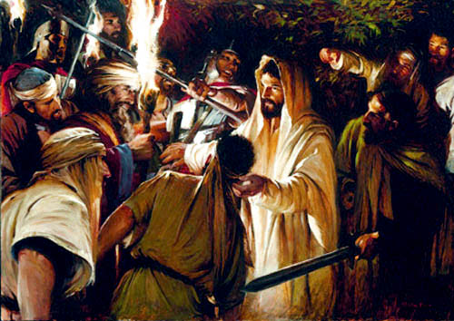
Figure 5 Arrest of Jesus
Handout Talk 7
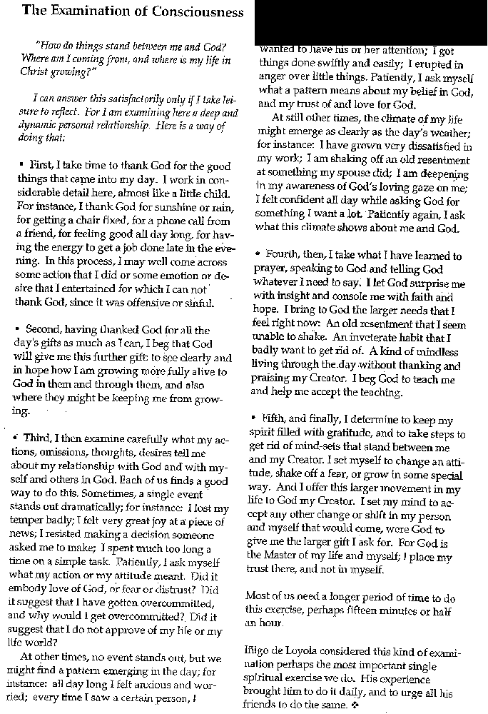

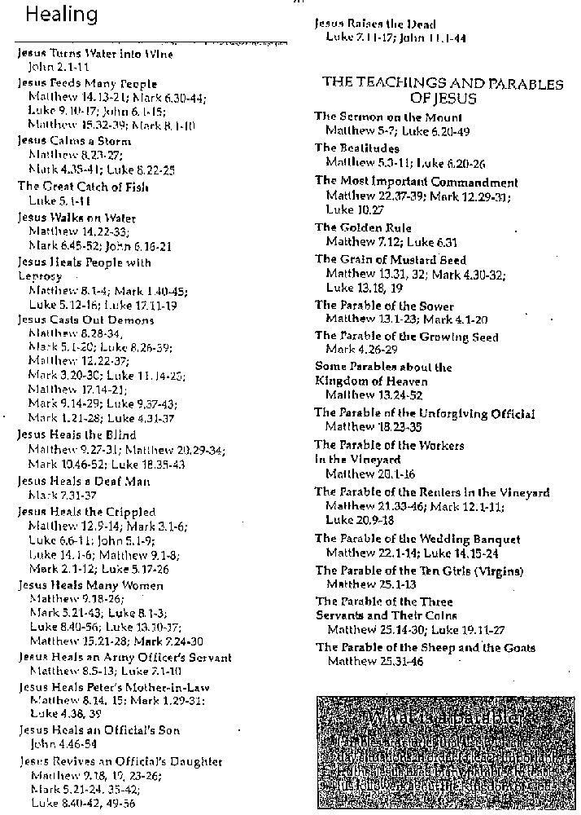
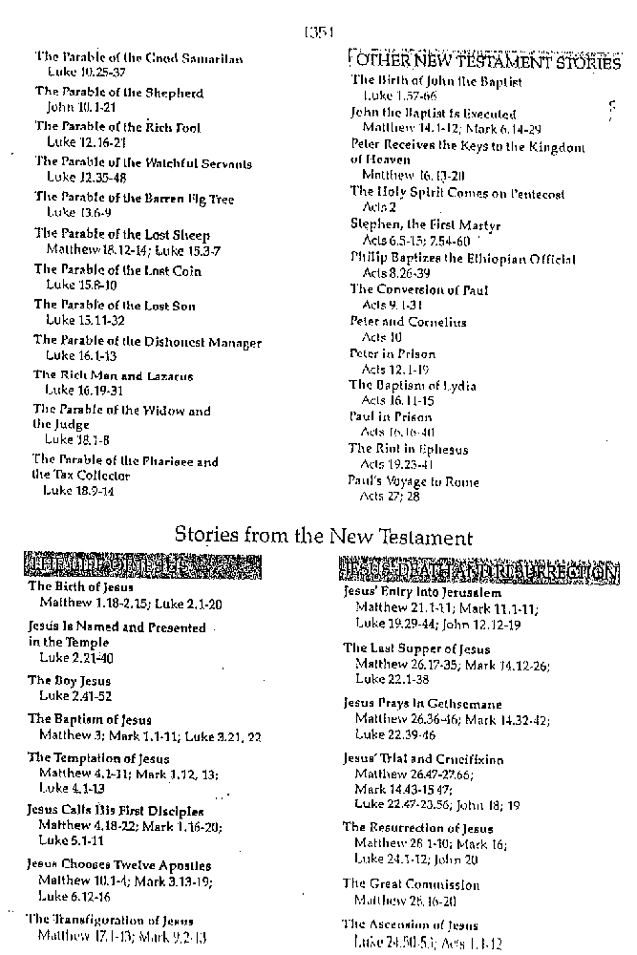
Helpful Scriptures
Matthew 26:17-45
Mark 14:12-42
Luke 22:7-46
John 13
Exodus 12:1-14, 24:1-11

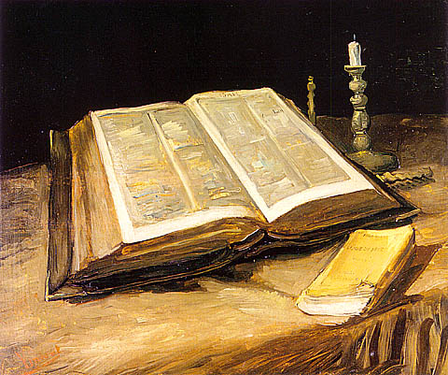
Figure 6 The Bible is a source of guidance and wisdom

Non talk Handout
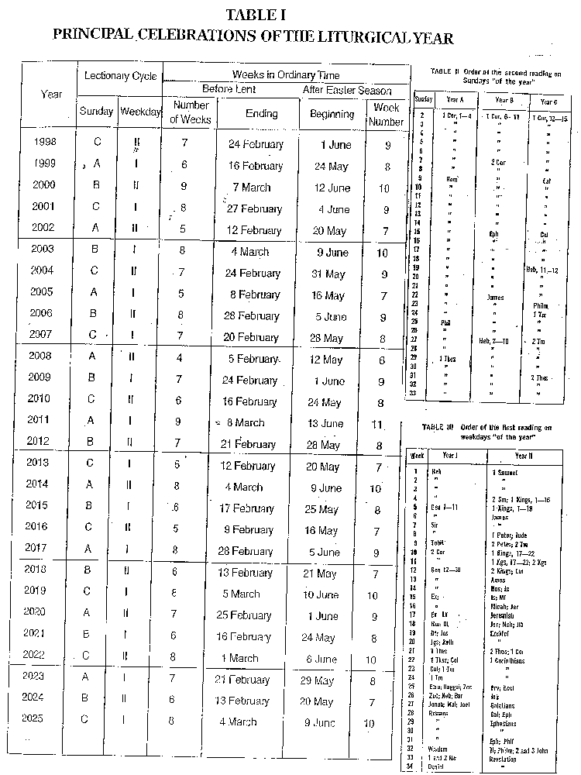
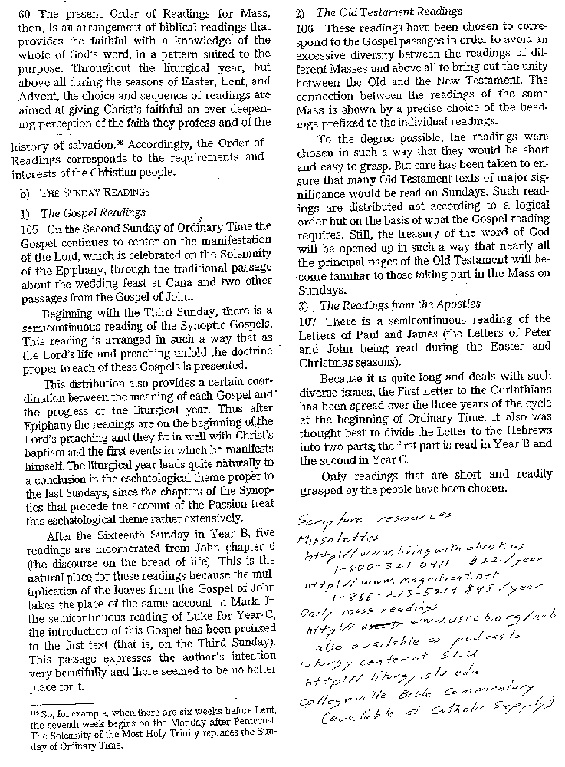

Saturday 8:15 PM Conference 8
Still in the 3rd “week” – Companions in Jesus’ suffering

Think of the Passion as an epic hero story.

Who are the heroes of my past? Who surrendered hopes and dreams for my benefit?

Focus on gratitude – “Now I get it!” JESUS DID IT FOR ME!

Sit quietly with Jesus. Reality: there are unfixable problems, so just be helpless – just be there and share. Sit quietly with Jesus.

Prayer for the Passion:
- Sit before the Eucharist – silent companionship
- Make the stations of the cross
- Meditate on the Sorrowful Mysteries of the rosary.

Reality Check:
- When bad things happen, do I ask why is this happening to me?
- Have I tried to bargain with God?
Fact: Suffering just happens – not always because I did something wrong. Jesus didn’t disserve his suffering.

Fr. Mike’s guided meditation:
One of the women who followed. I was there when nothing could be done. I sneak in and see them mistreat Jesus. I can’t help him, but I’ll try to move to where he might be able to see me and know he’s not alone. That’s all I can do. They scourge Jesus and I’m helpless I can’t imagine that my being there would bring any comfort, but that’s all I can do. So, I stay there in my helplessness.

I see him condemned and made to carry the cross bar to the place of his crucifixion. I want to take his place, but I can’t. I’m so embarrassed for him when they strip him, and I almost faint when they begin to pound in the nails.

I see him die. And I can’t stop it. I want to run away – to hide. All I can do is be there hoping he saw me and knew he wasn’t alone.

I collapse but manage to get up and follow when the lay him in the tomb. It’s over and he’s gone.

What about Jesus’ followers now. They are crushed – they don’t really know or believe that he will rise from the dead. They gather together and cry and hold each other and try to avoid the police.

Graces to seek: gratitude, being overwhelmed by Jesus’ death, What can I do? Just be there!

What do I want to say to Christ – a friend who did what he did for me?

My Reflection:
Jesus, I imagine that you knew what crucifixion was like. You’d been to Jerusalem before, and this was done by the Romans quite often. I guess some people looked upon this as entertainment like the gladiators in Rome.

It was more than just crucifixion too. They beat you bloody and forced a crown of thorns upon your head. Some of those desert plants have long, wicked thorns too. Then you had to carry the cross beam on your shoulders that were a mass of wounds from the beating the night before. I imagine every move tore open wounds and your salty sweat must have stung when it flowed into newly opened wounds.

Each of the times you fell, that cross beam probably knocked the breath out of you, and if you didn’t get up fast enough they whipped you some more. Along the way to Calvary, I guess you saw sorrowful faces on people you knew: Mary Magdalene, your mother Mary, and others. Some were crying because of their helplessness, while others were jeering at you. You saw great disappointment on some faces, didn’t you? They had such high hopes from your teachings, and it all seemed lost to them now. Knowing your heart of love, I bet you wanted to comfort those who were hurt, sorrowful, and hopeless, but you couldn’t. You had said to your Father, “Thy will be done!” so you had to let the horror unfold.

Even though you had spoken of rising, you still had to face the horror of death by torture as a human. You knew you’d experience all the pain of fear and terror and also the physical pain of the actual crucifixion. You also had to experience the pain of being stripped naked before the mocking crowd. It must have hurt to see the tortured faces of those who followed you right up to the cross and to see their embarrassment for you as you laid there naked as they pierced your hands and feet.

Oh, Lord, that you endured that for me – for us. I am grateful to you for it and sorrowful for you because it had to be done. It amazes me that before time began, you knew I’d be born and you knew every sin I’d commit in my lifetime and how much of your burden on the cross was laid upon you by, me. But you still wanted me part of your creation. From time immemorial, you held love for me in your heart. I know this to be true even though I will never be able to comprehend it all in this lifetime.

I’m bound by linear time, but you are God and beyond time –the past, present, and future are one with you. Does this mean that the crucifixion is always present to you? This is way beyond my comprehension, but I suspect that the true meaning and experience of the crucifixion may be far more encompassing than it seems from the perspective of linear time. So I will offer a prayer of thanks as you taught us to pray . . . . .

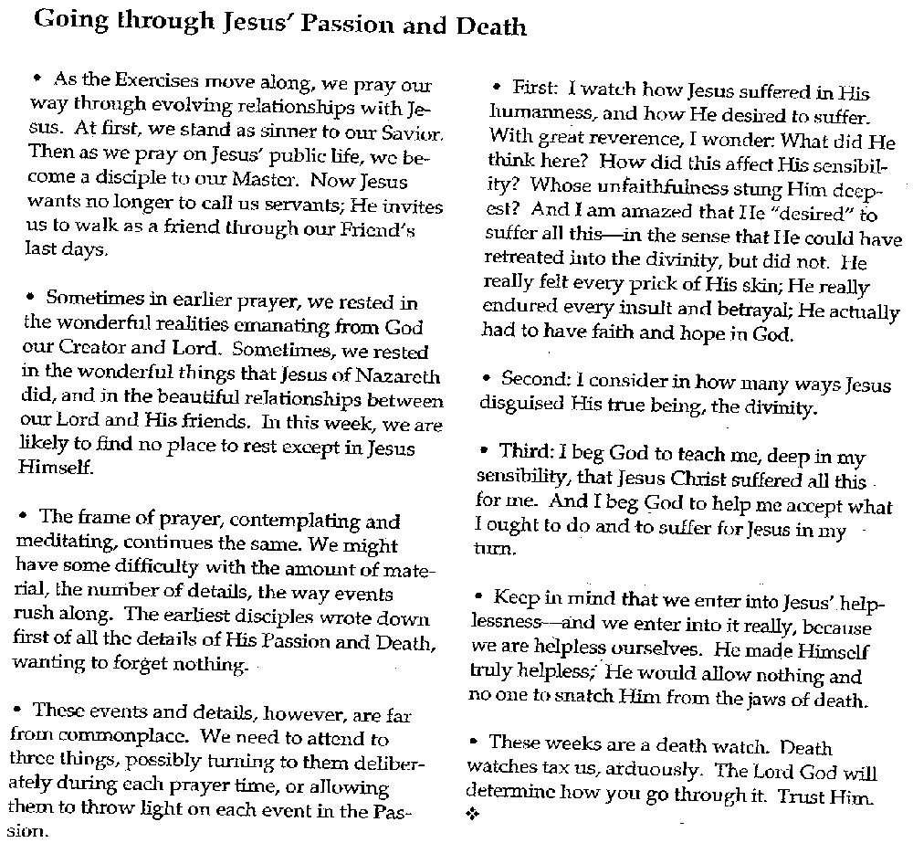
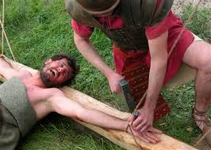
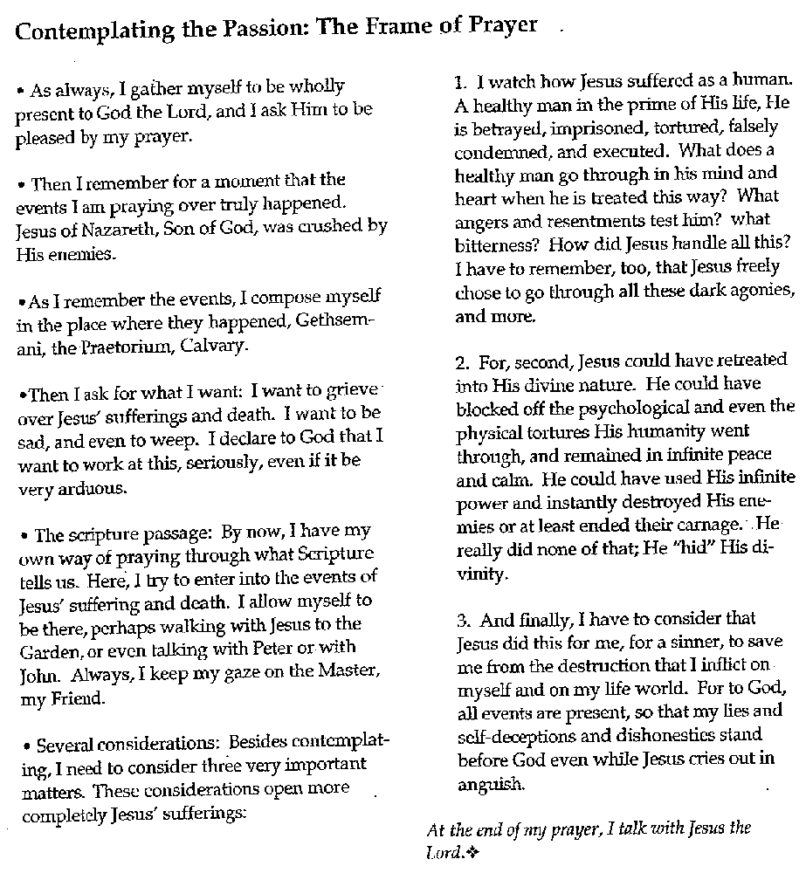
Helpful Scriptures:
Matthew 26:47-27:45
Mark 14:43-15:27
Luke 22:46-23:48
John 18:1-19:42

Sunday 9:15 AM Conference 9

Week Four: Return to the World – enter the joy of the resurrection

Enter into the resurrection through the resurrection stories. But they don’t all fit together, but that’s okay. Where do we find the resurrected Jesus?
- Scripture
- Eucharist

For meditation, Fr. Mike took the Apostle Thomas
The dream died on Friday – it’s gone
But they say “He’s alive!” TRANSFORMATION
So now the dream is transformed
The response – Joy! There’s a new beginning. So, the broken “me” can be transformed.

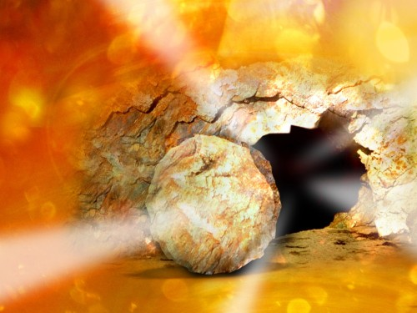
Figure 7 Resurrection

Handout Talk 9
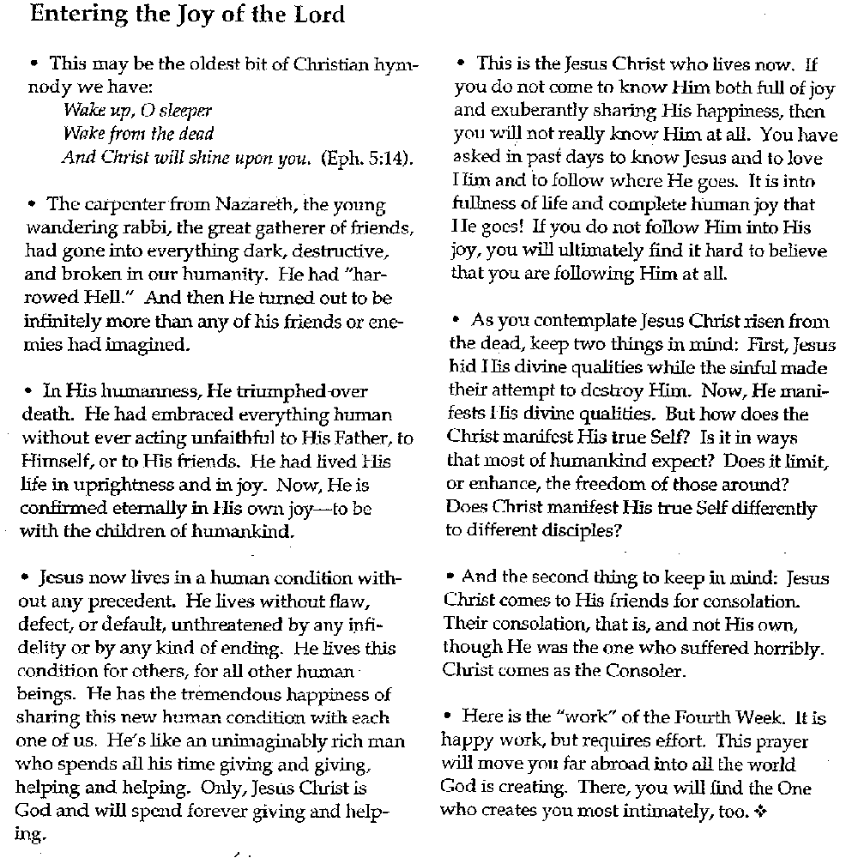
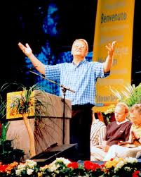
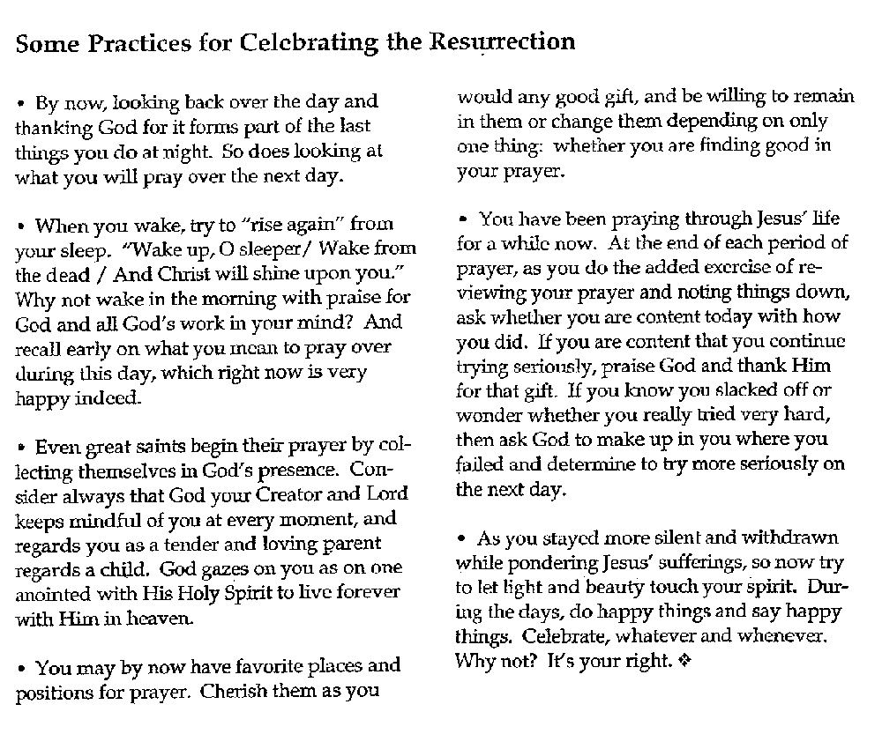
Helpful Scriptures:
Mark 16:1-8
Luke 24:1-11
Matthew 28:1-7
John 20:1-9
Matthew 28:8-9
Luke 24:13-35
John 20:19-24
John 21:1-14
John 21:15-22

Sunday 10:45 AM Conference 10
Gratitude – Contemplation for learning to love like God.

Look at and appreciate all the small, special things.

Grace: Aware of the Divine Presence – Offer myself to God

Place: Before the Divine throne
See all things as gifts
Settling of accounts (an interesting twist) –Announce to the world all that He has done for me.

God holds everything in existence, so everything is a gift.

God is present in every moment

God is continuing to create and calls for my (our) help.

What can I say to God?

God has shared so many good things that I want to share back. It is truly awesome.

Take, Lord, and receive all my liberty, my memory,
my understanding, and my entire will.
All I have and call my own.
Whatever I have or hold, you have given me.
I return it all to you and surrender it wholly
to be governed by your will.
Give me only your love and your grace
and I am rich enough and ask for nothing more.
St. Ignatius, from the end of the Spiritual Exercises

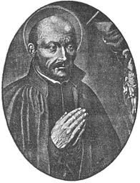

Handout Talk 10


