The Coming Death of Venice?
June 20, 2013 - Anna Somers Cocks
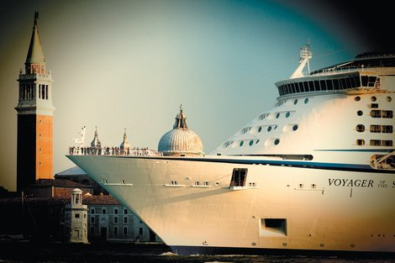
Fortunately, the €1.5 billion investment will probably not be found, but if it is, the City Council of Venice will be giving permission in July for an 820-foot-high skyscraper (130 feet taller than the Tour Montparnasse in Paris) to be built on the mainland behind Venice, about six miles from St. Mark’s Square.
The mayor, Giorgio Orsoni, assures us that the building will not spoil the skyline of Venice, but The Art Newspaper, of which I am the founding editor, published a photomontage based on calculations of what it would look like from the Lido, the strip of land opposite St. Mark’s Square separating the lagoon from the Adriatic. The skyscraper looms up, two thirds the height of the campanile of St. Mark’s, and would ruin the iconic (appropriate use of the word here) view that we all have in our mind’s eye.
Figure 1 A cruise ship in front of San Giorgio Maggiore, Venice, August 2011
Not true, insisted the mayor. So I asked the consulting firm Millerhare, which does this kind of projection for all big buildings in London, to go over the calculations. Like so many people, especially outside Venice, they love the city, so they donated their expertise. Their findings confirmed ours.
What is going on here? The answer is that over the last thirty years Venice has become the object of so much politicized wrangling, in which the truth has been the first victim, that an arithmetical fact can be treated as a matter of opinion and most people will just shrug their shoulders. This attitude lies behind much of what is described in this article and is putting the city at risk.
In 1987, Venice was declared a UNESCO World Heritage Site, at which point it was supposed to come up with a management plan. This March, the City Council finally presented it to the public. Its purpose, the council said, was to “define the strategies and choose the ways of putting them into practice through action plans.” Unfortunately, the document fails almost completely in both these objectives because its authors have fuSince 1997 the VPA has put €141 million into adapting and modernizing the passenger port, while the company it set up that year to manage the port, Venezia Terminal Passeggeri, has contributed €32 million. SAVE, the company that manages the Venice airport, is a shareholder in VPA and has an interest in the growth of the port because most of the cruise passengers arrive or depart by air. The City Council, on the other hand, has no shares in VPA or SAVE and no direct say whatever in how they are managed. It does not even have any authority over the Giudecca Canal down which the ships sail, because, unlike all the other canals in Venice, the Giudecca comes under the VPA. It is as though Broadway were not Mayor Bloomberg’s preserve but that of the federal Department of Transportation. 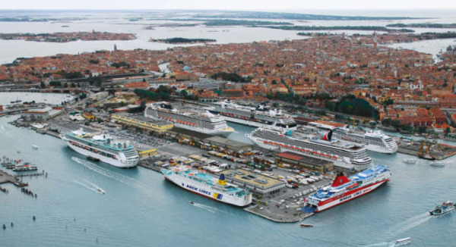
Figure 2 Venice Cruise Terminal
The number of berths in the Venice port has been increased so that it can now take eight ships at a time, and starting later this year they will all be big ones since the smaller ferry boats to Greece will be docking on the mainland side of the lagoon. The new facilities there have been a €250 million project, which shows that Costa is good at getting money, helped in this case by the fact that these docks are in an area of dying petrochemical industry, which central and local governments need to see cleaned up and converted to some other activity. And where there is construction, money flows, jobs are created, votes are won. So that is where the power lies—not with the impecunious City Council and mayor.
Costa denies that the passage of the ships affects either the buildings or the quality of the air, but opponents say that no truly independent studies have been carried out. What is certain, though, is that the 200,000 cruise tourists embarking in Venice in 1990 became 337,000 in 2000, one million in 2007, and reached 1.8 million in 2011. Silvio Testa, who leads the vociferous No Big Ships campaigners (they have lined the banks of the Giudecca Canal with long banners informing the passengers leaning over the rails how fed up they are), told me that on just one day in July 2011, six of these ships tied up in port and 35,000 tourists were disgorged all at once.
After the Costa Concordia ran aground on the island of Giglio on January 13, 2012, Francesco Bandarin, UNESCO’s assistant director-general for culture, wrote a letter to the Italian Ministry of the Environment saying that this accident reinforced “longstanding concern” over the risk posed to World Heritage Sites, and Venice and its lagoon in particular. A government decree shortly afterward banned ships of more than 40,000 tons from sailing down the Giudecca Canal. This decree has been ignored.
Yet despite this decree and the formal appeal by a senior member of UNESCO, despite the fact that the City Council was writing the management plan for UNESCO, despite being responsible for a UNESCO World Heritage Site, the authors of the plan could not muster enough courage to let out the smallest squeak against the interests of the VPA. I asked Giorgio de Vettor, one of the coordinators of the plan, why the cruise ships were not mentioned, and was not surprised, except by his candor, when he just said, “You understand the reason.”
So what is going to happen with the cruise ships? There is no doubt that the port plays a growing part in the city’s economy. According to Costa, it provides 1,600 direct jobs in services for the ships and passengers, 2,600 jobs in supplies, maintenance, repairs, bunker sales, etc., and 1,270 direct jobs created by tourist spending in Venice (at least €363 million a year) before and after the cruise, with one third of passengers disembarking and embarking there.
These are impressive considerations in a town where there are fewer and fewer jobs outside the tourist industry. But nothing is revealed about what the port contributes directly to the running costs of the city and who benefits from its profits. As so often in Venice, information is lacking or withheld, given grudgingly, or used as propaganda.
After having invested so much, the last thing Costa wants is for the cruise ships to dock anywhere else, yet he himself admits that “what they awaken in most people is fear and concern,” so he suggests a way of reducing the number of sailings through the city by deep-dredging an existing shallow channel through the lagoon called the Calle Contorta di Sant’Andrea so that the ships can either come down the Giudecca Canal and then sail out by this new route (his preferred option) or avoid the center of Venice altogether and come both in and out by the Calle Contorta. But the view from there is of the petrochemical works, so tourists who had expected to feast their eyes on the Doge’s Palace and St. Mark’s Square might well feel cheated, and this could be bad for business. However, since it is very unlikely that the ecologists will allow the Calle Contorta to be deep-dredged, Costa is probably not too worried.
Another local politician has come up with a plan for a new, relatively inexpensive dock capable of berthing up to eight ships, to be built within the huge, existing breakwater at the Lido opening; passengers would be brought into town by catamarans that would hardly disturb the waters. But at a cost of €200 million this is unlikely to happen soon because Italy is broke. So expect to go on seeing the cruise ships in Venice.
Since 1997 the VPA has put €141 million into adapting and modernizing the passenger port, while the company it set up that year to manage the port, Venezia Terminal Passeggeri, has contributed €32 million. SAVE, the company that manages the Venice airport, is a shareholder in VPA and has an interest in the growth of the port because most of the cruise passengers arrive or depart by air. The City Council, on the other hand, has no shares in VPA or SAVE and no direct say whatever in how they are managed. It does not even have any authority over the Giudecca Canal down which the ships sail, because, unlike all the other canals in Venice, the Giudecca comes under the VPA. It is as though Broadway were not Mayor Bloomberg’s preserve but that of the federal Department of Transportation.
The number of berths in the Venice port has been increased so that it can now take eight ships at a time, and starting later this year they will all be big ones since the smaller ferry boats to Greece will be docking on the mainland side of the lagoon. The new facilities there have been a €250 million project, which shows that Costa is good at getting money, helped in this case by the fact that these docks are in an area of dying petrochemical industry, which central and local governments need to see cleaned up and converted to some other activity. And where there is construction, money flows, jobs are created, votes are won. So that is where the power lies—not with the impecunious City Council and mayor.
Costa denies that the passage of the ships affects either the buildings or the quality of the air, but opponents say that no truly independent studies have been carried out. What is certain, though, is that the 200,000 cruise tourists embarking in Venice in 1990 became 337,000 in 2000, one million in 2007, and reached 1.8 million in 2011. Silvio Testa, who leads the vociferous No Big Ships campaigners (they have lined the banks of the Giudecca Canal with long banners informing the passengers leaning over the rails how fed up they are), told me that on just one day in July 2011, six of these ships tied up in port and 35,000 tourists were disgorged all at once.
After the Costa Concordia ran aground on the island of Giglio on January 13, 2012, Francesco Bandarin, UNESCO’s assistant director-general for culture, wrote a letter to the Italian Ministry of the Environment saying that this accident reinforced “longstanding concern” over the risk posed to World Heritage Sites, and Venice and its lagoon in particular. A government decree shortly afterward banned ships of more than 40,000 tons from sailing down the Giudecca Canal. This decree has been ignored.
Yet despite this decree and the formal appeal by a senior member of UNESCO, despite the fact that the City Council was writing the management plan for UNESCO, despite being responsible for a UNESCO World Heritage Site, the authors of the plan could not muster enough courage to let out the smallest squeak against the interests of the VPA. I asked Giorgio de Vettor, one of the coordinators of the plan, why the cruise ships were not mentioned, and was not surprised, except by his candor, when he just said, “You understand the reason.”
So what is going to happen with the cruise ships? There is no doubt that the port plays a growing part in the city’s economy. According to Costa, it provides 1,600 direct jobs in services for the ships and passengers, 2,600 jobs in supplies, maintenance, repairs, bunker sales, etc., and 1,270 direct jobs created by tourist spending in Venice (at least €363 million a year) before and after the cruise, with one third of passengers disembarking and embarking there.
Figure 3 Venice and its many canals.
These are impressive considerations in a town where there are fewer and fewer jobs outside the tourist industry. But nothing is revealed about what the port contributes directly to the running costs of the city and who benefits from its profits. As so often in Venice, information is lacking or withheld, given grudgingly, or used as propaganda.
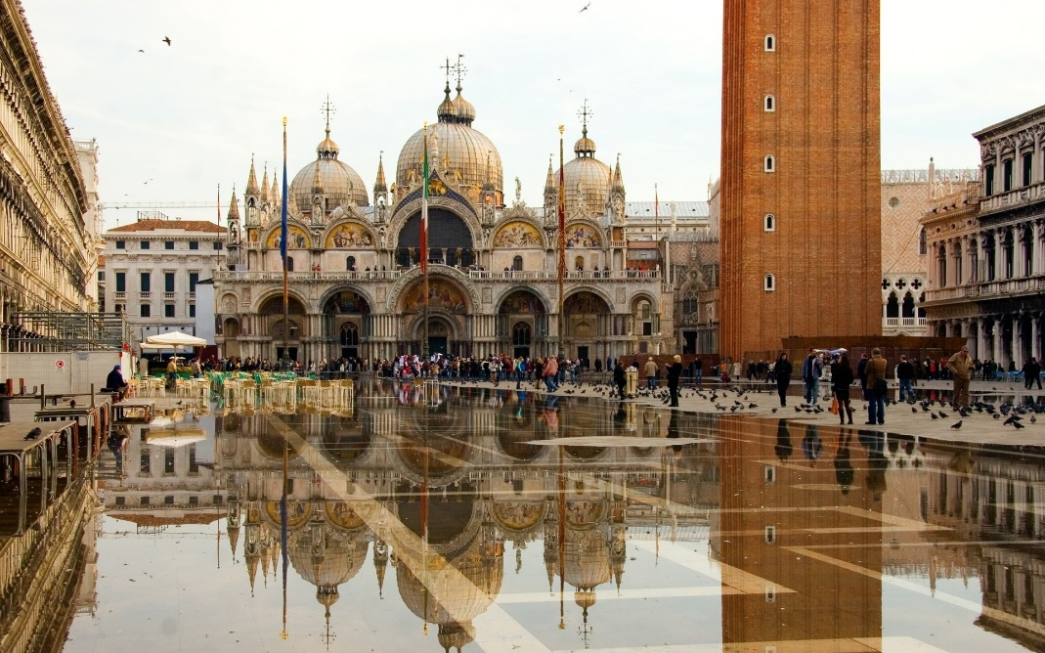
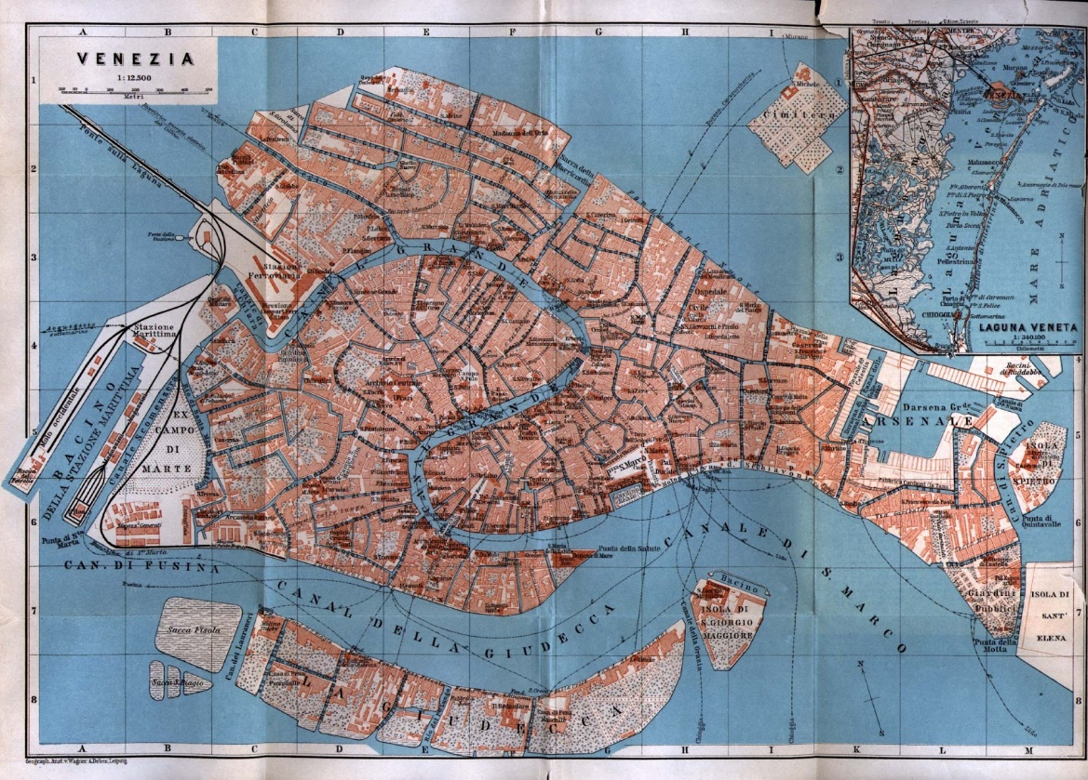
After having invested so much, the last thing Costa wants is for the cruise ships to dock anywhere else, yet he himself admits that “what they awaken in most people is fear and concern,” so he suggests a way of reducing the number of sailings through the city by deep-dredging an existing shallow channel through the lagoon called the Calle Contorta di Sant’Andrea so that the ships can either come down the Giudecca Canal and then sail out by this new route (his preferred option) or avoid the center of Venice altogether and come both in and out by the Calle Contorta. But the view from there is of the petrochemical works, so tourists who had expected to feast their eyes on the Doge’s Palace and St. Mark’s Square might well feel cheated, and this could be bad for business. However, since it is very unlikely that the ecologists will allow the Calle Contorta to be deep-dredged, Costa is probably not too worried.
Figure 4 Figure 5 St. Mark's Square floods at high tide.
Figure 3 Venice with its many canals
Another local politician has come up with a plan for a new, relatively inexpensive dock capable of berthing up to eight ships, to be built within the huge, existing breakwater at the Lido opening; passengers would be brought into town by catamarans that would hardly disturb the waters. But at a cost of €200 million this is unlikely to happen soon because Italy is broke. So expect to go on seeing the cruise ships in Venice.
This raises the issue of tourism. The management plan, basing itself on the numbers of people that stay overnight in Venice and its environs and are therefore documented, says there are 6.3 million visitors a year, who, multiplied by the average number of days they remain, represent 23 million “presences.” What the management plan does not mention is that many more tourists come just for the day and usually in large groups. There is incomplete information and serious confusion about the extent and nature of tourism and yet financial cuts have led the City Council to close its research body, COSES.
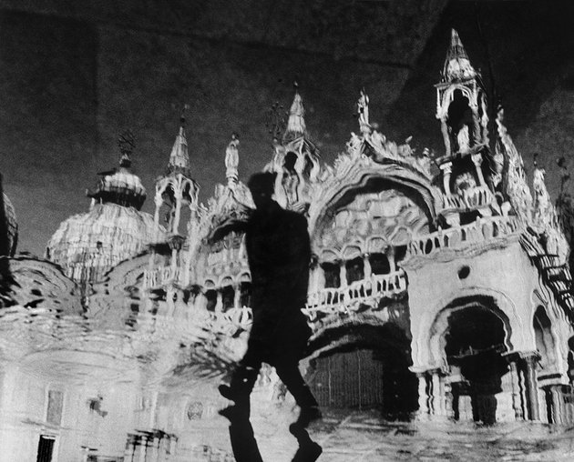
Like tourists visiting the Louvre for the first time and making straight for the Mona Lisa, most of these day tourists want to see St. Mark’s Square. What used to be called “the drawing room of Europe” now resembles the crowded concourse of a railway station, with hundreds of people milling around, sitting on the ground, resting on their rucksacks, and eating picnics. A huge queue obstructs the façade of St. Mark’s because the church will not adopt a timed ticket system, and advertisements the size of tennis courts defile the façades. The bands play on outside the Quadri and Florian cafés, but is this what people expect of Venice?
There is a great deal to be said about the abuse of the tourist trade here, but three things stand out. First, unless tourism is brought under control, a major objective of the management plan will be completely defeated; that is, to encourage Venetians to go on living in Venice and for a greater variety of economic life to take root. Second, in order to manage the tourism, someone at a high level has to admit in public that soon the numbers will need to be limited; visitors will have to book in advance, and if Venice is full on one day, they will have to come on another. Third, tourism is not contributing enough to the maintenance of the city.
Figure 5 Reflections of San Marco, Venice, 1953
But not only does the management plan not admit any of this, it makes no forward projections of numbers; nor does it set up a monitoring system for the day-trippers. The United Nations World Tourism Organization predicts that global tourism, currently standing at 1 billion people, will reach 1.6 billion by 2020, with Europe as the most popular destination. It is worth noting that official figures give Chinese tourists as 16.3 percent more numerous than in 2011. The citizens of BRIC—Brazil, Russia, India, and China—are coming and it is only a matter of time before the crowds become intolerable, even hazardous, in the narrow alleyways.
But just as the management plan dodges the issue of the cruise ships, it also dodges this crucial issue of tourist crowds. One timid suggestion has been made about introducing a system of controlling the entrance of visitors, but what the plan should be saying loudly and clearly is that controls are inevitable and we must think how to apply them without cutting off the city from ordinary life. Instead, the plan talks about “confining and regulating tourist numbers” by routing them around other parts of Venice, getting them to visit the lagoon and the surrounding countryside and practise “ecological sports.” This is pure fantasy; the millions of first-time visitors want to see the famous sights, not paddle around in the lagoon.
Limiting numbers would also mean ticketing, and this could involve the tourists in contributing directly to the maintenance of the city, which is costly and will become much more so. Presented properly, this would not be a hard sell. If just the 6.4 million visitors we are certain about paid €30 ($40)—it costs $25 after all to enter New York’s Museum of Modern Art—into a ring-fenced fund, that would amount to €192 million a year. The current objections to this are that it would infringe the legal right to untrammeled circulation, and that it would turn Venice into Disneyland. But laws can be amended, and it is not ticketing that will turn Venice into an amusement park but the current nonmanagement of the tourists. As the British economist John Kay has said, Venice would be a great deal better run if it were being managed by the Walt Disney Company; unfortunately, the Italian media failed to get the irony.
There is no proper study of what the tourist industry is worth to Venice because so much of it is a black economy. What is certain is that not enough of it ends up in the public coffers, while if it were exploited properly it could contribute very significantly to the city’s needs. But there has been no estimate of what the maintenance of Venice is going to cost even ten years ahead, let alone fifty or one hundred. In the meantime, the council limps along, not knowing from year to year what to expect in the way of special funding, which the city used to receive by virtue of its exceptional nature. In 2002, it was €592 million, but in 2003 the underwater flood barriers known as Mose—rows of hinged underwater gates at the lagoon openings, which rise up when needed—began to be built and nearly all funding has since been diverted to the project. Thus in 2005 the council received just €23 million and the €40 million allocated to it in 2011 only arrived from Rome this April.
Yet the management plan is afraid to raise any of these points because of the people who benefit in the shortest of short terms from the crowds—Costa with his cruise ships; the motor taxi drivers; the pizzerias and the stall-holders selling carnival masks. For them the idea of limiting numbers is still anathema, although the hoteliers, who need the higher-spending tourists, are beginning to plead for a reduction in the number of day-trippers.
Still, by far the most shocking gap in the management plan is its failure to consider the rise in sea level. Of course the flooding gets discussed, as does Mose, due to be completed in 2016, but the chronically rising water level—a global problem—only gets mentioned to say that research is needed to determine the implications of the rising damp for Venetian buildings, and climate change “may increase the hydraulic risk to the entire territory due to heavier rainfall and rising water levels.” Compare that ludicrously understated comment with the words of the report published by UNESCO in 2010 and entitled “From Global to Regional: Local Sea Level Rise Scenarios, Focus on the Mediterranean Sea and the Adriatic Sea”:
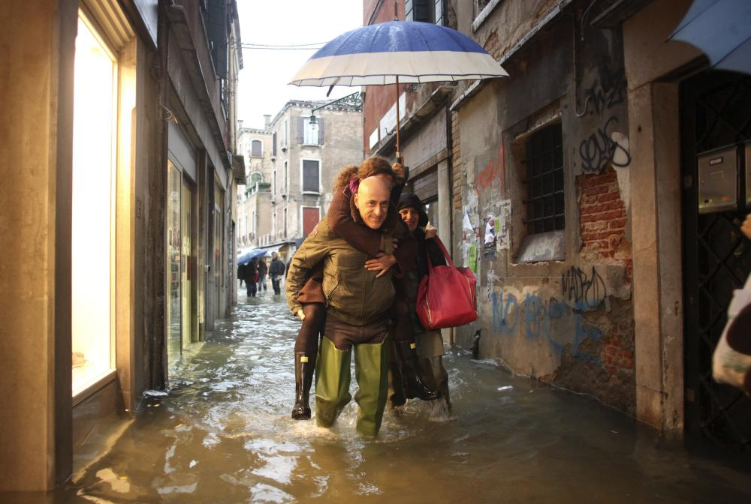
There should be no doubt that the sea level will eventually rise to a value that will not be sustainable for the lagoon and its old city. The planned mobile barriers might be able to avoid flooding for the next decades, but the sea will eventually rise to a level where even continuous closures will not be able to protect the city from flooding. The question is not if this will happen, but only when it will happen.
Figure 6 Flood of 2012
That was the conclusion of the meeting convoked in 2010 by UNESCO in its Venice office with scientists of the Istituto di Scienze Marine (ISMAR) and the Consiglio Nazionale delle Ricerche (CNR). The scientific consensus is that the level of the Mediterranean will lag by only a few months behind that of the Atlantic. The report says:
The average water level [in the lagoon] is now closer to 30 cm [11.8 inches] above datum [established 1897]. This indicates that a sea level rise of 80 cm [31.5 inches] would bring the mean water level to the critical threshold of 110 cm [43.3 inches, the level at which Venice begins to flood]. In this case, Venice would experience regular flooding twice a day, due to the tidal oscillation (tidal amplitude 40 cm [15.75 inches] during spring tide).
That is twice a day, every day, not to mention the much higher tides when there are the exceptional climatic conditions that cause flooding today.
The Intergovernmental Panel on Climate Change (IPCC) report of 2007 predicted a global sea level rise of 7 to 23 inches by 2100; but the 2014 report is expected to raise this estimate of increase considerably, taking account of the rapidly melting ice-caps.
Why is it wrong for the management plan to say that with the barriers the state has provided for this problem for the rest of the century? They will indeed be effective in severe flooding events of up to three meters, and, as their builders, the Consorzio Venezia Nuova say, they have been designed to go on being so even with an increase of up to 23.5 inches in the mean sea level. But the fudging that takes place in this and other official pronouncements is between the flooding events and the ineluctably rising water level. What the barriers cannot do is save the city from the effects of the rising water level (the chronic sickness) as opposed to the floods (the acute phases) except by being frequently, and eventually permanently, closed.
Figure 4 Venice flood of 2012
This drastic change to the ecology of the lagoon cannot be attempted without first cleaning up industrial pollution in it and in the waters descending from its 1,003-square-mile drainage basin, and without giving Venice a main drainage system (yes, Venice is medieval in that respect as well). And for this to come about, huge political will is needed, close collaboration between many governing bodies, long-term planning starting now, and regular financing, none of which exists at present.
The UNESCO report on sea level rise was not even sent on to Rome; in December 2012, I spoke to the undersecretary at the Ministry of Culture, Roberto Cecchi, and he denied ever having heard of it. I asked Giorgio de Vettor of the Venetian City Council to explain why sea level rise was not discussed in the plan and he simply evaded the question. “This is a problem that will have to be dealt with in a different way, taking into account all the factors and aspects of the case.”
What lies behind this is a fear of reigniting the arguments over Mose, which began to be built only after a delay of nearly twenty years because the Communist and Green parties opposed it passionately, and largely misguidedly, for environmental and political reasons. There is a lingering suspicion of the MOSE barriers in Venice (are they damaging the lagoon, will they fail, are they costing too much?), not helped by the defensive attitude and lack of transparency of the Consorzio Venezia Nuova, the group of Italian industries building the barriers, which fails to publish detailed accounts or scientific progress reports. At the political level, it is also worth noting that Mose is a very big project, worth €5.5 billion at the 2010 estimate, and that commands a lot of respect—like Costa with his port.
In the meantime, the city is being eaten up by damp. Every inch of sea level rise counts now, because the water has overtopped the impermeable stone bases of most buildings and is being absorbed into the porous bricks, fragmenting them and washing away the mortar. The damp has reached the upper floors and is rusting through the iron tie rods that hold the houses together. In the narthex of the basilica of St. Mark’s it has reached to a height of about twenty feet, causing the tesserae of the one-thousand-year-old mosaics, which are masterpieces of Italo-Byzantine art, to deteriorate. This state of affairs is unprecedented in the history of the city and will worsen rapidly as the water rises.
The town council concludes its management plan by saying that it will now take part in coordinating all the bodies that have a role or interest in the governance of Venice and its lagoon (see below for the principal players). At least it recognizes that this is the essence of the Venice problem; there are far too many organizations, some state, some local, some left-wing, some right-wing, and all with conflicting priorities. An overarching body, with real power, is what is desperately needed. But this document’s feeble analysis of the city’s problems, its capacity to ignore reality, and its obvious servility in the face of interest groups show that Mayor Orsoni and his council will never be that body.
Sadly, the question of who will save “the fairy city of the heart,” as Byron called it, remains open, and time is running out.

Who Does What in Venice?
• The City Council of Venice (controlled by a left-wing coalition). It has authority over buildings not listed for preservation and the canals within the city. Eight councils of small nearby towns also have a say in policymaking, especially relating to the lagoon.
• The Water Authority (a branch of the national Ministry of Infrastructure and Transport). It is responsible for pollution abatement and maintenance in the lagoon as well as flood defenses. Its projects are mostly carried out by its concessionary, the powerful Consorzio Venezia Nuova, a group of Italy’s leading industrial companies and local firms, which researches, develops, and executes measures to protect Venice from flooding. The Consorzio’s current mandate comes to an end in 2016 when MOSE is complete. There is no plan for what should take its place.
• The Venice Port Authority (a state body). It is responsible for the deep-dredged shipping channels across the lagoon, the Giudecca Canal through Venice, the port in Venice, and the ports around the lagoon.
• The Veneto regional government (currently controlled by a right-wing coalition). It is responsible for pollution abatement in the drainage basin of the lagoon, tourism and transport on the mainland, landscape, and some aspects of navigation.
• The Venice and Padua provincial governments: responsible for some aspects of the environment on the mainland and fisheries in the lagoon.
• The Superintendency for the Architectural and Landscape Heritage of Venice (part of the Ministry of Culture and Cultural Activities). It has authority over listed buildings and landscape declared to be of heritage importance.
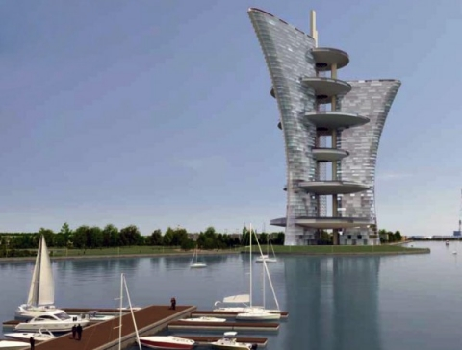
Figure 7 Design for a Venice skyscraper by Pierre Cardin

