The Big Melt
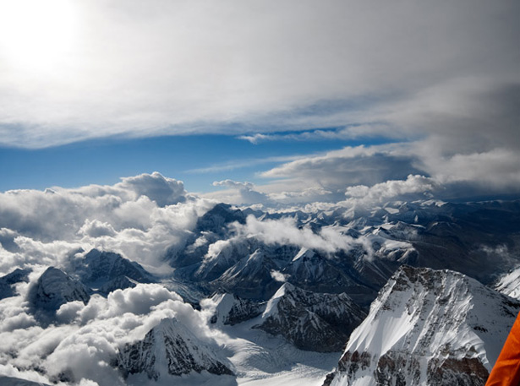
Figure 1 Glaciers in the high heart of Asia feed its greatest rivers, lifelines for two billion people. Now the ice and snow are diminishing.
By Brook Larmer
Photograph by Jonas Bendiksen
The gods must be furious.
It's the only explanation that makes sense to Jia Son, a Tibetan farmer surveying the catastrophe unfolding above his village in China's mountainous Yunnan Province. "We've upset the natural order," the devout, 52-year-old Buddhist says. "And now the gods are punishing us."
On a warm summer afternoon, Jia Son has hiked a mile and a half up the gorge that Mingyong Glacier has carved into sacred Mount Kawagebo, looming 22,113 feet high in the clouds above. There's no sign of ice, just a river roiling with silt-laden melt. For more than a century, ever since its tongue lapped at the edge of Mingyong village, the glacier has retreated like a dying serpent recoiling into its lair. Its pace has accelerated over the past decade, to more than a football field every year—a distinctly unglacial rate for an ancient ice mass.
"This all used to be ice ten years ago," Jia Son says, as he scrambles across the scree and brush. He points out a yak trail etched into the slope some 200 feet above the valley bottom. "The glacier sometimes used to cover that trail, so we had to lead our animals over the ice to get to the upper meadows."
Around a bend in the river, the glacier's snout finally comes into view: It's a deathly shade of black, permeated with pulverized rock and dirt. The water from this ice, once so pure it served in rituals as a symbol of Buddha himself, is now too loaded with sediment for the villagers to drink. For nearly a mile the glacier's once smooth surface is ragged and cratered like the skin of a leper. There are glimpses of blue-green ice within the fissures, but the cracks themselves signal trouble. "The beast is sick and wasting away," Jia Son says. "If our sacred glacier cannot survive, how can we?"
It is a question that echoes around the globe, but nowhere more urgently than across the vast swath of Asia that draws its water from the "roof of the world." This geologic colossus—the highest and largest plateau on the planet, ringed by its tallest mountains—covers an area greater than western Europe, at an average altitude of more than two miles. With nearly 37,000 glaciers on the Chinese side alone, the Tibetan Plateau and its surrounding arc of mountains contain the largest volume of ice outside the polar regions. This ice gives birth to Asia's largest and most legendary rivers, from the Yangtze and the Yellow to the Mekong and the Ganges—rivers that over the course of history have nurtured civilizations, inspired religions, and sustained ecosystems. Today they are lifelines for some of Asia's most densely settled areas, from the arid plains of Pakistan to the thirsty metropolises of northern China 3,000 miles away. All told, some two billion people in more than a dozen countries—nearly a third of the world's population—depend on rivers fed by the snow and ice of the plateau region.
But a crisis is brewing on the roof of the world, and it rests on a curious paradox: For all its seeming might and immutability, this geologic expanse is more vulnerable to climate change than almost anywhere else on Earth. The Tibetan Plateau as a whole is heating up twice as fast as the global average of 1.3°F over the past century—and in some places even faster. These warming rates, unprecedented for at least two millennia, are merciless on the glaciers, whose rare confluence of high altitudes and low latitudes make them especially sensitive to shifts in climate.
For thousands of years the glaciers have formed what Lonnie Thompson, a glaciologist at Ohio State University, calls "Asia's freshwater bank account"—an immense storehouse whose buildup of new ice and snow (deposits) has historically offset its annual runoff (withdrawals). Glacial melt plays its most vital role before and after the rainy season, when it supplies a greater portion of the flow in every river from the Yangtze (which irrigates more than half of China's rice) to the Ganges and the Indus (key to the agricultural heartlands of India and Pakistan).
But over the past half century, the balance has been lost, perhaps irrevocably. Of the 680 glaciers Chinese scientists monitor closely on the Tibetan Plateau, 95 percent are shedding more ice than they're adding, with the heaviest losses on its southern and eastern edges. "These glaciers are not simply retreating," Thompson says. "They're losing mass from the surface down." The ice cover in this portion of the plateau has shrunk more than 6 percent since the 1970s—and the damage is still greater in Tajikistan and northern India, with 35 percent and 20 percent declines respectively over the past five decades.
The rate of melting is not uniform, and a number of glaciers in the Karakoram Range on the western edge of the plateau are actually advancing. This anomaly may result from increases in snowfall in the higher latitude—and therefore colder—Karakorams, where snow and ice are less vulnerable to small temperature increases. The gaps in scientific knowledge are still great, and in the Tibetan Plateau they are deepened by the region's remoteness and political sensitivity—as well as by the inherent complexities of climate science.
Though scientists argue about the rate and cause of glacial retreat, most don't deny that it's happening. And they believe the worst may be yet to come. The more dark areas that are exposed by melting, the more sunlight is absorbed than reflected, causing temperatures to rise faster. (Some climatologists believe this warming feedback loop could intensify the Asian monsoon, triggering more violent storms and flooding in places such as Bangladesh and Myanmar.) If current trends hold, Chinese scientists believe that 40 percent of the plateau's glaciers could disappear by 2050. "Full-scale glacier shrinkage is inevitable," says Yao Tandong, a glaciologist at China's Institute of Tibetan Plateau Research. "And it will lead to ecological catastrophe."
The potential impacts extend far beyond the glaciers. On the Tibetan Plateau, especially its dry northern flank, people are already affected by a warmer climate. The grasslands and wetlands are deteriorating, and the permafrost that feeds them with spring and summer melt is retreating to higher elevations. Thousands of lakes have dried up. Desert now covers about one-sixth of the plateau, and in places sand dunes lap across the highlands like waves in a yellow sea. The herders who once thrived here are running out of options.
Along the plateau's southern edge, by contrast, many communities are coping with too much water. In alpine villages like Mingyong, the glacial melt has swelled rivers, with welcome side effects: expanded croplands and longer growing seasons. But such benefits often hide deeper costs. In Mingyong, surging meltwater has carried away topsoil; elsewhere, excess runoff has been blamed for more frequent flooding and landslides. In the mountains from Pakistan to Bhutan, thousands of glacial lakes have formed, many potentially unstable. Among the more dangerous is Imja Tsho, at 16,400 feet on the trail to Nepal's Island Peak. Fifty years ago the lake didn't exist; today, swollen by melt, it is a mile long and 300 feet deep. If it ever burst through its loose wall of moraine, it would drown the Sherpa villages in the valley below.
This situation—too much water, too little water—captures, in miniature, the trajectory of the overall crisis. Even if melting glaciers provide an abundance of water in the short run, they portend a frightening endgame: the eventual depletion of Asia's greatest rivers. Nobody can predict exactly when the glacier retreat will translate into a sharp drop in runoff. Whether it happens in 10, 30, or 50 years depends on local conditions, but the collateral damage across the region could be devastating. Along with acute water and electricity shortages, experts predict a plunge in food production, widespread migration in the face of ecological changes, even conflicts between Asian powers.
The nomads' tent is a pinprick of white against a canvas of green and brown. There is no other sign of human existence on the 14,000-foot-high prairie that seems to extend to the end of the world. As a vehicle rattles toward the tent, two young men emerge, their long black hair horizontal in the wind. Ba O and his brother Tsering are part of an unbroken line of Tibetan nomads who for at least a thousand years have led their herds to summer grazing grounds near the headwaters of the Yangtze and Yellow Rivers.
Inside the tent, Ba O's wife tosses patties of dried yak dung onto the fire while her four-year-old son plays with a spool of sheep's wool. The family matriarch, Lu Ji, churns yak milk into cheese, rocking back and forth in a hypnotic rhythm. Behind her are two weathered Tibetan chests topped with a small Buddhist shrine: a red prayer wheel, a couple of smudged Tibetan texts, and several yak butter candles whose flames are never allowed to go out. "This is the way we've always done things," Ba O says. "And we don't want that to change."
But it may be too late. The grasslands are dying out, as decades of warming temperatures—exacerbated by overgrazing—turn prairie into desert. Watering holes are drying up, and now, instead of traveling a short distance to find summer grazing for their herds, Ba O and his family must trek more than 30 miles across the high plateau. Even there the grass is meager. "It used to grow so high you could lose a sheep in it," Ba O says. "Now it doesn't reach above their hooves." The family's herd has dwindled from 500 animals to 120. The next step seems inevitable: selling their remaining livestock and moving into a government resettlement camp.
Across Asia the response to climate-induced threats has mostly been slow and piecemeal, as if governments would prefer to leave it up to the industrialized countries that pumped the greenhouse gases into the atmosphere in the first place. There are exceptions. In Ladakh, a bone-dry region in northern India and Pakistan that relies entirely on melting ice and snow, a retired civil engineer named Chewang Norphel has built "artificial glaciers"—simple stone embankments that trap and freeze glacial melt in the fall for use in the early spring growing season. Nepal is developing a remote monitoring system to gauge when glacial lakes are in danger of bursting, as well as the technology to drain them. Even in places facing destructive monsoonal flooding, such as Bangladesh, "floating schools" in the delta enable kids to continue their education—on boats.
But nothing compares to the campaign in China, which has less water than Canada but 40 times more people. In the vast desert in the Xinjiang region, just north of the Tibetan Plateau, China aims to build 59 reservoirs to capture and save glacial runoff. Across Tibet, artillery batteries have been installed to launch rain-inducing silver iodide into the clouds. In Qinghai the government is blocking off degraded grasslands in hopes they can be nurtured back to health. In areas where grasslands have already turned to scrub desert, bales of wire fencing are rolled out over the last remnants of plant life to prevent them from blowing away.
Along the road near the town of Madoi are two rows of newly built houses. This is a resettlement village for Tibetan nomads, part of a massive and controversial program to relieve pressure on the grasslands near the sources of China's three major rivers—the Yangtze, Yellow, and Mekong—where nearly half of Qinghai Province's 530,000 nomads have traditionally lived. Tens of thousands of nomads here have had to give up their way of life, and many more—including, perhaps, Ba O—may follow.
The subsidized housing is solid, and residents receive a small annual stipend. Even so, Jixi Lamu, a 33-year-old woman in a traditional embroidered dress, says her family is stuck in limbo, dependent on government handouts. "We've spent the $400 we had left from selling off our animals," she says. "There was no future with our herds, but there's no future here either." Her husband is away looking for menial work. Inside the one-room house, her mother sits on the bed, fingering her prayer beads. A Buddhist shrine stands on the other side of the room, but the candles have burned out.
It is not yet noon in Delhi, just 180 miles south of the Himalayan glaciers. But in the narrow corridors of Nehru Camp, a slum in this city of 16 million, the blast furnace of the north Indian summer has already sent temperatures soaring past 105 degrees Fahrenheit. Chaya, the 25-year-old wife of a fortune-teller, has spent seven hours joining the mad scramble for water that, even today, defines life in this heaving metropolis—and offers a taste of what the depletion of Tibet's water and ice portends.
Chaya's day began long before sunrise, when she and her five children fanned out in the darkness, armed with plastic jugs of every size. After daybreak, the rumor of a tap with running water sent her stumbling in a panic through the slum's narrow corridors. Now, with her containers still empty and the sun blazing overhead, she has returned home for a moment's rest. Asked if she's eaten anything today, she laughs: "We haven't even had any tea yet."
Suddenly cries erupt—a water truck has been spotted. Chaya leaps up and joins the human torrent in the street. A dozen boys swarm onto a blue tanker, jamming hoses in and siphoning the water out. Below, shouting women jostle for position with their containers. In six minutes the tanker is empty. Chaya arrived too late and must move on to chase the next rumor of water.
Delhi's water demand already exceeds supply by more than 300 million gallons a day, a shortfall worsened by inequitable distribution and a leaky infrastructure that loses an estimated 40 percent of the water. More than two-thirds of the city's water is pulled from the Yamuna and the Ganges, rivers fed by Himalayan ice. If that ice disappears, the future will almost certainly be worse. "We are facing an unsustainable situation," says Diwan Singh, a Delhi environmental activist. "Soon—not in thirty years but in five to ten—there will be an exodus because of the lack of water."
The tension already seethes. In the clogged alleyway around one of Nehru Camp's last functioning taps, which run for one hour a day, a man punches a woman who cut in line, leaving a purple welt on her face. "We wake up every morning fighting over water," says Kamal Bhate, a local astrologer watching the melee. This one dissolves into shouting and finger-pointing, but the brawls can be deadly. In a nearby slum a teenage boy was recently beaten to death for cutting in line.
As the rivers dwindle, the conflicts could spread. India, China, and Pakistan all face pressure to boost food production to keep up with their huge and growing populations. But climate change and diminishing water supplies could reduce cereal yields in South Asia by 5 percent within three decades. "We're going to see rising tensions over shared water resources, including political disputes between farmers, between farmers and cities, and between human and ecological demands for water," says Peter Gleick, a water expert and president of the Pacific Institute in Oakland, California. "And I believe more of these tensions will lead to violence."
The real challenge will be to prevent water conflicts from spilling across borders. There is already a growing sense of alarm in Central Asia over the prospect that poor but glacier-heavy nations (Tajikistan, Kyrgyzstan) may one day restrict the flow of water to their parched but oil-rich neighbors (Uzbekistan, Kazakhstan, Turkmenistan). In the future, peace between Pakistan and India may hinge as much on water as on nuclear weapons, for the two countries must share the glacier-dependent Indus.
The biggest question mark hangs over China, which controls the sources of the region's major rivers. Its damming of the Mekong has sparked anger downstream in Indochina. If Beijing follows through on tentative plans to divert the Brahmaputra, it could provoke its rival, India, in the very region where the two countries fought a war in 1962.
For the people in Nehru Camp, geopolitical concerns are lost in the frenzied pursuit of water. In the afternoon, a tap outside the slum is suddenly turned on, and Chaya, smiling triumphantly, hauls back a full, ten-gallon jug on top of her head. The water is dirty and bitter, and there are no means to boil it. But now, at last, she can give her children their first meal of the day: a piece of bread and a few spoonfuls of lentil stew. "They should be studying, but we keep shooing them away to find water," Chaya says. "We have no choice, because who knows if we'll find enough water tomorrow."
Fatalism may be a natural response to forces that seem beyond our control. But Jia Son, the Tibetan farmer watching Mingyong Glacier shrink, believes that every action counts—good or bad, large or small. Pausing on the mountain trail, he makes a guilty confession. The melting ice, he says, may be his fault.
When Jia Son first noticed the rising temperatures—an unfamiliar trickle of sweat down his back about a decade ago—he figured it was a gift from the gods. Winter soon lost some of its brutal sting. The glacier began releasing its water earlier in the summer, and for the first time in memory villagers had the luxury of two harvests a year.
Then came the Chinese tourists, a flood of city dwellers willing to pay locals to take them up to see the glacier. The Han tourists don't always respect Buddhist traditions; in their gleeful hollers to provoke an icefall, they seem unaware of the calamity that has befallen the glacier. Still, they have turned a poor village into one of the region's wealthiest. "Life is much easier now," says Jia Son, whose simple farmhouse, like all in the village, has a television and government-subsidized satellite dish. "But maybe our greed has made Kawagebo angry."
He is referring to the temperamental deity above his village. One of the holiest mountains in Tibetan Buddhism, Kawagebo has never been conquered, and locals believe its summit—and its glacier—should remain untouched. When a Sino-Japanese expedition tried to scale the peak in 1991, an avalanche near the top of the glacier killed all 17 climbers. Jia Son remains convinced the deaths were not an accident but an act of divine retribution. Could Mingyong's retreat be another sign of Kawagebo's displeasure?
Jia Son is taking no chances. Every year he embarks on a 15-day pilgrimage around Kawagebo to show his deepening Buddhist devotion. He no longer hunts animals or cuts down trees. As part of a government program, he has also given up a parcel of land to be reforested. His family still participates in the village's tourism cooperative, but Jia Son makes a point of telling visitors about the glacier's spiritual significance. "Nothing will get better," he says, "until we get rid of our materialistic thinking."
It's a simple pledge, perhaps, one that hardly seems enough to save the glaciers of the Tibetan Plateau—and stave off the water crisis that seems sure to follow. But here, in the shadow of one of the world's fastest retreating glaciers, this lone farmer has begun, in his own small way, to restore the balance.
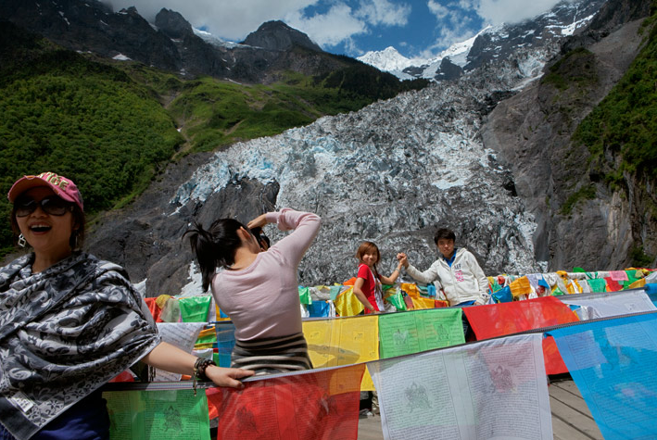
Figure 2 Tourists snap memories against a dirty tongue of melting ice. Mingyong Glacier in Yunnan Province, said to be one of China's fastest-shrinking glaciers, has receded a third of a mile over the past decade as temperatures have warmed. The glacier is blackened with debris, and the Mingyong's meltwater is no longer drinkable.

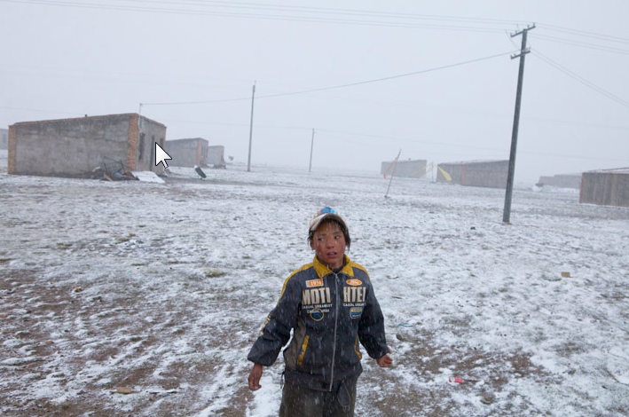
Figure 3 This child of Tibetan nomads is now growing up in a concrete hovel in a settlement near the town of Hua Shi Xia in Qinghai Province, where grasslands have become seriously degraded. The Chinese government has moved tens of thousands of herders into such communities, where they face unemployment and a difficult adjustment to sedentary living.
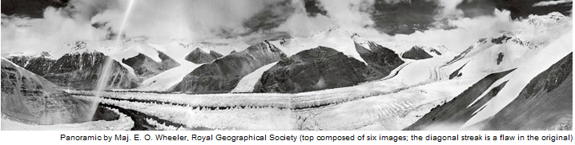
Figure 4 Mount Everest's East Rongbuk Glacier in August 1921.

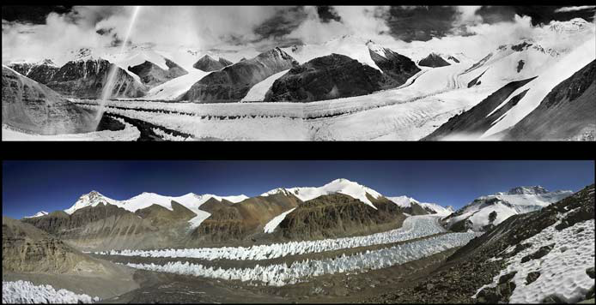
Figure 5 Mount Everest's East Rongbuk Glacier lost some 350 vertical feet of ice between August 1921 (above) and October 2008 (below)
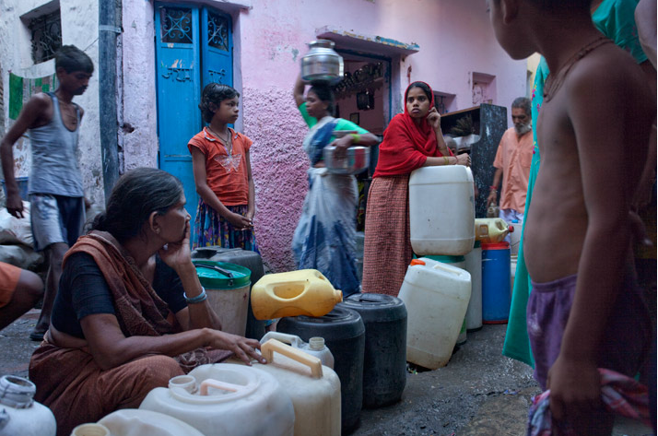
Figure 6 Slum dwellers in Delhi wait hours for a refill from a privately owned tap; many will be turned away. "Some have, some have not," says Syed Hasnain of Delhi's Energy and Resources Institute. "That will always be India."

