THE CASTE SYSTEM IN INDIA
Introduction
One of the most controversial topic regarding the India's society and culture is its stringent caste system. The word "caste" is taken from the Portuguese word casta. It can be defined as a rigid social system in which a social hierarchy is maintained generation after generation and allows little mobility out of the position to which a person is born (Encarta Encyclopedia).
This system dates almost 3000 years back and was formed based on the need to form a social order in ancient India. It is still very prevalent as part of India's society. Today, it occurs more in the rural villages than in big urban cities; and more in the social matters of kinship and marriages than in impersonal day-to-day interaction, such as taking the bus. Having been around for centuries, it is highly doubtful that the caste system will die out completely. Its presence will still be felt in the near future.
History and Description
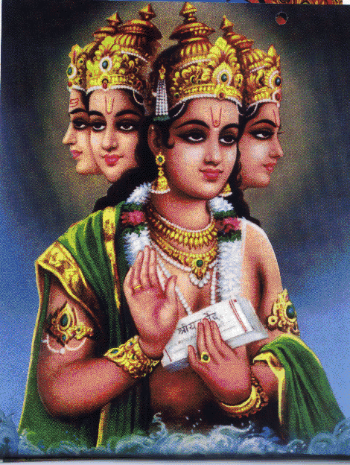
The original caste system came about when the Aryans migrated from the north to India around 1600BCE. During the Vedic age, Manu, "the founder of this ancient Hindu or Aryan society," and "the great leader who survived the mythical flood and established the new social order, reflecting a return to spiritual values from an earlier and materialistic humanity?" ("The Vedic Social Order", From The River of Heaven, Dr. David Frawley.) founded four social orders based on four main goals of both humans and society. A social classification system of four different classes (varnas) was thus devised so that the human race could have a smooth and ordered life in society.
Difference between jati & varna
In each system, each caste (jati) - birth-unit - is an endogamous group into which one is born into and will marry within. There are approximately 3,000 jatis in contemporary society. By contrast, varna is the typical functional division of an advanced society. It is one of the four large caste groups (Brahman, Kshatriya, Vaishya, and Shudra) from which most jatis are believed to derive. "While the term varna refers to the fours different classes in society, the term jati refers to the different endogamous sections of the Hindu Society which is known as castes." ("An Introduction to Hinduism", Gavin Flood.)
More about varna
Varna literally means "color". It refers to the distinct qualities (guna) that the four functional classes possess in their hearts and minds. There are four different qualities of human beings - white, red, yellow, black.
White (sattva = truthful) represents the quality of purity, love, faith and detachment. Those belonging to this color seek true knowledge and often exist in ones with spiritual temperment. Those that belong to this color, belong to the Brahman class.
Red (rajas = energetic) represents the quality of action, will, aggression, and energy. Those belonging to this color seek honor, power, and status and exist in people with martial and political temperament. Those that belong to this color belong to the Kshatriya class.
Yellow (rajas) represents the same quality as the red color but those in this quality seek communication, interchange, trade, and business instead. This color exists in those of commercial temperament. They make up the Vaishya class.
Black (tamas = inert, solid) represents quality of ignorance, inertia, and dullness. Those belonging to this color are dependent on the rest of the world for motivation and seek nothing. They exist in those of the servile disposition and make up the Shudra class.
Varna also means "veil". It shows the four different ways in which the Divine Self is hidden in human beings. By this, it refers to the ways in which his four body parts make up the four classes, depending on the nature or values that the human holds. The Brahmans hold spiritual and intellectual values and are in charge of teaching the Vedic Sanskrit, thus are made up of his head. The Kshatryas are the warriors that protect the countries and thus are made up of his arms. The Vaishyas are the farmers and merchants in the production nature and thus are made up of his belly and the Shudras are the laborers who perform menial chores and thus are made up of his legs.
The 4 Varna Groups
The four ranked varna groups were created from the various parts of the body of the primordial man, which Brahma created from clay. They are described in the earliest part of the Rg-Veda: Brahmans, Kshatriyas, Vaishyas, Shudras. The top four ranked varnas are referred to as "twice-born" (dvijas) in reference to the Hindu sacred thread ritual initiation which is suppose to represent re-birth.
These four groups are considered "clean castes."  Typical roles of these four varnas are:  Brahmans - priests, holy men, arbiters  Kshatriyas - kings, warriors, soldiers that protect and guard the country  Vaishyas - businessmen, traders, commercial class  Shudras - farmers, producers, peasants | 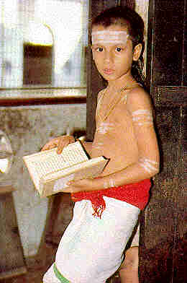
The Untouchables
Below the four varna castes lays a fifth group - The Untouchables. This group is not mentioned in the Vedas records until the Bhagavad-Gita and is supposed to be considered outside of the human society and of no caste. Unlike the upper four, it is not considered a "twice-born," having not gone through the Hindu sacred thread ritual initiation. The fifth varna is deemed "unclean" and polluting. Their role in life and society is to perform menial, degrading jobs.
The Untouchables are known by a variety of names. They call themselves "Dalits", priding themselves for the struggles they have fought against society. Mahatma Gandhi calls them "Harijans" - Children of God - when he adopted, against the caste rules, an Untouchable child. Finally, the Untouchables are also known as the "Scheduled Castes" after the 1935 constitution was erected to protect them in society both economically and socially.
"In India there are approximately 240 million Dalits. This means that nearly 25% of the population is Dalit. It also means that in a country, where everybody is supposed to have equal rights and opportunities, 1 out of 5 persons is condemned to be untouchable." (Web Source)  Despite the professed equal rights and duties in the Indian society, the Untouchables are still bounded in ways that keeps them in their place. They do not receive any education that can help them climb up in society and they live in poverty with scarce means of amenities, food, health care, and all other key survival needs in life. | 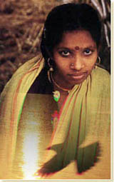
Dharma & Reincarnation 
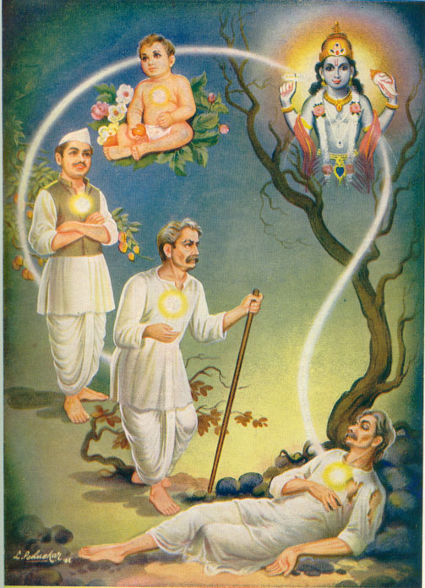
Different castes have different designated codes of proper conduct (dharma), according to their ranks on the hierarchy that they are obligated to perform to contribute to their society. For example, Brahman's proper behavior will be to be nonviolent, religious and have a vegetarian diet; Kshatriyas are expected to be aggressive warriors who fight and defend and consume meat and alcohol.
The original caste system supported the moving of individuals from one caste to another based on one's actions and performances (karma) in society. The mass population believe that the suffering in their present life is a result of the bad deeds they committed in their past life. The karma that they accumulate is the deciding factor as to which position in the caste hierarchy they will belong to in their next lives. They believe that the faithful execution of the duties obligated in their position in life, thus good karma performed, will be a promise to raise them up through the different classes in reincarnation until they reach the top of the ranks and take the next proceeding step to liberation (moksha). The rigid caste system is justified by this belief and it is thus possible to see why the masses stay muted and accept their suffering in life.
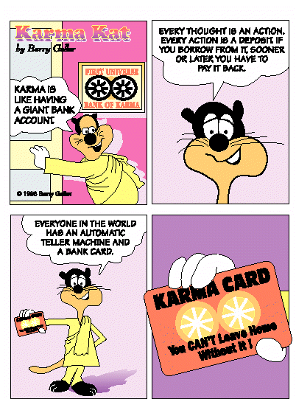
Purity vs. Pollution
Other than the roles in life (dharma), what makes the castes different from one another?
Inequalities amongst castes are a part of the ordained natural order and it is explained or justified in terms of purity and pollution. High-caste status is associated with purity and low-castes status, with pollution. Those born into high-ranking class would have inborn purity, like the Brahmans and similarly, the low caste Dalits are born into pollution. The Dalits can easily pollute a Brahman just by physical contact and the latter will have to perform ritual cleanliness like bathing in flowing water and changing clothes. This explains for the distance the upper and lower castes maintain in terms of intercaste relationships.
One of the theories of purity is that when a person is alive, both his body and soul are connected spiritually as one. When any part of the body leaves the whole entity, its connection to spirituality is broken and it is considered impure. Polluting. So anything emitted from the body is considered polluting. For example, corpses, manure, dirt, bodily fluids, etc. Similarly, anyone who deals or is in contact with such impure matters is considered tainted and polluting too.
Low-castes that hold perform menial jobs that deal with burying corpses, killing or skinning animals, cleaning toilets and clearing rubbish and body excretion, are considered tainted and polluting. They are kept away from any sacred learning and ritual and away from the mainstream society. The Untouchables have to live outside the villages and have their own wells so as not to pollute the rest of the people.
Since occupational specialization is believed to be in accord with the ordained order of the universe, and since purity or pollution is traditionally hereditary, low castes who hold demeaning jobs have their lives remain polluted forever. For example, a Sweeper will be a Sweeper for his entire life and his children will have to inherit the same job and be polluted as well. Similarly, the upper-class groups like the Brahmins will always retain their inherent purity from their parents, as long as they carry out the daily cleanliness rituals and do not violate any purity codes.
Intercaste Relations
a. Purity-Pollution
Intercaste relations are also affected by the purity and pollution dogma. High-caste groups shun and keep their distance from the lower castes. Dalits are suppose to be so polluting that even the cast of their shadows would stain the higher-castes. In some cases, they even have to wear bells to warn others of their presence.
Distance is maintained in all situations, even in the case of preparation of food. A Brahmin who accepts water or a meal from the hands of a Sweeper or any Dalit will immediately be polluted and could face social rejection from his fellow caste members. Certain exceptions hold. For example, only members of the Waterbearer caste who are employed to supply water from wells to homes can offer water by hand to all castes without polluting them. Only completely raw uncooked food like rice grains, uncooked vegetables, mangoes, or bananas can be accepted by anyone from anybody.
Another instance of inter-caste relation that is forbidden is inter-caste marriage. Given that even the issue of dining has so many regulations, marriage and consummation issues are under even heavier scrutiny. Marriages are traditionally arranged and within one's own caste. The background of each bride and groom are thoroughly studied to make sure they fit. Caste is the key qualification sought, and like how it affects basic socialization of society, is a filter system when seeking potential life partners. Marriage within caste is such a strong factor that there are directories that publish a list of eligible Indians and what caste groups they belong to. An example is this web site: www.marriage.com
Pollution and Purity have very strict rules and regulations to abide by. Every action in every single day (a drink of water, a meal, talking, touching, bathing) has immediate consequences to it. And one would have to take the necessary purifying rituals to correct the violation. These daily rules and regulations serve as a constant reminder of the multi-ranked caste society and shows how important and essential the hierarchy is to the lives of Indians.
b. Atrocities
Intercaste Relations can be seen as either economically cooperative or exploitative. In the prior perspective, the lower castes that perform jobs as farmers, carpenters, shoemakers, potters are hired by upper castes who owns lands and business to afford to pay them. In the latter perspective, since the higher-ranking castes are the ones with both social and economic power, they can economically exploit or plainly discriminates the low classes. Such cases range from minor levels of degrade and abuse to shocking states where the low castes are even killed by these high-ranked castes. Evidence of such atrocities appears in several controversial news reports in different parts of India.
"In 1990, blatant subjugation of low-caste laborers in the northern state of Bihar and eastern Uttar Pradesh was the subject of many news reports. In this region, scores of Dalits who have attempted to unite to protest low wages have been the victims of some 500 villagers."
"In 1991 the news magazine India Today reported that in an ostensibly prosperous village about 160 kilometers southeast of Delhi, when it became known that a rural Dalit laborer dared to have a love affair with the daughter of a high-caste landlord, the lovers and their Dalit go-between were tortured, publicly hanged and burnt by agents of the girl's family in the presence of some 500 villagers."
Changes in Caste System
There have been tremendous changes made to Indian’s society with regards to providing a more just system for the Dalits. Great leaders have paved the way to help the Untouchables.
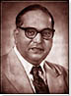
In 1967, Dr. Ambedkar, a Dalit, led a mass conversion to Buddhism, partly on the assumption that Buddhism had an anti-cast movement. He also wrote the constitution that outlawed untouchability and sanctioned positive discrimination programs for the Scheduled Castes and Tribes.
Mahatma Ghandi, a Vaishya, broke cast traditions by taking in an untouchable child. He started the name Harijan, meaning "Children of God" for the Untouchable caste. He also "persuaded the Indian National Congress to adopt a resolution in support of Harijan uplift, and published a magazine called Harijan, which was devoted to the welfare of the Untouchables." He helped lead India's independce and in doing so, unified India's social hierachy.

Today, more and more Dalits are getting educated and employed. In the academic arena, scholarships have helped increase their literacy rate increase "from 10.3% in 1961 to 21.4% in 1981."
This improvement has in turn, led to the emergence of educated Dalits holding higher positioned jobs, even white-collar jobs.
Along with urbanization, caste affiliations are no longer obvious and the observance of purity-pollution regulations is negligible. It is no longer an issue to take the public transport together or to be in the same meeting room. With so many people in such urban public places, it is very easy to forget the rigid, purity-pollution rules.
However, despite the decline in purity-pollution rules, there is still the observance of caste as can be witnessed in caste associations that still organize activities in quest of building numbers and thus influential power in society. Match-made marriages and activities are still present, proving another evidence of caste consciousness in today's time.
Still, it would be too general a statement to assume that all purity-pollution consciousness has melted away. In the rural outskirts, it is safe to say that there are still low-caste workers facing discrimination. In the mid-1990s, about 90% of the Dalit population live in rural areas where an increasing proportion - more than 50% - work as landless agricultural laborers. (U.S. Library of Congress Country Study, ) Evasive tactics by high-caste landowners have managed to avoid government regulations that try to secure more even distribution of land. Modernization also posses competition as now, in addition to the minimal pay and benefits, workers have to compete against tractors and other machines for their jobs.
Today's Caste System
According to the Bhagavad-Gita, the Aryan family system has broken down in India over 3000 years ago in Krishna's time. Therefore today, 3000 years later, the social system of natural aptitude has degenerated into the caste system, which only resembles it in form.
So with the modernization and more liberalized and the changes that have been made to fight against caste discrimination, why is there such thing as outcastes still? One reason might be that the whole ethical code of belief that the Indians uphold is very fatalistic and idealistic. This applies in the dharma and moksha beliefs where the lower castes have kept quiet and accepted the discriminating treatment as the life God has set for them. Even if the lower castes change their beliefs about being resigned to the fate of their lives and do something about it, it is important to bear in mind that it is almost impossible for one to change their castes. An Untouchable will always be an Untouchable.
There is a backfiring effect to the protected actions administered for the scheduled castes. The affirmative action by the government serves to further perpetuate the discrimination problem because the lower castes are highlighted and made different again compared to the rest of the castes. The special treatments of being on the government"s list or schedule, academic entries, voting rights, only make the discrimination glaring, adding onto the existing stigma.
My Other Sources
Here are some other sources of research from which I draw more knowledge of the caste system topic.
A. INTERVIEW WITH INDIANS IN AMERICA
1.Rakhi Patel, 21, Vaishya, Gujrat, Leva-patibad
According to Rahki,
Q: What do you think of India's caste system? What do you know about it?
A: And no matter how people try to deny that it doesn't exist anymore, it does exist. My dad's did. Although he lived in a small village, I think in the big city, they say that the cast system doesn't exist anymore and I think that it does exist. But I think in bigger cites you're less vulnerable to it because you're coming to a big city where nobody knows you. Whereas in a small village, everybody knows everybody and your status is known amongst everybody so it's harder for you to associate with a higher class or a lower caste ,etc. And I think even in America, caste is easily apparent because a lot of, well Gujrati families anyways, in particularly the Leva-pativad caste, they like to marry within the caste, they're very specific about it.
Q: How do you know they are the lower caste and were there much contact between your dad's ?.. did you see that there were any contacts between your dad's family with them. Did they keep a lot of distance?
A: I'm sure they were because it was just the way they look and the way they carry on their lives. Kind of the whole pollution and purity thing where they dealt with the polluted things where as the higher caste, its something they won't want to deal with, something they're not proud to do. In terms of interaction when they talk about them and talk to them, they're very condescending, like the family towards the workers because I remember one time where one of the lady's daughters was sick and couldn't come and I remember my grandma just mauling off. "Oh god, her daughter is sick. They're not doing a good job. Blah, blah, blah." It was really condescending. It was never to the point where they come inside and eat in the house. You know, like eat with us and sit at the table with us.
An insightful episode:
I was assuming that he may be of the lower caste as well but because he was a driver and he'll drive you everwhere so when you went to someone's house for dinner, he was invited as well. But he wouldn't sit at the table with you with as part of your family, but they wouldn't let him-maybe he'll sit on the floor and eat but not at the same time as you. I remember one time where I was wondering where he went and when I woke up I found out that overnight he slept on top of his taxi. He didn't sleep inside. And this was a two-week trip that we took.
So the whole two weeks he just slept outside?
Not all the time but sometimes he slept in the car and if the place we visited had a room for him?.But he would sleep outside or in the car or whatever.
Q: Why do you think different caste stick together within the same group?
A: Kind of like when you go to college, for some odd reason, you see ethnicism just happen like that. And you have certain pride that goes along with it too. Like a certain tradition that you want to keep going. I think with certain caste comes certain rituals, etc.
So they just want to basically uphold the tradition and also it's just natural to just stick together?
It's the same way as when you join an association of the same ethnicity cos you want to keep the culture together, you wanna keep the culture alive. Just like if my parents want me to marry within my caste system they want the tradition going, they want it to survive throughout the years.
2.Anok Aggrawal, 54, Vaishya, New Delhi
According to Anok,
Q: So you're saying that the caste system is breaking down. Even 30 years back already all the different people from different caste actually socialize together. There isn't this thing about how all the Vaishyas mix only with Vaishyas and all the Brahmins mix only with Brahmins?
A: The cast system is definitely broken down. Because in any metropolitan city, in big town or big city, people don't even know who you are. Nobody cares which cast you come from. It may have been practiced long time back but always in smaller places. Because smaller places people know who you are, type of thing
Many many years back when I used to hear from my father, the Scheduled Caste were not allowed in the temple. But these days you go to a temple in Delhi, you don't know who's standing next to you. You don?t know anybody. Whether the person is a scheduled caste or a Vaishya. What you do, where you live in life has nothing to do with caste system.
Q: Either way in India and America there's really not that much difference in terms of the caste system would you say that in India there would be more traditional families that would adhere more to the caste system and arrange marriage compared to America because they're more westernized here?
A: Within the Indian families, def in this country, nobody believes in caste system or they don?t care who they marry. An Indian can marry a girl form Philippine, or China or Japan or England. Or a black girl for that matter or vice versa. Almost everybody I know if they're going out with somebody or they've gone out with someone and most of the marriages are not arranged actually. Its very common for girls and boys to arrange they"re own marriages. They come and tell their parents, "Ok now we're ready to get married." So things are very different here. But in India, the old traditions are also breaking down. And people accept it because people feel the value in it because when people arrange marriages, parents have to go through a lot of stress and tension to find what they consider a suitable match.
3.Veena Dayah, late 40s, Vaishya, Gujrat, Leva-patibad (translated by Rakhi Patel)
According to Veena:
In terms of caste, she says that in the olden days it was really important, people used to, if they were of the lower caste they do not even let them inside the house and they were definitely, definitely not allowed inside the kitchen and even if they were allowed inside the house they were told not to touch anything.
She says that nowadays, she is enthusiastic about everyone being friends no matter what caste they are. However in term of marriage, she is very adamant that her kids marry within the caste. And her two main things are, one, it"s only her belief, that it's her personal preference more than anything, that her kids marry into the leva-patibad. And two, the only bad thing about marrying out of your caste is that then your kids will be confused as to what caste they are and that it may cause problems for them.
Basically her personal thing is that her kids marry within her own caste and it's just a personal preference and its not something that. It's just something to make her happy?It has nothing to do with god basically.
Why will it make her happy?
It?s just a personal belief that?s all it is. And it's nothing to do with her going to heaven its just something she wants.
Did she have a strict upbringing? Yes she did
Is hers an arranged or love marriage? Yes, it was an arranged marriage. Very arranged.
Another thing in terms of marriage is that basically that once they find a person for you, the parents duties are to research the other person's family and make sure they are of good background because they're going into that family so you want to make sure your daughter or your son will be taken care of and they'll be able to perform the duties.
B. FILM REVIEW - CASTE AT BIRTH (written/directed/produced by Mira Hamaresh)
The film was featured the caste system of India. It opens up with the question of intermarriage between a daughter and mother, followed by a classroom scene where the students are questioned about the subject of India's caste system. Then the film interviews a number of people from a variety of castes to show the difference in their everyday lives. Topics of the sacred thread ceremony, the lower castes working in the household, and a lower caste's fate as a worker for the rest of his/her life are shown.
The film ends dramatically with the atrocities that the outcastes face in rural villages. One of the most disturbing was a massacre of an Untouchable community in Nanhi Village near Jahanabad in the Bihar state. It was covered by Javleen Singh, a journalist, who interviewed family members of the deceased. The killings were by the landlords, over low wage and water.
In the film, the audience was exposed to how unfair the society is in India where there is such a vast disparity in quality of life just because of one's birth. The film paints a very realistic portrayal as to what the Untouchables suffer from in India. However, the film seemed a little biased or seems to want to prove a point, showing only one side of the story. Still, it was educational to watch and absorb the one side of the India that the rest of the society seems to try to cover up for.
Conclusion
My overall conclusion is that despite all the modernization and westernization of the Indian society, there will always be the presence of the caste system. Even though most high-caste Indians claim that they do not follow the caste system, and that the caste system does not exist anymore, it should not be the overall concluded statement. For if there were no such thing as the caste system, then why are there still reports of caste-related atrocities in the news? Why are there still Untouchables living outside the village walls?
I guess the assumption is that caste system refers to purity and pollution issues only. Even though people of all castes are mixing together, it does not mean that the caste system does not exist. One good example is marriage within castes. If there is no such thing as the caste system, then there would not be marriage advertisements and directories of Indians with their castes specifically stated, and there would not be the emphasis on marrying someone in the same caste.
The caste system has been around for centuries and it is rooted deep into the Indian culture. It will not be a system that can be changed overnight just because of western influence or minor rebellions by the Dalits. Even the laws set by the British in the past have not proven effective.
The only factor that may be slowly changing this ancient system is the fact that the younger generations, who are more educated and more open in thinking, do not know or believe in the system. As with any other traditions, it depends strongly on the parent?s teachings for the traditions to survive. Ultimately, it depends on the upcoming generations to carry on the tradition and if they do not believe in it, then the great ?walls? of the caste system, like the ones that keep the Dalits out of the villages, may soon come crumbling down.

