Behold the incredible shrinking Colorado River

Experts: Even worse water shortages possible due to warming, population

MSNBC staff and news service reports
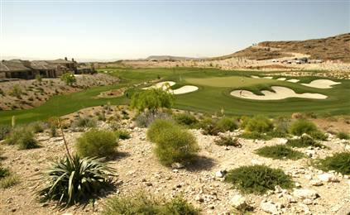
Updated: 12:25 p.m. CT Feb 22, 2007
Figure 1 Water from the Colorado River is used for everything from farming to golf, like this course in Las Vegas, Nev., where water use doubled from 1985 to 2000.
PHOENIX - The 25 million Americans who rely on the Colorado River for water should expect continued — and even worsening — drought spells and water shortages as rising temperatures and growing populations create a double whammy, experts warned in a new report.
The experts, convened by the National Research Council, based their concerns on climate models and recent studies that found a cycle of droughts in the region over time. The studies used tree-ring histories to reconstruct local climate patterns over the last 500 years.
"These reconstructions, along with temperature trends and projections for the region, suggest that future droughts will recur and that they may exceed the severity of droughts of historical experience, such as the drought of the late 1990s and early 2000s," the experts wrote in the report released Wednesday.
The report said the region should expect higher temperatures that melt snow too early and allow too much runoff to evaporate.
"Temperature records across the Colorado River basin and the western United States document a significant warming over the past century," the experts noted. "These temperature records, along with climate model projections that forecast further increases, collectively suggest that temperatures across the region will continue to rise for the foreseeable future."
More than 25 million people in seven states — Arizona, California, Colorado, New Mexico, Nevada, Utah and Wyoming — rely on the Colorado River for water and power. The river also supports a diverse riparian system that has suffered as flows dropped.
'Trade-off choices' necessary
The report said the combination of threats could overwhelm the seven river states, which have struggled to produce a short-term drought plan.
The scientists did not propose specific policy changes, but urged Western water managers to work together on new ideas and prepare to make difficult decisions about how water is used.
"The basin is going to face increasingly costly, controversial and unavoidable trade-off choices," said Ernest Smerdon, a former dean of engineering at the University of Arizona and one of the report's authors. "Our hope would be that the community and the decision-makers will have planned before crises occur."
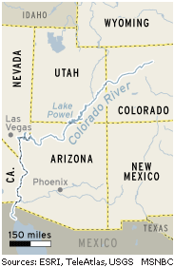
The experts noted that population pressure has added to the problem. Arizona's population grew by 40 percent in the 1990s, they noted, while Colorado's grew by 30 percent.
Water conservation measures have helped somewhat, but consumption has boomed in certain areas. For example, Nevada's Clark County, which includes Las Vegas, saw water use double from 1985 to 2000.
"The combination of limited water supplies, rapidly increasing populations, warmer regional temperatures, and the specter of recurrent drought point to a future in which the potential for conflict among existing and prospective new water users will prove endemic," the research council said in a statement that accompanied the report.
The report was commissioned by the U.S. Bureau of Reclamation, the Southern Nevada Water Authority and two California water agencies.
No panacea
Growing cities will force states to strike more deals with farmers for water rights, but even that supply is limited, according to the scientists.
In addition, the report ruled out the idea of a solution built around conservation or water-saving technologies.
"Technological and conservation options for augmenting or extending water supplies — although useful and necessary — in the long run will not constitute a panacea for coping with the reality that water supplies in the Colorado River basin are limited, and that demand is inexorably rising," the experts wrote.
Much of the region has seen severe drought since the late 1990s, with 2002 and 2004 being among the 10 driest years on record in the upper basin states of Colorado, New Mexico, Utah, and Wyoming.
Water storage in basin reservoirs dropped sharply during that time due to very low streamflows, the experts noted. For example, 2002 water year flows into Lake Powell were roughly 25 percent of average.
The Associated Press contributed to this report.
Evidence of troubles in the Colorado River basin.
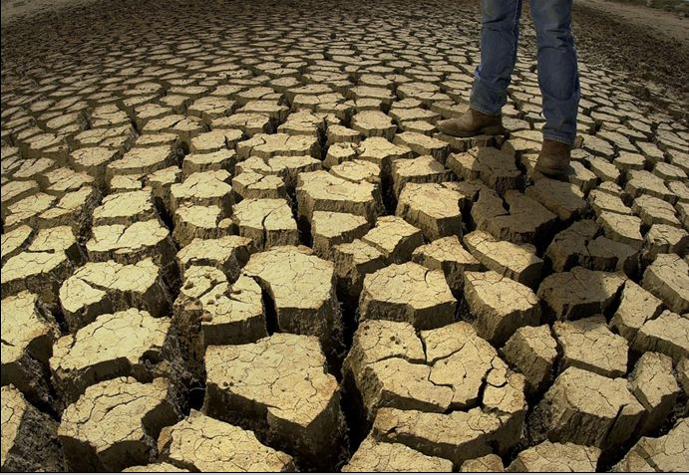
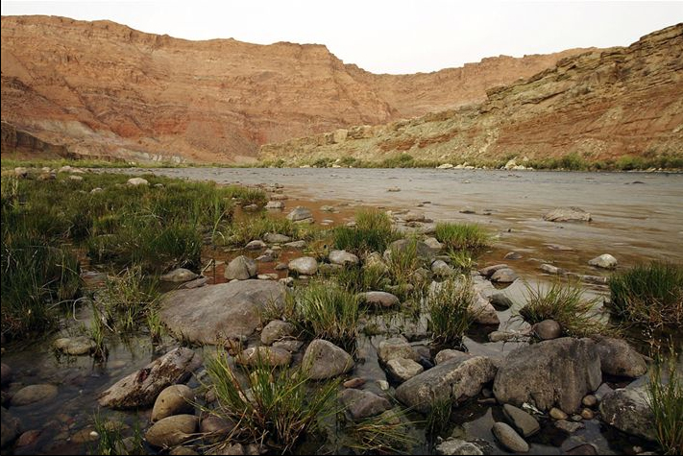
Figure 2 Dried pond bottom on a cattle ranch in Colorado.
Figure 3 Colorado river downstream from the Glen Canyon Dam.

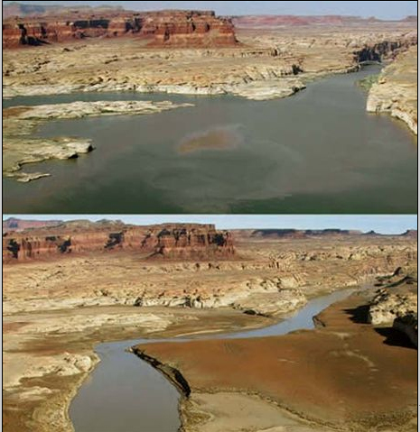
Figure 4 This is where dirty devil river flows into Lake Powell before and after the 2002 drought.
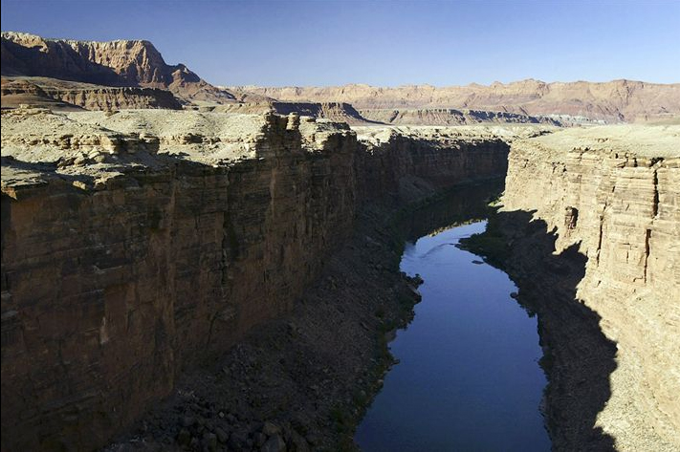
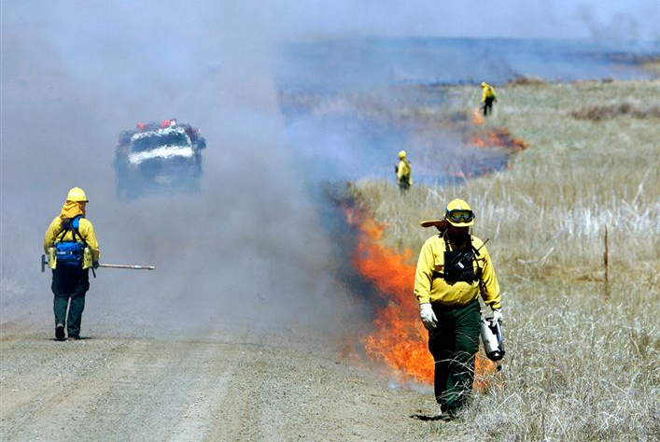
Figure 6 The 2004 drought set the stage for this wild fire north of Denver, Colorado
Figure 5 The plateau on both sides of Marble Canyon is very dry
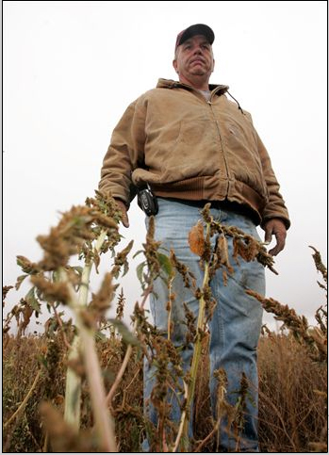
Figure 7 crop lost on an unirrigated field in Wiggins, Colorado. The state required farmers to reduce their use of water for irrigation.

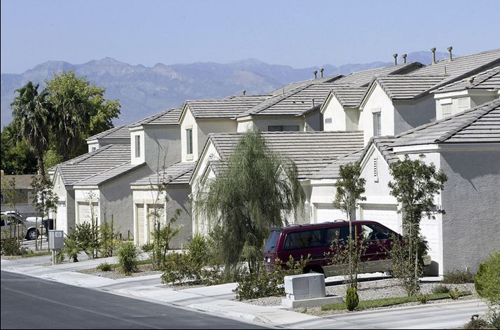
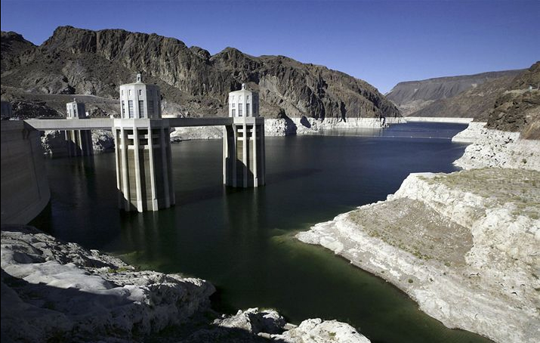
Figure 8 Las Vegas water use doubled from 1985 to 2000. Other users of Colorado River water also increased their demands on the river.
Figure 9 The bathtub ring around Lake Mead – in 2004, the water was at a near record low.

