This poor farmer has the answer to India's food crisis
Last updated on: September 23, 2010 19:27 IST
Manu A B in Mumbai
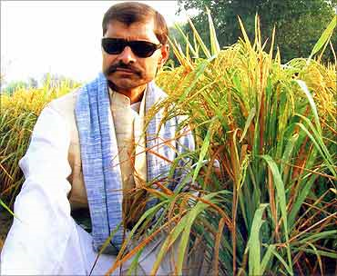
Apni kheti, apna khaad / Apna beej, apna swaad (Our own farm, our own fertiliser / Our own seeds, our own taste) -- Prakash Singh Raghuvanshi.
A farmer from Tandia village in Varanasi has a solution to India's burgeoning food crisis.
In a land where poverty, hunger, malnutrition and farmer suicides are rampant, Prakash Singh Raghuvanshi's innovation could work wonders.
He has single-handedly developed a number of high yielding, nutritious and disease-resistant varieties of wheat, paddy, pigeon pea (tur dal) and mustard, which can also withstand adverse weather changes.
Financial problems and falling crop yield prompted him to think about starting a seed bank of the best varieties of crops.
It has been a relentless crusade of over five years, despite lack of funds, formal education, illness, and weak eyesight to develop the best quality seeds in India. But there seems to be no end to his woes.
"The Union Bank has sent a notice as I have not been able to pay up the loan. They will seize my property if I do not pay Rs 75,000 immediately. I can't imagine losing my precious land. I hope someone will help me out of this crisis," he says.
"I believe that God has given me the power to help other farmers and help my country be self-sufficient in foodgrain production. Every variety I developed has a yield of 20-40 per cent more than the ones available in the market. I can challenge anyone to grow a better variety of crop beside my plot," says 50-year-old Prakash Singh, who is ushering in a unique green revolution by supplying seeds free of cost to hundreds of thousands of farmers across India.
No help from the government yet
Prakash Singh has developed over 80 varieties of high yielding wheat, 25 varieties of paddy, besides pigeon peas, mustard and vegetables.
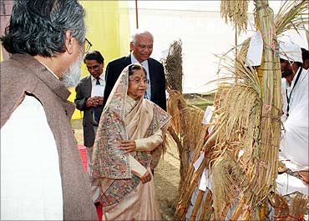
As an indigenous creator of a seed bank, he has sent samples of seeds to the Prime Minister's Office, the Ministry of Agriculture and the rice research institute in Hyderabad.
However, he has not received any help from the government yet.
While he has applied for a patent for the different varieties of seeds, he has also distributed the seeds free of cost to over 20 lakh (2 million) farmers across Maharashtra, Punjab, Haryana, Himachal Pradesh, Uttarakhand, Gujarat, Chhattishgarh, Madhya Pradesh, Bihar and West Bengal.
"In the Sangli district of Maharashtra, some poor farmers have become rich by using only my seeds. They are now selling the seeds to other farmers in the district," Prakash says
'Foreign companies are taking our farmers for a ride'
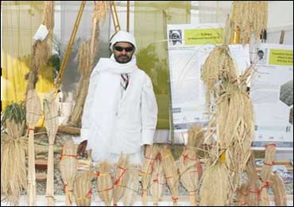
While many farmers have benefited from Prakash's seed bank, some big companies have cheated him by buying some of his seeds from other farmers and selling it as their brand.
He does not reveal the companies' names to avoid a controversy. "Unless a patent is granted to me at the earliest, how will I protect my innovation? Even granting a patent takes years in India," he laments.
Today, India has become a hotbed for companies selling seeds. "Several companies have made agriculture a big business, looting poor farmers. They claim to sell seeds with a high yield and charge up to Rs 200 per kg but the yield is never good and the cost of conventional farming is high."
"The debt-ridden farmers fall prey to their false claims. Foreign companies are taking our farmers for a ride. We need to make them aware of the potential dangers of buying seeds from these companies. They have an ulterior motive of destroying our environment and make us diseased."
"Today, we have more sales of medicines than essential food items," Prakash Singh explains.
He also trains farmers in different aspects of plant breeding and farming techniques.
'Seeds sold by big companies are not pest-resistant'
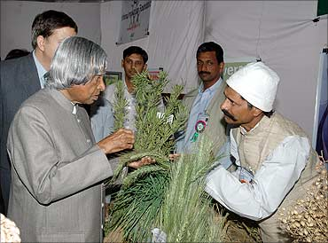
A promoter of organic farming, he says using pesticides and chemicals destroys the soil and contaminates the food, water and the entire life cycle of plants.
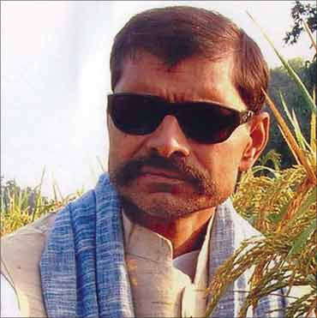
"The seeds sold by big companies are not pest-resistant, though they claim to be. We should preserve Nature, agriculture and the indigenous seed varieties. Nature by itself is so knowledgeable; it knows when there should be sunshine, when it should rain, the change of seasons, everything happens on time. We should not reverse this cycle by going against Nature," he remarks.
While companies selling seeds claim that the yield will be 70 quintals from 200 kg of seeds grown in 1 hectare of land, in reality it will not be more 50 quintals, he says. Besides this, they are not disease-resistant, they are heavily dependent of pesticides, cannot withstand the changes in weather.
A deeply religious person, he also performs Agnihotra (an offering in fire of a combination of natural products) in the fields and house for better productivity, and purification of the atmosphere.
So how did he get interested in agriculture?
'I almost lost my eyesight; even today I have blurred vision'
Prakash was a good student, used to score high marks and participate in all activities in school. Unfortunately, when he was in class 9, he was down with fever. A dose of penicillin was given to him, which had an adverse reaction. And that changed his life forever.
"I thought my life ended there. My whole body started hurting badly; I almost lost my eyesight. I couldn't see properly for 3-4 years. I have blurred vision. A lot of treatment was done, but till today I have not been fully cured. I still get blisters inside my mouth frequently. I have learned to live with this pain," he says.
He has to wear goggles all the time and cover his head while going out. After being ill for almost a year, Prakash realised he could no longer go back to school. People took pity on Prakash. They thought he would never recover from his illness and be confined to his house.
But he proved them wrong.
'I realised I could make seeds that give a better yield'
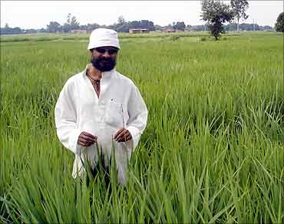
Prakash always loved Nature. He liked farming as well. His father was a primary school teacher who also did farming. Slowly, he started going to the farm. He started helping in whatever way he could.
His father had started looking for better yielding crops as earlier crops failed to deliver as expected. "I used to observe the plants very closely. I noticed that in the midst of similar looking plants, there were some which were slightly different. Some were able to withstand the vagaries of nature while other wilted," he says.
He started by sowing seeds of the plans that appeared to be stronger. He carried out a lot of experiments in a small plot of land to develop better varieties of crops.
"After a year or so I realised that I could actually make seeds that could give a better yield. I could do what many of our scientists have not been able to do yet despite having funds, infrastructure and government support," he says.
All his wheat varieties are named Kudrat
Prakash continued with his experiments. He took part in agricultural fairs, met scientists and agricultural officers to gain more knowledge. His inspiration to develop new varieties came from Mahatim Singh, former Professor at Banaras Hindu University.
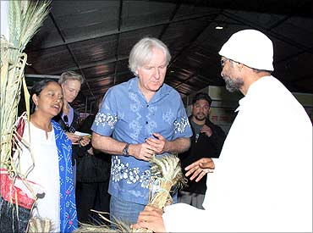
"Mahatim Singhji used to give us seeds, which we used to try in our fields. Singh motivated me to develop better varieties. Today, I have wheat varieties, called Kudrat 3, 5, 7, 9, 11, 17," he says.
All the varieties are named Kudrat (nature) as he believes, it's all thanks to nature that he could achieve so much despite his constraints.
"People have always remarked how I could achieve so much without any help. They have also appreciated me for reaching out to lakhs of other farmers," he says.
Nature's gift
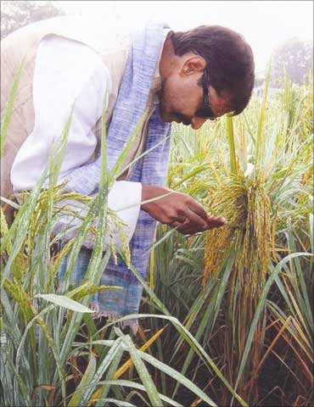
The wheat varieties in general are characterised by higher number of ear-bearing tillers, lengthy spikes, and more number of seeds per spike, hardy stem and high protein content.
"These crops can withstand changes in weather and temperature. They also have more vitamins, carbohydrates and vitamins.
Besides wheat, he has developed 3 varieties of rice Kudrat 1, 2 and Lal Basmati of paddy were developed from HUVR-2-1 and Pusa basmati varieties.
The yield per acre of each is 25-30 quintals, 20-22 quintals and 15-17 quintals, respectively.
Mustard varieties are Kudrat-Gita, Vandana and Suryamukhi. The three Pigeon pea varieties are Kudrat 3, Chamatkar, Karishma.
'Even the law of the land is against the farmers'
"Today even the law of the land is against the farmers. I cannot pack these seeds and sell. I will be caught for committing an offence while big companies can steal my product and sell, it. They go scot free."
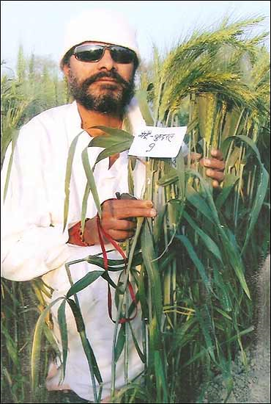
"I met the state Agriculture Minister Chaudhari Laxmi Narayan, who in turn helped me get in touch with Chandrasekhar Krishi Vishwa Vidhayala and Acharya Narendra Dev Krishi Vishwa Vidhayala. They tested my seeds and were impressed with the results. They have given me a test report saying they got 40 per cent higher yield."
The Banasthali Vidyapith in Rajasthan, has also tested his wheat varieties.
Despite a bumper yield, farmers in India hardly get a good price for their produce. Though organically grown products are sold at exorbitant rates by big companies, Prakash Singh sells his yield for Rs 15-20 a kg. Wheat from his farm is sold at Rs 12 per kg.
"The traders and middlemen make all the money leaving the hapless farmers poor. I myself have taken loans all through my life," he says.

'Foreigners who visit Benares come to meet me'
"After I got in touch with the National Innovation Foundation, my life has improved a lot. They granted me a loan of Rs 190,000. They also facilitated my travel across the country so I could go organise meetings, popularise these varieties."
"Wherever I go, thousands of people gather to meet me. The media has given good publicity. Every day I get calls from across the country from people who would like to do farming with Kudrat seeds. Even foreigners who visit Benares (Varanasi) come to meet me and my farm," he says.
When Prakash Singh went to Pune, one farmer said, 'We feel as if 'Shirdi Baba' has taken your form to come and save us.' "It was a great compliment," says Prakash.
'Our farmers have little choice but to borrow from moneylenders'
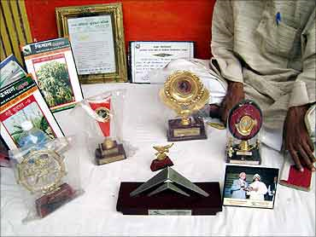
"Many of them are in the clutches of moneylenders who lend money at exorbitant interest rates. It's the same story across India. Companies make crores (tens of millions) selling seeds and moneylenders mint money at the cost of the farmers' life," says Prakash.
"Our farmers are left with little choice. Where is our country headed to? I often wonder why our government does not take any initiative to help us. I had a loan for 15 years. I still have a loan from Union Bank. It is such a big burden," he says.
Besides money, frequent power cuts affect agriculture. There are many days when farmers do not get power for more than a few hours, making it difficult to manage things, says Prakash.
'I got the chance to do this work due to divine intervention'
Prakash likes to believe that all the misfortunes in his life have now tuned into a miracle.
"I believe it is due to divine intervention that I have got the opportunity to do this work. And yet worries do not let go of me. My wife has fallen ill too. I need Rs 500 every week to buy her medicines."
"I have six children, 3 daughters and 3 sons. All my daughters are educated. My elder daughter did her MA. My younger daughters have completed graduation. They promote our seeds and make other children, women in the village aware of various aspects of farming. My youngest daughter, Soni, performs Agnihotra which is very useful for the environment and the fields.
He has received 2 national innovation awards
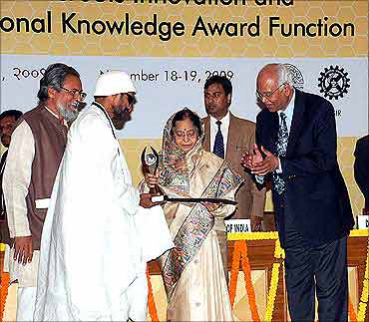
Prakash Singh has won the National Innovation Award twice. He was felicitated by President Pratibha Patil and former President Abdul Kalam. He has also been honoured by people across the country.
"Once a person from Karjat in Maharashtra sent me air tickets to travel to his place. He wanted me to show him my unique technique of farming. I have been honoured by so many people. People have always praised my work and farmers have enjoyed the fruits of using Kudrat seeds," he says.
He was also invited to talk at a forum attended by Sri Sri Ravishankar. So more people have come to know about Kudrat.
"I have the habit of sending a gift of seeds to everyone who is interested in farming," says Prakash.
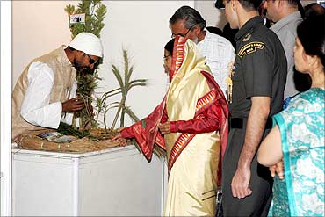
"I have 5-6 varieties which I have not distributed yet. I will release it only after I get a patent or start my own company. I will need at least Rs 15 lakh (Rs 1.5 million) to start my company and about Rs 1.5 lakh (Rs 150,000) to buy a seed grading machine. At the moment, everything is beyond my reach," Prakash points out.
'A day will come when no farmer will commit suicide'
Prakash Singh dreams of a day when every farmer in India will have Kudrat varieties in his farm. He plans to pass on the seeds and the technique of farming to as many farmers as possible.
"This would make them self-reliant, protect our crops and the agriculture sector. A day will come when no child in India will go hungry, no farmer in India will commit suicide. We will have bumper production across India. Our soil, our land and the environment will be free of pollution," he says.
He also dreams of starting an agriculture university to impart knowledge to many students who have a genuine interest in farming.
"I can teach them many things, which books cannot. Whatever I have learned is from my own experience. My mission will be incomplete if I do not pass on this knowledge."
'Aage aage badhnaa hai to himmat haare mat baitho'
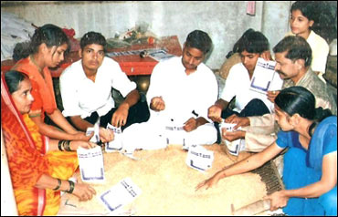
Prakash Singh hopes at least his sons will be able to start a company, which can stock all varieties of seeds. It will help in easy distribution across the country.
"I am very proud of my father. I also wish our Kudrat seeds reach each and every farmer in India," says Soni, his daughter.
An expert at bhajans and keertans, Prakash Singh has taught his daughters to sing as well. Prakash starts his day with a bhajan and Agnihotra. "It is very useful for us and our farm," says Soni and she sings melodiously...
Jeevan mein kuch karnaa hai to mann ko maare mat baitho / Aage aage badhnaa hai to himmat haare mat baitho / Himmat haare mat baitho... (If you want to achieve something, never suppress your dreams / If you want to keep progressing, never lose courage. . .)

