Threats to Biodiversity

The worst thing that can happen during the 1980s is not energy depletion, economic collapse, limited nuclear war, or conquest by a totalitarian government. As terrible as these catastrophes would be for us, they can be repaired within a few generations. The one process ongoing in the 1980s that will take millions of years to correct is the loss of genetic and species diversity by the destruction of natural habitats. This is the folly that our descendents are least likely to forgive us.

- E.O. Wilson, 1985

We wish to learn:
- What is biodiversity?
- What are the threats to biodiversity?
- How can we estimate rates of species loss?
- What can we do about this issue?

1. What is Biodiversity?
What is biological diversity ? In its narrowest sense this term refers to the number of species on the planet, and it also is used more broadly as an umbrella term.
Biological diversity refers to the variety and variability among living organisms and the ecological complexes in which they occur. Diversity can be defined as the number of different items and their relative frequency. For biological diversity, these items are organized at many levels, ranging from complete ecosystems to the chemical structures that are the molecular basis of heredity. Thus, the term encompasses different ecosystems, species, genes, and their relative abundance (Office of Technology Assessment, 1987). Or to paraphrase: number and variety of species, ecological systems, and the genetic variability they contain.
The simplest representation is:
Group | Number of Described Species
Bacteria and blue-green algae | 4,760
Fungi | 46,983
Algae | 26,900
Bryophytes (mosses and liverworts) | 17,000
Gymnosperms (conifers) | 750
Angiosperms (flowering plants) | 250,000
Protozoans | 30,800
Sponges | 5,000
Corals and Jellyfish | 9,000
Roundworms and earthworms | 24,000
Crustaceans | 38,000
Insects | 751,000
Other Arthropods and minor invertebrates | 132,461
Mollusks | 50,000
Starfish | 6,100
Fishes (teleosts) | 19,056
Amphibians | 4,184
Reptiles | 6,300
Birds | 9,198
Mammals | 4,170
Total | 1,435,662
These three pie charts (number of species of all kinds, number of animal species, number of plant species) show the same information diagrammatically.
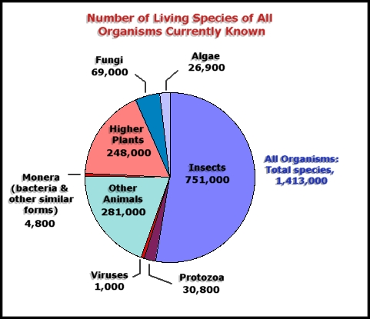
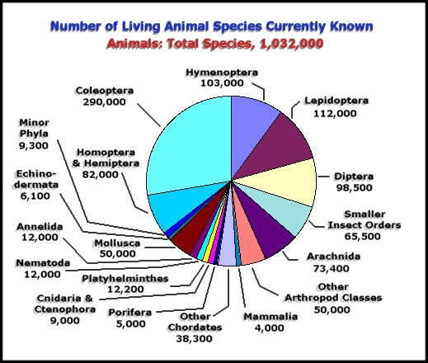
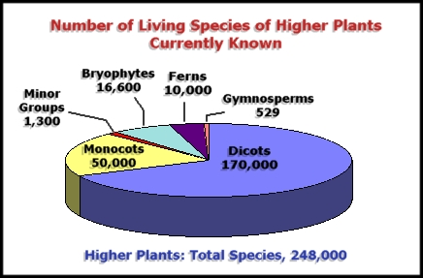
These numbers reflect a huge amount of scientific study. In order for a species to be included on the above list, it was examined by a specialist, who carefully compared its features to those of all similar species; then, once satisfied that the species in hand was different from all known forms, the specialist published a thorough description including drawings, counts of hairs along forelegs, length of measurable parts such as limbs and antennae, photographs, etc. The new species has then been described, and is added to our list of "known" species.
Remarkably, our estimates of the number of unknown species greatly exceed our count of the number of known species. Most experts estimate the world's species diversity at 10 to 30 million, but that is very approximate. Only 1.4 million species are "known to science" -- meaning that they have been classified by a specialist. The estimates of 10 to 30 million species are based on expert opinion of how many species are yet to be formally identified. One study of insects in the forest canopy found 5 out of 6 to be new species. Even vertebrates are not completely known -- it is estimated that nearly half of the freshwater fishes of South America are not described. New finds are made continuously in the tropics, and exploration of deep-sea hydrothermal vents recently led to the discovery not just of new species, but of new life forms at the family level (20 families or sub-families). When you consider that virtually every species has its own parasite, and how many groups such as nematodes and bacteria have yet to be well-studied, it is apparent that the estimates of 10 to 30 million are not out of line.

2. What are the Threats to Biodiversity?
Extinction is a natural event and, from a geological perspective, routine. We now know that most species that have ever lived have gone extinct. The average rate over the past 200 my is 1-2 species per year, and 3-4 families per my. The average duration of a species is 2-10 million years (based on last 200 million years). There have also been occasional episodes of mass extinction, when many taxa representing a wide array of lifeforms have gone extinct in the same blink of geological time.
In the modern era, due to human actions, species and ecosystems are threatened with destruction to an extent rarely seen in earth history. Probably only during the handful of mass extinction events have so many species been threatened, in so short a time.
What are these human actions? There are many ways to conceive of these - let's consider two.
First, we can attribute the loss of species and ecosystems to the accelerating transformation of the earth by a growing human population. As the human population closes in on the six billion mark (link), we have transformed, degraded or destroyed roughly half of the word's forests (link). We appropriate roughly half of the world's net primary productivity for human use (link). We appropriate most available fresh water (link), and we harvest virtually all of the available productivity of the oceans (link). It is little wonder that species are disappearing and ecosystems are being destroyed.
Second, we can examine six specific types of human actions that threaten species and ecosystems - the "sinister sextet"
Over-hunting has been a significant factor in past, causing the extinction of the passenger pigeon, dodo, and eastern elk, and the endangerment of many more, such as whales. For the future, it is dwarfed by other factors mentioned next.
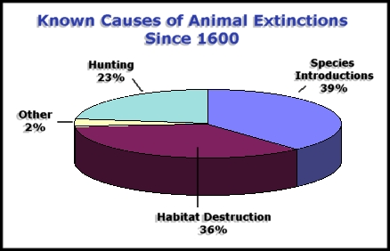

Source: World Conservation Monitoring Centre, "Global Biodiversity" Chapman & Hall, London, 1992).
Habitat loss/degradation/fragmentation have played a role in past extinction/ endangerment. Reduction of the forests of the eastern US restricted the habitat of animals such as the eastern sub-species of elk, making it easier to hunt to extinction. As we shall see, this is the single most important factor in the projected extinction crisis.
Invasion of non-native species is an important and often-overlooked factor. For example, the African Great Lakes - Victoria, Malawi and Tanganyika - are famous for their great diversity of endemic species, termed "species flocks", of cichlid fishes. In Lake Victoria, a single, exotic species, the Nile Perch, has become established and may cause the extinction of most of the native species, by simply eating them all. It was a purposeful introduction for subsistence and sports fishing, and a great disaster.
Of documented extinctions since 1600, introduced species appear to have played a role in at least half. The clue is the disproportionate number of species lost from islands: 93% of 30 documented extinctions of species and sub-species of herps, 93% of 176 species and sub-species of land and freshwater birds, but only 27% of 114 species and subspecies of mammals. Islands have many endemic species that have evolved with few competitors and predators, hence are extremely vulnerable to invading species. The explanation for mammals, is that most of these are large-bodied species of continents, hunted to extinction.
Domino ("ripple") effects occur when the removal of one species (an extinction event) or the addition of one species (an invasion event) affects the entire biological system. Domino effects are especially likely when two or more species are highly inter-dependent, or when the affected species is a "keystone" species, meaning that it has strong connections to many other species.
The seeds of the tree Calvaria major, now found exclusively on the island of Mauritius, must pass through the abrasive gut of a large animal in order to germinate. None of the animals currently on Mauritius have that ability. The dodo (a 25 kg pigeon), hunted to extinction in the late 17th century, probably was the key to recruitment in this species. Only a few very old trees now survive. The blackfooted ferret was once very abundant in the western prairies. It preyed upon prairie dogs and used their burrows to nest in. Poisoning of prairie dogs has greatly reduced their abundance, and the blackfooted ferret is now the rarest mammal in North America
Pollution from chemical contaminants certainly poses a further threat to species and ecosystems. While not commonly a cause of extinction, it likely can be for species whose range is extremely small, and threatened by contamination. Several species of desert pupfish, occurring in small isolated pools in the US southwest, are examples.
Climate change: A changing global climate threatens species and ecosystems. The distribution of species (biogeography) is largely determined by climate, as is the distribution of ecosystems and plant vegetation zones (biomes) [link to 110 lecture on ecosystems]. Climate change may simply shift these distributions but, often, barriers and human presence will provide no opportunity for distributional shifts. For these reasons, some species and ecosystems are likely to be eliminated by climate change.
As a consequence of these multiple forces, many scientists fear that by end of next century, perhaps 25% of existing species will be lost. Current rates of known extinctions of large, conspicuous species - mainly birds and mammals - are approximately 1 species per year (~280 species and sub-species over past 300-400 years). The current/future rate is estimated to be 10,000+ species per year, based on habitat loss and species-area curves.

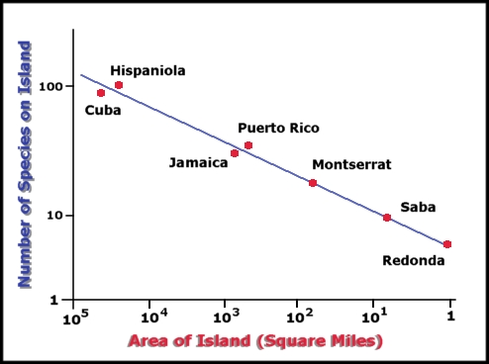
3. How Can We Estimate Rates of Species Loss?
Estimates of current and future extinction rates are based on well-documented relationships between the number of species in a region and habitat area, and on reasonably well-known rates of habitat loss. We must also employ some ratio to approximate the total number of species (described and undescribed), from the number of described species.
The Number of species living on islands increases or decreases with the area of the island. The diversity of reptiles and amphibians in the West Indies is depicted here. A reduction of 90 percent in area from one island to the next results in a 50 percent loss of species.
The relationship between species (S) and area (A) is described by the equation:

S = c A ^{z}
where z is the slope of the log-linear relationship, and c is a constant which described the height of the line. Based on censuses of species on islands, the number of species found on an island increases log-linearly with island area. Conversely, as island (or habitat area) is reduced, so is the number of species that will be found there. The slope (z) usually varies between 0.15 to 0.35. When combined with current rates of loss of tropical forest (this calculation uses 1.8% per year), these values of the slope translate into species extinction rates of roughly 0.5% annually. Extrapolated to the year 2020, roughly 20% of remaining species will disappear. Simply using the most conservative values of the slope, and assuming the true biodiversity of tropical forests is roughly 10 million species, the projected rate of loss of species is 27,000 per year, and three during this hour.

4. What Can We Do About This Issue?
The problem is serious, and many species and ecosystems will disappear over the next century. However, starting with recognizing the problem, and then by identifying management objectives, much can be done. A sound strategy would emphasize efforts to increase the amount of protected land, and to better manage non-protected lands.
Protected areas: Only about 2% of the earth's land surface is in strictly protected scientific reserves and national parks. Moreover, in many developing countries, enforcement of laws protecting parks is minimal. The amount of protected land needs to be increased and, due to growing awareness of the problem, it is being increased. However, it is unlikely to ever exceed 6% of the earth's land surface, and even that amount may be optimistic. Nonetheless, parks and sanctuaries can be very effective, protecting a significant fraction of an area's wildlife.
Gap analysis is a new approach using remote sensing and GIS to map the distribution of species and ecosystems, for comparison to the distribution of protected land. When important species or ecosystem types are found to lie outside of the network of protected land, there is a "gap" in the protective network of parks and sanctuaries, suggesting a target for land acquisition.
Non-protected areas cannot be ignored, however - they make up >95% of the landscape. Parks and sanctuaries exist in a matrix of developed land. Species wander outside of parks routinely. Future climate change raises the alarming likelihood that the entire flora and fauna of parks will migrate outside their current sanctuaries, as the climate within the park boundaries becomes unsuitable. Clearly, how we manage lands outside of parks is a critical component of any biodiversity management strategy. Managing conflicts between human activities and conservation, and educating the public to a conservation ethic, are important parts of the strategy here.

5. Summary
- Biodiversity refers to the number and variety of species, of ecosystems, and of the genetic variation contained within species.
- Roughly 1.4 million species are known to science, but because many species are undescribed, an estimated 10-30 million species likely exists at present.
- Biodiversity is threatened by the sum of all human activities. It is useful to group threats into the categories of over-hunting, habitat destruction, invasion of non-native species, domino effects, pollution, and climate change.
- Habitat loss presents the single greatest threat to world biodiversity, and the magnitude of this threat can be approximated from species-area curves and rates of habitat loss. The spread of non-native species threatens many local species with extinction, and pushes the world's biota toward a more homogeneous and widely distributed sub-set of survivors. Climate change threatens to force species and ecosystems to migrate poleward, with no guarantee of suitable habitat or access routes. These three factors thus are of special concern.
- Protected lands comprise roughly 2% of the earth's land surface, and might someday approach 6%. They can serve as critical refuges for biodiversity. However, management of the >95% of the earth's land surface not in reserves must be a critical part of a biodiversity protection strategy.
Number of Protected Areas and the Total Area of Various Biogeographical Regions They Cover
 | Scientific Reserve |  | National Park |  | National Monument |  | Wildlife Reserve |  | Protected Landscape |  | Total
Region | No. | km | No. | km | No. | km | No. | km | No. | km | No. | km
Nearctic | 5 | 11,600 | 142 | 1,155,500 | 32 | 64,200 | 249 | 380,700 | 40 | 113,600 | 478 | 1,725,600
Palearctic | 313 | 273,100 | 204 | 112,300 | 24 | 2,000 | 649 | 172,800 | 494 | 171,700 | 1684 | 731,900
Afrotropical | 23 | 17,600 | 152 | 574,300 | 1 | < 100 | 260 | 268,700 | 8 | 300 | 444 | 860,900
Indomalayan | 63 | 27,900 | 158 | 111,300 | 5 | 300 | 411 | 180,400 | 39 | 2,900 | 676 | 322,800
Oceanian | 17 | 25,900 | 10 | 3,300 | 0 | 0 | 24 | 19,600 | 1 | < 100 | 52 | 48,900
Austrailian | 58 | 23,100 | 248 | 192,600 | 0 | 0 | 277 | 137,500 | 40 | 3,700 | 623 | 356,900
Antartic | 29 | 6,500 | 11 | 21,000 | 5 | 200 | 85 | 3,500 | 0 | 0 | 130 | 31,200
Neotropical | 55 | 63,900 | 224 | 423,900 | 22 | 2,900 | 126 | 244,900 | 31 | 32,500 | 458 | 768,100
Total | 563 | 449,600 | 1,149 | 2,549,200 | 89 | 69,600 | 2,091 | 1,408,100 | 653 | 324,800 | 4,545 | 4,846,300
Source. Protected Areas Data Unit, World Conservation Monitoring Centre, May 1989. Table from Reid and Miller 1989.
The rate at which new protected areas have been established throughout the world Date Established | Number of areas | Total area protected (km^2)
Unknown | 711 | 194,395
Pre-1900 | 37 | 51,455
1900-1909 | 52 | 131,385
1910-1919 | 68 | 76,983
1920-1929 | 92 | 172,474
1930-1939 | 251 | 275,381
1940-1949 | 119 | 97,107
1950-1959 | 319 | 229,025
1960-1969 | 573 | 537,924
1970-1979 | 1,317 | 2,029,302
1980-1989 | 781 | 1,068,572
From Reid and Miller 1989.
Percent of a country's bird species found within protected areas for selected African nations. Country | Percent of national land area protected | Number of bird species | Percent of bird species found in protected areas
Cameroon | 3.6 | 848 | 76.5
Cote dIvoire | 6.2 | 683 | 83.2
Ghana | 5.1 | 721 | 77.4
Kenya | 5.4 | 1064 | 85.3
Malawi | 11.3 | 624 | 77.7
Nigeria | 1.1 | 831 | 86.5
Somalia | 0.5 | 639 | 47.3
Tanzania | 12.0 | 1016 | 82.0
Uganda | 6.7 | 989 | 89.0
Zaire | 3.9 | 1086 | 89.0
Zambia | 8.6 | 728 | 87.5
Zimbabwe | 7.1 | 635 | 91.5
From Sayer and Stuart 1988.

