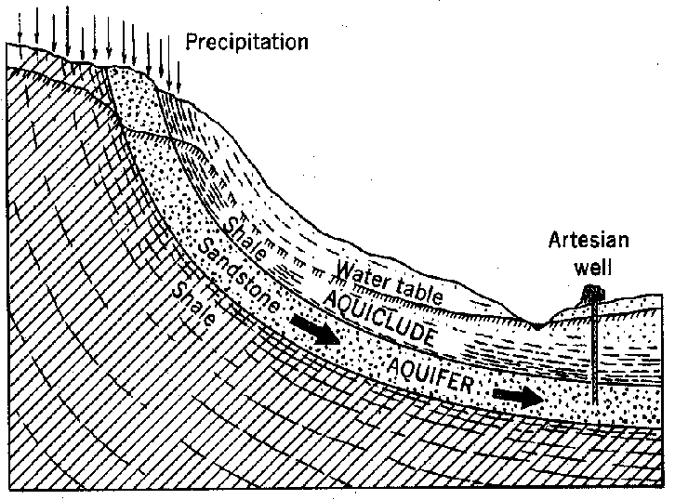
Artesian wells and other wells which tap aquifers in dry regions allow irrigated farming in the dry lands. If water is extracted from the wells at a rate greater than it is replenished, the aquifer will eventually run dry. This is only a partial fix unless it is managed on a sustained yield basis. Due to many variables, the yearly amount of water which can be regularly siphoned from the aquifer may be difficult to compute.

