Yangon bloggers outsmart Myanmar censors
by Shino Yuasa Tue Sep 25, 5:33 AM ET
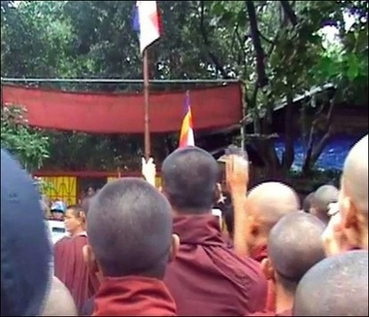
BANGKOK (AFP) - Savvy young bloggers in Myanmar are breaking through the military junta's tight Internet controls to post photos and videos of swelling anti-government protests, experts said Tuesday.
Figure 1 This photo obtained 23 September 2007 from the Democratic Voice of Burma shows a picture of monks gathered outside the home of detained democracy leader Aung San Suu Kyi in Yangon. Savvy young bloggers in Myanmar are breaking through the military juntatight Internet controls to post photos and videos of swelling anti-government protests.'
The government blocks almost every website that carries news or information about the Southeast Asian country, and even bars access to web-based email.
But an army of young techies in Yangon works around the clock to circumvent the censors, posting pictures and videos on blogs almost as soon as the protests happen.
Many of these images have been picked up by mainstream news organisations, because bloggers have managed to capture images that no one else can get.
When Myanmar's detained democracy icon Aung San Suu Kyi stepped outside her home in Yangon to greet marching monks and supporters on Saturday, the only pictures of the landmark moment were posted on blogs.
Mizzima News, an India-based news group run by exiled dissidents, picked up one of the photos of Aung San Suu Kyi and said more than 50,000 people accessed their website that day.
"People were saying they wanted to see more pictures of Aung San Suu Kyi," said Sein Win, Mizzima's managing editor.
These bloggers are mainly young university students in Yangon who have made it their mission to post messages and pictures since the anti-junta rallies broke out there on August 19, he said.
"We have many volunteers in Yangon. They are mostly university students and they keep sending us messages, pictures and video clips about the demonstrations," said Sein Win.
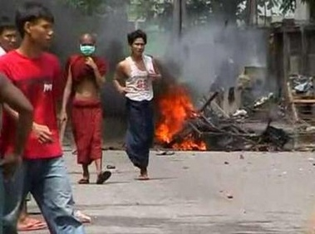
Messages on blogs have applauded Buddhist monks, who have led the protest movement. The movement has grown into the biggest challenge to the junta since a 1988 uprising that was crushed by the military, killing at least 3,000.
Figure 2 A monk wears a surgical mask as he walks past a fire in Yangon September 26, 2007. Troops fired shots over the heads of large crowds in Myanmar's main city on Wednesday, sending people scurrying for cover as a crackdown against the biggest anti-junta protests 20 years intensified.
"Many people were thanking monks for their courage, and were rallying support behind monks," Sein Win said from Thailand's northern city of Chiang Mai.
"The censorship is very tough, but many people want the world to know what is happening in Burma," he said.
The California-based Mandalay Gazette also said young people in Yangon were supplying pictures on the protests.
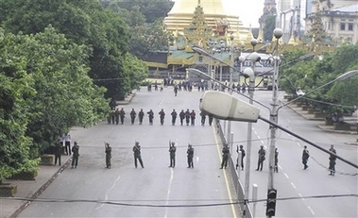
"It's encouraging to see messages of support coming as far as from Russia, and some messages said monks were correcting the junta's 'wrongdoing,'" said a US-based editor, who declined to be named.
Figure 3 Myanmar soldiers block a road leading to Shwedagon Pagoda in Yangon, Myanmar on Wednesday Sept. 26, 2007.
A Thai-based Burmese reporter from the Democratic Voice of Burma, a Norway-based broadcaster, said it had received video clips and photos from "many volunteers" in Yangon since the protests began last month.
"The quality of pictures from Yangon is very good. Many young people were helping us, and the junta cannot control our freedom of information," said the reporter, who operates anonymously for safety reasons.
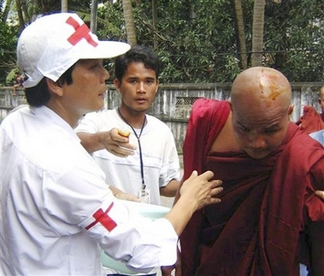
The Paris-based Reporters Without Borders has called Myanmar a "paradise for censors" and listed the military-ruled nation as one of the world's most restrictive for press freedoms.
Figure 4 Myanmar Red cross workers treat a monk after security forces shot tear gas into the air in an attempt to disperse protesters in Yangon, Myanmar on Wednesday.
Since the protests, the regime has cut off the mobile phones of prominent pro-democracy supporters and of some journalists representing foreign media.
State media on Tuesday accused the foreign press of stirring unrest.
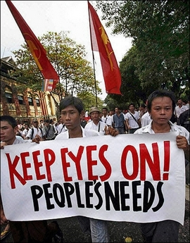
No foreign journalist has obtained a visa to enter Myanmar, under military since 1962, since the start of the anti-junta rallies, rights groups said.
Figure 5 Supporters of the Buddhist monks march down a street in downtown Yangon, 25 September 2007.

