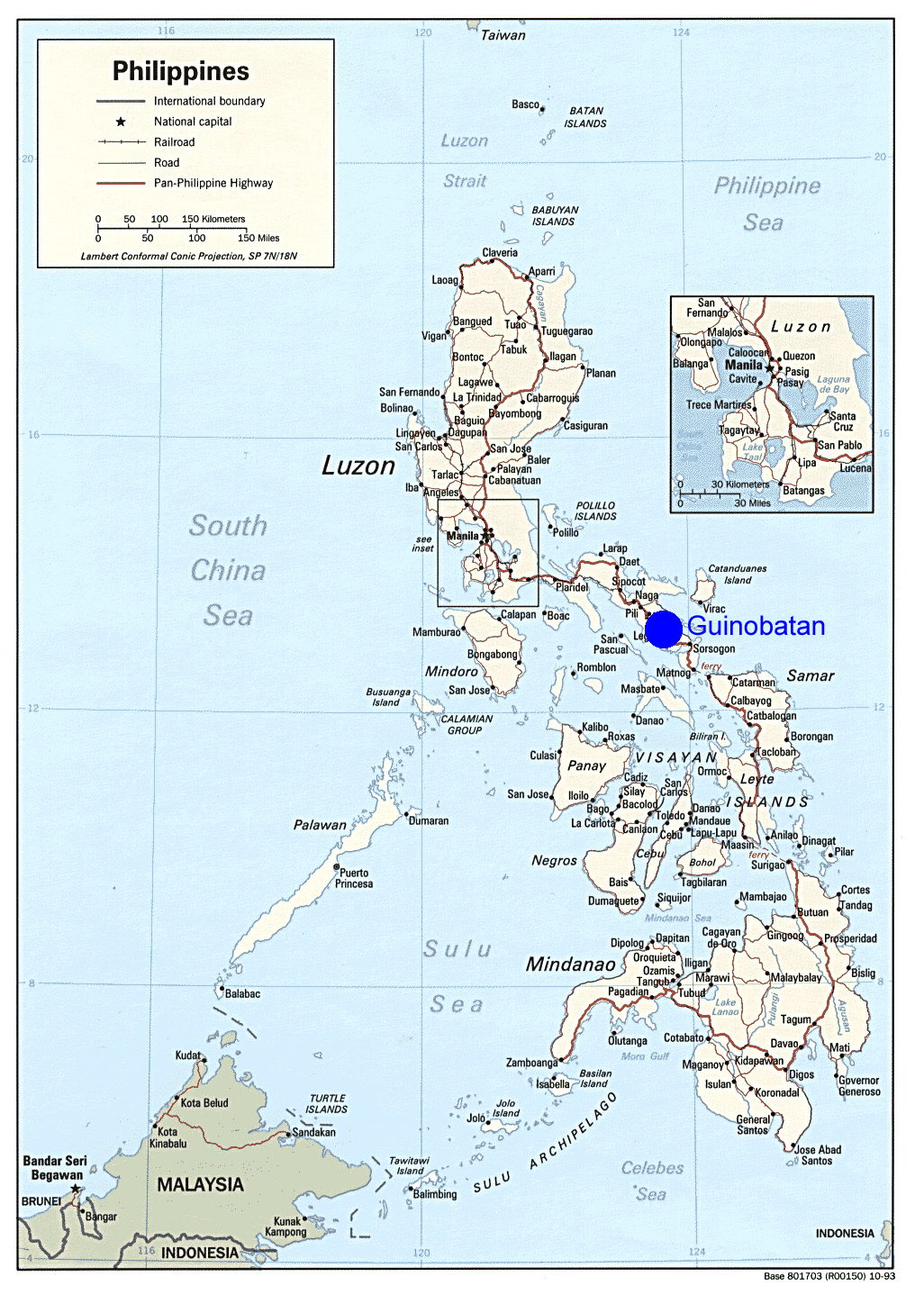
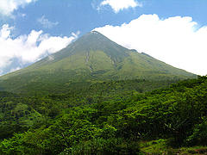
Wall of volcanic mud swamps Philippine hamlets, leaving 198 dead, 260 missing
THE ASSOCIATED PRESS
Saturday, Dec. 02 2006
Over 200 people are reported killed as typhoon lets loose volcanic debris.
GUINOBATAN, Philippines The ash and boulders had been building since an eruption in July, high on the slopes of the Mayon volcano. Typhoon Durian struck the island Thursday, and its 165 mph wind and drenching rain brought down a deadly black wall of debris to the valleys below.
For almost three hours, mudslides ripped through Mayon's gullies, uprooting trees, flattening houses and engulfing people. Entire hamlets were buried.
About 208 people were killed — most in mudslides on Mayon — and 261 were missing, the national Office of Civil Defense reported. Another 130 were injured.
With power and phone lines down, it took until Friday morning, when the first flights managed to survey the area, for the extent of the devastation to emerge.
"The disaster covered almost every corner of this province — rampaging floods, falling trees, damaged houses," said Fernando Gonzalez, governor of Albay province, the site of all but a few of the deaths.
"Our rescue teams are overstretched rescuing people on rooftops," said Glen Rabonza, the Civil Defense chief.
Officials briefed President Gloria Macapagal Arroyo on the disaster and the difficulties of getting to survivors stranded by seas of black mud.
Bodies were wrapped in blankets and slung on bamboo poles to be carried to trucks, then covered with coconut leaves and transferred to makeshift morgues.
"It's terrible. We now call this place a black desert," Noel Rosal, mayor of Legazpi city, Albay province's capital, said after visiting a stricken village.
Rosal said three of the five communities that make up the village of 1,400 people had been destroyed, with only the roofs of several houses jutting out of the debris. He said people claimed some of the boulders were as big as cars and red hot, suggesting fresh lava from 8,077-foot Mayon.
Figure 1 Mt Mayon

More dead are recovered in villages buried by mudslide

12/03/2006
'We need food, tents, water, body bags,' says a Philippine National Red Cross official

THE ASSOCIATED PRESS
PADANG, PHILIPPINES — Rescuers scouring mountain villages buried under mud and boulders loosened by a powerful typhoon discovered more bodies Saturday, raising the death total to more than 300, with another 300 missing.
Officials fear the number of those killed by Typhoon Durian will rise as rescue operations continue in devastated villages on the slopes of the Mayon volcano, 210 miles southeast of Manila in the northern Philippines.
The Disaster Coordinating Council of worst-hit Albay province reported 285 dead, including 165 in the town of Guinobatan, swamped by floodwater in the Mayon volcano's foothills. At least 66 people were reported dead in three towns on Mayon's slopes.
Another 300 people were missing, and the storm affected 800,000 people, officials said. Four other provinces reported deaths, but accurate figures were hard to come by, with the disaster's devastation so widespread and power and phone lines down.
"We need food, tents, water, body bags," Philippine National Red Cross official Andrew Nocon told DZMM radio. "We sent initially 300 bags, but we need more."
In Padang, a few miles from Guinobatan, houses were buried under mud and debris, with only roofs protruding. Power pylons were toppled.
Some of the bodies had been washed out to sea and brought back by currents to the shores of an adjacent town.
Silangan Santander, 21, attended funeral services for her brother, Larry, whose widow is five months pregnant. Only his lower torso and legs were found near the sea. Another brother was missing.
"In the community where my brother lived, all the houses there were gone," she said. "There are only rocks, sand and water."
Ash and boulders had been building on the slopes of the 8,077-foot Mayon — one of 22 active volcanos in the Philippines. Durian's winds of 139 mph and drenching rain on Thursday raked it all down on the deluged villages.

